THOMAS STRAND
Cybersecurity & Infrastructure Portfolio
Enterprise Cybersecurity | Infrastructure | Automation | Technology Leadership
35,000+  USERS SUPPORTED | 60,000+  ENDPOINT ESTATE | 62  SITES | 15+  YEARS IN IT

Designing secure, resilient systems where identity, endpoints, networks, automation, operations, and documentation reinforce one another.
PORTFOLIO FOCUS
Enterprise security architecture • Microsoft identity and endpoint security • network segmentation • incident response • PowerShell and Graph automation • operational resilience • executive and technical documentation
Hephzibah, Georgia | (706) 526-7846 | ttcstrand@gmail.com
Updated July 2026 | Public portfolio edition

PORTFOLIO MAP
Selected Work & Evidence
A concise guide to the capabilities, projects, and documentation represented in this portfolio.
01 Leadership Profile — Scale, operating model, and technical breadth
02 Security Architecture — Identity, endpoint, network, and operations integration
03 BusinessPlus Identity Automation — Secure cross-boundary Entra-to-SQL synchronization
04 Identity Modernization — Passkeys, FIDO2, MFA migration, and executive planning
05 Endpoint Security & Intune — Defender, remediation engineering, and evidence-based diagnosis
06 Network, Infrastructure & Compliance — Segmentation, GCIC, Exchange, Kerberos, and continuity
07 Security Awareness Leadership — Districtwide KnowBe4 rollout and measurable behavior change
08 Incident Response & Forensics — Evidence preservation, correlation, and defensible reporting
09 Documentation Portfolio — Sanitized excerpts from operational and executive deliverables
10 Impact & Credentials — Results, education, certifications, and professional value
SANITIZATION NOTE
Documentation excerpts are intentionally generalized. Production hostnames, IP addresses, tenant and application identifiers, certificate thumbprints, credentials, personal data, and other internal-only details are omitted.

01 LEADERSHIP PROFILE
Security Engineering at Enterprise Scale
Cybersecurity and infrastructure leader with more than 15 years of hands-on IT experience supporting a large K–12 environment. I combine architecture, implementation, operations, incident response, and documentation to reduce risk without losing sight of availability, supportability, or the realities of school-based technology.
My work spans Microsoft identity and endpoint platforms, Palo Alto and Aruba network security, Windows and virtualization infrastructure, cloud-to-on-premises integration, compliance, and automation. I am most effective where complex systems cross boundaries and require a clear control model, defensible evidence, and an operational plan.
CAPABILITY | SELECTED PLATFORMS & PRACTICES
Identity & Access | Microsoft Entra ID, Active Directory, SSO, Conditional Access, MFA, passkeys, FIDO2, RBAC, privileged access
Endpoint Security | Microsoft Defender for Endpoint, Intune, Autopilot, configuration profiles, remediation scripts, shared-device controls
Network & Infrastructure | Palo Alto HA firewalls, Aruba switching, segmentation, VMware ESXi, Hyper-V, Windows Server, Exchange
Automation & Integration | PowerShell, Microsoft Graph, SQL stored procedures, scheduled tasks, certificate-based authentication, audit logging
Monitoring & Response | Microsoft Defender XDR, Sentinel, SolarWinds, KQL, Purview audit, evidence correlation, forensic workflows
Governance & Compliance | CJIS/GCIC, FERPA, CIPA, COPPA, PCI DSS, NIST-aligned controls, change management, disaster recovery
OPERATING PRINCIPLE
A control is not complete until it is secure, testable, observable, recoverable, and documented.

02 SECURITY ARCHITECTURE
Integrated Enterprise Security Architecture
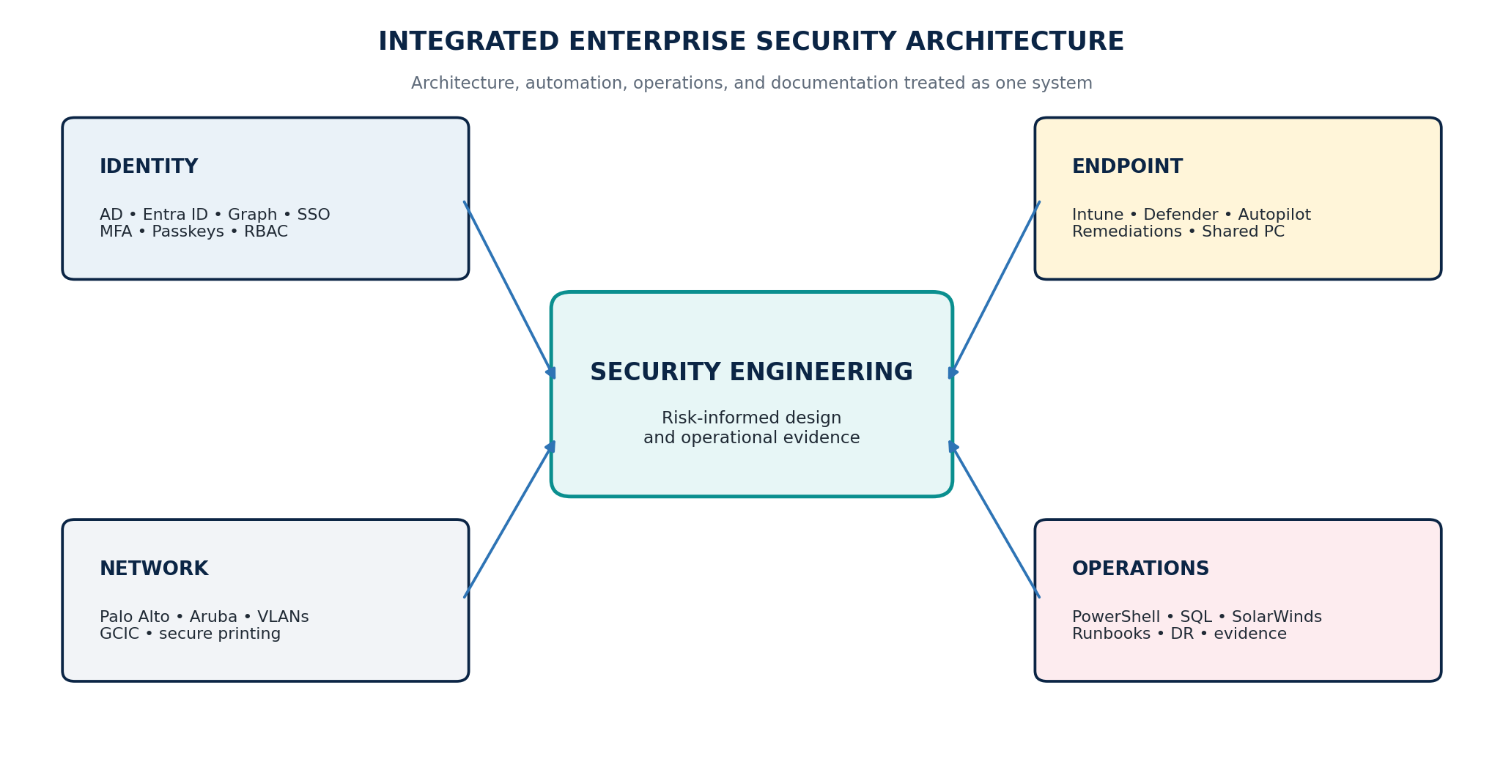
Architecture model: identity, endpoint, network, and operations converge through risk-informed security engineering.
This model reflects how I approach enterprise security work: establish authoritative identity, enforce least privilege, segment trust boundaries, protect endpoints, collect evidence, and build operational recovery into the design. Documentation is part of the control—not an afterthought.
- Identity decisions drive access, authentication, and automation boundaries.
- Endpoint and network controls provide layered prevention, detection, and containment.
- Runbooks, logs, testing, and rollback criteria make security changes supportable.

03 FEATURED ENGINEERING PROJECT
BusinessPlus Entra Object ID Daily Sync
Secure automation across Active Directory, Microsoft Entra ID, and a non-domain SQL environment.
CHALLENGE | A remote BusinessPlus database needed reliable Entra Object IDs for approximately 600 staff records, while the SQL system remained outside the on-premises domain trust boundary.
ROLE | Solution architect and primary engineer: identity mapping, PowerShell workflow, Graph authentication, SQL controls, commissioning, disaster recovery, and documentation.
SOLUTION | Built a daily PowerShell process hosted on a domain-joined operations server. It selects only queued AD users, performs exact Entra matching, calls a constrained SQL stored procedure, clears the AD marker only after verified success, and records timestamped evidence.
SECURITY CONTROLS | gMSA task identity; certificate-based Graph app authentication; validated SQL TLS; encrypted credential file; procedure EXECUTE only; conflict-safe writes; WhatIf; pilot; idempotency; structured CSV and transcript logging.
OUTCOME | Production task validated and enabled with clean dry-run and pilot results, no duplicate identity conflicts, safe retry behavior, and a 27-page operations/disaster-recovery runbook.
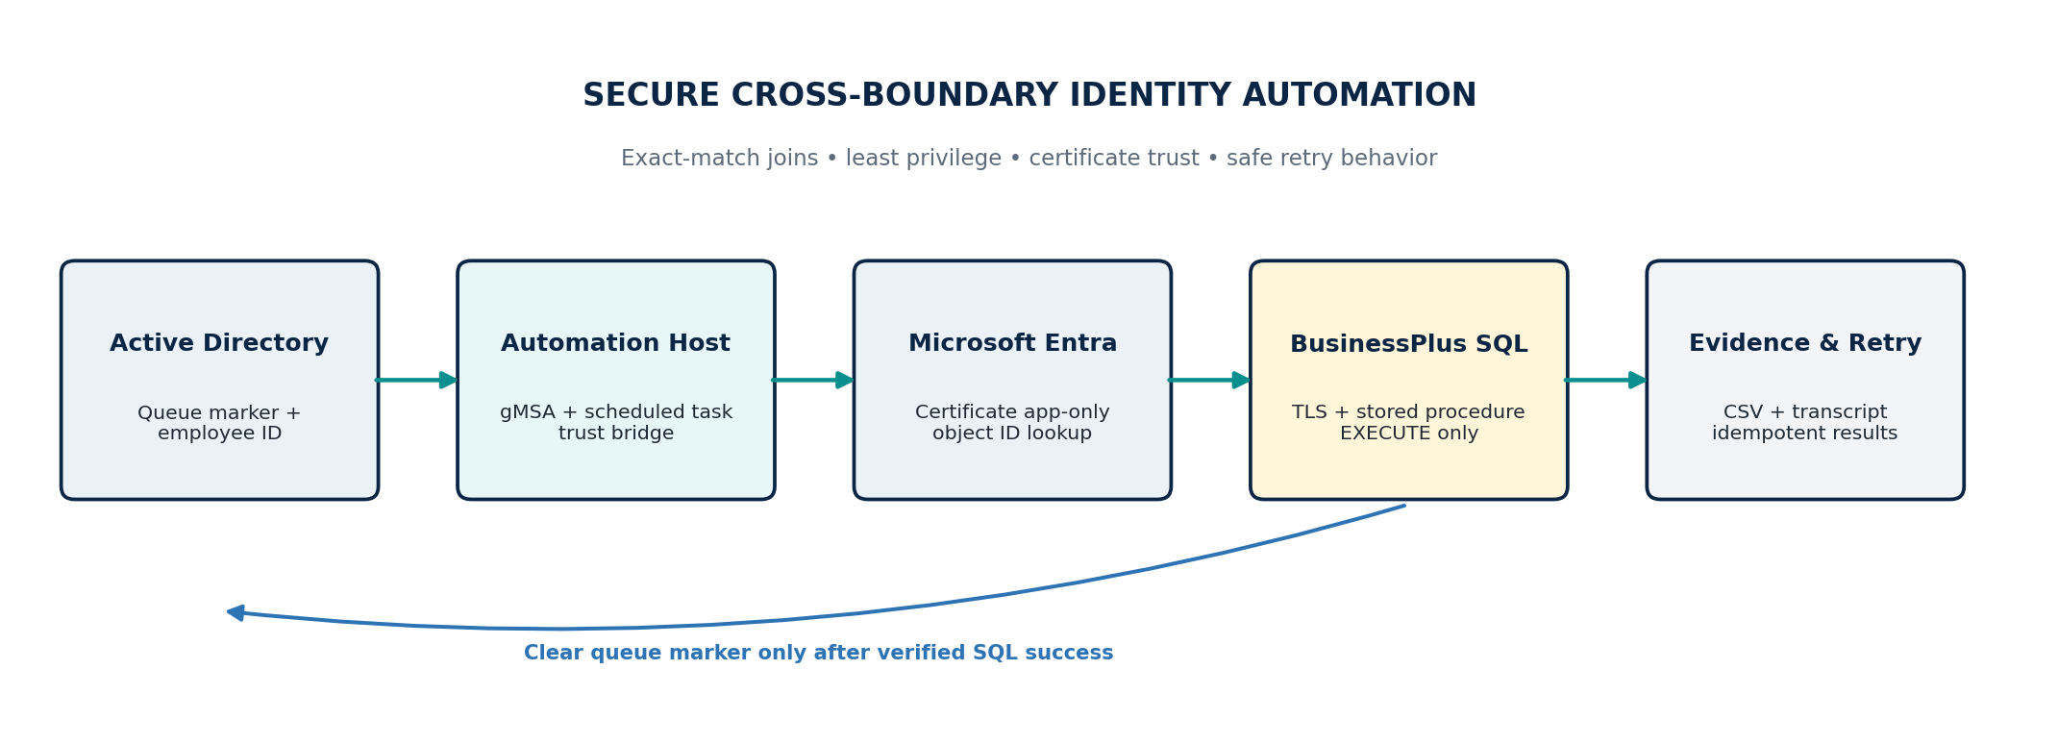
Sanitized production data flow. Operational identifiers and secrets are not shown.

03 FEATURED ENGINEERING PROJECT — EVIDENCE
Engineering Judgment & Recovery Readiness
The project was designed around explicit failure boundaries. A different nonblank mapping is treated as an investigation condition rather than overwritten. A successful SQL result can be retried safely if the AD marker clear fails. Database access is limited to a single stored procedure instead of direct table permissions.
DOCUMENTATION EXCERPT — RECOVERY GATE
“Do not enable database writes until certificate access, Graph app-only authentication, SQL TLS validation, stored-procedure access, a two-user WhatIf, and a two-user pilot have all passed.”
Sanitized excerpt from the BusinessPlus Entra OID Sync operations runbook, Version 1.0, July 23, 2026.
DOCUMENTATION EXCERPT — RECOVERY PRIORITIES
Contain unsafe activity. Preserve the newest CSV and transcript evidence. Restore identity and trust. Restore controlled code and configuration. Validate in WhatIf and limited pilot modes. Enable the scheduled task only after acceptance checks pass.
Condensed from the runbook’s disaster-recovery sequence; internal identifiers omitted.
Deliverables included:
- Production synchronization script and configuration schema.
- SQL deployment script with constrained stored-procedure access.
- Credential-protection and scheduled-task installation utilities.
- Commissioning, pilot, idempotency, rollback, certificate-renewal, and recovery procedures.
- Troubleshooting matrix, evidence-retention guidance, and acceptance record.

04 IDENTITY MODERNIZATION
From Legacy MFA to Phishing-Resistant Authentication
CHALLENGE | Microsoft’s retirement of provider-delivered SMS and voice authentication creates a districtwide migration and continuity risk for users who rely on those methods.
ROLE | Security architect and technical writer: impact assessment, migration strategy, executive communication, population segmentation, and support planning.
SOLUTION | Developed a five-phase plan covering discovery, pilot design, phased staff rollout, exceptions, final remediation, and post-retirement validation.
SECURITY CONTROLS | Microsoft Authenticator passkeys, Windows Hello for Business, FIDO2 security keys, Temporary Access Pass, Conditional Access review, SSPR redesign, exception governance, and Help Desk recovery workflows.
OUTCOME | Created an executive-ready brief that translates a platform deadline into accountable actions, leadership decisions, timelines, and measurable readiness criteria for nearly 3,000 SMS-primary staff members.
DOCUMENTATION EXCERPT — EXECUTIVE ACTION PLAN
Inventory affected accounts; segment users by operational need; pilot phishing-resistant methods; roll out by department or school; track registration weekly; document exceptions; and complete final readiness validation before enforcement.
Sanitized excerpt from the Microsoft Entra SMS and Voice Authentication Retirement executive brief.

04 IDENTITY MODERNIZATION — ACCESS GOVERNANCE
Privileged Access & Least Privilege
I developed a tiered access model that separates broad user access from high-consequence administrative authority. The model supports distinct role boundaries, dedicated administrative accounts, stronger controls for privileged work, and deliberate escalation into the highest tiers.
- Students, teachers, and administrative staff receive access aligned to business and instructional need.
- Help Desk, systems, server, and enterprise administrators use progressively narrower and more controlled privileges.
- Enterprise-level access is reserved for exceptional tasks and governed through separation of duties and additional oversight.
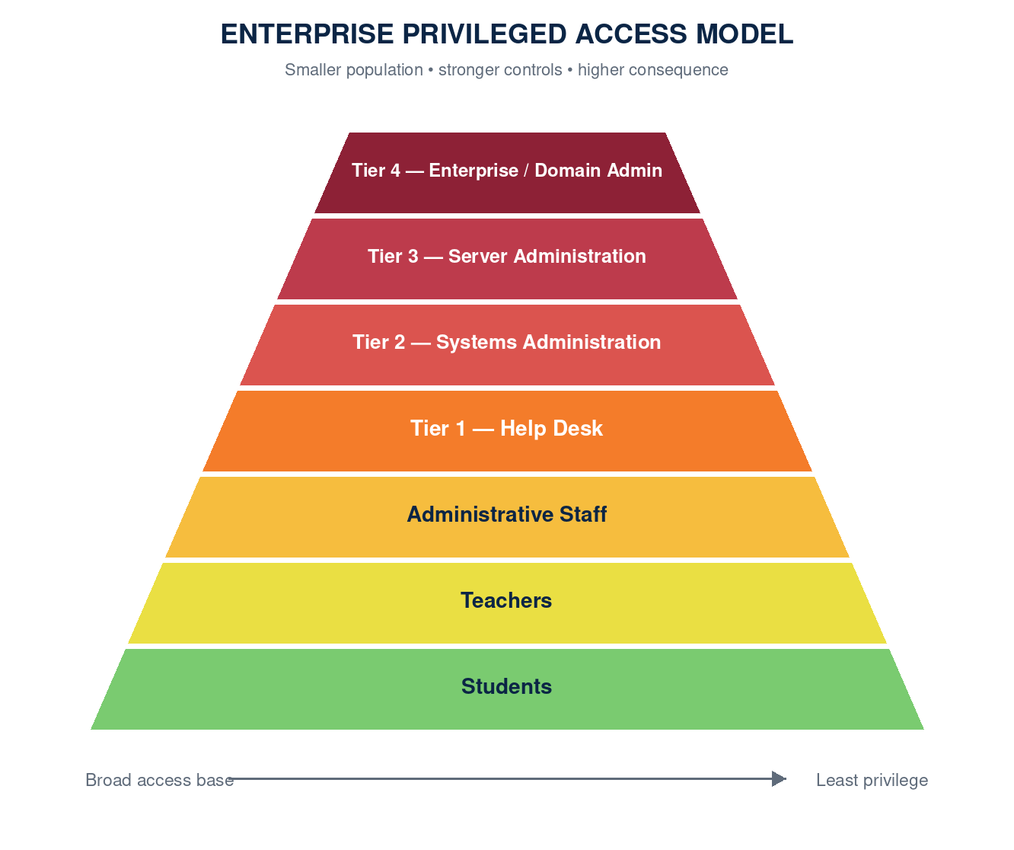
Enterprise privileged access model: access narrows and control strength increases toward the highest-risk roles.
SECURITY OUTCOME
The model substantially reduced excessive administrative access while preserving clear support and escalation paths for day-to-day operations.

05 ENDPOINT SECURITY & INTUNE
Evidence-Based Endpoint Engineering
My endpoint work combines enterprise deployment, safe automation, and detailed investigation. I led or contributed to Microsoft Defender migration, Intune deployment, Autopilot and cellular device management, least-privilege enforcement, remediation engineering, and device-level incident analysis.
WHEN | INITIATIVE | PORTFOLIO VALUE
Enterprise | Defender migration | Replaced legacy antivirus through phased inventory, pilot, onboarding, and policy enforcement across modern and domain-joined devices.
July 2026 | Taskbar policy investigation | Correlated device logs, Intune transcript output, registry evidence, and policy behavior to identify an unsafe remediation policy; coordinated disablement and documented recovery expectations.
July 2026 | Shared-PC-aware OneDrive v4 | Changed detection logic to recognize Shared PC modes and report a configuration conflict instead of attempting an unsafe repair.
July 2026 | Application crash diagnosis | Reviewed diagnostic evidence for an Autodesk Licensing Agent failure and translated findings into actionable end-user remediation guidance.
DOCUMENTATION EXCERPT — REMEDIATION INCIDENT
Finding: the Windows 11 Taskbar Alignment remediation policy was actively reapplying a registry setting. Evidence from multiple devices showed the behavior originated from the policy’s detection and remediation scripts. Action: the policy was disabled on July 20, 2026 at 4:10 p.m. ET, with impact expected to decline as managed devices completed subsequent Intune check-ins.
Sanitized investigation summary; device names and individual identities omitted.
The consistent pattern across this work is restraint: detect the actual device state, preserve evidence, avoid repairs that conflict with intentional shared-device controls, and communicate the expected time-to-effect after a central policy change.

06 NETWORK, INFRASTRUCTURE & COMPLIANCE
Secure Infrastructure That Supports Operations
I design and operate controls across Palo Alto firewalls, Aruba switching, VLAN segmentation, Windows Server, VMware, Exchange, SQL, DNS, and secure printing. The emphasis is on clear trust boundaries, least privilege, auditability, and operational continuity.
CAPABILITY | SELECTED PLATFORMS & PRACTICES
GCIC secure enclave | Designed a CJIS-aligned segmented environment with controlled workstation/server flows, logging, secure printing, and audit-ready documentation; supported a successful GBI audit.
Domain controller lifecycle | Built a reusable demotion and cleanup toolkit covering AD health, replication, DNS delegation, stale records, object protection, and pre/post validation.
Exchange relay | Rebuilt and validated restricted anonymous SMTP relay behavior, remote IP scoping, and the required recipient acceptance permission without widening access.
Kerberos RC4 readiness | Audited domain-controller patch levels and RC4 disablement phase readiness, separating update status from policy state to support controlled change planning.
PaperCut secure printing | Supported districtwide secure release and developed a staged driver-update plan to correct application-specific color behavior while minimizing disruption.
Monitoring modernization | Expanded SolarWinds monitoring and replaced legacy mail relay dependencies with Microsoft Graph-based notification workflows.
CONTROL DESIGN EXAMPLE
GCIC workstation traffic was constrained to authorized services and management paths, while printing used secure release and administrative access followed defined role boundaries.

07 SECURITY AWARENESS LEADERSHIP
Districtwide KnowBe4 Rollout Strategy
CHALLENGE | RCBOE had successfully used KnowBe4 with IT and Public Safety for more than three years, but the broader staff population needed a structured and measurable awareness program.
ROLE | Program architect and proposal author: executive case, phased rollout, training cadence, communications, reporting, and success measures.
SOLUTION | Designed a supportive rollout beginning with Phish Alert Button training, followed by an announced practice phishing exercise, monthly simulations, quarterly awareness modules, targeted follow-up, and quarterly leadership reporting.
SECURITY CONTROLS | Clear non-punitive communication; role-aware campaigns; reporting and trend analysis; targeted education for repeat clickers; governance of themes and metrics.
OUTCOME | Produced an executive proposal and implementation approach designed to improve reporting behavior, reduce phishing susceptibility, and build a shared security culture using an existing district platform.
DOCUMENTATION EXCERPT — ROLLOUT SEQUENCE
Train staff to use the Phish Alert Button. Announce and conduct a practice phishing exercise. Begin monthly simulated phishing campaigns. Assign short quarterly training modules. Review metrics monthly and provide leadership with quarterly trend summaries.
Condensed from the RCBOE KnowBe4 Rollout Proposal, July 2026.
Proposed measurement framework:
- Training completion and phish-prone percentage.
- Simulation click rate and repeat-clicker trend.
- Reports submitted through the Phish Alert Button.
- Report-to-click ratio and school/department trends.
- Quarter-over-quarter improvement and real suspicious-email reporting.

08 INCIDENT RESPONSE & DIGITAL FORENSICS
Preserve Evidence. Correlate Facts. Document Decisions.
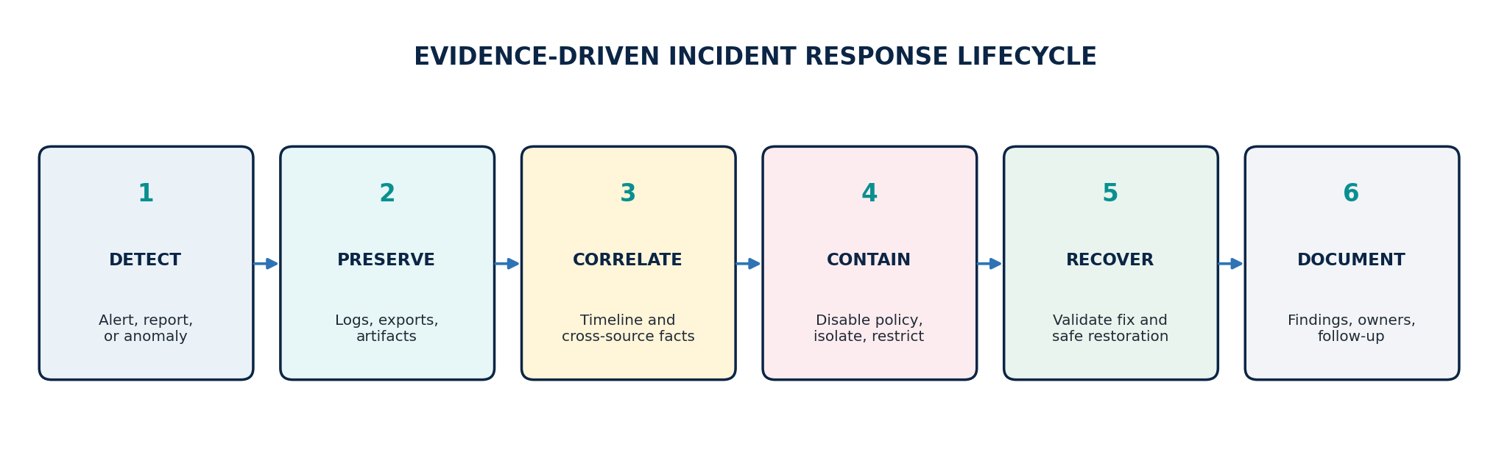
Incident response lifecycle used across endpoint, identity, email, cloud audit, and infrastructure investigations.
My response work is evidence-driven and cross-platform. I use Defender, Microsoft 365 and Purview audit data, Active Directory and Entra logs, device diagnostics, SolarWinds, application logs, and forensic tools to construct defensible timelines and separate cause from correlation.
CAPABILITY | SELECTED PLATFORMS & PRACTICES
Endpoint investigations | Suspicious scripts, remote-access tooling, policy-driven changes, application crashes, device isolation, and Windows event evidence.
Cloud and identity | Authentication events, Graph and Entra behavior, Conditional Access, MFA posture, and audit-log correlation.
Email and collaboration | Exchange relay, message trace, Purview content and audit searches, phishing triage, and OneDrive/SharePoint activity analysis.
Digital forensics | Autopsy, FTK Imager, deleted-file recovery, browser artifacts, event logs, USB activity, chain-of-custody awareness, and structured reporting.
Reporting | Executive summaries, technical findings, evidence tables, timelines, remediation ownership, and law-enforcement-ready narrative structure.
DOCUMENTATION STANDARD
Reports distinguish verified findings from hypotheses, preserve relevant timestamps and source systems, identify changes made during response, document limitations, and define follow-up owners.

09 DOCUMENTATION PORTFOLIO
Documentation as a Security Control
I write for multiple audiences: operators who need exact recovery steps, executives who need decisions and timelines, support teams who need safe procedures, and investigators who need an evidence-based record. The excerpts below show that range.
OPERATIONS RUNBOOK
Recovery order: contain unsafe automation; preserve CSV and transcript logs; restore identity and certificate trust; restore controlled code and configuration; validate WhatIf and pilot results; then enable and monitor the first unattended run.
BusinessPlus Entra OID Sync Disaster Recovery and Operations.
EXECUTIVE BRIEF
The authentication retirement is a mandatory platform change, but early action allows the organization to improve phishing resistance while avoiding a rushed migration and preventable sign-in disruption.
Microsoft Entra SMS and Voice Authentication Retirement.
TECHNICAL INVESTIGATION
Correlate central policy configuration with client-side transcripts, event logs, registry evidence, and device timelines. Document the change time, affected population, recovery behavior, and expected client check-in delay.
Windows 11 Taskbar Alignment remediation investigation.
KNOWLEDGE BASE
Start with symptom and scope, verify the user and device state, collect the minimum useful evidence, apply the safest supported fix, validate the result, and record any escalation criteria.
Representative structure used for passkey, Microsoft Authenticator, Mitel/ShoreTel, and endpoint support guidance.
Additional documentation includes disaster-recovery plans, certificate renewal procedures, Intune detection/remediation packages, executive proposals, audit scripts, incident summaries, Microsoft 365 investigation queries, and step-by-step knowledge base articles.

10 IMPACT & CREDENTIALS
Selected Outcomes
62  SITES SUPPORTED | 35K+  USERS | 60K+  ENDPOINTS | GBI  AUDIT SUCCESS

Selected enterprise contributions:
- Modernized endpoint protection by migrating from Symantec to Microsoft Defender and expanding centralized security visibility.
- Implemented Intune and modern device-management practices across a large mixed endpoint estate.
- Designed and enforced a tiered least-privilege model with stronger separation of administrative duties.
- Built secure identity, monitoring, and operational automations with PowerShell and Microsoft Graph.
- Designed a CJIS-aligned GCIC environment and maintained audit-ready operational controls.
- Improved resilience through runbooks, disaster-recovery planning, certificate lifecycle procedures, and repeatable validation scripts.
- Translated emerging platform changes and security risks into executive-ready plans, timelines, communications, and measurable outcomes.

Education & Certifications
Bachelor of Science, Cybersecurity and Information Assurance — Western Governors University (in progress; expected July 2027)
Associate of Applied Science, Electronics Technology — Augusta Technical College
CompTIA Security+ • CompTIA Network+ • CompTIA A+

Professional Value
Broad technical leadership across cybersecurity, infrastructure, identity, endpoint management, automation, incident response, compliance, and operational resilience—grounded in hands-on engineering, clear documentation, and accountable execution.
CONTACT
Thomas Strand | Hephzibah, Georgia | (706) 526-7846 | ttcstrand@gmail.com

