Literature

On influenza neuraminidase

(Le et al. 2011) Molecular modeling of swine influenza A/H1N1, Spanish H1N1, and avian H5N1 flu N1 neuraminidases bound to Tamiflu and Relenza
crystal structure of NA/H1N1, homology model of NA/H5N1, crystal structure of NA/swine flu H1N1
(H. Nguyen, Le, et al. 2011) Top-hits for H1N1pdm Identified by Virtual Screening Using Ensemble-based Docking
same subjects of above
(T. T. Nguyen et al. 2011) Study of Tamiflu Sensitivity to Variants of A/H5N1 Virus Using Different Force Fields
crystal structure of NA/H1N1 wildtype (2HU4), mutant H274Y and N294S.
(Wang & Zheng 2009) Computational studies of H5N1 influenza virus resistance to oseltamivir
(Malaisree et al. 2008) Source of oseltamivir resistance in avian influenza H5N1 virus
with the H274Y mutation
Within the N1 active site of OTV-MT, bulky side chain of the Y274 phenol ring drives the E276 carboxylate group to rotate away in a direction toward an ethyl moiety of oseltamivir’s bulky group, resulting in a rather small hydrophobic pocket that is unable to accommodate this bulky group. This is found to be the primary source of the oseltamivir-resistance associated with the H274Y mutation, which is in contrast with the proposed mechanism of oseltamivir-resistance to this particular mutation in H5N1 NA
(Russell et al. 2006) The structure of H5N1 avian influenza neuraminidase suggests new opportunities for drug design
It seems likely that the binding of oseltamivir to N8, at least in the crystalline state, is a two-step process. First, inhibitor binds to the ‘open’ form of N8 and then a slow conformational change occurs that results in the ‘closed’ form of the enzyme that is able to make a tighter interaction with ligand. At this stage we have no information about how the slow conformational change that occurs in the crystalline state relates to the enzyme in solution, but our structural observations show that this type of inhibitor is capable of binding to the open conformation of group-1 neuraminidases.
“Thus, the active sites of all influenza neuraminidases contain three arginine residues, Arg 118, Arg 292 and Arg 371, that bind the carboxylate of the substrate sialic acid; Arg 152 that interacts with the acetamido substituent of the substrate; and Glu 276 that forms hydrogen bonds with the 8- and 9-hydroxyl groups of the substrate.” (inference from N2 and N9 structure)
difference in 150-loop cavity → drugs can bind to both group 1 and group 2, yet binding resulting in conformational changes in group-1 into closed conformation similar to that of group 2
(Moscona 2005) Oseltamivir resistance—disabling our influenza defenses
Molecular-level analysis (Panel C) shows that the amino acid termed E276 must rotate and bond with R224 to form a pocket for the side chain of oseltamivir. The mutations R292K, N294S, and H274Y inhibit this rotation and prevent the pocket from forming, resulting in resistance to oseltamivir. The mutations nonetheless allow the binding of natural sialic acid substrate, so mutated virus can survive and propagate.
(Sung et al. 2010) Secondary sialic acid binding site, influenza N1
HA actitivity exhibited by N9 NA in avian isolates

(Lai et al. 2012) secondary binding sites, fact or fiction?

[active sites of influenza neuraminidase? is it include N294 and H274?]

questions raised
Can binding affinities from docking explain drug-resistance of mutants?
docking box

 | oseltamivir Ki | exp-deltaG | docked score by Vina | autodock score  (298.15 K) | autodock  100runs | autodock  200 runs
2HU4 | 0.320 | -13.460 | -5.8 (d4, most similar to xray) | -7.930 | -7.0 (43 in cluster) | -6.95 (82 in cluster)
3CL0 | 84.800 | -10.025 | -6.300 (best energy, no close binding pose) | -7.3 / -5.4 | -7.330 (50 in cluster) | -7.39 (95 in cluster)
3CL2 | 25.900 | -10.755 | -5.6 (d4,most similar to xray) | -7.060 | -5.6 (49 in cluster) | -5.45 (92 in cluster)

Can pathway docking help to explain drug-resistance mechanism? No.
- ability of docking algorithm to determine correct binding pose: Autodock favors binding of oseltamivir in site totally different from that found in x-ray structure (Illustration 1).
- receptor conformation may change from apo conformation into holo conformation during approaching of drug. MD simulation (of 20ns) may not be able to sampling enough conformations to represent both states.
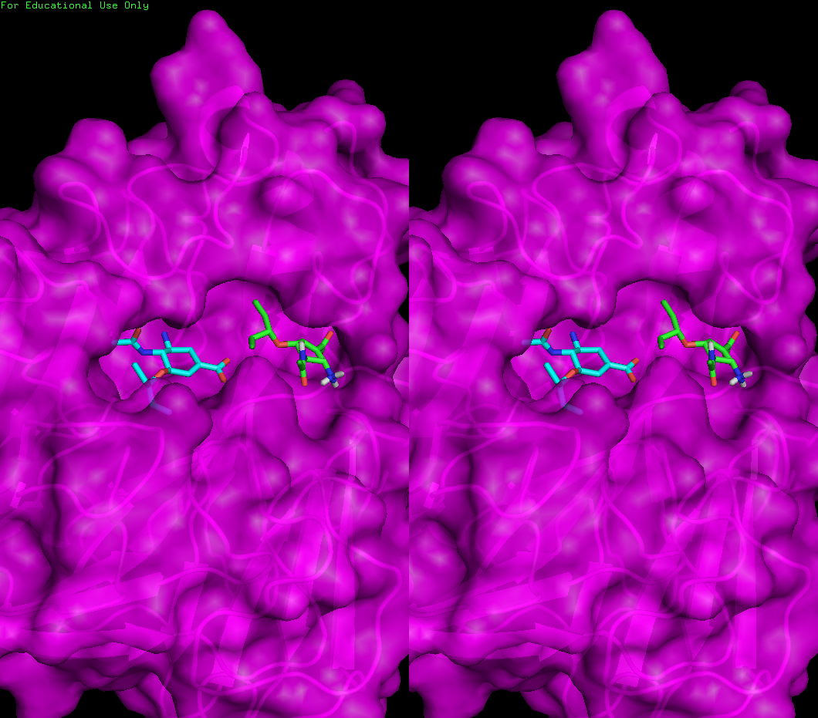Illustration 1: Docked conformation by Autodock in green (largest cluster, lowest E), WT-100runs-BC.pdbqt, x-ray ligand in cyan

On pathway methods
Monte-Carlo
Brownian Dynamics
Molecular dynamics

Experimental Details

Preparation of receptors (ensemble-based docking)

MD simulation
extend to 40ns simulation (from tructrang's 20ns-simulation)
gromacs, double precision
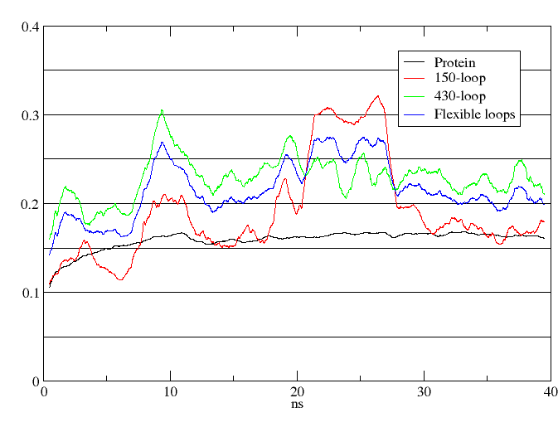
Overall RMSD indicates stability of simulated system from 20th nanosecond → trajectories of the last 20ns are used for clustering.

clustering
probing RMSD cutoff

RMSD (nm) | Number of clusters | log file
0.7 | 1571 | #cluster.log.16#
1 | 16 | #cluster.log.17#
0.9 | 127 | #cluster.log.18#
1.5 | 1 | middle structure: frame 28090 | cluster-0010.pdb in WT/ensemble

Calculating rmsd, exporting rmsd matrix file (xpm) to use in clustering
RMSD_MATRIX=${PREFIX}_40-rmsd-flexloops-last20.xpm
g_rms$GMX_SUFFIX -s $INTPR -f $TRJOUT -n $INDEX -o ${PREFIX}_40-rmsd-flexloops-last20.xvg -m $RMSD_MATRIX -b 20000 <<EOIN
3
24
EOIN
g_cluster$GMX_SUFFIX -dm $RMSD_MATRIX -f $TRJOUT -s $INTPR -o -g -dist -clid -cl -b 20000 -cutoff 0.09 <<EOIN
3
1
EOIN
# group for lsq fit: C-alpha, group for output: Protein

with index file wt_md_40.ndx
0 System : 47182 atoms
1 Protein : 5749 atoms
2 Protein-H : 2963 atoms
3 C-alpha : 385 atoms
4 Backbone : 1155 atoms
5 MainChain : 1541 atoms
6 MainChain+Cb : 1886 atoms
7 MainChain+H : 1908 atoms
8 SideChain : 3841 atoms
9 SideChain-H : 1422 atoms
10 Prot-Masses : 5749 atoms
11 non-Protein : 41433 atoms
12 Other : 44 atoms
13 MOL : 44 atoms
14 NA : 4 atoms
15 Water : 41385 atoms
16 SOL : 41385 atoms
17 non-Water : 5797 atoms
18 Ion : 4 atoms
19 MOL : 44 atoms
20 NA : 4 atoms
21 Water_and_ions : 41389 atoms
22 150-loop : 109 atoms
23 430-loop : 157 atoms
24 flexible-loops : 266 atoms

Preparation of receptors (rigid docking)

Files in $PATHWAY/structures
PDB entries (WT: 2HU4, H274Y: 3CL0, N294S: 3CL2)
align 3CL0, 2HU4
align 3CL2, 2HU4
extract chain A to NA_2HU4.ori.pdb, NA_3CL0.ori.pdb, NA_3CL2.ori.pdb
extract oseltamivir to ose_2HU4.pdb …
protein center determined by AutodockVina plugin: (-6.08, 77.38, 100.43)
axes draw at center, by axes.py

box dimension: 48x48x10.5 Å
box center
 | center_x | center_y | center_z
config1.txt | -6.08 | 77.43 | 122.43
config2.txt | -6.08 | 77.43 | 119.805
 | -6.08 | 77.43 | 117.18
 | -6.08 | 77.43 | 114.555
 | -6.08 | 77.43 | 111.93
 | -6.08 | 77.43 | 109.305

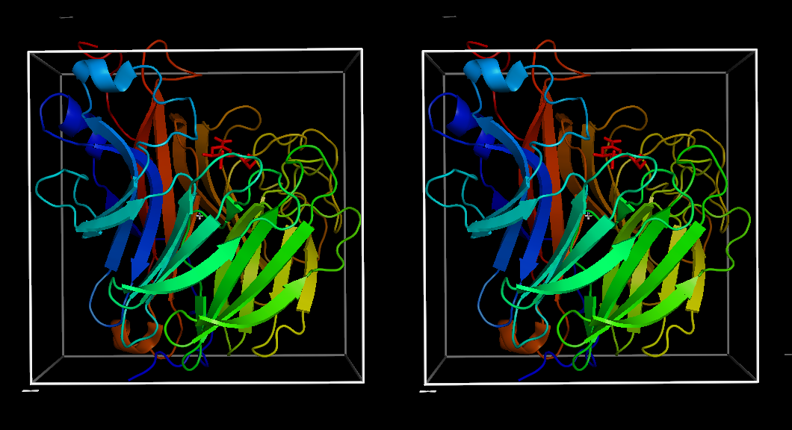
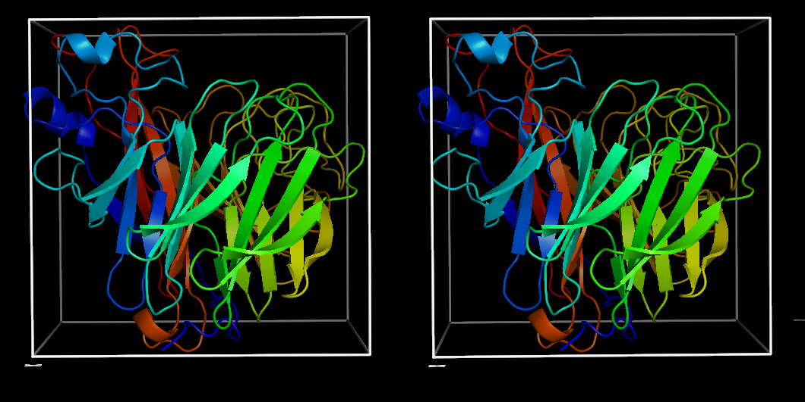

preparation of ligand
http://toxnet.nlm.nih.gov/cgi-bin/sis/search/r?dbs+hsdb:@term+@rn+@rel+196618-13-0
Mechanism of Action:
Oseltamivir is an ethyl ester prodrug requiring ester hydrolysis for conversion to the active form, oseltamivir carboxylate. The proposed mechanism of action of oseltamivir is inhibition of influenza virus neuraminidase with the possibility of alteration of virus particle aggregation and release.
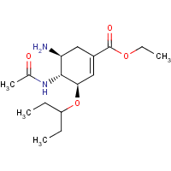
run on PRODRG server, obtain mol2 file (fullH)
set up with AutodockTools

Docking with vina
results in vina-ensemble
grid box is moved along z-axis by ¼ of the z-dimension, until reaching binding pocket

Pathway analysis

Pathway description
Pathway is comprised by residues involving in ligand interactions. Four types of interactions are considered: electrostatic, hydrophobic, hydrogen bonds and close contact.
Electrostatic interactions are only considered when having coulomb energy more negative than -30 kJ/mol, to exclude hydrogen bonds.
Close contacts, if not steric clashes, are favorable hydrophobic interactions.
Hydrogen bonds are found less frequently. Most stable hydrogen bonds (found in more than 30% of the ensemble) are associated with the residues R371, R292 and E277.
Representative pathway is visualized on middle structure of cluster (cluster-0010.pdb)
PyMOL>com docked_b1, object=D1
State 1:-6.637958 79.623749 118.968958
PyMOL>com docked_b2, object=D2
State 1:0.398375 59.637583 117.988541
PyMOL>com docked_b3, object=D3
State 1:-7.232750 77.309875 117.271166
PyMOL>com docked_b4, object=D4
State 1:2.606875 85.795290 113.007542
PyMOL>com docked_b5, object=D5
State 1:0.657458 81.512625 110.800083
PyMOL>com docked_b6, object=D6
State 1:0.678208 81.526834 110.853042
path 1: D1-D3-D5-D6
Example use of pathway.py
>>> box3 = p[2]
>>> tyr347= Residue('TYR', 347)
>>> cluster10= box3.interaction_tables[9]
>>> len(cluster10)
7
>>> cluster10[tyr347]
{'electrostatic': [<Interactions.ElectrostaticInteraction object at 0xb40b6ac>, <Interactions.ElectrostaticInteraction object at 0xb40be6c>, <Interactions.ElectrostaticInteraction object at 0xb40b8ac>], 'hydrophobic': [<Interactions.HydrophobicInteraction object at 0xb40bb0c>, <Interactions.HydrophobicInteraction object at 0xb40be2c>, <Interactions.HydrophobicInteraction object at 0xb40bf2c>]}
>>> hyp = cluster10[tyr347]['hydrophobic']
>>> elect = cluster10[tyr347]['electrostatic']
>>> for i in hyp:
... print "%s%s - %s" % (i.ligand_atom.atomtype, i.ligand_atom.PDBIndex, i.receptor_atom.atomname)
...
C8 - CD1
C10 - CD1
C11 - CD1
>>> for e in elect:
... print "%s%s - %s" % (e.ligand_atom.atomtype, i.ligand_atom.PDBIndex, i.receptor_atom.atomname)
...
C11 - CD1
C11 - CD1
C11 - CD1

>>> cluster115[arg292].keys()
['closecontact', 'electrostatic', 'hydrogen', 'hydrophobic']
>>> for i in cluster115[arg292]['closecontact']:print "%s%s - %s" % (i.ligand_atom.atomtype, i.ligand_atom.PDBIndex, i.receptor_atom.atomname)
...
HD20 - 2HH2
>>> for e in cluster115[arg292]['electrostatic']: print "%s%s (%s) - %s (%s): %s" % (e.ligand_atom.atomtype, e.ligand_atom.PDBIndex, e.ligand_atom.charge, e.receptor_atom.atomname, e.receptor_atom.charge, e.coulomb_energy)
...
N18 (0.381) - NH1 (-0.376): -50417.2879652
N18 (0.381) - NH2 (-0.274): -38214.1776699
>>> for i in cluster115[arg292]['hydrogen']: print "%s%s - %s, d=%s, a=%s" % (i.ligand_atom.atomtype, i.ligand_atom.PDBIndex, i.receptor_atom.atomname, i.distance, i.angle)
...
N18 - NH2 , d=3.79564658523, a=38.9995899505
>>> for i in cluster115[arg292]['hydrophobic']:print "%s%s - %s" % (i.ligand_atom.atomtype, i.ligand_atom.PDBIndex, i.receptor_atom.atomname)
...
C4 - CZ

>>> for k,v in cluster10.items():
... print "%s: %s" % (k, v.keys())
...
TYR 347: ['hydrophobic']
ARG 371: ['closecontact', 'electrostatic', 'hydrogen', 'hydrophobic']
ARG 118: ['closecontact', 'electrostatic', 'hydrogen']
SER 370: ['electrostatic']
ILE 427: ['hydrophobic']
PRO 431: ['hydrophobic']
LYS 432: ['electrostatic', 'hydrogen', 'hydrophobic']
>>> for i in range(len(p[2].interaction_tables)):
... t = p[2].interaction_tables[i]
... if t.has_key(arg371):
... if t[arg371].has_key('hydrogen'):
... for j in t[arg371]['hydrogen']:
... print "Cluster #%i : %s%s - %s [ %s ]" % (i+1, j.ligand_atom.atomtype, j.ligand_atom.PDBIndex,j.receptor_atom.atomname, j.receptor_atom.coordinates)

visualizing interactions
using LigPlot
Ligand atom name (PDB column 13-16) imported from pdbqt is not appropriate for pdb format readable by LigPlot. Modification:
alter docked_b1-61, name=("%s%s" % (name, ID) )

for i in range(1,4): cmd.alter("docked_b%s-61" % i, "name=('%s%s' % (name,ID))" )

Plotting ligand centers of geometry
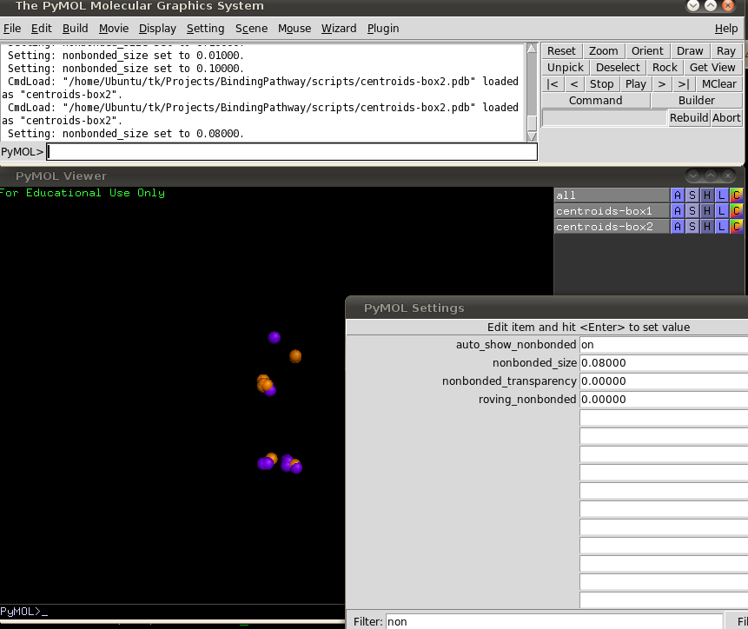
3D Plot reveal secondary binding sites → may affect inhibitory concentration. More favorable secondary binding sites → less active drug.
Groups of ligand binding sites (represented by centers of mass/geometry) indicate lowest energy pathway of drug to enter binding site.

Binding energies along axis
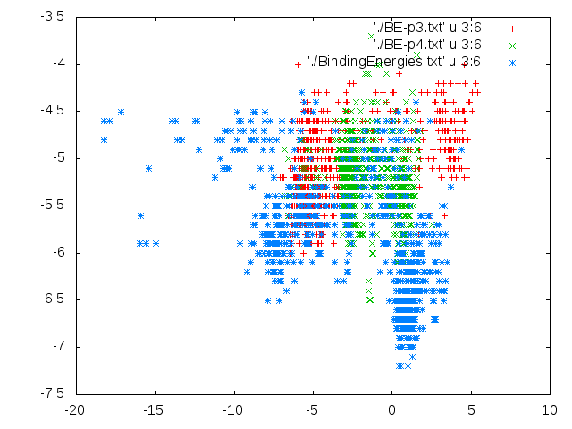
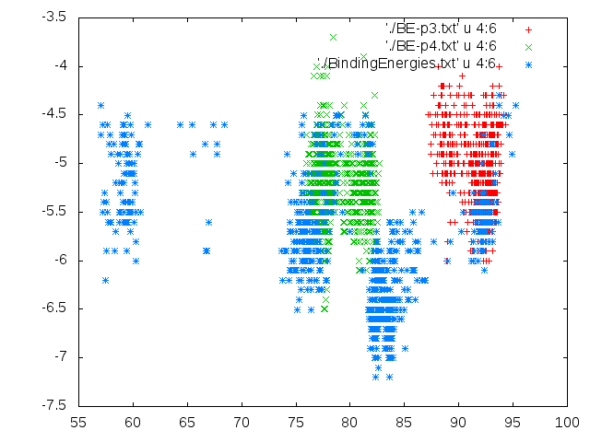
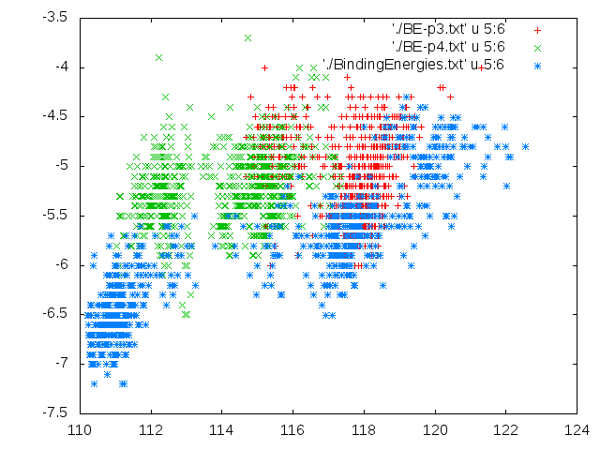

Binding energies vs distance from binding sites
Reference point: center of mass of oseltamivir in complex with NA, solved by x-ray
(0.369457, 82.145423, 111.322362)
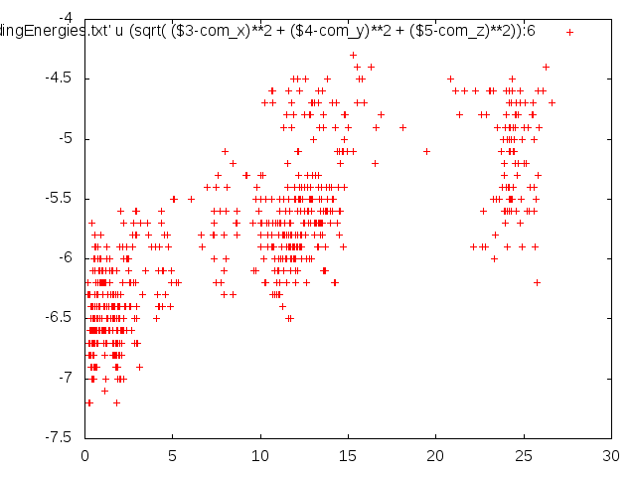

Visually clustering centers of mass
PyMOL>iterate Y1,print "box%s-%s" % (chain, ID)
boxA-7
boxA-20
boxA-22
boxA-42
boxA-70
boxA-72
boxA-93
boxA-97
boxA-100
boxA-108
boxB-7
boxB-8
boxB-15
boxB-22

select Y3, (com-box3 and resi 63) expand 3.3 and (resn COM) and (b < -5.2)
select Y4,(com-box4 and resi 77) expand 2. and resn COM
select Y5, (com-box4 and resi 99) expand 2.3 and resn COM
select Y6, (com-box6 and resi 17) expand 2.5 and (b < -5.9)

com.pse
select A1, (com-box1 and resi 72) expand 3.5 and (resn COM) and (b > -5)
select A2, (com-box2 and resi 89) expand 3.5 and (resn COM) and (b < -5)
select A3, (com-box4 and resi 78) expand 2.5 and (resn COM) and (b > -6.5)
Selector: selection "A3" defined with 32 atoms.
You clicked /com-box5//E/COM`77/COM
Selector: selection "A3" defined with 31 atoms.
You clicked /com-box4//D/COM`48/COM
Selector: selection "A3" defined with 30 atoms.
You clicked /com-box4//D/COM`82/COM
Selector: selection "A3" defined with 29 atoms.
You clicked /com-box5//E/COM`86/COM
Selector: selection "A3" defined with 30 atoms.
select A4, (com-box5 and resi 52) expand 2.4 and (resn COM) and (b < -6.)
Selector: selection "A4" defined with 287 atoms.
select A4, (com-box5 and resi 52) expand 2.4 and (resn COM)
Selector: selection "A4" defined with 318 atoms.

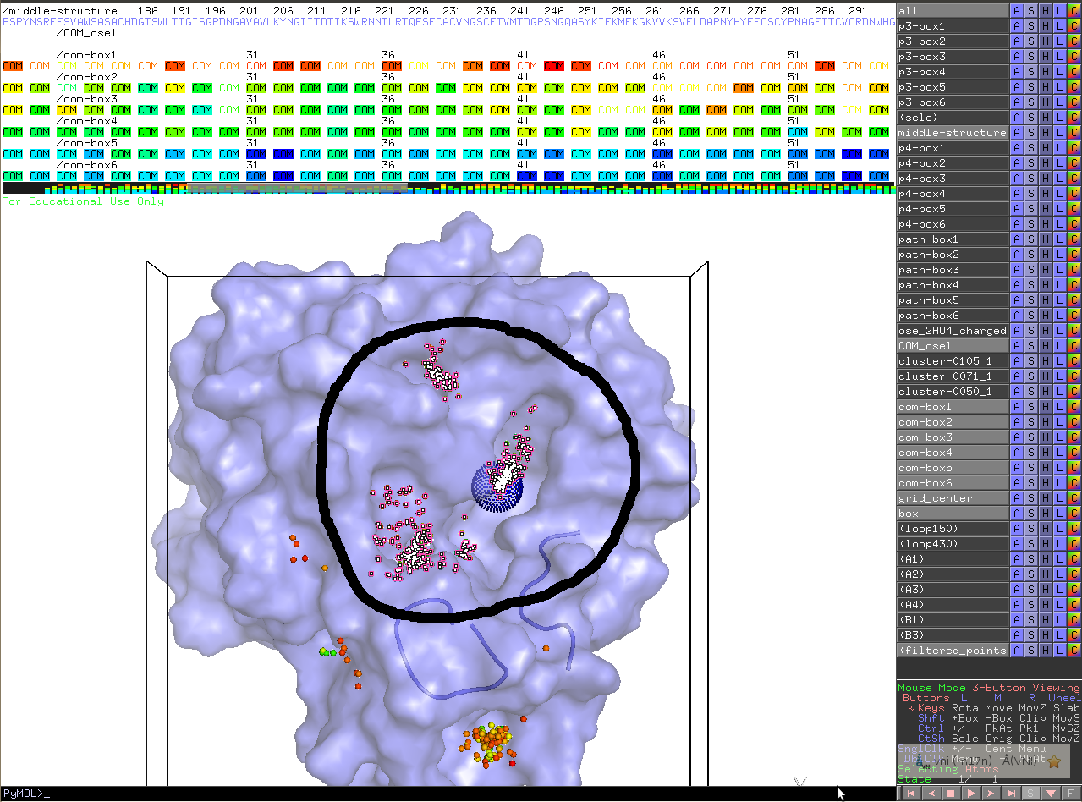Illustration 2: select filtered_points, (COM_osel) expand 18. and resn COM

Binding Pathway methodologies

MD
(Hofacker & K. Schulten 1998) for oxygen and proton pathways
(Ruscio et al. 2008) for ligand pathway in myoglobin
(Baron et al. 2009) for oxygen pathway, using in-house algorithm PathFinder: tracing the appearance of a spherical volume through static snapshots of protein matrix.
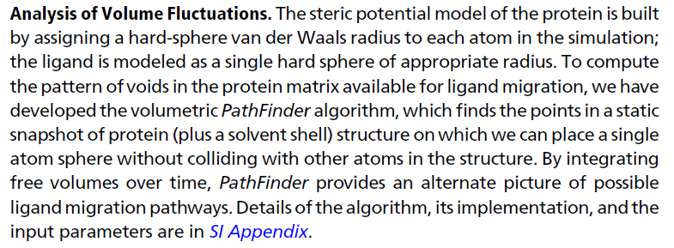

Influenza A drug-resistance

to neuraminidase inhibitors
Neuraminidase inhibitors used as drugs: oseltamivir (tamiflu), zanamivir (relenza)...
Systematic review on influenza resistance (Thorlund et al. 2011) showed that “substantial number of patients may become oseltamivir-resistant as a result of oseltamivir use, and that oseltamivir resistance may be significantly associated with pneumonia”
Zanamivir-resistant variants were also reported (Hurt et al. 2009).

sequence surveys
http://www.ncbi.nlm.nih.gov/genomes/FLU/Database/nph-select.cgi?cmd=show_query&collapse=on&country=any&go=database&host=Human&lab=exclude&lineage=include&niaid=include&qcollapse=on&searchin=mutation&segment=NA&sequence=P&subtype_h=any&subtype_n=1&swine=include&type=a&vac_strain=include
N1 sequences from influenza A on human which are drug-resistant: 2558 protein sequences after collapsing (7949 total) (on Influenza Virus Resource, NCBI)
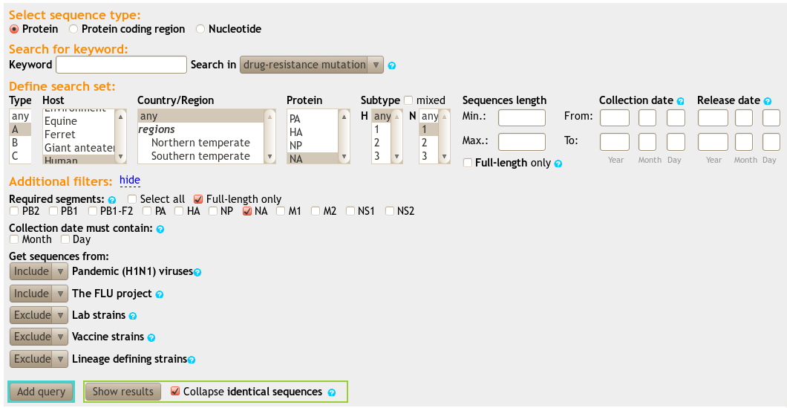

Structure entries on PDB
Numbering on NA sequences are based on that of N2 (Varghese & Colman 1991).
Receptors
wildtype
H274Y mutant (oseltamivir-resistant)
N294S mutant (oseltamivir-resistant)
wildtype-apo (2HTY)
 | WT (2HU4) | H274Y (3CL0) | N294S (3CL2) | WT-apo (2HTY)
WT (2HU4) | 0.000
H274Y (3CL0) | 0.267 | 0.000
N294S (3CL2) | 0.243 | 0.213 | 0.000
WT-apo (2HTY) | 0.308
 | RMSD (by align cmd, pymol)

