How Tamiflu enters the active site of the avian H5N1 neuraminidase?
Hung T. Nguyen§ and Thanh N. Truong§*
§ Life Science Laboratory, Institute for Computational Science and Technology, HCM city, Vietnam
* Department of Chemistry, University of Utah, Salt Lake city, Utah

Materials and Methods
Details of the MD simulation were given in our previous report.¹ Clustering analysis was done using the g_cluster tool in Gromacs package² on a subset of residues that lie in or near the binding pocket,³ namely 117-119, 133-138, 146-152, 156, 179, 180, 196-200, 223-228, 243-247, 277, 278, 293, 295, 344-347, 368, 401, 402, and 426-441 with a cutoff of 1.4 Å. The top two centroids which represent nearly a half (44.8%) of the whole 40 ns trajectory were used as receptors in the pathway docking.
AutoDockTools 1.5.2⁴ was used to add polar hydrogens, assign Gasteiger charges⁵ and create grid binding boxes. To allow sufficient sampling and avoid loss of important minima due to artificial boundary condition, each box was constructed to overlap with the neighborings three fourth its depth. In addition, each box covered large space of 48 x 48 x 10.5 Å to guarantee that all possibility of entering the pocket was incorporated and full extension of Tamiflu was permitted. AutoGrid version 4.2.1 was used to calculate the binding affinities using the following atom types as in Tamiflu: C, NA (hydrogen bond accepting N), OA (hydrogen bond accepting O), HD (polar hydrogen), and two additional ones e (electrostatics) and d (desolvation map).
Lamarckian genetic algorithm was used to do the docking experiments using AutoDock 4.2.1.⁶ Docking parameters were as follows: trials of 200 dockings, population size of 200, random starting position and conformation, translation step range of 2.0 Å, rotation step range of 50 degrees, maximum number of generations of 27000, elitism of 1, mutation rate of 2%, crossover rate of 80%, local search rate of 6%, 10 million energy evaluations, unbound model was “same as bound”, and docked conformations were clustered with the tolerance of 2.0 Å RMSD.

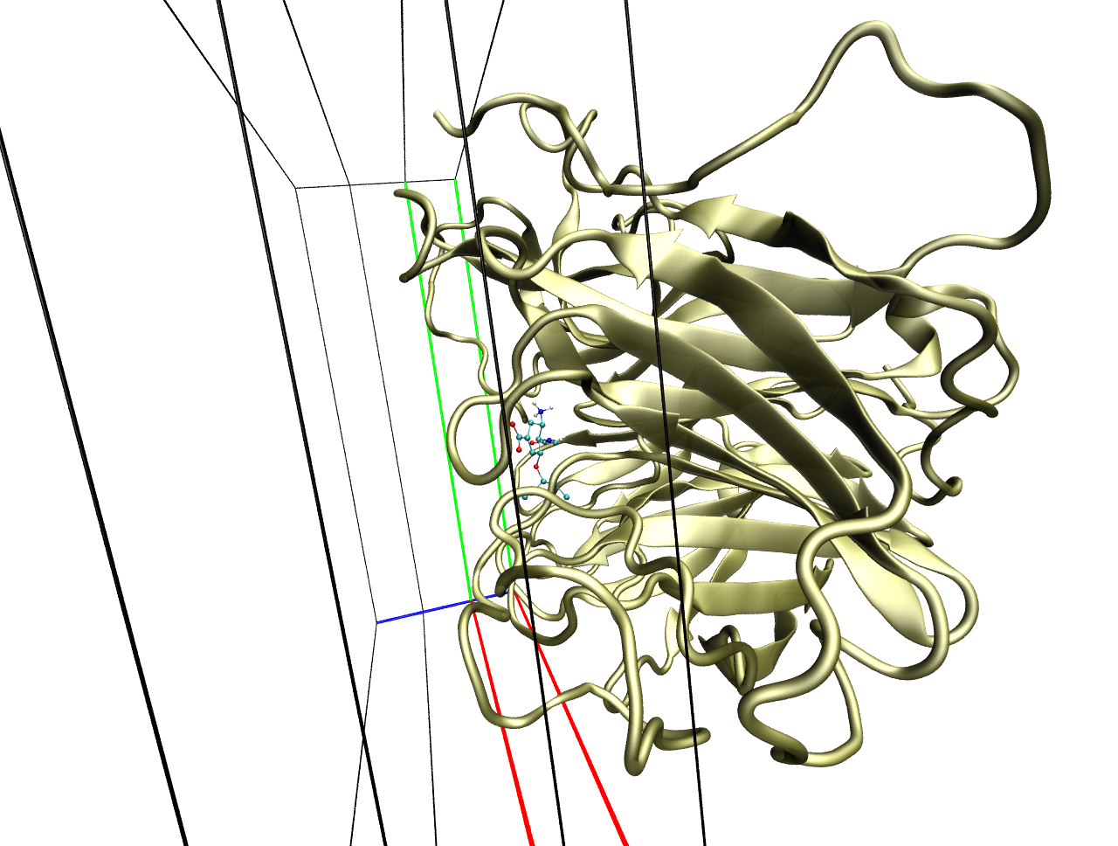
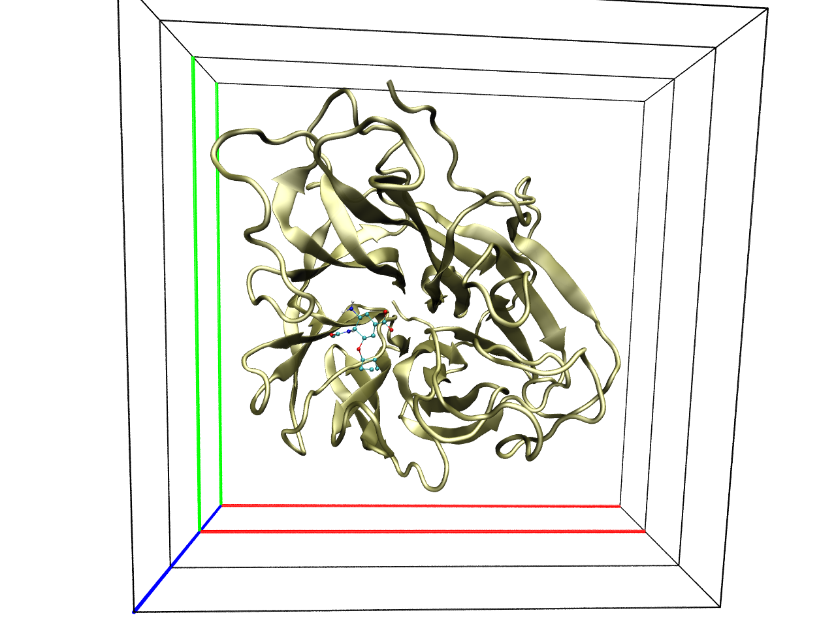
A
B

Figure S1. Boxes used in the pathway docking protocol. These boxes covered a large area and thus guaranteed full extension of Tamiflu and any possible direction towards the binding pocket.
To rank the clusters, we calculated the probability of cluster appearance in each box
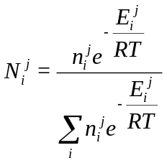
where 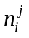,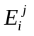,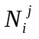 are the population, the lowest binding energy and the probability of finding cluster i in box j, respectively
R is the ideal gas constant and T is the temperature (298.15K).
Table S1. The most probable clusters in each box from the initial docking results against the most representative ensemble receptor, sorted with the appearance probability. Red numbers are corresponding to major path whereas blue ones are the minor.
Box | Ranking | E_{binding} (kcal/mol) | Population | Probability (%)
1 | 1 | -3.43 | 36 | 62.26
1 | 2 | -2.67 | 26 | 12.47
2 | 1 | -3.70 | 32 | 41.32
2 | 2 | -3.59 | 9 | 9.65
2 | 3 | -3.20 | 17 | 9.44
3 | 1 | -4.61 | 59 | 63.03
3 | 2 | -4.20 | 21 | 11.23
4 | 1 | -5.04 | 104 | 75.80
4 | 2 | -4.70 | 25 | 10.26
5 | 1 | -6.00 | 70 | 52.70
5 | 2 | -5.79 | 63 | 33.28
6 | 1 | -8.44 | 65 | 89.72
6 | 2 | -6.71 | 117 | 8.71
7 | 1 | -8.46 | 196 | 100.00

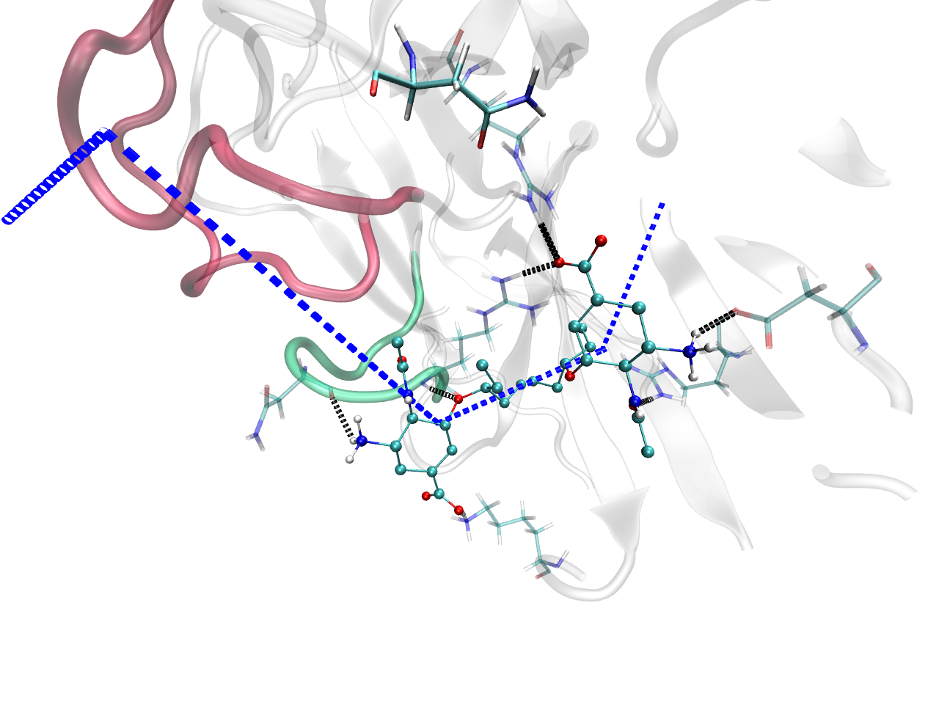
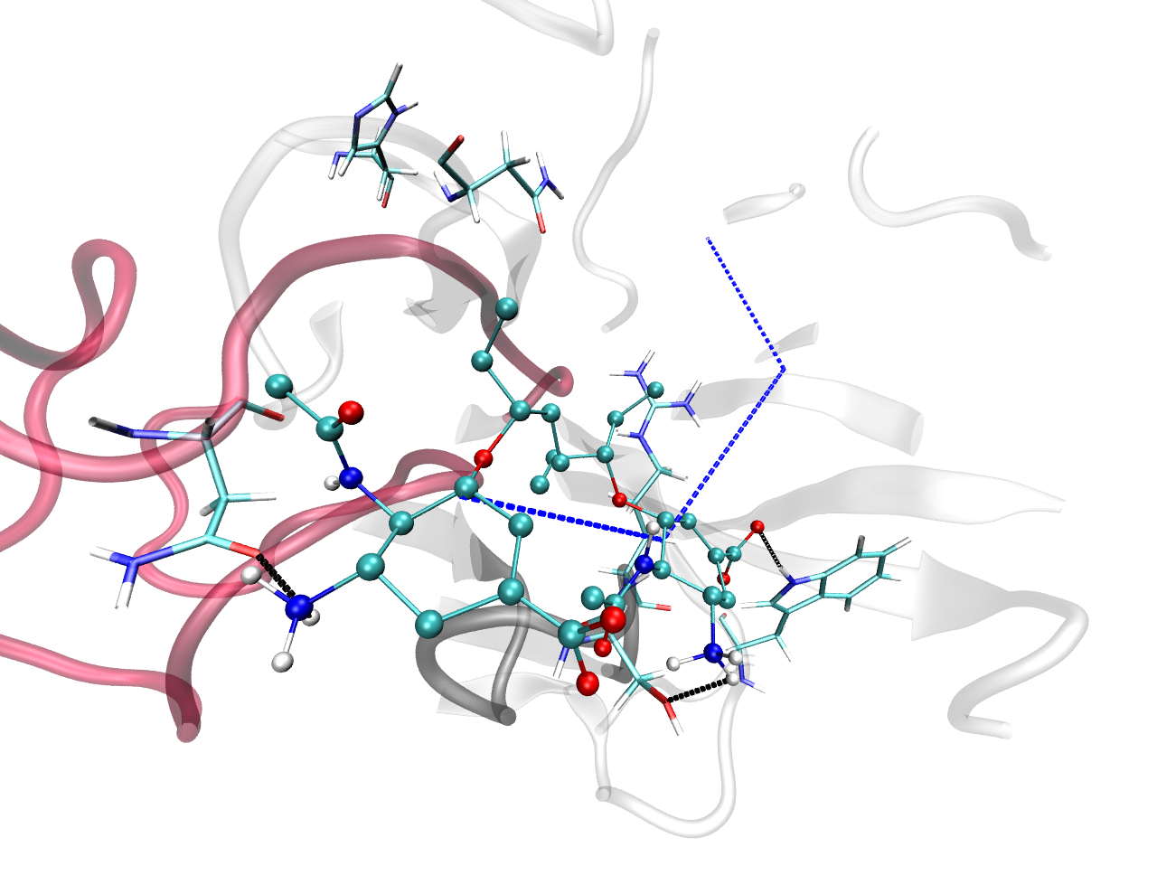
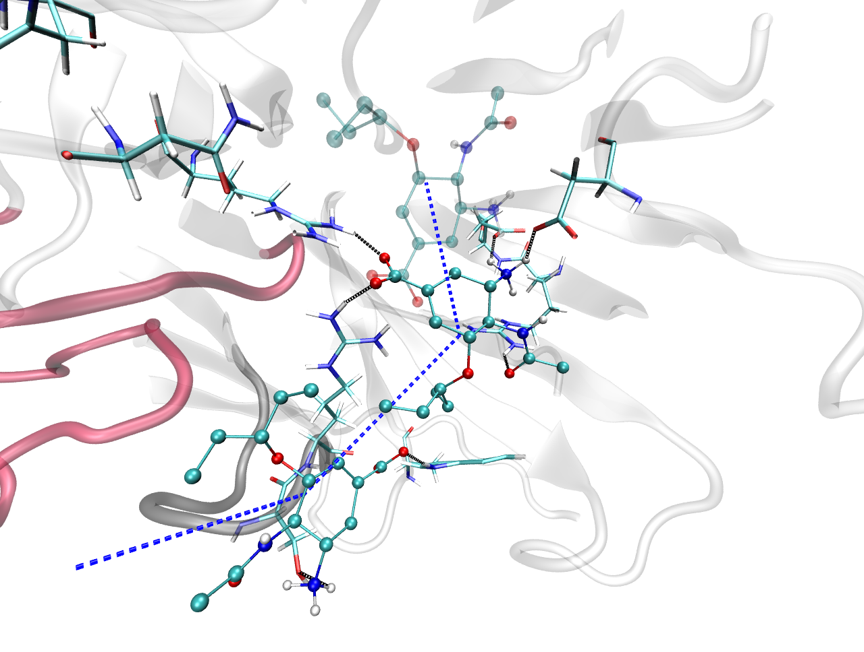
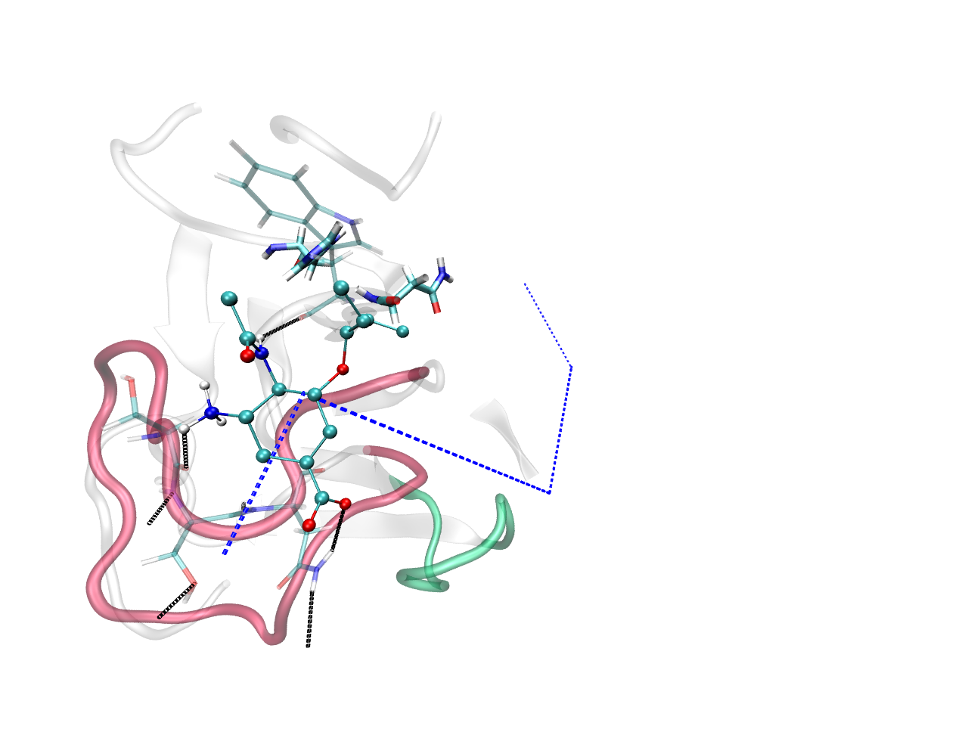
N294
R292
R371
N369
D151
R118
H274
N294
R371
N345
S370
W403
N294
H274
S367
D151
R118
E119
R292
R371
W403
W295
H274
N294
S344
S342
N345
A
B
C
D

Figure S2. Hydrogen bond network between Tamiflu (shown in CPK) and key residues (shown in bonds) in the minor path (the dashed blue line). (A), (B): from outside to inside, respectively, of the top ensemble receptor while (C), (D) are counterparts for the second receptor. 340-loop is depicted in pink, while 370-loop is represented in green or grey.

References
- Le, L.; Lee, E.; Hardy, D.; Schulten, K.; Truong, T. N. Molecular modeling of mutation-induced Tamiflu drug resistance for swine influenza H1N1pdm and avian H5N1 influenza N1 neuraminidase. J. Mol. Med. 2009, submitted.
- Hess, B.; Kutzner, C.; van der Spoel, D.; Lindahl, R. GROMACS 4: Algorithms for highly efficient, load-balanced, and scalable molecular simulation. J. Chem. Theory Comput. 2008, 4 (3), 435-447.
- Cheng, L. S.; Amaro, R. E.; Xu, D.; Li, W. W.; Arzberger, P. W.; McCammon, J. A. Ensemble-based virtual screening reveals potential novel antiviral compounds for avian influenza neuraminidase. J. Med. Chem. 2008, 51, 3878-3894.
- Sanner, M. F. A component-based software environment for visualizing large macromolecular assemblies. Structure 2005, 13 (3), 447-462.
- Gasteiger, J.; Marsili, M. Iterative partial equalization of orbital electronegativity: a rapid access to atomic charges. Tetrahedron 1980, 36 (22), 3219-3228.
- Morris, G. M.; Goodsell, D. S.; Halliday, R. S.; Huey, R.; Hart, W. E.; Belew, R. K.; Olson, A. J. Automated docking using a Lamarckian genetic algorithm and an empirical binding free energy function. J. Comp. Chem. 1998, 19 (14), 1639-1662.

