Binding pathway of Tamiflu
to avian influenza A/H5N1 neuraminidase

Diem-Trang T. Tran, Ly T. Le, Thanh N. Truong

KEYWORDS

ABSTRACT

INTRODUCTION
[Why avian influenza A/H5N1?]
[why pathway?]
Studies on binding affinities of influenza neuraminidase inhibitors are abundant. There are, however, very few studies focusing on binding mechanism, i.e. the way ligands approach neuraminidase active site. These studies include those using MD simulation of inhibitor molecules along with rigorous analyzing procedures [1] … The only work trying to identify a tangible pathway of ligand migration into active site until recently is that using steered molecular dynamics (SMD) [2]...
[how people have been studying pathway?]
study ligand diffusion using brownian dynamics simulation [3], monte-carlo simulation [4] and md simulations [5, 6], multiple steered MD [7].
study migration of small non-polar molecules through protein cavities by volumetric algorithm that integrates cavities available for ligand migration [8]
calculation of pathway by Monte-Carlo search combined with minimization [9].
[why docking?]
The only study on pathway of tamiflu to neuraminidase active site by far employed SMD [2], yet this approach requires exertion of an external force to pull the ligand out of the active site. The direction of this force is arbitrary, leading to some extent of bias in determined pathways. Here we introduce another approach in studying binding pathway by docking. In our approach, docking is used to screen the receptor surface for possible binding sites. Further analysis of these sites can reveal possible paths of ligand approaching protein binding pocket. Pathway docking thus allows identification of metastable states during binding without rigorous sampling and can be a valuable tool to look at binding mechanism of ligand molecules.

RESULTS AND DISCUSSION

Receptor ensembles
To account for protein flexibility, we employed ensemble-based docking procedure in which target ligand is simultanously docked against ensembles of receptor conformations instead of a single rigid conformation [10–12]. Receptor ensembles were resulted from clustering the conformations sampled during the last 20 nanoseconds of a 40-ns molecular dynamics simulation [13]. During equilibrium simulation, protein fluctuations were very small, as indicated by overall RMSD of the protein (black line in Figure 1). As 150-loop and 430-loop were still very flexible during the simulation (Figure 1), clustering was performed based on RMSD of these flexible loops, resulting in 127 representative clusters at 0.9Å cutoff.
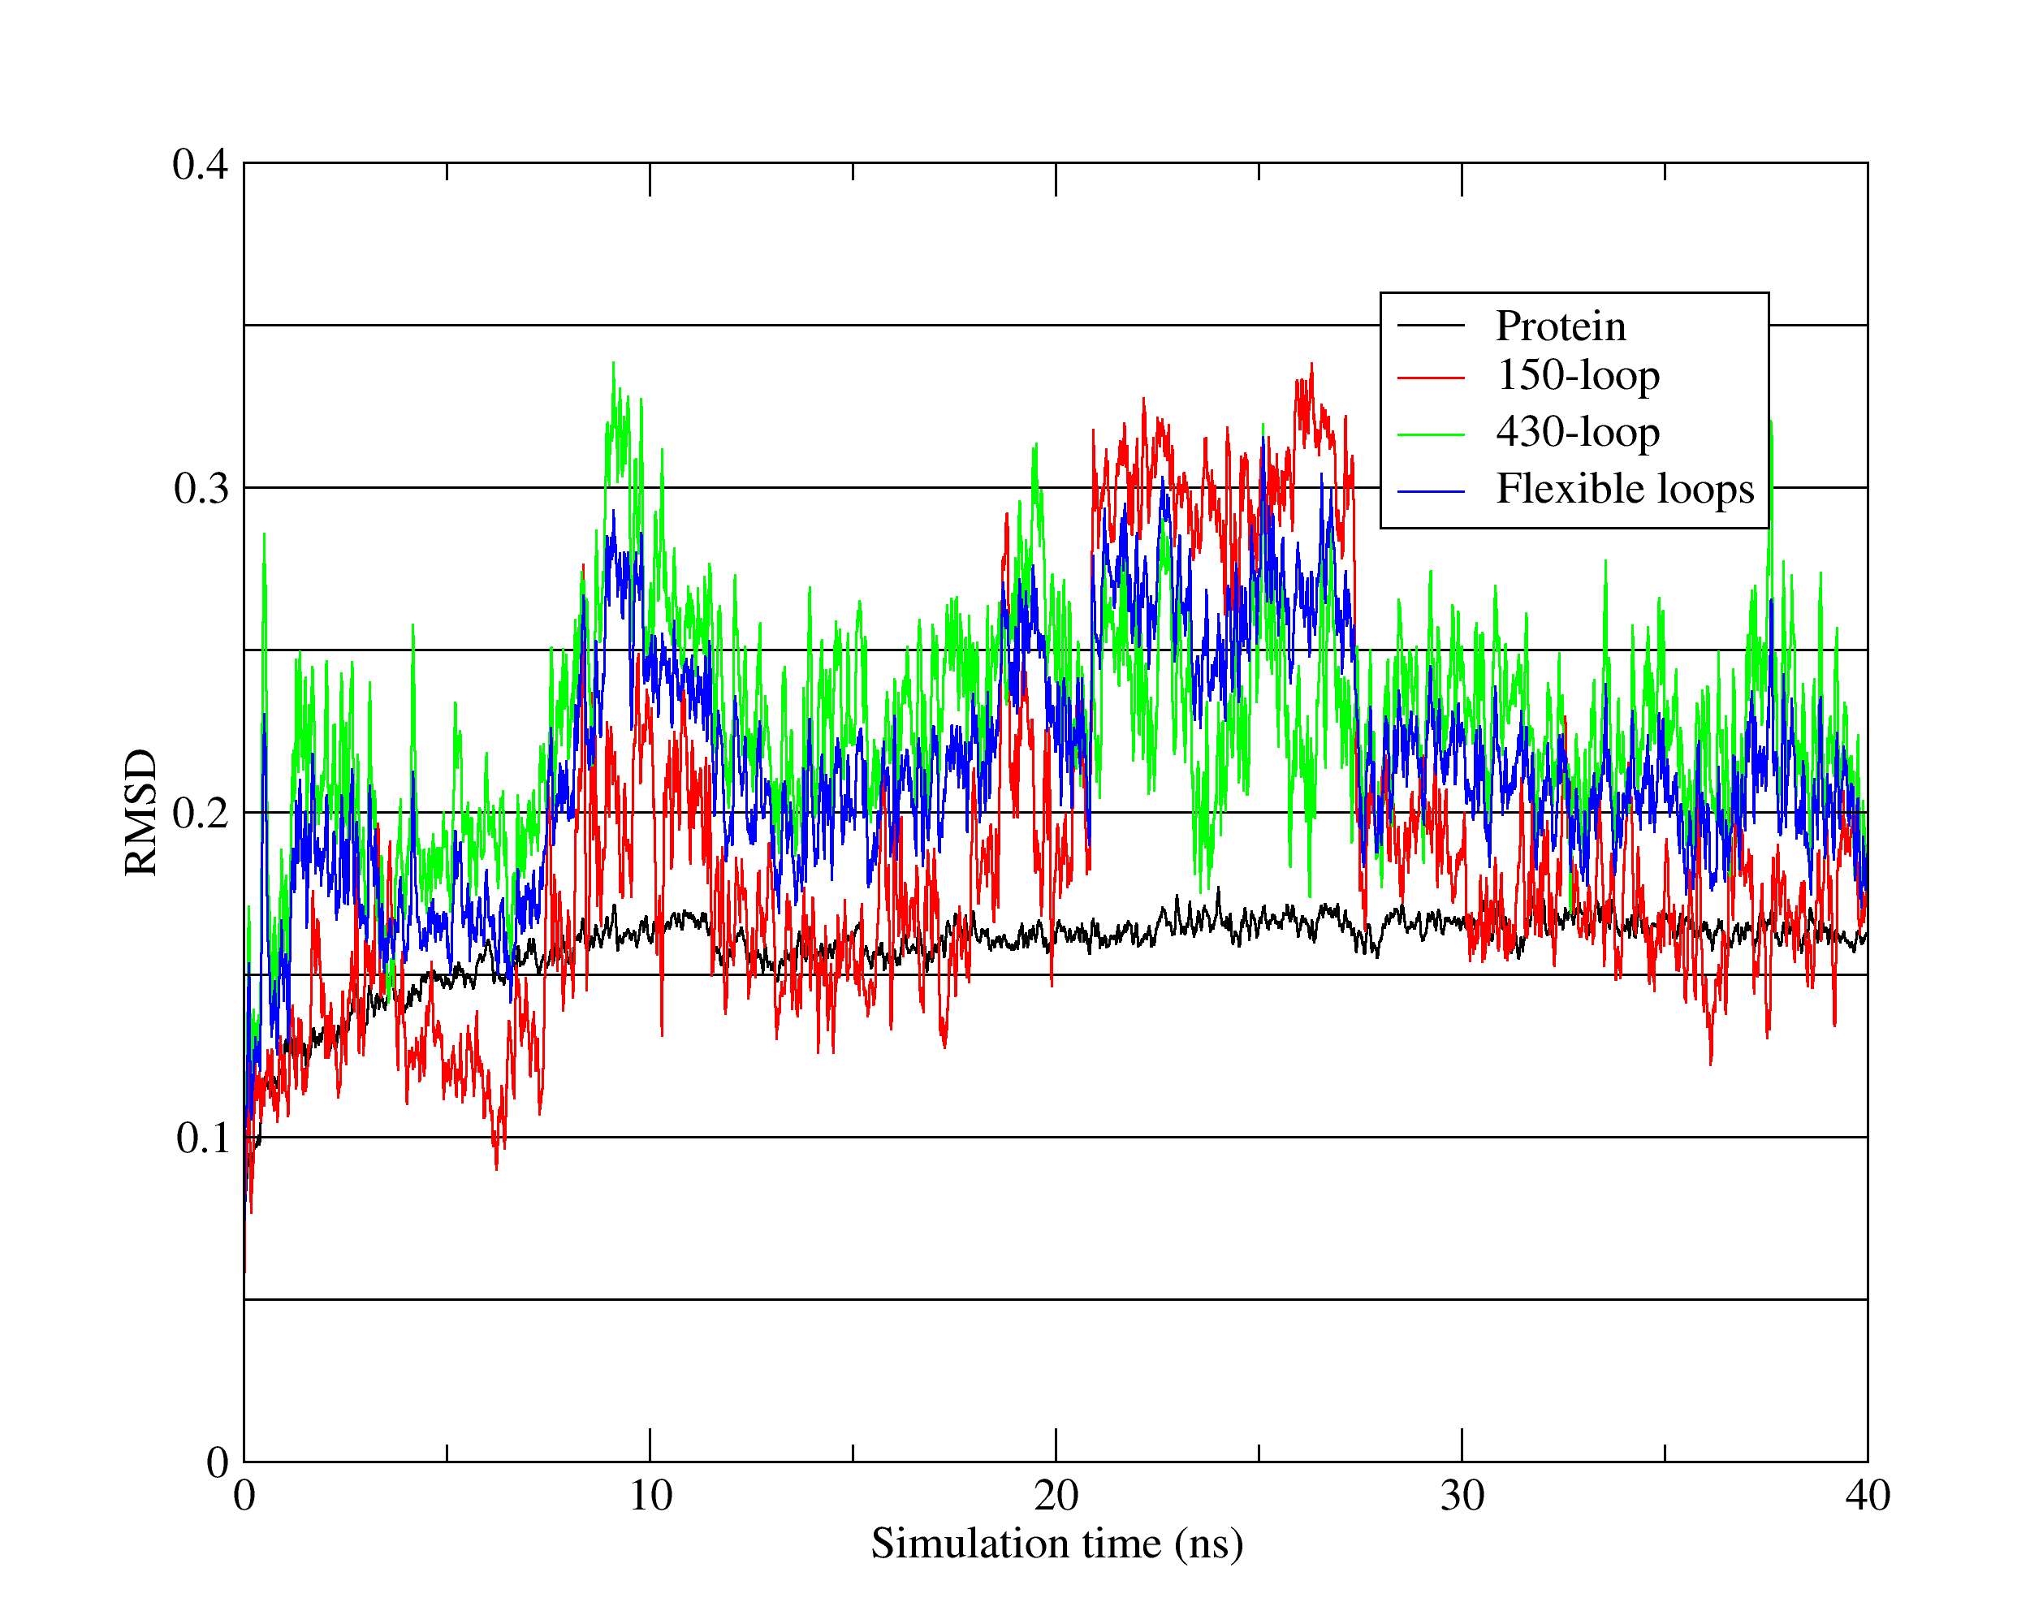Figure 1. RMSD of neuraminidase complex over simulation time

Binding pathway of tamiflu to influenza neuraminidase
Docking results over 127 representative structures proposed two lowest-energy pathways approaching neuraminidase active site (Figure 2). The first pathway, namely climbing path, is indicated in Figure 2 as the line C3-C2-C1-A and the second pathway, namely tunneling path, as the line T3-T2-T1-A. These two pathways are relatively similar to those found by Le et al. [2].
In the climbing path, inhibitor molecule was loosely hold on the enzyme surface in a small cavity between the two loops 294-296 (Asn-Trp-His) and 345-347 (Gly-Ala-Tyr) before moving toward the active site (Figure 4). This small cavity may not be a prevailing feature on the enzyme surface, as it is not found in the crystalized structure. However, it can provide a harbor that favors landing of freely diffusing ligands on protein surface. It is not clear how oseltamivir moves from C3 to C2, yet it is possible for the ligand to climb and then slide to C2 along with the movements of Asn294 and Tyr347 side chains. Although moving from C2 through C1 to A is clearly possible by simple diffusion, the movement in this direction is favorable as indicated by a significant decrease in binding energies (Figure 3). Role of Asn294 as one of the gates in this path implies about how this mutation may cause oseltamivir resistance: without this gating residue with bulky side chain, sliding movement toward binding pocket may not be favored in N294S mutant enzyme.
In the so-called tunneling path, oseltamivir was found to be in close contact with Ser170 which is among the minimum pattern of secondary sialic acid binding site [14, 15] with Pro-431 and Lys432 which are residues of the flexible 430-loop. Interaction analysis also showed that Arg371 has a high frequency of hydrogen bonds with oseltamivir carboxylate thanks to the guanidinium group on its side chain, while Pro431 and Lys432 contribute to the binding mainly via side chain hydrophobic contacts. These interactions indicate that this path may be similar to the second path identified by Le et al. (2010) [2] which emphasizes the movement of 430-loop during ligand binding. However, a closer look at distribution of binding energies in this area raises a question if it is possible for ligand to reach T1 from T2. Although T1 is closer to the active site, average binding energy of T1 group is not significantly different from, and even less favorable than, that of T2 group (Figure 3). This distribution of binding energies poses a question on moving direction of ligand from T2 to T1, thus prevent us from concluding about a binding path from this direction.
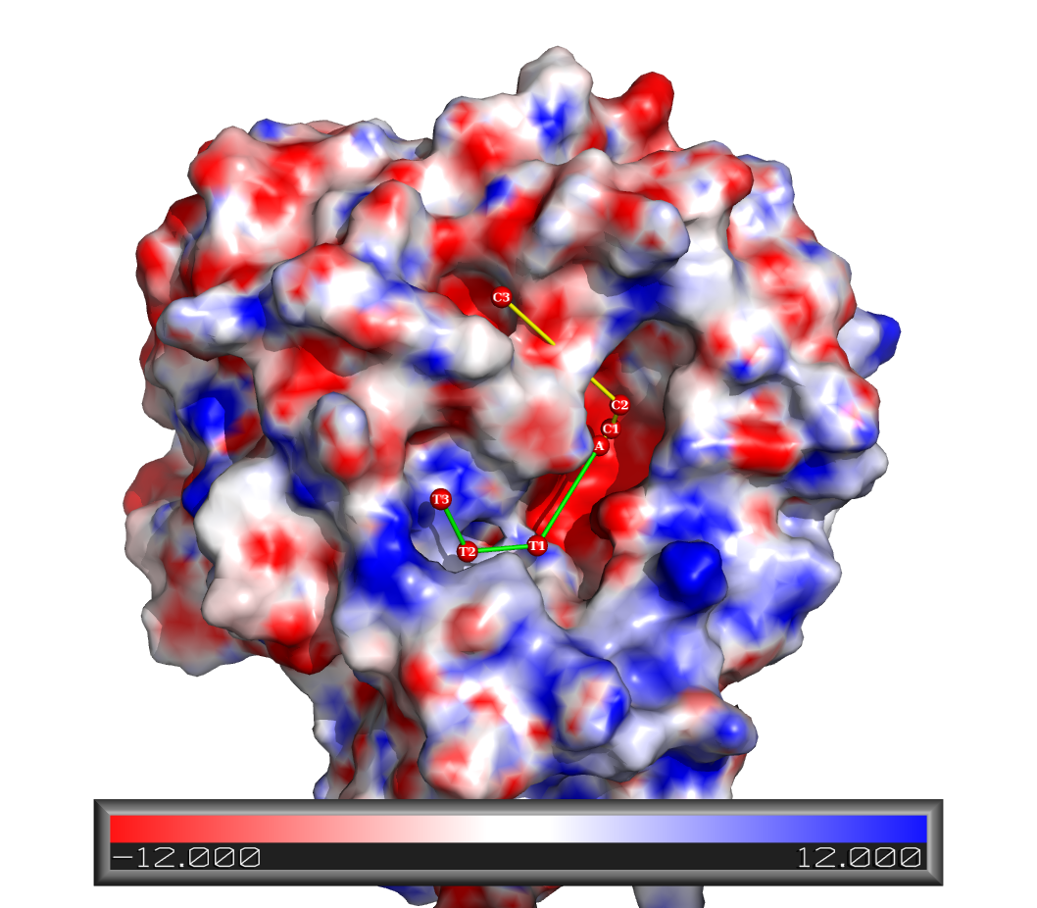
Figure 2. Pathways of tamiflu approaching neuraminidase active site (labeled A) suggested by docking. The climbing pathway is made of C3-C2-C1, while the tunneling pathway is made of T3-T2-T1.
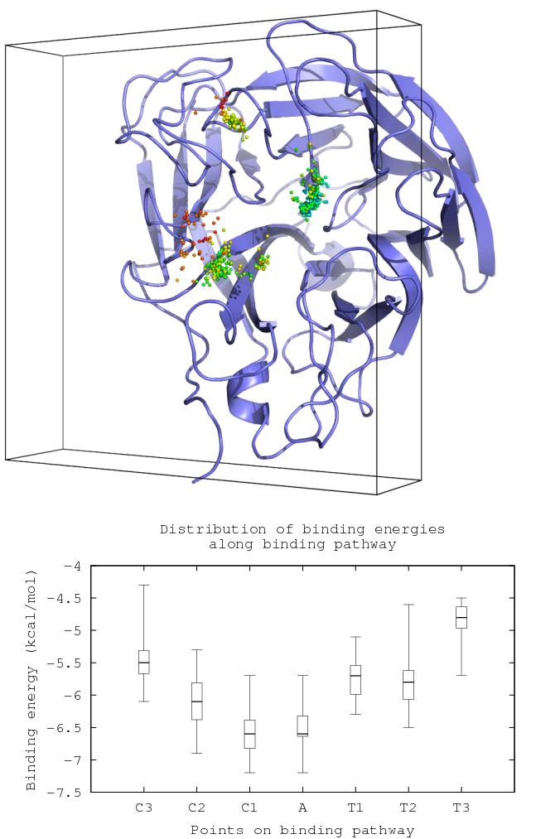
Figure 3. Distribution of binding energies of docked conformations.
Upper: Docked coformations represented by ligand centers of mass, colored by binding energies, with highest energy in red, lowest in blue. Lower: Statistical distribution of binding energies at each points of potential binding paths.
It is also questionable about accuracy of scoring function of AutodockVina when applying for sites far from binding pocket and more exposed to solvent, as AutodockVina scoring function is fine-tuned on experimental complexes in which ligands are bound at hydrophobic binding pocket. Regarding that, distribution of binding energies showed that the scoring function is still applicable, as binding energies are reasonably decrease when heading toward the binding pocket, and we expect that minor errors can be negated with large number of docking.
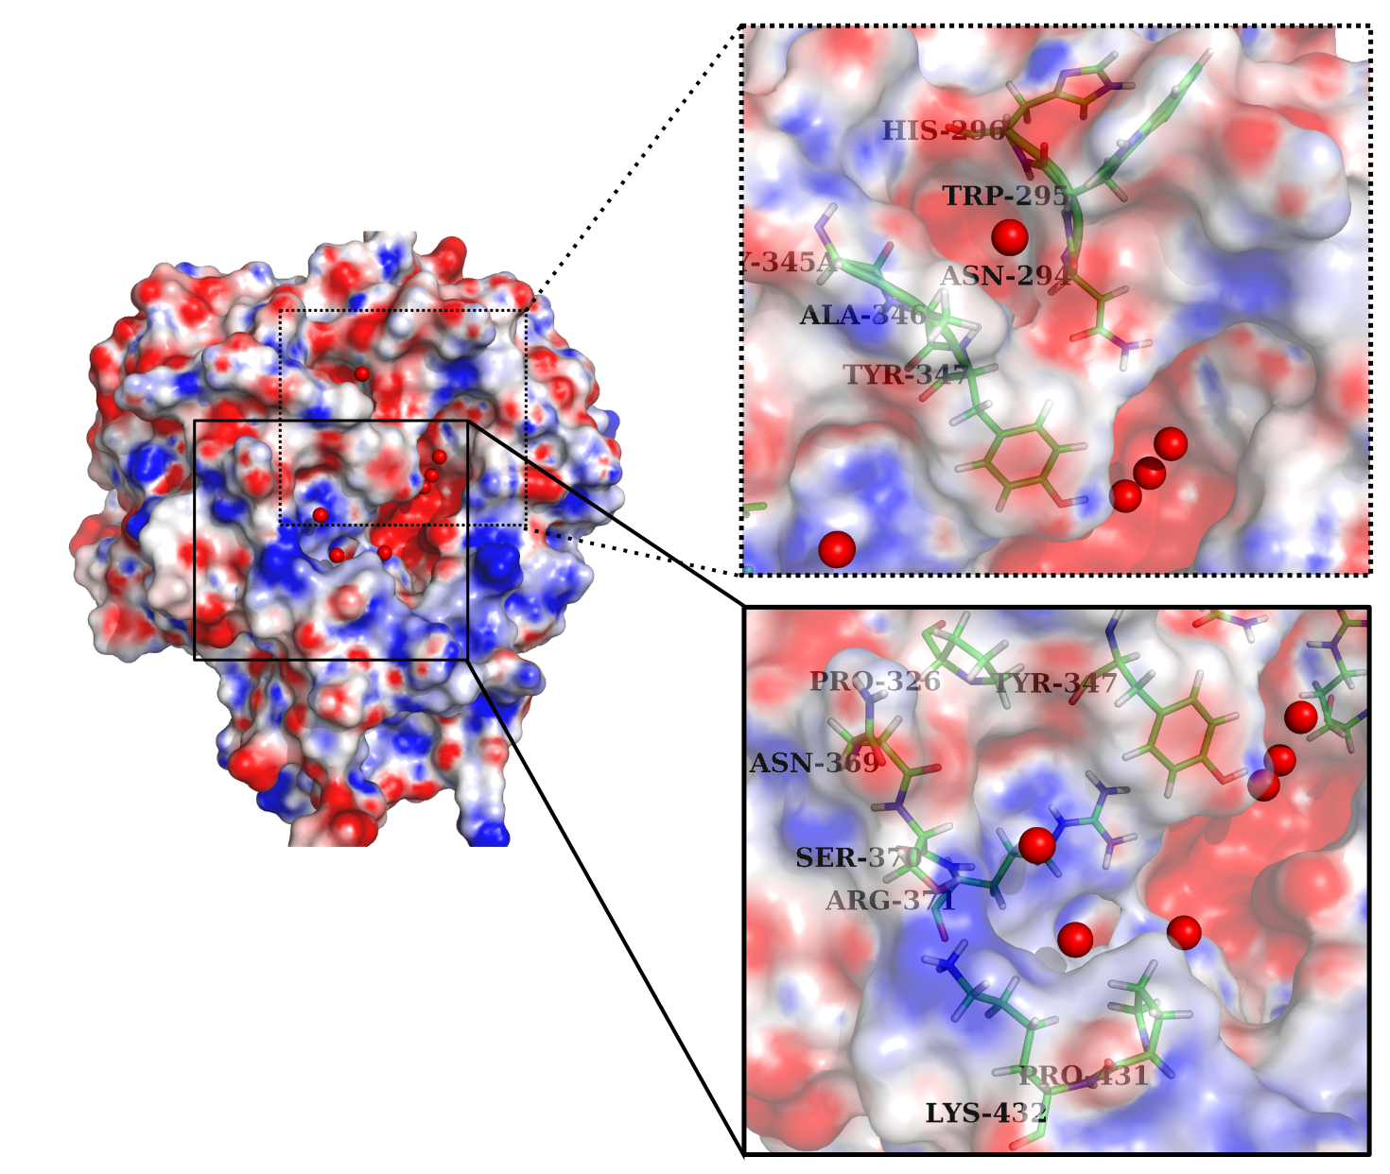
Figure 4. Important interactions in early stage of binding of climbing pathway (upper frame) of tunneling pathway (lower frame).

CONCLUSION
[what is the contribution of this paper?] We expect to provide an example of an affordable method to identify pathway using docking program, introducing an alternative view of binding pathway. The pathways identified by the method used in this paper represent equilibrium positions along a pathway, contrasting to non-equilibrium pathways identified by other dynamic methods like SMD...
Pathway docking can quickly suggest possible binding pathways of ligand molecules like native substrate or drugs, which cannot be infered from volumetric algorithms as with small molecules. However, due to the limitation from its approximation, it is required that pathways suggested are further analyzed to decide if the pathways are possible.

COMPUTATIONAL DETAILS

Sampling of receptor conformations
Protein flexibility was accounted for by ensemle-based docking approach which is increasingly common in virtual screening [11]. In our case, protein conformations were sampled through an equilibrium molecular dynamics simulation and representative ensembles were then generated by clustering the conformations by variations of important flexible loops.
Conformational sampling was performed by molecular dynamics simulation of neuraminidase N1 in complex with tamiflu. The complex structure (PDB ID: 2HU4) was solvated by TIP3P water and simulated using AMBER99SB Force Field implemented in Gromacs package as elaborated in Nguyen et al. [13] with simulation time extended to 40ns. Trajectories of the last 20ns were extracted to generate representative ensembles for docking.
Clustering was performed using g_cluster program also provided in Gromacs package, at 0.9Å cutoff, based on RMSD of flexible loops, specifically 150-loop Asn146-Arg152 and 430-loop Arg430-Thr439 [16], resulting in 127 clusters. One representative of each cluster is used as receptor.

Pathway docking procedure
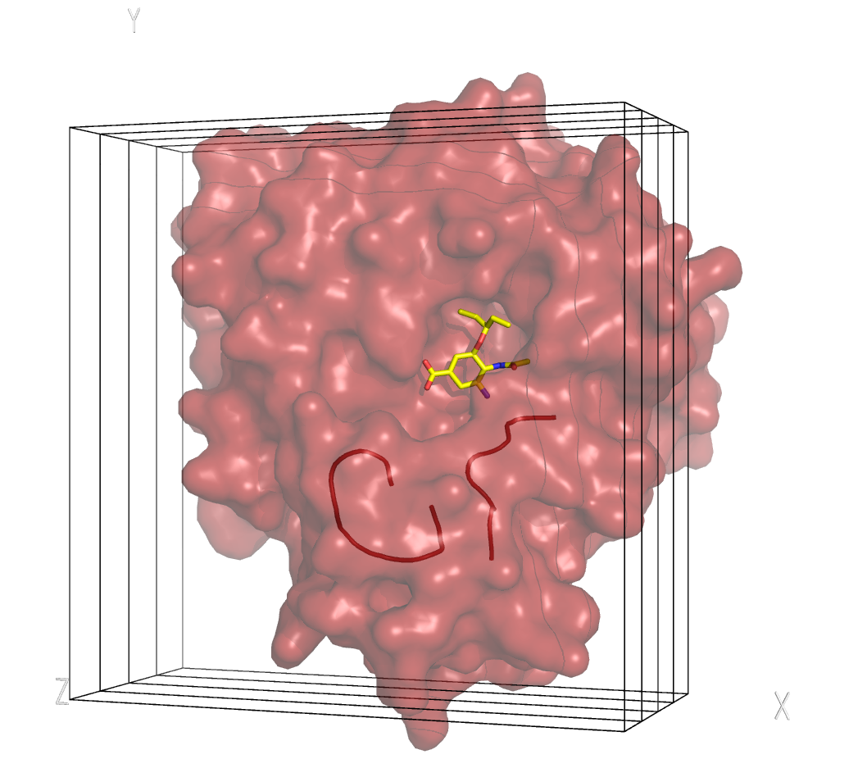Figure 5. Pathway docking methodology. Grid box is defined to cover a large area on protein surface and moved along z-axis toward the active site (indicated by the bound oseltamivir molecule). Neuraminidase structure is re-oriented to maximize the opening area cut by XY-clipping plane.430-loop and 150-loop are displayed in cartoon.
Figure 6. Pathway identification based on k-means clustering of ligand centers of mass. Centroids are colored by binding energy (left) and by cluster (right).
The main idea of finding ligand binding pathway by docking is probing for additional equilibrium states of bound ligands along the way toward binding pocket lying deep in the core. Protein must be reoriented so that the direction from its main binding pocket to the opening exposed to solvent is parallel to z-axis. Grid box is defined to cover a large area on protein surface and a minimal z-dimension that enables full extension of drug in any possible direction towards the binding pocket (Figure 5), and moved along z-axis by ¼ of its depth, until reaching binding pocket, resulting in 6 boxes 48x48x10.5 Å each, overlapping with its neighbors by ¾ its depth.
At each placement of the box, docking can be performed by any regular docking program. In this work, we chose Autodock Vina [17] for speed and convenience in parsing results.
As boxes are largely overlapping, box numbering do not necessarily correspond with points on binding path. Thus we clustered ligand centers of mass to reveal points on pathway. Clustering is performed using k-means algorithm on four dimensions including x, y, z coordinates and binding energy value weighted by 0.7, resulting in seven clusters each of which consisting points that are close enough in space and not different much in binding energy (Figure 6). Outliers are removed before clustering, include those that are sparsely distributed and those that are unable to reach the binding pocket in a continous path.

REFERENCES

[1] Malaisree, M., Rungrotmongkol, T., Nunthaboot, N., Aruksakunwong, O., Intharathep, P., Decha, P., Sompornpisut, P., Hannongbua, S. (2008) Source of oseltamivir resistance in avian influenza H5N1 virus with the H274Y mutation. Amino Acids, 37, 725-732.
[2] Le, L., Lee, E.H., Hardy, D.J., Truong, T.N., Schulten, K. (2010) Molecular Dynamics Simulations Suggest that Electrostatic Funnel Directs Binding of Tamiflu to Influenza N1 Neuraminidases. PLoS Comput Biol, 6, e1000939.
[3] Tan, R.C., Truong, T.N., McCammon, J.A., Sussman, J.L. (1993) Acetylcholinesterase: electrostatic steering increases the rate of ligand binding. Biochemistry, 32, 401-403.
[4] Borrelli, K.W., Vitalis, A., Alcantara, R., Guallar, V. (2005) PELE: Protein Energy Landscape Exploration. A Novel Monte Carlo Based Technique. J. Chem. Theory Comput., 1, 1304-1311.
[5] Sai Ram, K.V.V.M., Rambabu, G., Sarma, J.A.R.P., Desiraju, G.R. (2006) Ligand Coordinate Analysis of SC-558 from the Active Site to the Surface of COX-2: A Molecular Dynamics Study. J. Chem. Inf. Model., 46, 1784-1794.
[6] Buch, I., Giorgino, T., De Fabritiis, G. (2011) Complete reconstruction of an enzyme-inhibitor binding process by molecular dynamics simulations. Proceedings of the National Academy of Sciences, 108, 10184.
[7] Martí, M.A., Lebrero, M.C.G., Roitberg, A.E., Estrin, D.A. (2008) Bond or Cage Effect: How Nitrophorins Transport and Release Nitric Oxide. J. Am. Chem. Soc., 130, 1611-1618.
[8] Ruscio, J.Z., Kumar, D., Shukla, M., Prisant, M.G., Murali, T.M., Onufriev, A.V. (2008) Atomic level computational identification of ligand migration pathways between solvent and binding site in myoglobin. Proceedings of the National Academy of Sciences, 105, 9204 -9209.
[9] Straßer, A., Wittmann, H.-J. (2006) LigPath: a module for predictive calculation of a ligand’s pathway into a receptor-application to the gpH1 - receptor. Journal of Molecular Modeling, 13, 209-218.
[10] Cheng, L.S., Amaro, R.E., Xu, D., Li, W.W., Arzberger, P.W., McCammon, J.A. (2008) Ensemble-Based Virtual Screening Reveals Potential Novel Antiviral Compounds for Avian Influenza Neuraminidase. J. Med. Chem., 51, 3878-3894.
[11] Amaro, R.E., Li, W.W. (2010) Emerging Methods for Ensemble-Based Virtual Screening. Curr Top Med Chem, 10, 3-13.
[12] Nguyen, H., Le, L., Truong, T.N. (2011) Top-hits for H1N1pdm Identified by Virtual Screening Using Ensemble-based Docking. PLoS Curr, 3.
[13] Nguyen, T.T., Mai, B.K., Li, M.S. (2011) Study of Tamiflu Sensitivity to Variants of A/H5N1 Virus Using Different Force Fields. J. Chem. Inf. Model., 51, 2266-2276.
[14] Landon, M.R., Amaro, R.E., Baron, R., Ngan, C.H., Ozonoff, D., Andrew McCammon, J., Vajda, S. (2008) Novel Druggable Hot Spots in Avian Influenza Neuraminidase H5N1 Revealed by Computational Solvent Mapping of a Reduced and Representative Receptor Ensemble. Chem Biol Drug Des, 71, 106-116.
[15] Sung, J.C., Wynsberghe, A.W.V., Amaro, R.E., Li, W.W., McCammon, J.A. (2010) Role of Secondary Sialic Acid Binding Sites in Influenza N1 Neuraminidase. Journal of the American Chemical Society, 132, 2883-2885.
[16] Amaro, R.E., Minh, D.D.L., Cheng, L.S., Lindstrom, Olson, A.J., Lin, J.-H., Li, W.W., McCammon, J.A. (2007) Remarkable Loop Flexibility in Avian Influenza N1 and Its Implications for Antiviral Drug Design. J. Am. Chem. Soc., 129, 7764-7765.
[17] Trott, O., Olson, A.J. (2010) AutoDock Vina: improving the speed and accuracy of docking with a new scoring function, efficient optimization, and multithreading. Journal of computational chemistry, 31, 455–461.

