WIREFRAME

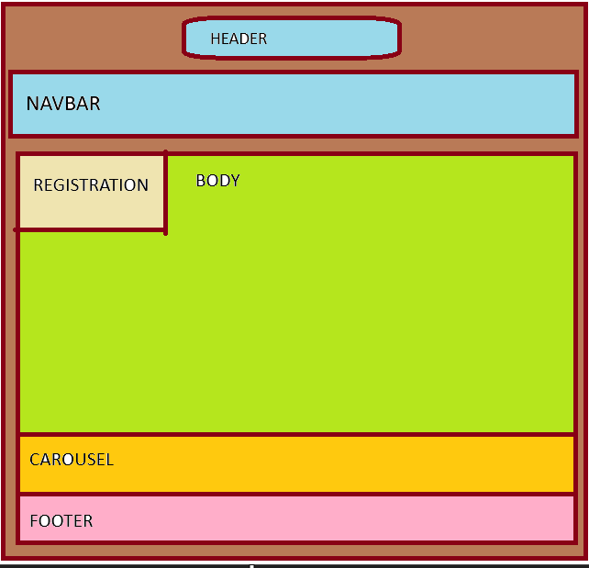

GITHUB LINK:

[**https://tte05.github.io/Webass2/**](https://tte05.github.io/Webass2/)