Databases
2022
Date

Tino Teittinen
Town_db


Table of Contents

1. Designing the database 3
1.1 Description of the purpose of the database 3
1.2 ER model 3
1.3 Physical design of the DB: Relational schema 4
1.4 Normalization process 5
2. Implementation of the DB 8
2.1 RDBMS selection 8
2.2 User management 9
2.3 SQL DDL sentences 15
3. Inserting data to the DB 15
3.1 Inserted data 15
3.2 SQL INSERT examples 16
4. Querying data 17
4.1 SQL queries 17
4.2 SQL VIEW 19
4.3 Querying from an application 20

Designing the database

Description of the purpose of the database
This database is designed for personal use. The purpose of the DB is to provide structure for a game program, so that it can effectively search and add required elements related to the towns content. The program can download required citizens to players current structure with the help of the database. When player is buying equippable or consumable items, the database provides organized stash to find the availability and information of the items in the current context. Some structures of the town are also buildable and sellable, so the database provides fields for the value and building date for those structures.

ER model
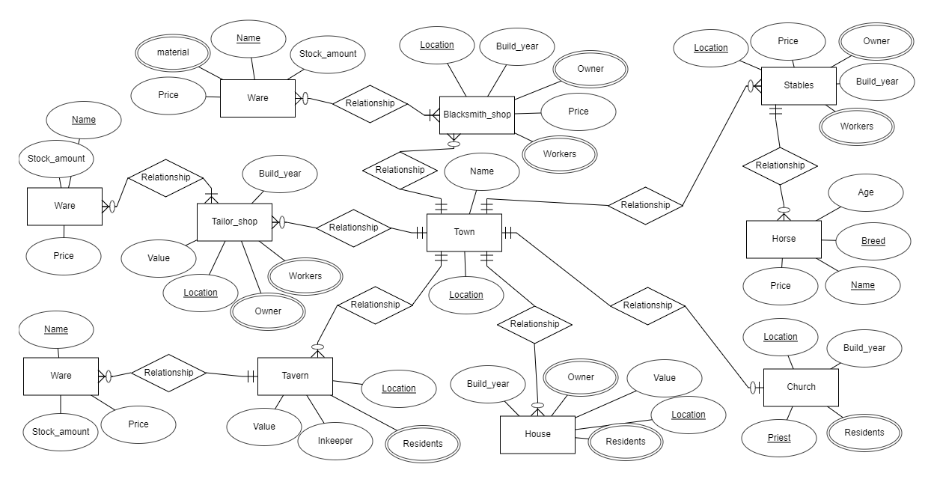
Conceptual ER model:

Physical design of the DB: Relational schema
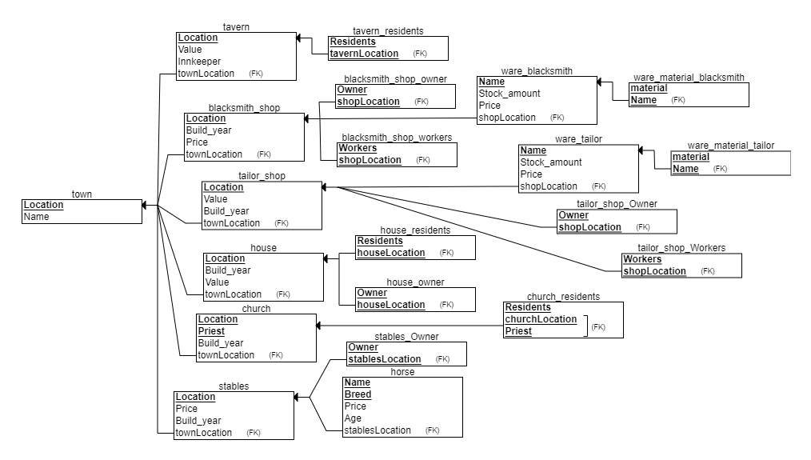
Logical model (relational schema)

Normalization process

TABLENAMEINBLUE
1NF: TOWN: Location Name
TAVERN: Location Value Innkeeper townLocation
TAVERN_RESIDENTS: Residents tavernLocation
BLACKSMITH_SHOP: Location Build_year Price townLocation
BLACKSMITH_SHOP_OWNER: Owner shopLocation
BLACKSMITH_SHOW_WORKERS: Workers shopLocation
WARE: Name Stock_amount Price shopLocation
TAILOR_SHOP: Location Value Build_year townLocation
TAILOR_SHOP_OWNER: Owner shopLocation
TAILOR_SHOP_WORKERS: Workers shopLocation
WARE: Name Stock_amount Price shopLocation
HOUSE: Location Build_year value townLocation
HOUSE_RESIDENTS: Residents houseLocation
HOUSE_OWNER: Owner houseLocation
CHURCH: Location Priest Build_year townLocation
CHURCH_RESIDENTS: Residents churchLocation Priest
STABLES: Location Price Build_year townLocation
STABLES_OWNER: Owner stablesLocation
HORSE: Name Breed Price Age stablesLocation
No multivalues they have already been put into their own tables, no duplicates. All tables have a primary key.

2NF: TOWN: Location Name
TAVERN: Location Value Innkeeper townLocation
TAVERN_RESIDENTS: Residents tavernLocation
BLACKSMITH_SHOP: Location Build_year Price townLocation
BLACKSMITH_SHOP_OWNER: Owner shopLocation
BLACKSMITH_SHOW_WORKERS: Workers shopLocation
WARE: Name Stock_amount Price shopLocation
TAILOR_SHOP: Location Value Build_year townLocation
TAILOR_SHOP_OWNER: Owner shopLocation
TAILOR_SHOP_WORKERS: Workers shopLocation
WARE: Name Stock_amount Price shopLocation
HOUSE: Location Build_year value townLocation
HOUSE_RESIDENTS: Residents houseLocation
HOUSE_OWNER: Owner houseLocation
CHURCH: Location Priest townLocation
CHURCH_RESIDENTS: Residents churchLocation Priest
CHURCH_LOCATION: Location Build_year
STABLES: Location Price Build_year townLocation
STABLES_OWNER: Owner stablesLocation
HORSE: Name Breed Price Age stablesLocation
Some partial dependencies on the primary key, can define horses price with only breed since the horse specific can affect the value, but we don’t need to know the priest for churches building date. So they are moved to a separate table.

3NF: TOWN: Location Name
TAVERN: Location Value Innkeeper townLocation
TAVERN_RESIDENTS: Residents tavernLocation
BLACKSMITH_SHOP: Location Build_year Price townLocation
BLACKSMITH_SHOP_OWNER: Owner shopLocation
BLACKSMITH_SHOW_WORKERS: Workers shopLocation
WARE: Name Stock_amount Price shopLocation
TAILOR_SHOP: Location Value Build_year townLocation
TAILOR_SHOP_OWNER: Owner shopLocation
TAILOR_SHOP_WORKERS: Workers shopLocation
WARE: Name Stock_amount Price shopLocation
HOUSE: Location Build_year value townLocation
HOUSE_RESIDENTS: Residents houseLocation
HOUSE_OWNER: Owner houseLocation
CHURCH: Location Priest townLocation
CHURCH_RESIDENTS: Residents churchLocation Priest
CHURCH_LOCATION: Location Build_year
STABLES: Location Price Build_year townLocation
STABLES_OWNER: Owner stablesLocation
HORSE: Name Breed Price Age stablesLocation

No dependencies between normal columns.

Implementation of the DB

RDBMS selection
This was created with an open source relational database management system (RDBMS) called MySQL using the LAMP stack UwAmp and phpMyAdmin user interface.
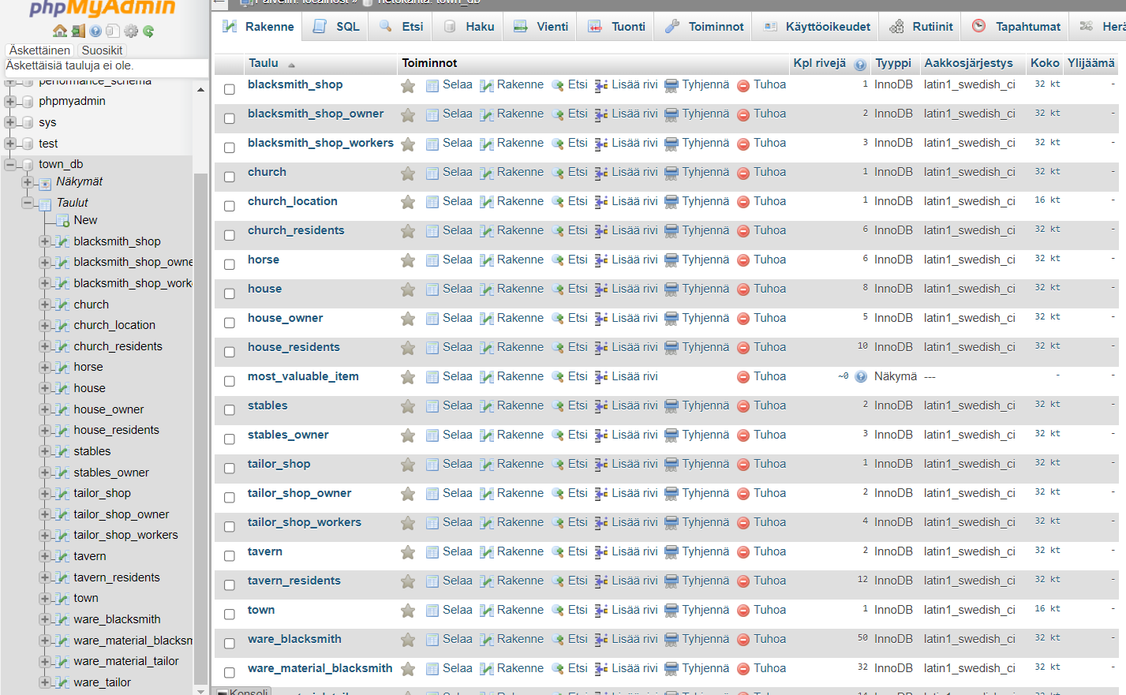

User management
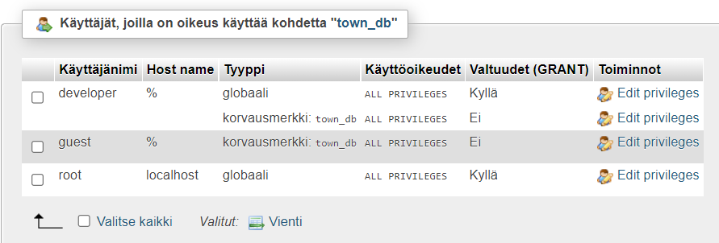

SQL DDL sentences
CREATE DATABASE town_db;
- use town_db;
CREATE TABLE town (
Location VARCHAR(20) NOT NULL,
Name VARCHAR(40) NOT NULL,
PRIMARY KEY (Location)

);

CREATE TABLE tavern(
Location VARCHAR(30),
Value INT,
Innkeeper VARCHAR(20),
townLocation VARCHAR(20) NOT NULL,
PRIMARY KEY (Location),
FOREIGN KEY (townLocation) REFERENCES town(Location)
);

ALTER TABLE tavern
ADD CONSTRAINT residents_migration FOREIGN KEY(townLocation) REFERENCES town(Location) ON DELETE CASCADE ON UPDATE CASCADE;

CREATE TABLE tavern_residents(
Residents VARCHAR(20),
tavernLocation VARCHAR(30),
PRIMARY KEY (RESIDENTS, tavernLocation),
CONSTRAINT residents_removal FOREIGN KEY (tavernLocation) REFERENCES tavern(Location) ON DELETE CASCADE ON UPDATE CASCADE
);

CREATE TABLE blacksmith_shop(
Location VARCHAR(30) NOT NULL,
Build_year INT NOT NULL,
Price DOUBLE(10,2),
townLocation VARCHAR(30) NOT NULL,
PRIMARY KEY(Location),
CONSTRAINT shopRemoval FOREIGN KEY(townLocation) REFERENCES town(Location) ON DELETE CASCADE ON UPDATE CASCADE
);

CREATE TABLE blacksmith_shop_owner(
Owner VARCHAR(20),
shopLocation VARCHAR(30) NOT NULL,
PRIMARY KEY(Owner, shopLocation),
CONSTRAINT shop FOREIGN KEY(shopLocation) REFERENCES blacksmith_shop(Location) ON DELETE CASCADE ON UPDATE CASCADE
);

CREATE TABLE blacksmith_shop_workers (
Workers VARCHAR(20),
shopLocation VARCHAR(30),
PRIMARY KEY (Workers, shopLocation),
CONSTRAINT shopworkers FOREIGN KEY(shopLocation) REFERENCES blacksmith_shop(Location) ON DELETE CASCADE ON UPDATE CASCADE
);

CREATE TABLE ware_blacksmith(
Name VARCHAR(30) NOT NULL,
Stock_amount INT NOT NULL,
Price DOUBLE(10,2) NOT NULL,
shopLocation VARCHAR(30) NOT NULL,
PRIMARY KEY(Name),
CONSTRAINT ware_removal FOREIGN KEY(shopLocation) REFERENCES blacksmith_shop(Location) ON DELETE CASCADE ON UPDATE CASCADE
);

CREATE TABLE ware_material_blacksmith(
material VARCHAR(20) NOT NULL,
Name VARCHAR(20) NOT NULL,
PRIMARY KEY(material, Name),
CONSTRAINT material_removal FOREIGN KEY(Name) REFERENCES ware(Name) ON DELETE CASCADE ON UPDATE CASCADE
);

CREATE TABLE tailor_shop(
Location VARCHAR(30) NOT NULL,
Value double(10,2),
Name VARCHAR(20) NOT NULL,
Build_year INT NOT NULL,
townLocation VARCHAR(30),
PRIMARY KEY(Location),
CONSTRAINT tailor_removal FOREIGN KEY(townLocation) REFERENCES town(Location) ON DELETE CASCADE ON UPDATE CASCADE
);

CREATE TABLE ware_tailor(
Name VARCHAR(20) NOT NULL,
Stock_amount INT NOT NULL,
Price INT,
shopLocation VARCHAR(30),
PRIMARY KEY(Name),
CONSTRAINT tailorWareRemoval FOREIGN KEY(shopLocation) REFERENCES tailor_shop(Location) ON DELETE CASCADE ON UPDATE CASCADE
);

CREATE TABLE ware_material_tailor(
material VARCHAR(20) NOT NULL,
Name VARCHAR(20) NOT NULL,
PRIMARY KEY(material, Name),
CONSTRAINT tailorMaterialRemoval FOREIGN KEY(Name) REFERENCES ware_tailor(Name) ON DELETE CASCADE ON UPDATE CASCADE
);

CREATE TABLE tailor_shop_owner(
Owner VARCHAR(20) NOT NULL,
shopLocation VARCHAR(30) NOT NULL,
PRIMARY KEY(Owner, shopLocation),
CONSTRAINT tailorOwner_removal FOREIGN KEY(shopLocation) REFERENCES tailor_shop(Location) ON DELETE CASCADE ON UPDATE CASCADE
);

CREATE TABLE tailor_shop_workers (
Workers VARCHAR(20),
shopLocation VARCHAR(30) NOT NULL,
PRIMARY KEY(Workers, shopLocation),
CONSTRAINT tailorWorkersRemoval FOREIGN KEY(shopLocation) REFERENCES tailor_shop(Location) ON DELETE CASCADE ON UPDATE CASCADE
);

CREATE TABLE house(
Location VARCHAR(30) NOT NULL,
Build_year INT,
Value DOUBLE(10,2),
townLocation VARCHAR(30) NOT NULL,
PRIMARY KEY(Location),
CONSTRAINT houseRemoval FOREIGN KEY(townLocation) REFERENCES town(Location) ON DELETE CASCADE ON UPDATE CASCADE
);

CREATE TABLE house_residents(
Residents VARCHAR(20),
houseLocation VARCHAR(30) NOT NULL,
PRIMARY KEY(Residents, houseLocation),
CONSTRAINT houseResidentsRemoval FOREIGN KEY(houseLocation) REFERENCES house(Location) ON DELETE CASCADE ON UPDATE CASCADE
);

CREATE TABLE house_owner(
Owner VARCHAR(20),
houseLocation VARCHAR(30) NOT NULL,
PRIMARY KEY(Owner, houseLocation),
CONSTRAINT houseOwnerRemoval FOREIGN KEY(houseLocation) REFERENCES house(Location) ON DELETE CASCADE ON UPDATE CASCADE
);

CREATE TABLE church (
Location VARCHAR(30) NOT NULL,
townLocation VARCHAR(30) NOT NULL,
PRIMARY KEY(Location),
CONSTRAINT churchRemoval FOREIGN KEY(townLocation) REFERENCES town(Location) ON DELETE CASCADE ON UPDATE CASCADE
);

CREATE TABLE church_location (
Location VARCHAR(30) NOT NULL,
Build_year int NOT NULL,
PRIMARY KEY(Location),
CONSTRAINT churchLocationRemoval FOREIGN KEY(Location) REFERENCES church(Location) ON DELETE CASCADE ON UPDATE CASCADE
);

CREATE TABLE church_residents (
Residents VARCHAR(20),
churchLocation VARCHAR(30) NOT NULL,
PRIMARY KEY(Residents, churchLocation),
CONSTRAINT churchResidentsRemoval FOREIGN KEY(churchLocation) REFERENCES church(Location) ON DELETE CASCADE ON UPDATE CASCADE
);

CREATE TABLE stables (
Location VARcHAR(30) NOT NULL,
Price DOUBLE(10,2),
Build_year INT NOT NULL,
townLocation VARCHAR(30) NOT NULL,
PRIMARY KEY(Location),
CONSTRAINT stablesRemoval FOREIGN KEY(townLocation) REFERENCES town(Location) ON DELETE CASCADE ON UPDATE CASCADE
);

CREATE TABLE stables_owner (
Owner VARCHAR(30),
stablesLocation VARCHAR(30) NOT NULL,
PRIMARY KEY(Owner, stablesLocation),
CONSTRAINT stablesOwnerRemoval FOREIGN KEY(stablesLocation) REFERENCES stables(Location) ON DELETE CASCADE ON UPDATE CASCADE
);

CREATE TABLE horse (
Name VARCHAR(30) NOT NULL,
Breed VARCHAR(20) NOT NULL,
Price DOUBLE(5,2) NOT NULL,
Age INT NOT NULL,
stablesLocation VARCHAR(30) NOT NULL,
PRIMARY KEY(Name, Breed),
CONSTRAINT horseRemoval FOREIGN KEY(stablesLocation) REFERENCES stables(Location) ON DELETE CASCADE ON UPDATE CASCADE
);

Inserting data to the DB
Load your database with data.

Inserted data

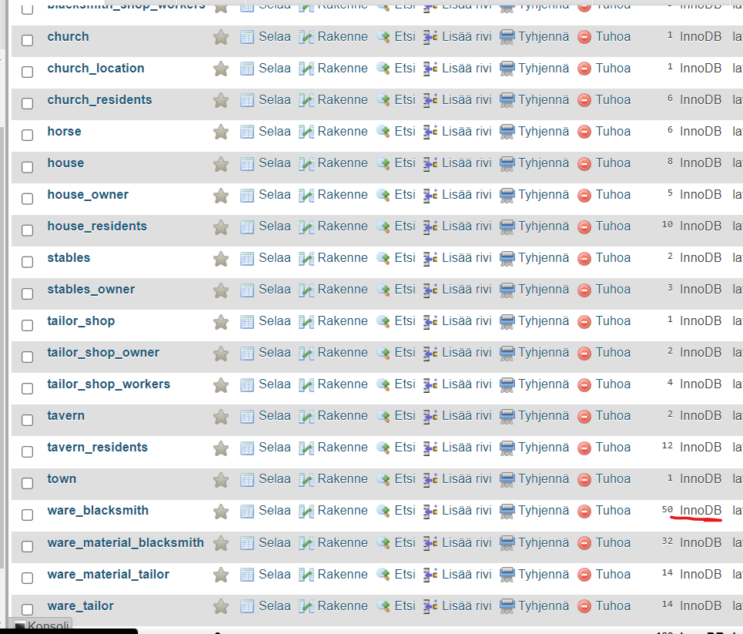

SQL INSERT examples

INSERT INTO ware_blacksmith (Name, Price, shopLocation, Stock_amount)
VALUES ('Copper Sword', 20, 'Old Street 5', 6), ('Copper Dagger', 10, 'Old Street 5', 10), ('Copper Mace', 20, 'Old Street 5', 3),('Copper Breastplate', 50, 'Old Street 5', 2), ('Copper chainmail', 25, 'Old Street 5', 2), ('Copper leggings', 40, 'Old Street 5', 2), ('Copper Helmet', 25, 'Old Street 5', 2), ('Copper bracers', 15, 'Old Street 5', 2), ('Copper gloves', 20, 'Old Street 5', 2),('Copper Boots', 20, 'Old Street 5', 2), ('Copper Pickaxe', 20, 'Old Street 5', 3), ('Copper Axe', 25, 'Old Street 5', 2),('Copper Battleaxe', 35, 'Old Street 5', 1), ('Copper Greatsword', 35, 'Old Street 5', 1), ('Copper Crossbow', 30, 'Old Street 5', 2),('Copper Bolt', 1, 'Old Street 5', 400), ('Iron Sword', 20, 'Old Street 5', 6), ('Iron Dagger', 10, 'Old Street 5', 10), ('Iron Mace', 20, 'Old Street 5', 3),('Iron Breastplate', 90, 'Old Street 5', 2), ('Iron chainmail', 45, 'Old Street 5', 2), ('Iron leggings', 70, 'Old Street 5', 2), ('Iron Helmet', 35, 'Old Street 5', 2), ('Iron bracers', 25, 'Old Street 5', 2), ('Iron gloves', 30, 'Old Street 5', 2),('Iron Boots', 30, 'Old Street 5', 2), ('Iron Pickaxe', 30, 'Old Street 5', 3), ('Iron Axe', 35, 'Old Street 5', 2),('Iron Battleaxe', 55, 'Old Street 5', 1), ('Iron Greatsword', 55, 'Old Street 5', 1), ('Iron Crossbow', 50, 'Old Street 5', 2),('Iron Bolt', 2, 'Old Street 5', 300)

INSERT INTO tavern (Innkeeper, Location, townLocation, Value)
VALUES ('Sophia Miller', 'Middle Square 2', 'Green Hills', 4500)

INSERT INTO tavern_residents (Residents, tavernLocation)
VALUES ('Ronald Poorpocket', 'Middle Square 2'), ('Emma Miller', 'Middle Square 2'), ('Oscar Basicman', 'Middle Square 2'), ('Helena Berrypicker', 'Middle Square 2'), ('Björg the cook', 'Middle Square 2'), ('James', 'Middle Square 2')

INSERT INTO horse (Name, Breed, Price, Age, stablesLocation)
VALUES ('Roast', 'Friesian', 3500, 8, 'New Avenue 5'), ('Wildfire', 'Arabian', 4300, 7, 'New Avenue 5'), ('Dover', 'Friesian', 2600, 11, 'New Avenue 5');

Querying data
Answering the information needs by creating meaningful queries

SQL queries
1- What is the location of the blacksmith in town and what are the iron-made items that can be bought with 10 coins and how much do they cost?
Location | Name | Price
Old Street 5 | Iron Bolt | 2.00
Old Street 5 | Iron Dagger | 10.00

2- What is the oldest house in the town (public buildings excluded), who owns it and who live there?
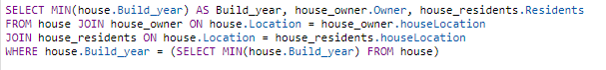
Build_year | Owner | Residents
1012 | Samuel Oldfield | Samuel Oldfield

3- How many horses does the stables New Avenue 5 have, what is the combined value of all of them and who owns them?
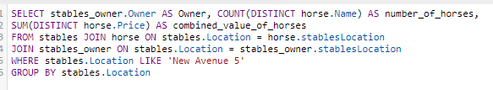
Owner | number_of_horses | combined_value_of_horses
Harald Gambler | 3 | 10400
4- How many residents does each tavern in the town have excluding cooks and cleaners?
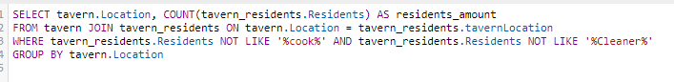
Location | residents_amount
Middle Square 2 | 5
New avenue 4 | 4

5- What are the names, ages and breeds of the horses owned by Harald Gambler?
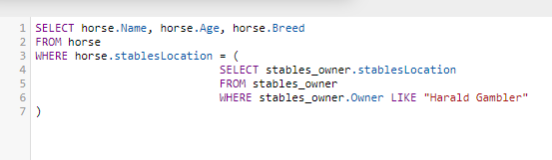
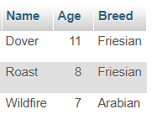
6 – What is the most expensive item the blacksmith sells. Show its price and name.
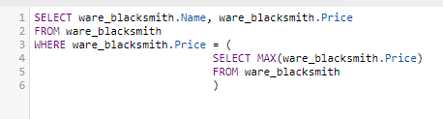
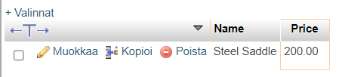

SQL VIEW
Create your fifth query and store its results as a View-table (show here how the view was created).
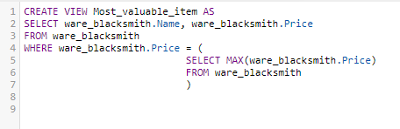
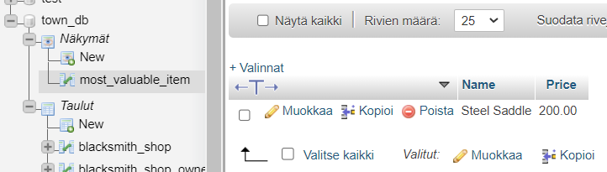

Querying from an application
With your favorite programming language (e.g. Python), create and show the source code which
- establishes a connection to your database
- executes one of your queries above and
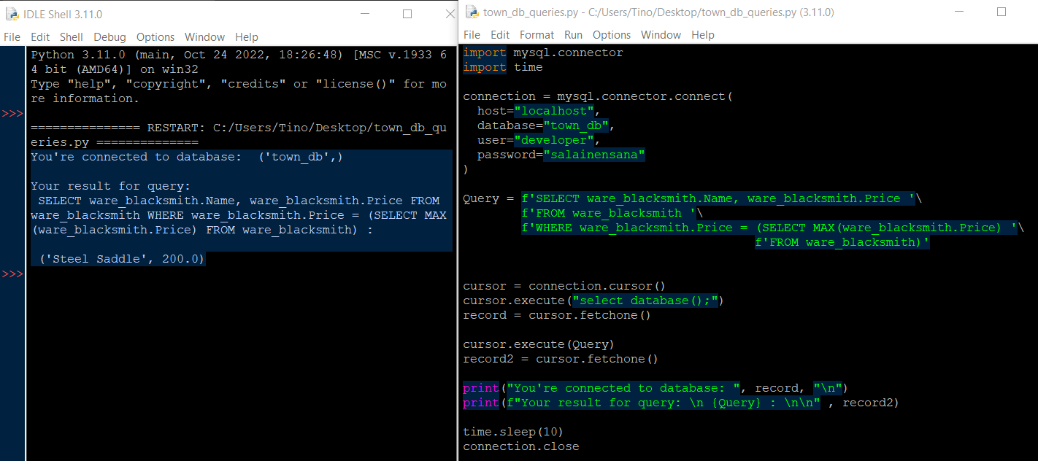
- closes the database connection

Evaluation:
Contents and maximum points:

1. Designing the database 20
Description of the purpose of the database 5
ER model 5
Relational schema 5
Normalization process 5
2. Implementing the DB 5
DBMS selection 3
User management 2
SQL DDL sentences 5
3. Inserting data to the DB 10
Inserted data 5
SQL INSERT examples 5
4. Querying data 15
SQL queries: 2p/each 8
SQL View 2
Querying from an application 5

Total 50 points

