VICE – mathematical proof and reasoning (in progress)

-by tterrag

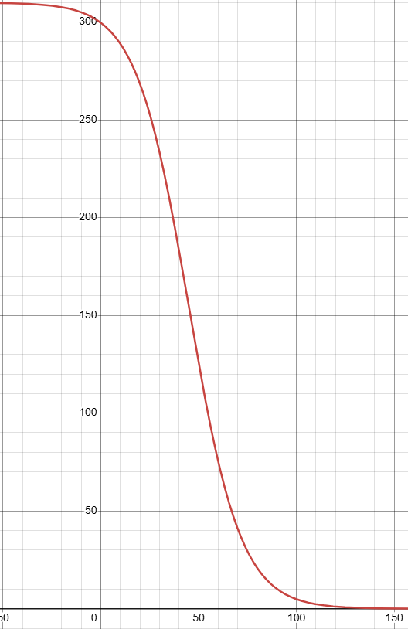

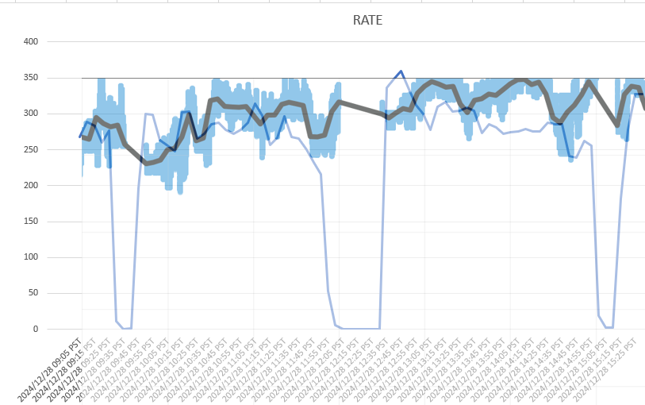PROOF :

* 0.04 p-value indicates modern level of coorelation
* 310-(310/1-29e^-0.075x) where x represents Conveyance health
* Logarithmic axis swap on graph overlay = function