SAMPLE RStudio lab assignment: generating a table

General instructions
In this assignment, you will be pasting a screenshot of a table generated in RStudio into this document. Then you will add a comment on your R script file with a hashtag (#)

Assignment instructions
- Open the related lecture’s R script file in RStudio.
- You will see a single line of code under the “# WORKING SPACE” > “## Assignment”:
  - frq(gss$marital, out = "v")
  - Triple-click (Clicking three times really fast) on that code and click “Run.”
- Paste the code you run (next to the “Code -5” box under “Answers”) and the generated table below (next to the “Table” box under “Answers”). Paste the screenshot of the table.
- Right below the code under the “# WORKING SPACE” > “## Assignment”:
  - Add a blank line (hit “enter”),
  - Put a hashtag (#), add space, and type “The code above generates the frequency table of marital status variable.”
  - Paste the screenshot of this comment as seen on RStudio.

Answers (100 points)
1. Code (-5): | frq(gss$degree, out = "v")
2. Table (80 points): | 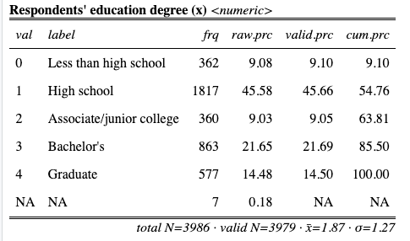
3. Screenshot of hashtag comment (20 points): | 