SAMPLE RStudio lab assignment: keyboard shortcuts and scripting

General instructions
In this assignment, (1) you will practice keyboard and mouse shortcuts, and (2) you will be pasting screenshots of two tables and two figures generated in RStudio into this document.
- Copy-paste-undo exercise (5 points)
  - Copy: Windows: `ctrl` + `C` | macOS: `cmd` + `C`
  - Paste: Windows: `ctrl` + `V` | macOS: `cmd` + `V`
  - Undo: Windows: `ctrl` + `Z` | macOS: `cmd` + `Z`
Instruction | cell A | cell B
Double-click on tiger (cell A), copy, click on cell B, and paste  This will copy “tiger” and paste it to cell B. | tiger | tiger
Double-click on elephant (cell A), copy, click on cell B, and paste  This will copy “elephant” and paste it to cell B. | elephant | elephant
Triple-click on lion giraffe (cell A), copy, click on cell B, and paste  This will copy the entire line and paste it to cell B. | lion giraffe | lion giraffe
Triple-click on owl duck (cell A), copy, click on cell B, and paste  This will copy the entire line and paste it to cell B. | owl duck | owl duck
Do the same above, but for some reason you changed your mind. Undo. | whale bat

- Triple click exercise (10 points)
When there is a single line code, we triple click (clicking three times really fast).
Triple click on the codes below, copy and paste in the box (“Paste here”)
  - Triple click 1
descr(gss$age, out = "v", show = "short")
Paste here (2.5 points) | descr(gss$age, out = "v", show = "short")
  - Triple click 2
sjt.xtab(gss$marital, gss$born, show.row.prc = TRUE)
Paste here (2.5 points) | sjt.xtab(gss$marital, gss$born, show.row.prc = TRUE)
  - Triple click 3
plot_frq(gss$marital, type = "bar", geom.colors = "#336699")
Paste here (2.5 points) | plot_frq(gss$marital, type = "bar", geom.colors = "#336699")
  - Triple click 4
frq(gss$sex, out="v")
Paste here (2.5 points) | frq(gss$sex, out="v")

- Changing variables exercise (5 points)
You will NEVER type the variable names. Instead replace the variable names by copying and pasting.
  - Double click on “conrinc” below and copy. Then, double click on “variablehere” in the box and paste.
Variable: conrinc
(2.5 points) | descr(gss$conrinc, out = "v", show = "short")
  - Double click on “educ” below and copy. Then, double click on “variablehere” in the box and paste.
Variable: educ
(2.5 points) | descr(gss$educ, out = "v", show = "short")

- Highlighting exercise (5 points)
When there are multiple lines of codes, we do not triple click but highlight all the lines with a mouse/trackpad. Make sure you highlight all the lines and do not leave any letter or character out.
Highlight the codes below, copy and paste in the box (“Paste here”).
gss$satjobreversed <-
rec(gss$satjob, rec =
"1 = 4 [Very satisfied];
2 = 3 [Moderately satisfied];
3 = 2 [A little dissatisfied];
4 = 1 [Very dissatisfied]",
var.label = "Recoded level of work satisfaction")
Paste here (2.5 points): | gss$satjobreversed <-  rec(gss$satjob, rec =  "1 = 4 [Very satisfied];  2 = 3 [Moderately satisfied];  3 = 2 [A little dissatisfied];  4 = 1 [Very dissatisfied]",  var.label = "Recoded level of work satisfaction")
tab_corr (gss[c("hrs1", "sibs")],
p.numeric = T, triangle="lower")
Paste here (2.5 points): | tab_corr (gss[c("hrs1", "sibs")],  p.numeric = T, triangle="lower")

For the following questions, you will practice your scripting and using model codes and working code skills. You will work under “# WORKING SPACE” and “# Assignment” in this lecture’s R script file.
- Frequency table of marital variable (10 points)
- Search in the site: Windows: `ctrl` + `K` | macOS: `cmd` + `K`
  - Type and hit “enter”: Frequency table #code
- Create your model code and working code
  - The variable name: marital
- Highlight your working code and click “Run” on Rstudio
Code (-5): | frq(gss$marital, out = "v")
Table (10 points): | 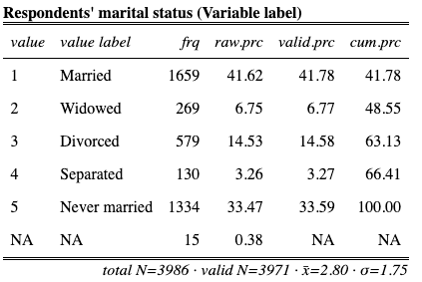
- Bar graph of marital variable (10 points)
- Search in the site: Windows: `ctrl` + `K` | macOS: `cmd` + `K`
  - Type and hit “enter”: Bar graph #code
- Create your model code and working code
  - The variable name: marital
- Highlight your working code and click “Run” on RStudio
Code (-5): | plot_frq(gss$marital,  type = "bar",  geom.colors = "#336699")
Graph (10 points): | 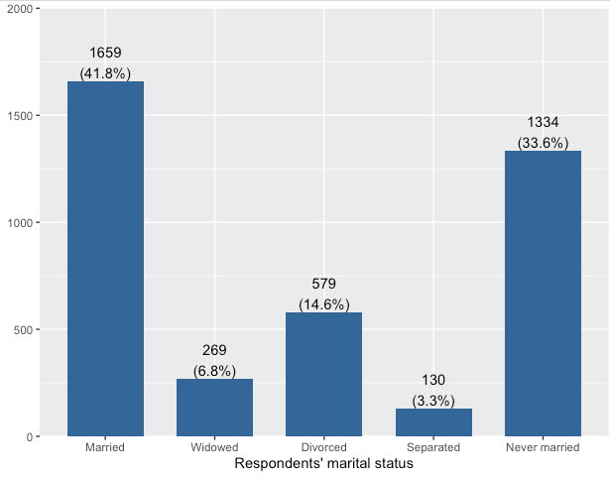
- Descriptive table of sei10 variable (10 points)
- Search in the site: Windows: `ctrl` + `K` | macOS: `cmd` + `K`
  - Type and hit “enter”: Descriptive table #code
- Create your model code and working code
  - The variable name: sei10
- Highlight your working code and click “Run” on RStudio
Code (-5): | descr(gss$sei10, out = "v", show = "short")
Table (10 points): | 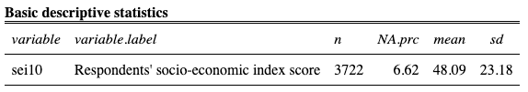
- Histogram of sei10 variable (10 points)
- Search in the site: Windows: `ctrl` + `K` | macOS: `cmd` + `K`
  - Type and hit “enter”: Histogram #code
- Create your model code and working code
  - The variable name: sei10
- Highlight your working code and click “Run” on RStudio
Code (-5): | plot_frq(gss$sei10,  type = "hist", normal.curve = T, show.mean = T, show.sd = T,  geom.colors = "#336699", normal.curve.color = "#9b2226")
Graph (10 points): | 