SAMPLE RStudio lab assignment: descriptive statistics

Assignment instructions
During this assignment, you will learn how to use [Variables in GSS] page, practice creating model codes and working codes skills, and interpreting outputs.
For each variable below, you will record the following details as seen in [Variables in GSS] page:
- Paste Table # and Table name,
- Paste variable name (do not type),
- Paste variable label,
- Paste variable type,
- Paste question wording and response categories,
- Paste the code you run for the question,
- Paste the output (table or graph depending on the question),
- Interpret the outputs.

Open [Variables in GSS] page:
- Search in the site: Windows: `ctrl` + `K` | macOS: `cmd` + `K`
  - Type and hit “enter”: Variables in GSS
  - Or use the link in the left navigation bar (Lab Resources)

Searching variables in [Variables in GSS] page:
- Search in the page: Windows: `ctrl` + `F` | macOS: `cmd` + `F`
- Frequency table of fear variable (10 points)
Find the fear variable in [Variables in GSS] page and fill out the table below.
Create a frequency table. Paste the code you used. Paste the output (take a screenshot of the output, not all screen) and interpret it.
1. Table # and Table name (-1): | Table 21. Miscellaneous
2. Variable name (-1 point): | fear
3. Variable label (-1 point): | Sense of neighborhood security
4. Variable type (-1 point): | Binary
5. Question wording and response categories (-1 point): | Is there any area right around here — that is, within a mile — where you would be afraid to walk alone at night?  (1: Yes; 2: No)
6. Code (-5): | frq(gss$fear, out = "v")
7. Output (10 points): | 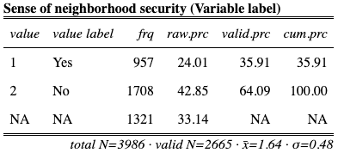
8. Interpretation (15 points): | The sense of neighborhood variable shows that 35.91% of the respondents are afraid to walk alone at night and 64.09% of the respondents are not afraid to walk alone at night.

- Bar graph of contv variable (10 points)
Find the contv variable in [Variables in GSS] page and fill out the table below.
Create a bar graph. Paste the code you used. Paste the output (take a screenshot of the output, not all screen) and interpret it.
1. Table # and Table name (-1): | Table 18. Confidence in institutions
2. Variable name (-1 point): | contv
3. Variable label (-1 point): | Confidence level in television
4. Variable type (-1 point): | Ordinal
5. Question wording and response categories (-1 point): | Would you say you have confidence in television?  (1: A great deal; 2: Only some; 3: Hardly any)
6. Code (-5): | plot_frq(gss$contv,  type = "bar",  geom.colors = "#336699")
7. Output (10 points): | 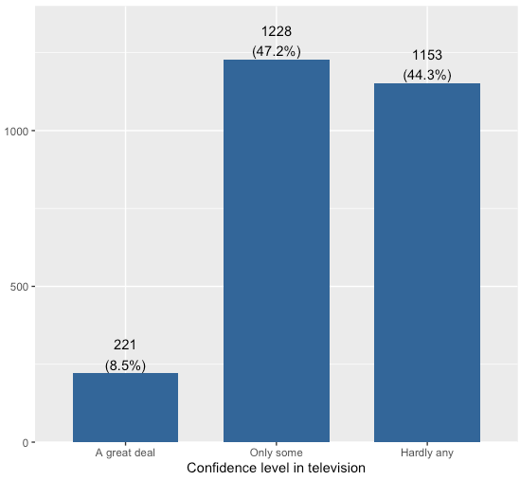
8. Interpretation (15 points): | The confidence level in television variable shows that 8.5% of the respondents have a great deal of confidence in television; 47.2% of the respondents have only some confidence in television, and 44.3% of the respondents have hardly any confidence in television.

- Descriptive table of weekswrk variable (10 points)
Find the weekswrk variable in [Variables in GSS] page and fill out the table below.
Create a descriptive table. Paste the code you used. Paste the output (take a screenshot of the output, not all screen) and interpret it.
1. Table # and Table name (-1): | Table 6. Work
2. Variable name (-1 point): | weekswrk
3. Variable label (-1 point): | Weeks respondents worked last year
4. Variable type (-1 point): | Continuous
5. Question wording and response categories (-1 point): | In the previous year how many weeks did you work either full-time or part-time not counting work around the house — including paid vacations and sick leave?  (Min: 0, Max: 52)
6. Code (-5): | descr(gss$weekswrk, out = "v", show = "short")
7. Output (10 points): | 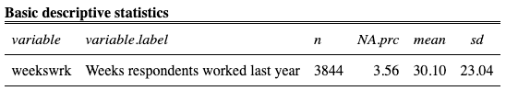
8. Interpretation (15 points): | The weeks respondents worked last year variable shows the average weeks respondents worked last year of the respondents is 30.10, with standard deviation 23.04.

- Histogram graph of maeduc variable (10 points)
Find the maeduc variable in [Variables in GSS] page and fill out the table below.
Create a histogram graph. Paste the code you used. Paste the output (take a screenshot of the output, not all screen) and interpret it.
1. Table # and Table name (-1): | Table 3. Respondents' parents and adolescence years
2. Variable name (-1 point): | maeduc
3. Variable label (-1 point): | Respondents' mothers' education in years
4. Variable type (-1 point): | Continuous
5. Question wording and response categories (-1 point): | What is the highest year of school your mother completed?  (Min: 0, Max: 20)
6. Code (-5): | plot_frq(gss$maeduc,  type = "hist", normal.curve = T, show.mean = T, show.sd = T,  geom.colors = "#336699", normal.curve.color = "#9b2226")
7. Output (10 points): | 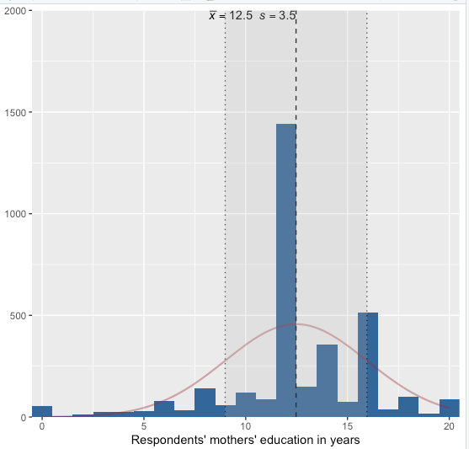
8. Interpretation (15 points): | The respondents' mothers' education in years variable shows the average years of education of respondents’ mothers' is 12.5, with standard deviation 3.5.

