SAMPLE RStudio lab assignment: recoding

Task 2
- Recoding 1 (merging values)
Fill out the table for the “spanking” variable (from 1-4). You will recode this variable by applying the “merging values” procedure.
Recoded (new) variable name will be: spankingrecoded
1 and 2 will be 1 Value label: [Agree]
3 and 4 will be 2 Value label: [Disagree]
After recoding, you will create a frequency table for the recoded (new) variable. Paste the code you used for recording. Paste the code you used for the frequency table for the recoded (new) variable, paste the frequency table (take a screenshot of the table, not all screen) and interpret the table.
1. Variable name (-1 point): | spanking
2. Variable label (-1 point): | Favoring spanking children to discipline
3. Variable type (-1 point): | Ordinal
4. Question wording and response categories (-1 point): | Do you strongly agree, agree, disagree, or strongly disagree that it is sometimes necessary to discipline a child with a good, hard spanking?  (1: Strongly agree; 2: Agree; 3: Disagree; 4: Strongly disagree)
5. Recoding code (-5): | gss$spankingrecoded <-  rec(gss$spanking, rec =  "1, 2 = 1 [Agree];  3, 4 = 2 [Disagree]",  var.label = "Recoded favoring spanking children to discipline")
6. Frequency table code (-5): | frq(gss$spankingrecoded, out = "v")
7. Output (10 points): | 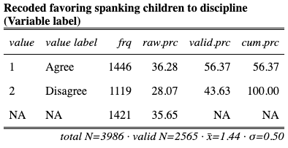
8. Interpretation (10 points): | The recoded favoring spanking children to discipline variable shows that 56.37% of the respondents agree with spanking children to discipline; 43.63% of the respondents disagree with spanking children to discipline.

- Recoding 2 (reversing values)
Fill out the table for the “natenrgy” variable (from 1-4). You will recode this variable by applying the “(2) reversing values” procedure.
Recoded (new) variable name will be: natenrgyreversed
1 will be 3 Value label: [Too much]
2 will be 2 Value label: [About right]
3 will be 1 Value label: [Too little]

After recoding, you will create a frequency table for the recoded (new) variable. Paste the code you used for recording. Paste the code you used for the frequency table for the recoded (new) variable, paste the frequency table (take a screenshot of the table, not all screen) and interpret the table.
1. Variable name (-1 point): | natenrgy
2. Variable label (-1 point): | Support level for government spending for developing alternative energy sources
3. Variable type (-1 point): | Ordinal
4. Question wording and response categories (-1 point): | Are we spending too much money, too little money, or about the right amount on developing alternative energy sources?  (1: Too little; 2: About right; 3: Too much)
5. Recoding code (-5): | gss$natenrgyreversed <-  rec(gss$natenrgy, rec =  "1 = 3 [Too much];  2 = 2 [About right];  3 = 1 [Too little]",  var.label = "Recoded support level for government spending for developing alternative energy sources")
6. Frequency table code (-5): | frq(gss$natenrgyreversed, out = "v")
7. Output (10 points): | 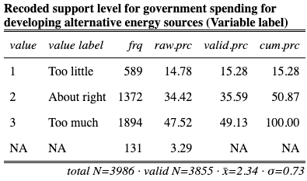
8. Interpretation (15 points): | The recoded support level for government spending for developing alternative energy sources variable shows that 15.28% of the respondents think we spent too little; 35.59% of the respondents think we spent about right, and 49.13% of the respondents think we spent too much on developing alternative energy sources.

- Recoding 3 (transforming continuous variables into groups)
Fill out the table for the “weekswrk” variable (from 1-4). You will recode this variable by applying the (3) “transforming continuous variables into groups” procedure.
Recoded (new) variable name will be: weekswrkgroups
from 0 to 10 will be 1 Value label: [Worked less than 10 weeks]
from 11 to 40 will be 1 Value label: [Worked between 10 and 40 weeks]
from 41 to 52 will be 2 Value label: [Worked more than 40 weeks]
After recoding, you will create a frequency table for the recoded (new) variable. Paste the code you used for recording. Paste the code you used for the frequency table for the recoded (new) variable, paste the frequency table (take a screenshot of the table, not all screen) and interpret the table.
1. Variable name (-1 point): | weekswrk
2. Variable label (-1 point): | Weeks respondents worked last year
3. Variable type (-1 point): | Continuous
4. Question wording and response categories (-1 point): | In the previous year how many weeks did you work either full-time or part-time not counting work around the house — including paid vacations and sick leave?  (Min: 0, Max: 52)
5. Recoding code (-5): | gss$weekswrkgroups <-  rec(gss$weekswrk, rec =  "0 : 10 = 1 [Worked less than 10 weeks];  11 : 40 = 2 [Worked between 10 and 40 weeks];  41 : 52 = 3 [Worked more than 40 weeks]",  var.label = "Recoded weeks respondents worked last year")
6. Frequency table code (-5): | frq(gss$weekswrkgroups, out = "v")
7. Output (10 points): | 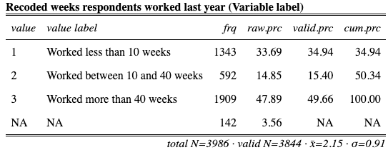
8. Interpretation (15 points): | The recoded weeks respondents worked last year variable shows that 34.94% of the respondents worked less than 10 weeks; 15.40% of the respondents worked between 10 and 40 weeks, and 49.66% of the respondents worked more than 40 weeks.

