SAMPLE RStudio lab assignment: computing

Assignment instructions
There are two tasks in this assignment:
Task 1: Learning three most common computing issues and troubleshooting in RStudio (15 points).
Task 2: Practicing computing skills (85 points).

Task 2
- Frequency table of relpersn variable
Find the relpersn variable in [Variables in GSS] page and fill out the table below.
Create a frequency table. Paste the code you used. Paste the output (take a screenshot of the output, not all screen) and interpret it.
1. Variable name (-1 point): | relpersn
2. Variable label (-1 point): | Subjective religiosity
3. Variable type (-1 point): | Ordinal
4. Question wording and response categories (-1 point): | To what extent do you consider yourself a religious person?  (1: Very religious; 2: Moderately religious; 3: Slightly religious; 4: Not religious at all)
5. Code (-5): | frq(gss$relpersn, out = "v")
6. Output (10 points): | 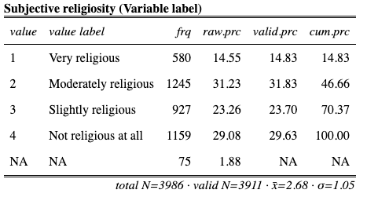
7. Interpretation (15 points): | The subjective religiosity variable shows that 14.83% of the respondents are very religious; 31.83% of the respondents are moderately religious; 23.70% of the respondents are slightly religious; 29.63% of the respondents are not religious at all.

- Frequency table of sprtprsn variable
Find the sprtprsn variable in [Variables in GSS] page and fill out the table below.
Create a frequency table. Paste the code you used. Paste the output (take a screenshot of the output, not all screen) and interpret it.
1. Variable name (-1 point): | sprtprsn
2. Variable label (-1 point): | Level of spirituality
3. Variable type (-1 point): | Ordinal
4. Question wording and response categories (-1 point): | To what extent do you consider yourself a spiritual person?  (1: Very spiritual; 2: Moderately spiritual; 3: Slightly spiritual; 4: Not spiritual at all)
5. Code (-5): | frq(gss$sprtprsn, out = "v")
6. Output (10 points): | 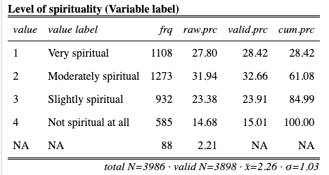
7. Interpretation (15 points): | The level of spirituality variable shows that 28.42% of the respondents are very spiritual; 32.66% of the respondents are moderately spiritual; 23.91% of the respondents are slightly spiritual, and 15.01% of the respondents are not spiritual at all.
- Recode the variables
Recode the responses of these variables one by one.
- 1 will be 4 Value label: [Very religious] Value label: [Very spiritual]
- 2 will be 3 Value label: [Moderately religious] Value label: [Moderately spiritual]
- 3 will be 2 Value label: [Slightly religious] Value label: [Slightly spiritual]
- 4 will be 1 Value label: [Not religious at all] Value label: [Not spiritual at all]
The new variable names will be relpersnreversed and sprtprsnreversed respectively. You will recode these variables by applying the “(2) reversing values” procedure.
Code (-5): | gss$relpersnreversed <-  rec(gss$relpersn, rec =  "1 = 4 [Very religious];  2 = 3 [Moderately religious];  3 = 2 [Slightly religious];  4 = 1 [Not religious at all]",  var.label = "Recoded subjective religiosity")  gss$sprtprsnreversed <-  rec(gss$sprtprsn, rec =  "1 = 4 [Very spiritual];  2 = 3 [Moderately spiritual];  3 = 2 [Slightly spiritual];  4 = 1 [Not spiritual at all]",  var.label = "Recoded level of spirituality")
- Compute the index variable
Create an index variable using relpersnreversed and sprtprsnreversed.
The name of the new variable will be relspiindex (Variable label: The religiosity and spirituality index score).
Code (-5): | gss$relspiindex <- structure(rowMeans(  gss[, c("relpersnreversed", "sprtprsnreversed")]),  label = "The religiosity and spirituality index score")
- Descriptive table of relspiindex variable
Create a descriptive table. Paste the code you used. Paste the output (take a screenshot of the output, not all screen) and interpret it.
1. Code (-5): | descr(gss$relspiindex, out = "v", show = "short")
2. Table (25 points): | 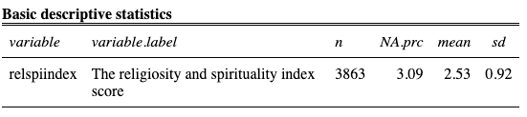
3.Interpretation (30 points): | The religiosity and spirituality index score of the respondents is 2.53 out of 4, with standard deviation 0.92.

