RStudio lab assignment: chi-square

Assignment instructions
- Chi-square1: Find the factor variable
Find the race variable in [Variables in GSS] page and fill out the table below.
1. Variable name (-1 point): | race
2. Variable label (-1 point): | Respondents' race
3. Variable type (-1 point): | Nominal
4. Question wording and response categories (-1 point): | What's your race?  (1: White; 2: Black; 3: Other)
- Chi-square1: Find the outcome variable
Find the satfin variable in [Variables in GSS] page and fill out the table below.
1. Variable name (-1 point): | satfin
2. Variable label (-1 point): | Level of financial satisfaction
3. Variable type (-1 point): | Ordinal
4. Question wording and response categories (-1 point): | So far as you and your family are concerned, how satisfied are you with your present financial situation?  (1: Pretty well satisfied; 2: More or less satisfied; 3: Not satisfied at all)

- Chi-square1: Chi-square analysis
1. Code (-5): | sjt.xtab(gss$race, gss$satfin, show.row.prc = TRUE)
2. Output (20 points): | 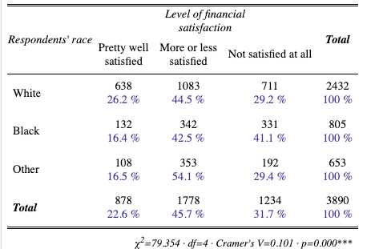
3. Interpretation (30 points): | The respondents' race variable has an effect on the level of financial satisfaction since the p-value is less than 0.05.  We can conclude that White, Black, and Other race respondents have substantially different level of financial satisfaction.

- Chi-square2: Find the factor variable
Find the sex variable in [Variables in GSS] page and fill out the table below.
1. Variable name (-1 point): | sex
2. Variable label (-1 point): | Respondents' sex
3. Variable type (-1 point): | Binary
4. Question wording and response categories (-1 point): | What's your sex?  (1: Male; 2: Female)
- Chi-square2: Find the outcome variable
Find the parsol [Variables in GSS] page and fill out the table below.
1. Variable name (-1 point): | parsol
2. Variable label (-1 point): | Level of higher living standard compared to parents
3. Variable type (-1 point): | Ordinal
4. Question wording and response categories (-1 point): | Compared to your parents when they were the age you are now, do you think your own standard of living now is much better, somewhat better, about the same, somewhat worse, or much worse than theirs was?  (1: Much better; 2: Somewhat better; 3: About the same; 4: Somewhat worse; 5: Much worse)

- Chi-square2: Chi-square analysis
1. Code (-5): | sjt.xtab(gss$sex, gss$parsol, show.row.prc = TRUE)
2. Output (20 points): | 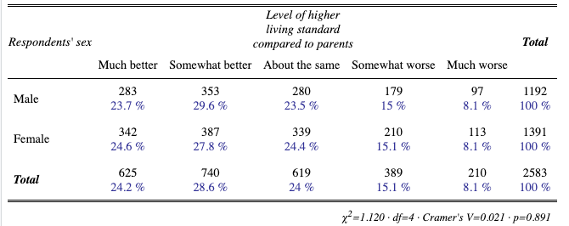
3. Interpretation (30 points): | The respondents' sex variable has no effect on the level of higher living standard compared to parents since the p-value is greater than 0.05.  We can conclude that males and females have similar perception about the level of higher living standard compared to parents.

