SAMPLE RStudio lab assignment: sampling

Assignment instructions
In this assignment, you will compare different kinds of samples from GSS.
To compare the different samples, you will use the means for the socio-economic status score (sei10).
Specifically, you will compare the overall sample mean (all GSS respondents) to various kinds of samples of the GSS data, including non-random, 30% simple random, and 20% systematic random samples.
Since different kinds of samples have different degrees of sampling error, the means from different kinds of samples will also differ. In this assignment, you will interpret means from different samples to see if samples with larger potential errors yield means that are very different from the GSS sample mean.
Throughout this assignment, consider “substantially different” if the socio-economic status score differs by more than 1 point score.

- GSS overall sample
Create a descriptive table for sei10. Paste (5 points) and interpret the table (5 points).
Code (-5): | descr(gss$sei10, out = "v", show = "short")
Table: | 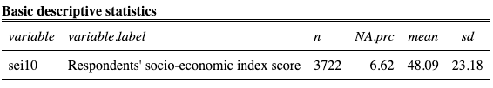
Interpretation: | The respondents' socio-economic index score variable shows that the average socio-economic index score is 48.09, with standard deviation 23.18.

- GSS overall sample vs. 40% non-random sampling
  - Create the descriptive table of sei10 using the 40% non-random sampling in the GSS sample. Paste the table (10 points).
1. Code (-5) | gssfirst40per <- head(gss, round(0.40 * nrow(gss)))
2. Code (-5): | descr(gssfirst40per$sei10, out = "v", show = "short")
Table: | 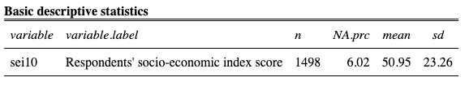
  - Throughout this assignment, consider “substantially different” if mean scores of sei10 differ by more than 1 point score.
Interpretation: | 2.2.1) Check your interpretations for question 1 and question 2.1. Discuss the mean scores. When comparing the overall mean to the mean computed from the 40% non-random sample of GSS data file, are the mean scores substantially different? Use full sentences. (10 points).  The overall socio-economic index score mean among GSS respondents is 48.09, while the socio-economic index score mean with a 40% non-random sample is 50.95. In this case since the mean socio-economic index score differ by more than 1 point, we can conclude that these mean socio-economic index scores are substantially different.  2.2.2) Is a non-random sample preferable method for obtaining generalizable results? Why or why not? Use full sentences (10 points). Interpret in your own words, do not copy and paste from the modules page.  Your answer here…

- GSS overall sample vs. 30% simple random sampling.
  - Create the descriptive table of sei10 using the 30% simple random sample of the GSS. Paste the table (10 points).
1. Code (-5) | gssrandom30per <- gss[sample(nrow(gss), round(0.30 * nrow(gss))), ]
2. Code (-5): | descr(gssrandom30per$sei10, out = "v", show = "short")
Table: | 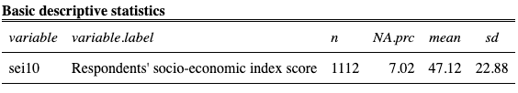
  - Throughout this assignment, consider “substantially different” if mean scores of sei10 differ by more than 1 point score.
Interpretation: | 3.2.1) Check your interpretations for question 1 and question 3.1. Discuss the mean scores. When comparing the overall mean to the mean computed from the 30% simple random sample of the GSS, are the mean scores substantially different? Use full sentences (10 points).  The overall socio-economic index score mean among GSS respondents is 48.09, while the socio-economic index score mean with a 30% simple random sample is 47.12. In this case since the mean socio-economic index scores do not differ by more than 1 point, we can conclude that these mean socio-economic index scores are not substantially different.  3.2.2) Is a 25% simple random sample preferable to a non-random sample? Why or why not? Use full sentences. (10 points). Interpret in your own words, do not copy and paste from the modules page.  Your answer here…

- GSS overall sample vs. 20% systematic random sampling.
  - Create the descriptive table of sei10 using the 20% systematic random sample of the GSS. Paste the table (10 points).
1. Code (-5) | gss20persystematic <- gss[seq(4, nrow(gss), 5), ]
2. Code (-5): | descr(gss20persystematic$sei10, out = "v", show = "short")
Table: | 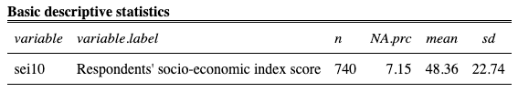
  - Throughout this assignment, consider “substantially different” if mean scores of sei10 differ by more than 1 point score.
Interpretation: | 4.2.1) Check your interpretations for question 1 and question 4.1. Discuss the mean scores. When comparing the overall mean to the mean computed from the 20% systematic random sample, are the mean scores substantially different? Use full sentences (10 points).  The overall socio-economic index score mean among GSS respondents is 48.09, while the socio-economic index score mean with a 20% systematic random sample is 48.36. In this case since the mean socio-economic index scores do not differ by more than 1 point, we can conclude that these mean socio-economic index scores are not substantially different.  4.2.2) Is a 20% systematic random sample preferable to a 30% simple random sample? Why or why not? Use full sentences (10 points). Interpret in your own words, do not copy and paste from the modules page.  Your answer here…

