SAMPLE RStudio lab assignment: visualization

Assignment instructions
In this assignment, you will follow the procedures for visualizing different graphs.

- Create a stacked bar graph for multiple variables
Use the following variables: are we spending too much, too little, or about right money on natsci (scientific research), nateduc (nation's education system), natspac (space exploration).
Change the title of the graph to Attitudes on government expenditure for science
- change font size of x-axis labels to 10
- change font size of y-axis labels to 10
- change font size of plot title to 12
- change font size of legend to 10
Interpret the percentages of “too little.” [graph: 5 points; interpretation: 3 points - interpret “too little” category; title changed: 3 points; font sizes changed: 4 points]
Code (-5): | graph <- gss |>  select(natsci, nateduc, natspac) |>  plot_stackfrq(sort.frq = "first.asc", geom.colors = "Blues",  show.total = FALSE, title = "Attitudes on government expenditure for science")  graph + theme(  axis.text.x = element_text(size=10),  axis.text.y = element_text(size=10),  plot.title = element_text(size=12),  legend.text = element_text(size=10))
Graph: | 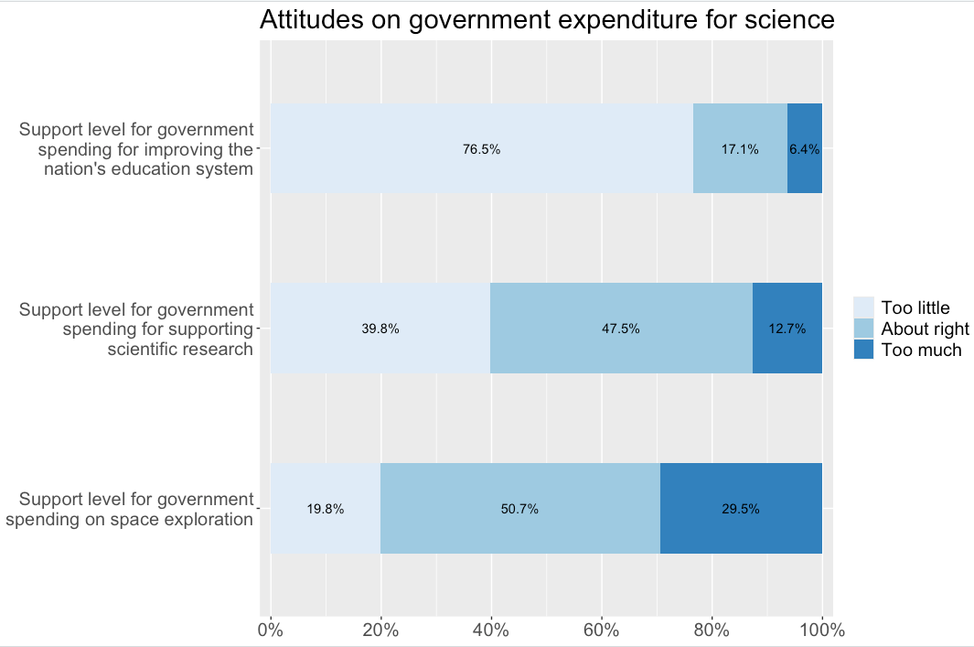
Interpretation: | Of the GSS respondents, 76.5% think we spend too little on nation’s education system; 39.8% think we spend too little on scientific research; 19.8% think we spend too little on space exploration.

- Create a stacked bar graph by different groups
Create a stacked bar graph by different groups by using nateduc (outcome variable) and degree (factor variable).
Change the title of the graph to Support level for government spending for improving the nation's education system by respondents' education degree
- change font size of x-axis labels to 11
- change font size of y-axis labels to 11
- change font size of plot title to 13
- change font size of legend to 12
Interpret the percentages of “high school.” [graph: 5 points; interpretation: 3 points - interpret “high school” category; title changed: 3 points; font sizes changed: 4 points]

Code (-5): | graph <- gss |>  select(natsci, nateduc, natspac) |>  plot_stackfrq(sort.frq = "first.asc", geom.colors = "Blues",  show.total = FALSE, title = "Attitudes on government expenditure for science")  graph + theme(  axis.text.x = element_text(size=11),  axis.text.y = element_text(size=11),  plot.title = element_text(size=13),  legend.text = element_text(size=12))
Graph: | 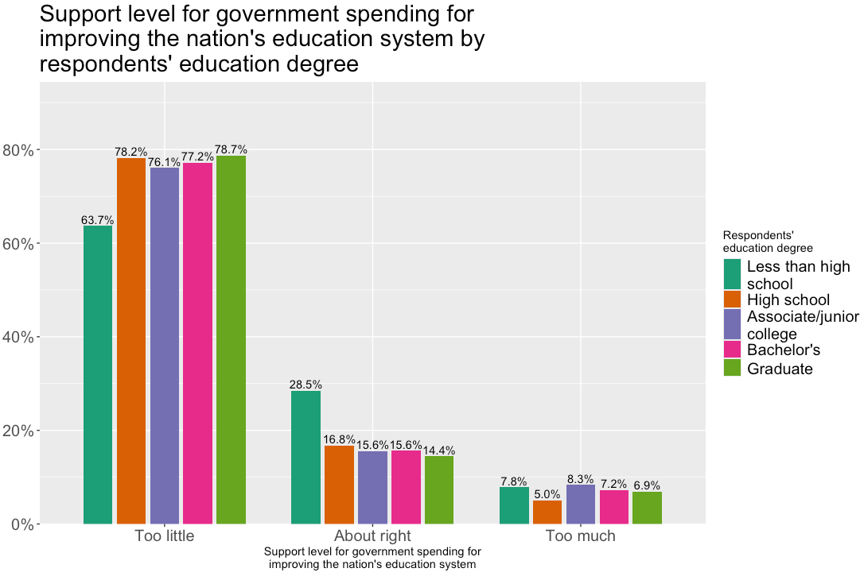
Interpretation: | Of the GSS respondents, 78.2% of those who think we spend too little on nation’s education system, 16.8% of those who think we spend about right on nation’s education system, and 5% of those who think we spend too much on nation’s education system have a high school degree.

