SAMPLE RStudio lab assignment: correlation

Assignment instructions
- Create a correlation analysis table using conrinc and tvhours variables (5 points) and interpret it using r-value and p-value (10 points).
Code (-5): | tab_corr (gss[c("conrinc", "tvhours")],  p.numeric = T, triangle="lower")
Table: | 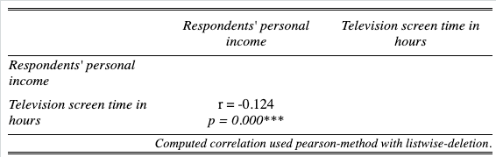
Interpretation: | There is a significant correlation between respondents' personal income and the television screen time in hours since the p-value is less than .05.  This correlation is negative and weak since the r-value is -0.124 (less than |0.3|).  This means that as respondents' personal income increases the television screen time in hours decreases, and vice versa.
- Create a correlation scatterplot graph using conrinc and tvhours variables (5 points).
Code (-5): | scatterplot(gss, "conrinc", "tvhours")
Graph: | 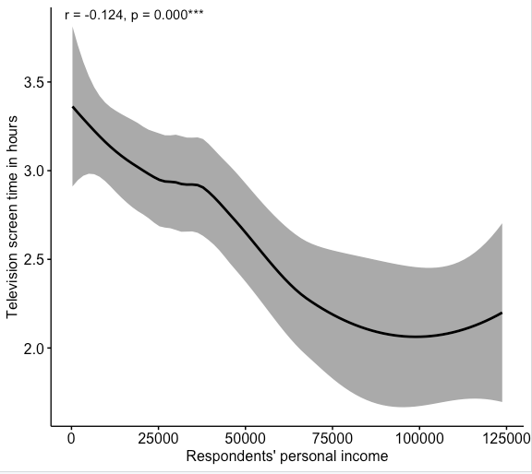
- Create a correlation analysis table using maeduc and paeduc variables (5 points) and interpret it using r-value and p-value (10 points).
Code (-5): | tab_corr (gss[c("maeduc", "paeduc")],  p.numeric = T, triangle="lower")
Table: | 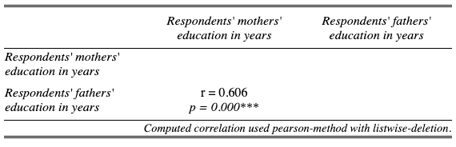
Interpretation: | There is a significant correlation between respondents' mothers’ education in years and respondents' fathers’ education in years since the p-value is less than .05.  This correlation is positive and strong since the r-value is 0.606 (higher than |0.5|).  This means that respondents' mothers’ education in years and respondents' fathers’ education in years increase and decrease together.
- Create a correlation scatterplot graph using maeduc and paeduc variables (5 points).
Code (-5): | scatterplot(gss, "maeduc", "paeduc")
Graph: | 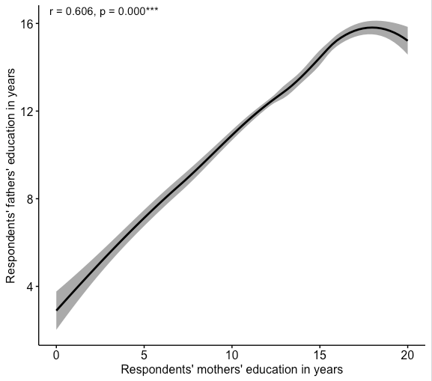

- Create a correlation table matrix using conrinc, tvhours, maeduc, childs, paeduc, age, and sei10 variables (10 points)
  - interpret the correlation between maeduc and tvhours variables (5 points).
  - interpret the correlation between age and paeduc variables (5 points).
Code (-5): | tab_corr (gss[, c("conrinc", "tvhours", "maeduc", "paeduc", "age", "sei10")],  p.numeric = T, triangle="lower", na.deletion = "pairwise")
Table: | 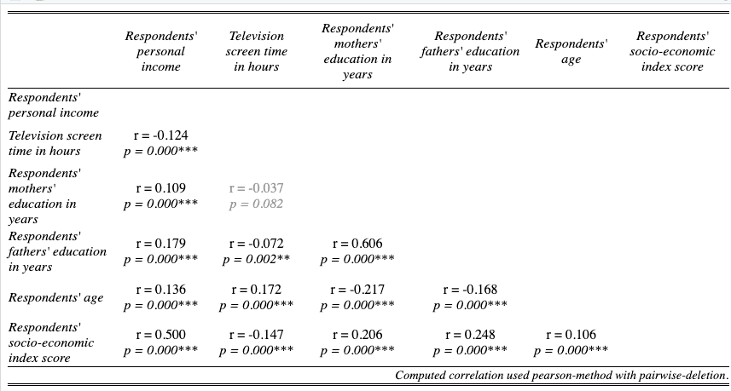
Interpretation (maeduc and tvhours): | There is a no significant correlation between the respondents' mothers’ education in years and the television screen time in hours since the p-value is greater than .05.  This means that the the respondents' mothers’ education in years and the television screen time in hours are not related.
Interpretation (age and paeduc): | There is a significant correlation between respondents' age and respondents' fathers’ education in years since the p-value is less than .05.  This correlation is negative and weak since the r-value is -0.168 (less than |0.3|).  This means that as respondents' age increases respondents' fathers’ education in , and vice versa.

- Create a scatterplot graph matrix using conrinc, tvhours, maeduc, childs, paeduc, age, and sei10 variables (15 points)
Code (-5): | scatterplot_matrix <- gss[, c("conrinc", "tvhours", "maeduc", "paeduc", "age", "sei10")]  pairs_panels_pval(scatterplot_matrix, color = "#15616d")
Graph: | 