SAMPLE RStudio lab assignment: linear regression basics

Assignment instructions
The following are the variables to use in this assignment. You will use the information below the model in the final question (interpretation).
Variable name | Variable label | Variable type | Question wording and response categories
sei10 | Respondents' socio-economic index score | Continuous | Socio-economic index score of the respondent (calculated)  (Min: 9, Max: 92.8)
age | Respondents' age | Continuous | What is your age?  (Min: 18, Max: 89)
educ | Respondents' education in years | Continuous | What is the highest year of school you completed?  (Min: 0, Max: 20)
prestg10 | Respondents' occupational prestige score | Continuous | Respondent’s occupational prestige score (calculated)  (Min: 16, Max: 80)
class | Respondents' subjective class identification | Ordinal | If you were asked to use one of four names for your social class, which would you say you belong in?  (1: Lower class; 2: Working class; 3: Middle class; 4: Upper class)

- Run a linear regression model (model 1) using:
- Outcome variable: sei10
- Factor variable 1: age
Code (-5): | model1 <- lm(sei10 ~ age, data = gss)  tab_model(model1, show.std = T, show.ci = F, collapse.se = T)
Table (5 points): | 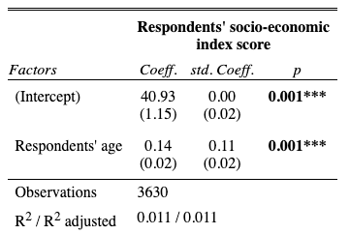
- Run a linear regression model (model 2) using:
- Outcome variable: sei10
- Factor variable 1: age
- Factor variable 2: educ
Code (-5): | model2 <- lm(sei10 ~ age + educ, data = gss)  tab_model(model2, show.std = T, show.ci = F, collapse.se = T)
Table (5 points): | 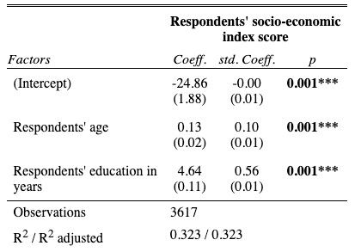
- Run a linear regression model (model 3) using:
- Outcome variable: sei10
- Factor variable 1: age
- Factor variable 2: educ
- Factor variable 3: prestg10
Code (-5): | model3 <- lm(sei10 ~ age + educ + prestg10, data = gss)  tab_model(model3, show.std = T, show.ci = F, collapse.se = T)
Table (5 points): | 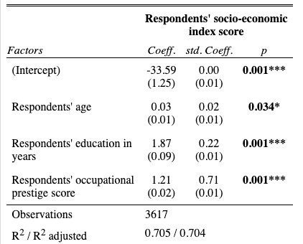
- Run a linear regression model (model 4) using:
- Outcome variable: sei10
- Factor variable 1: age
- Factor variable 2: educ
- Factor variable 3: prestg10
- Factor variable 4: class
Code (-5): | model4 <- lm(sei10 ~ age + educ + prestg10 + class, data = gss)  tab_model(model4, show.std = T, show.ci = F, collapse.se = T)
Table (20 points): | 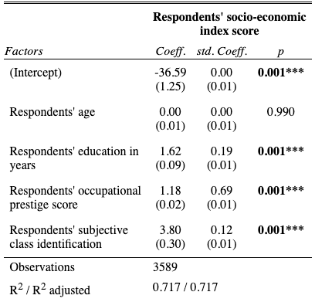
Interpretation (50 points): | First paragraph:  Respondents' education in years, respondents' occupational prestige score, and respondents' subjective class identification are statistically significant predictors of respondents’ socio-economic index score since the p values are less than 0.05. Respondents’ age is not a statistically significant predictor of socio-economic index score since the p value is greater than 0.05.  Second paragraph:  A year increase in respondents' education increases respondents’ socio-economic index score by 1.62 points. One unit increase in occupational prestige score increases respondents’ socio-economic index score by 1.18 points. One unit increase in respondents' subjective class identification increases socio-economic index score by 0.12 points.  Third paragraph:  The strongest predictor of respondents’ socio-economic index score is occupational prestige score (std.Coeff=0.69), followed by respondents' education in years (std.Coeff=0.19), and respondents' subjective class identification (std.Coeff=0.12).  Fourth paragraph:  The adjusted R squared value indicates that 71.7% of the variation in respondents’ socio-economic index score can be explained by the occupational prestige score, respondents' education in years, and respondents' subjective class identification.

