SAMPLE RStudio lab assignment: dummy variables

Assignment instructions
In this assignment, you will be creating dummy variables and adding them to the model you generated during the RStudio lab assignment linear regression basics assignment.
The following are the variables to use in this assignment. You will use the information below the model in the final question (interpretation).
Variable name | Variable label | Variable type | Question wording and response categories
sei10 | Respondents' socio-economic index score | Continuous | Socio-economic index score of the respondent (calculated)  (Min: 9, Max: 92.8)
age | Respondents' age | Continuous | What is your age?  (Min: 18, Max: 89)
educ | Respondents' education in years | Continuous | What is the highest year of school you completed?  (Min: 0, Max: 20)
prestg10 | Respondents' occupational prestige score | Continuous | Respondent’s occupational prestige score (calculated)  (Min: 16, Max: 80)
class | Respondents' subjective class identification | Ordinal | If you were asked to use one of four names for your social class, which would you say you belong in?  (1: Lower class; 2: Working class; 3: Middle class; 4: Upper class)
compuse | Use of computer | Binary | Do you personally ever use a computer at home, at work, or at some other location?  (1: Yes; 2: No)
satjob | Level of work satisfaction | Ordinal | On the whole, how satisfied are you with the work you do?  (1: Very satisfied; 2: Moderately satisfied; 3: A little dissatisfied; 4: Very dissatisfied)
coninc | Respondents' family income | Continuous | What is your family income in dollars?  (Min: $281.5, Max: $139,024.4)

- Paste the code, table, and interpretation of the fourth model (the last model) from the RStudio lab assignment linear regression basics.
Code (-5): | model4 <- lm(sei10 ~ age + educ + prestg10 + class, data = gss)  tab_model(model4, show.std = T, show.ci = F, collapse.se = T)
Table (5 points): | 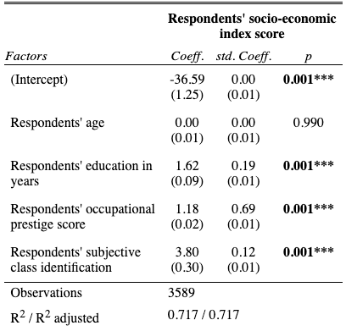
Interpretation (5 points): | First paragraph:  Respondents' education in years, respondents' occupational prestige score, and respondents' subjective class identification are statistically significant predictors of respondents’ socio-economic index score since the p values are less than 0.05.  Respondents’ age is not a statistically significant predictor of socio-economic index score since the p value is greater than 0.05.  Second paragraph:  A year increase in respondents' education increases respondents’ socio-economic index score by 1.62 points.  One unit increase in occupational prestige score increases respondents’ socio-economic index score by 1.18 points.  One unit increase in respondents' subjective class identification increases socio-economic index score by 0.12 points.  Third paragraph:  The strongest predictor of respondents’ socio-economic index score is occupational prestige score (std.Coeff=0.69), followed by respondents' education in years (std.Coeff=0.19), and respondents' subjective class identification (std.Coeff=0.12).  Fourth paragraph:  The adjusted R squared value indicates that 71.7% of the variation in respondents’ socio-economic index score can be explained by the occupational prestige score, respondents' education in years, and respondents' subjective class identification.
- Creating dummy variables 1
  - Create a frequency table of compuse. Paste the frequency table and interpret it.
Code (-5): | frq(gss$compuse, out = "v")
Table (5 points): | 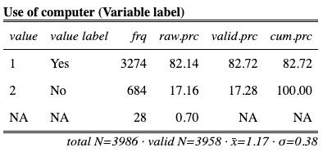
Interpretation (5 points): | The perceived change in financial situation variable shows that 29.70% of the respondents think their financial situation has gotten better; 31.80% of the respondents think their financial situation has gotten worse; and 38.50% of the respondents think their financial situation has stayed same better during the last few years.
  - Using the original variable of compuse, create two dummy variables.
- The name of the first dummy variable: usecomputer
  - The variable label: Using computer

- The name of the second dummy variable: nousecomputer
  - The variable label: Not using computer
    - This is the comparison dummy variable (omit this variable)
Code (-5): | gss$usecomputeratwork <-  ifelse(gss$compuse == 1, 1, 0,  label = "Using computer")
Code (-5): | gss$nousecomputeratwork <-  ifelse(gss$compuse == 2, 1, 0,  label = "Not using computer")
- Creating dummy variables 2
  - Create a frequency table of satjob. Paste the frequency table and interpret it.
Code (-5): | frq(gss$satjob, out = "v")
Table (5 points): | 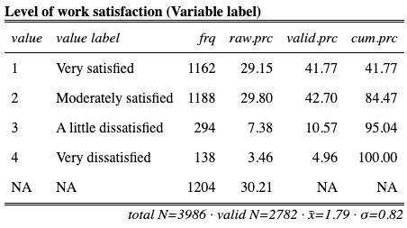
Interpretation (5 points): | The level of work satisfaction variable shows that 41.77% of the respondents are very satisfied; 42.70% of the respondents are moderately satisfied; 10.57% of the respondents are a little dissatisfied; and 4.96% of the respondents are very dissatisfied with their work.
  - Using the original variable of satjob, create three dummy variables.
- The name of the first dummy variable: verysatisfied
  - No merging for this dummy variable
  - The variable label: Being very satisfied with work

- The name of the second dummy variable: moderatelysatisfied
  - No merging for this dummy variable
  - The variable label: Being moderately satisfied with work

- The name of the third dummy variable: notsatisfied
  - Merge “a little dissatisfied” and “very dissatisfied” values for this dummy variable
  - The variable label: Being dissatisfied with work
    - This is the comparison dummy variable (omit this variable)
Code (-5): | gss$verysatisfied <-  ifelse(gss$satjob == 1, 1, 0,  label = "Being very satisfied with work")
Code (-5): | gss$moderatelysatisfied <-  ifelse(gss$satjob == 2, 1, 0,  label = "Being moderately satisfied with work")
Code (-5): | gss$dissatisfied <-  ifelse(gss$satjob == 3 | gss$satjob == 4, 1, 0,  label = "Being dissatisfied with work")
- Creating dummy variables 3
  - Create a descriptive table of conrinc. Paste the descriptive table and interpret it.
Code (-5): | descr(gss$conrinc, out = "v", show = "short")
Table (5 points): | 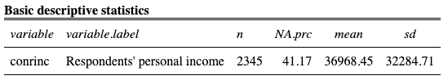
Interpretation (5 points): | The respondents' personal income variable shows that the average personal income is $36,968, with standard deviation $32,284.
  - Using the original variable of conrinc, create three dummy variables.
- The name of the first dummy variable: lowfamincome
  - This dummy variable will include those whose family income is less than 30000 dollars.
  - The variable label: Having low family income

- The name of the second dummy variable: mediumfamincome
  - This dummy variable will include those whose family income is more than 30001 dollars and less than 70000
  - The variable label: Having medium family income

- The name of the third dummy variable: highfamincome
  - This dummy variable will include those whose family income is more than 70001 dollars
  - The variable label: Having high family income
    - This is the comparison dummy variable (omit this variable)
Code (-5): | gss$lowfamincome <-  ifelse(gss$conrinc <= 30000, 1, 0,  label = "Having low family income")
Code (-5): | gss$mediumfamincome <-  ifelse(gss$conrinc >= 30001 & gss$conrinc <= 70000, 1, 0,  label = "Having medium family income")
Code (-5): | gss$highfamincome <-  ifelse(gss$conrinc >=70001, 1, 0,  label = "Having high family income")

- Run the model 5.
The model 5 should include all the variables used in the fourth model of RStudio lab assignment linear regression basics (the code section of the first question of this assignment) + the dummy variables.
Paste the model 5 linear regression model table and interpret it.
Code (-5): | model5 <- lm(sei10 ~ age + educ + prestg10 + class + usecomputer + moderatelysatisfied + dissatisfied + lowfamincome + mediumfamincome, data = gss)  tab_model(model5, show.std = T, show.ci = F, collapse.se = T)
Table (10 points): | 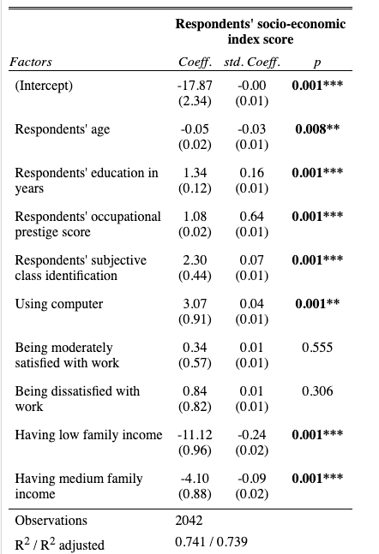
Interpretation (50 points): | First paragraph:  Respondents' age, respondents' education in years, respondents' occupational prestige score, respondents' subjective class identification, using computer, having low family income, and having medium family income are statistically significant predictors of respondents’ socio-economic index score since the p values are less than 0.05.  Being moderately satisfied with work and being dissatisfied with work are not statistically significant predictors of socio-economic index score since the p value is greater than 0.05.  Second paragraph:  A year increase in respondents' age decreases respondents’ socio-economic index score by 0.05 points.  A year increases in respondents' education increases respondents’ socio-economic index score by 1.34 points.  One unit increase in occupational prestige score increases respondents’ socio-economic index score by 1.08 points.  One unit increase in respondents' subjective class identification increases socio-economic index score by 2.30 points.  Using computer increases socio-economic index score by 3.07 points compared to not using computer.  Having low family income decreases socio-economic index score by 11.12 points compared to having high family income.  Having medium family income decreases socio-economic index score by 4.10 points compared to having high family income.  Third paragraph:  The strongest predictor of respondents’ socio-economic index score is occupational prestige score (std.Coeff=0.64), followed by having low family income (std.Coeff=-0.24), respondents' education in years (std.Coeff=0.16), having medium family income (std.Coeff=-0.09), respondents' subjective class identification (std.Coeff=0.07), using computer (std.Coeff=0.04), and respondents’ age (std.Coeff=-0.03).  Fourth paragraph:  The adjusted R squared value indicates that 73.9% of the variation in respondents’ socio-economic index score can be explained by respondents' age, respondents' education in years, respondents' occupational prestige score, respondents' subjective class identification, using computer, having low family income, and having medium family income.

