SAMPLE RStudio lab assignment: logistic regression

Assignment instructions
In this assignment, you will be creating dummy variables and adding them to a logistic regression model.
The following are the variables to use in this assignment. You will use the information below the model in the final question (interpretation).
Variable name | Variable label | Variable type | Question wording and response categories
relpersn | Subjective religiosity | Ordinal | To what extent do you consider yourself a religious person?  (1: Very religious; 2: Moderately religious; 3: Slightly religious; 4: Not religious at all)
sex | Respondents' sex | Binary | What's your sex?  (1: Male; 2: Female)
race | Respondents' race | Nominal | What's your race?  (1: White; 2: Black; 3: Other)
educ | Respondents' education in years | Continuous | What is the highest year of school you completed?  (Min: 0, Max: 20)
age | Respondents' age | Continuous | What is your age?  (Min: 18, Max: 89)

- Create dummy variables for the outcome variable
Using the original variable of relpersn, create two dummy variables.
- The name of the first dummy variable: religious
  - Merge “very religious” and “moderately religious” values for this dummy variable
  - The variable label: Being religious

- The name of the second dummy variable: notreligious
  - Merge “slightly religious” and “not religious at all” values for this dummy variable
  - The variable label: Being not religious
    - This is the comparison dummy variable (omit this variable)
Code (-5): | gss$religious <-  ifelse(gss$relpersn == 1 | gss$relpersn == 2, 1, 0,  label = "Being religious")
Code (-5): | gss$notreligious <-  ifelse(gss$relpersn == 3 | gss$relpersn == 4, 1, 0,  label = "Being not religious")

- Create dummy variables for the first factor variable
Using the original variable of sex, create two dummy variables.
- The name of the first dummy variable: male
  - No merging for this dummy variable
  - The variable label: Being male
    - This is the comparison dummy variable (omit this variable)

- The name of the second dummy variable: female
  - No merging for this dummy variable
  - The variable label: Being not female
Code (-5): | gss$male <-  ifelse(gss$sex == 1, 1, 0,  label = "Being male")
Code (-5): | gss$female <-  ifelse(gss$sex == 2, 1, 0,  label = "Being female")

- Create dummy variables for the second factor variable
Using the original variable of race, create two dummy variables.
- The name of the first dummy variable: white
  - No merging for this dummy variable
  - The variable label: Being white
    - This is the comparison dummy variable (omit this variable)

- The name of the second dummy variable: nonwhite
  - Merge “black” and “other” values for this dummy variable
  - The variable label: Being non-white

Code (-5): | gss$white <-  ifelse(gss$race == 1, 1, 0,  label = "Being white")
Code (-5): | gss$nonwhite <-  ifelse(gss$race == 2 | gss$race == 3, 1, 0,  label = "Being nonwhite")

- Run a logistic regression model using:
- Outcome variable: religious
- Factor variable 1: female
- Factor variable 2: white
- Factor variable 3: educ – use as is (no dummy)
- Factor variable 4: age – use as is (no dummy)
Finally interpret the model 1.
Code (-5): | model1 <- glm(religious ~ female + white + educ + age, data = gss, family = binomial(link="logit"))  tab_model(model1, show.std = T, show.ci = F, collapse.se = T)
Table (20 points): | 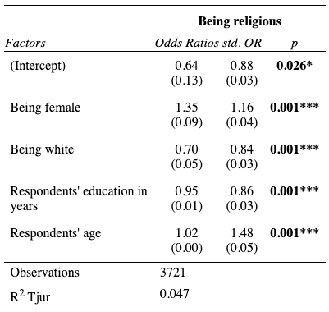
Interpretation (80 points): | First paragraph:  Being female, being white, respondents’ education in years, and respondents’ age are statistically significant factors of being religious.  Second paragraph:  Being female increases the odds of being religious by 1.31 times compared to being male.  Being white decreases the odds of being religious by 1.42 times compared to being non-white.  A year increase in respondents' education in years decreases the odds of being religious by 1.05 times.  A year increase in respondents' age decreases the odds of being religious by 1.02 times.  Third paragraph:  The strongest factor of being religious is respondents' age (std. OR=1.48), followed by being white (std. OR=1.19), being female (std. OR=1.16) and respondents' education in years (std. OR=1.16)  Fourth paragraph:  The Tjur R-squared value indicates that 4.7% of the variation in being religious can be explained by being female, being white, respondents’ education in years, and respondents’ age.

