SAMPLE RStudio lab assignment: modeling exercises

Assignment instructions
You will use the dataset created during in-person classes in previous semesters.
189 students tossed a ball into a trash can from various distances.
Those 189 students also filled out a survey with information (both relevant and irrelevant) to predict targeting trash can.
In this assignment, you will work on one question. You will run a logistic regression where the;
- Outcome variable: success
- Factor variable 1: distance
- Factor variable 2: narrow
- Factor variable 3: sleep
- Factor variable 4: nervous
- Run a logistic regression model and interpret it
Code (-5): | model1 <- glm(success ~ distance + narrow + sleep + nervous, data = trashball, family = binomial(link="logit"))  tab_model(model1, show.std = T, show.ci = F, collapse.se = T)
Table (20 points): | 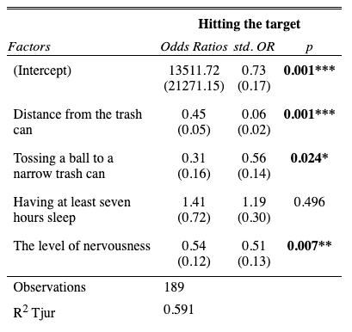
Interpretation (80 points): | First paragraph:  Distance from the trash can, tossing a ball to a narrow trash can, and the level of nervousness are statistically significant factors of hitting the target since the p values are less than 0.05. Having at least seven hours sleep is not a statistically significant factor of hitting the target since the p value is greater than 0.05.  Second paragraph:  A foot increase in distance from the trash can decreases the odds of hitting the target by 2.22 times.  Tossing a ball to a narrow trash can decreases the odds of hitting the target by 3.22 times compared to tossing a ball to a wide trash can.  One unit increase in level of nervousness decreases the odds of hitting the target by 1.85 times.  Third paragraph:  The strongest factor of hitting the target is distance from the trash can (std. OR=16.66), followed by the level of nervousness (std. OR=1.96), and tossing a ball to a narrow trash can (std. OR=1.78).  Fourth paragraph:  The Tjur R-squared value indicates that 59.1% of the variation in hitting the target can be explained by distance from the trash can, tossing a ball to a narrow trash can, and the level of nervousness.

