RStudio lab assignment: regression analysis assumptions and diagnostics

Assignment instructions
In this assignment, you will run the exact same codes provided in the R script file without making any changes. Therefore, there’s no sample lab assignment file.
The outputs should not be copied and pasted from the modules; they should be generated in your RStudio session (Otherwise no credit for the whole assignment). Paste the interpretations from the module page.

Important note:
For this lab assignment, expand the right pane in RStudio as much as possible before running the codes.
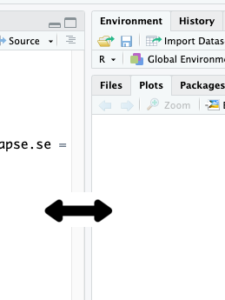
- During this lab session, you’ll create graphs that consume a significant amount of RAM.
  - If RStudio stops working, follow this guideline to free up your RAM: What to do if RStudio Cloud crashes?

- Paste all the codes that create the sociallife_index (social life index score) variable, including the recoding and computing codes. Then, paste the dummy variable codes for `life`.
Code (-5):
- Run the model 1. Paste the table from RStudio plots tab and interpretation from the module page.
Code (-5):
Output (5 points):
Interpretation (5 points):
- Run the Performance diagnostic (Model 1) code and paste the figure.
Code (-5):
Output (10 points):
- Run the Homoscedasticity (Model 1) code and paste the information as seen in RStudio console.
Code (-5):
Output (10 points):
- Run the Multicollinearity (Model 1) code and paste the output as seen in RStudio console.
Code (-5):
Output (10 points):
- Run the Scatterplot graph matrix (Model 1) code and paste the figure.
Code (-5):
Output (10 points):
- Paste the new dummy variable codes for `life`.
Code (-5):
- Run the model 2. Paste the table from RStudio plots tab and interpretation from the module page.
Code (-5):
Output (10 points):
Interpretation (10 points):
- Run the Performance diagnostic (Model 2) code and paste the figure.
Code (-5):
Output (10 points):
- Run the Homoscedasticity (Model 2) code and paste the information as seen in RStudio console.
Code (-5):
Output (10 points):
- Run the Multicollinearity (Model 2) code and paste the output as seen in RStudio console.
Code (-5):
Output (10 points):

