SAMPLE RStudio lab assignment: logistic regression

Assignment instructions
In this assignment, you will be creating dummy variables and adding them to a logistic regression model.
The following are the variables to use in this assignment. You will use the information below the model in the final question (interpretation).
Variable name | Variable label | Variable type | Question wording and response categories
relpersn | Subjective religiosity | Ordinal | To what extent do you consider yourself a religious person?  (1: Very religious; 2: Moderately religious; 3: Slightly religious; 4: Not religious at all)
sex | Respondents' sex | Binary | What's your sex?  (1: Male; 2: Female)
race | Respondents' race | Nominal | What's your race?  (1: White; 2: Black; 3: Other)
educ | Respondents' education in years | Continuous | What is the highest year of school you completed?  (Min: 0, Max: 20)
age | Respondents' age | Continuous | What is your age?  (Min: 18, Max: 89)

- Create dummy variables for the outcome variable
Using the original variable of relpersn, create two dummy variables.
- The name of the first dummy variable: religious
  - Merge “very religious” and “moderately religious” values for this dummy variable
  - The variable label: Being religious

- The name of the second dummy variable: notreligious
  - Merge “slightly religious” and “not religious at all” values for this dummy variable
  - The variable label: Being not religious
    - This is the comparison dummy variable (omit this variable)
Code (-5): | gss$religious <-  ifelse(gss$relpersn == 1 | gss$relpersn == 2, 1, 0,  label = "Being religious")
Code (-5): | gss$notreligious <-  ifelse(gss$relpersn == 3 | gss$relpersn == 4, 1, 0,  label = "Being not religious")

- Create dummy variables for the first factor variable
Using the original variable of sex, create two dummy variables.
- The name of the first dummy variable: male
  - No merging for this dummy variable
  - The variable label: Being male
    - This is the comparison dummy variable (omit this variable)

- The name of the second dummy variable: female
  - No merging for this dummy variable
  - The variable label: Being not female
Code (-5): | gss$male <-  ifelse(gss$sex == 1, 1, 0,  label = "Being male")
Code (-5): | gss$female <-  ifelse(gss$sex == 2, 1, 0,  label = "Being female")

- Create dummy variables for the second factor variable
Using the original variable of race, create two dummy variables.
- The name of the first dummy variable: white
  - No merging for this dummy variable
  - The variable label: Being white
    - This is the comparison dummy variable (omit this variable)

- The name of the second dummy variable: nonwhite
  - Merge “black” and “other” values for this dummy variable
  - The variable label: Being non-white

Code (-5): | gss$white <-  ifelse(gss$race == 1, 1, 0,  label = "Being white")
Code (-5): | gss$nonwhite <-  ifelse(gss$race == 2 | gss$race == 3, 1, 0,  label = "Being nonwhite")

- Run a logistic regression model using:
- Outcome variable: religious
- Factor variable 1: female
- Factor variable 2: white
- Factor variable 3: educ – use as is (no dummy)
- Factor variable 4: age – use as is (no dummy)
Finally interpret the model 1.
Code (-5): | model1 <- glm(religious ~ female + white + educ + age, data = gss, family = binomial(link="logit"))  tab_model(model1, show.std = T, show.ci = F, collapse.se = T)
Table (20 points): | 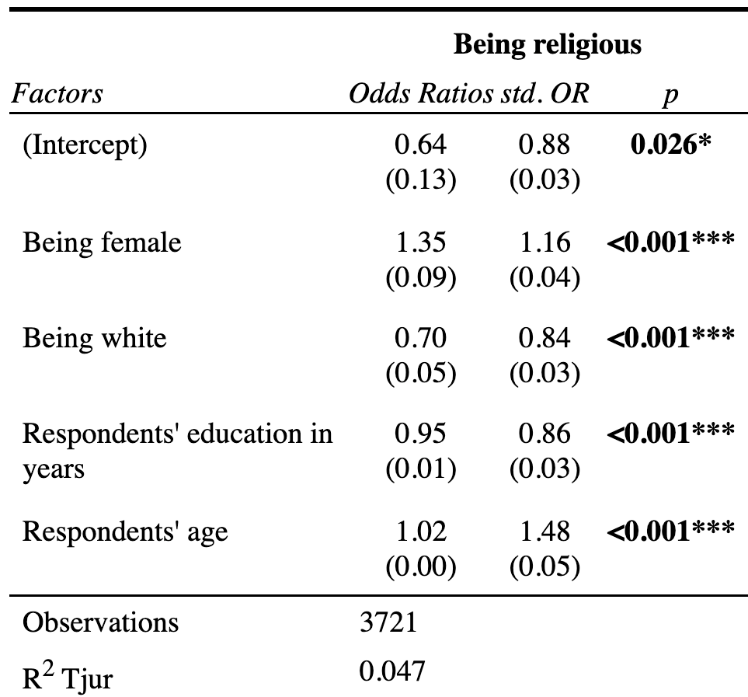
Interpretation (80 points): | First paragraph: The significance levels  Being female, being white, respondents' education in years, and respondents' age have statistically significant associations with being religious since their p-values are less than 0.05.  Second paragraph: The explanation of odds ratios  Being female is associated with 1.31 times higher odds of being religious compared with being male.  Being white is associated with 1.42 times lower odds of being religious compared with being nonwhite.  One additional year of respondents' education is associated with 1.05 times lower odds of being religious.  One additional year of respondents' age is associated with 1.02 times lower odds of being religious.  Third paragraph: The explanation of standardized odds ratios  The largest standardized association with the odds of being religious is for respondents' age (std. OR=1.48), followed by being white (std. OR=1.19), being female (std. OR=1.16), and respondents' education in years (std. OR=1.16).  Fourth paragraph: The explanation of Tjur R-squared  The Tjur R-squared value indicates that the model, which includes being female, being white, respondents' education in years, and respondents' age, distinguishes between the two groups with a 4.7 percentage-point difference in their average predicted probabilities.

