SAMPLE RStudio lab assignment: modeling exercises

Assignment instructions
You will use the dataset created during in-person classes in previous semesters.
189 students tossed a ball into a trash can from various distances.
Those 189 students also filled out a survey with information (both relevant and irrelevant) to predict targeting trash can.
In this assignment, you will work on one question. You will run a logistic regression where the;
- Outcome variable: success
- Factor variable 1: distance
- Factor variable 2: narrow
- Factor variable 3: sleep
- Factor variable 4: nervous
- Run a logistic regression model and interpret it
Code (-5): | model1 <- glm(success ~ distance + narrow + sleep + nervous, data = trashball, family = binomial(link="logit"))  tab_model(model1, show.std = T, show.ci = F, collapse.se = T)
Table (20 points): | 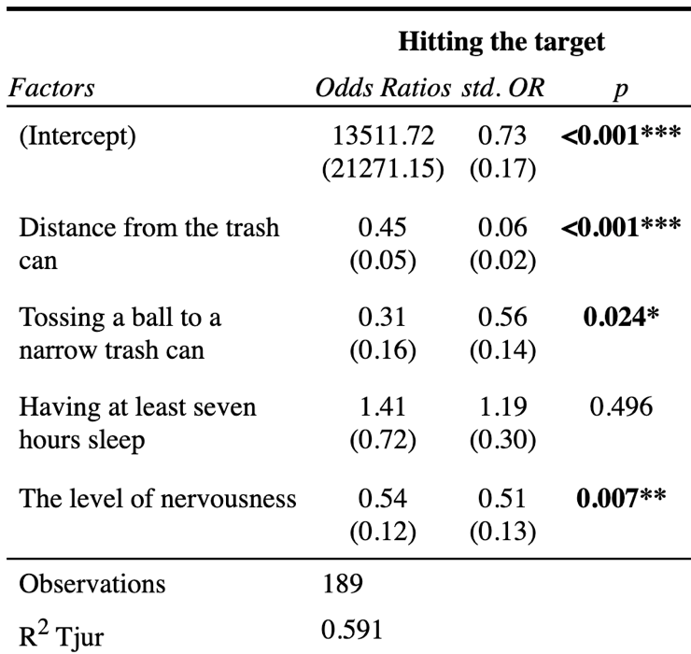
Interpretation (80 points): | First paragraph: The significance levels  Distance from the trash can, tossing a ball to a narrow trash can, and the level of nervousness have statistically significant associations with hitting the target since their p-values are less than 0.05.  Having at least seven hours of sleep is not a statistically significant factor of hitting the target since the p-value is greater than 0.05.  Second paragraph: The explanation of odds ratios  One additional foot of distance from the trash can is associated with 2.22 times lower odds of hitting the target.  Tossing a ball to a narrow trash can is associated with 3.22 times lower odds of hitting the target compared with tossing a ball to a wide trash can.  One additional point in the level of nervousness is associated with 1.85 times lower odds of hitting the target.  Third paragraph: The explanation of standardized odds ratios  The largest standardized association with the odds of hitting the target is for distance from the trash can (std. OR=16.66), followed by the level of nervousness (std. OR=1.96), and tossing a ball to a narrow trash can (std. OR=1.78).  Fourth paragraph: The explanation of Tjur R-squared  The Tjur R-squared value indicates that the model, which includes distance from the trash can, tossing a ball to a narrow trash can, the level of nervousness, and having at least seven hours of sleep, distinguishes between the two groups with a 59.1 percentage-point difference in their average predicted probabilities.

