SAMPLE RStudio lab assignment: linear regression basics

Assignment instructions
The following are the variables to use in this assignment. You will use the information below the model in the final question (interpretation).
Variable name | Variable label | Variable type | Question wording and response categories
sei10 | Respondents' socio-economic index score | Continuous | Socio-economic index score of the respondent (calculated)  (Min: 9, Max: 92.8)
age | Respondents' age | Continuous | What is your age?  (Min: 18, Max: 89)
educ | Respondents' education in years | Continuous | What is the highest year of school you completed?  (Min: 0, Max: 20)
prestg10 | Respondents' occupational prestige score | Continuous | Respondent’s occupational prestige score (calculated)  (Min: 16, Max: 80)
class | Respondents' subjective class identification | Ordinal | If you were asked to use one of four names for your social class, which would you say you belong in?  (1: Lower class; 2: Working class; 3: Middle class; 4: Upper class)

- Run a linear regression model (model 1) using:
- Outcome variable: sei10
- Factor variable 1: age
Code (-5): | model1 <- lm(sei10 ~ age, data = gss)  tab_model(model1, show.std = T, show.ci = F, collapse.se = T)
Table (5 points): | 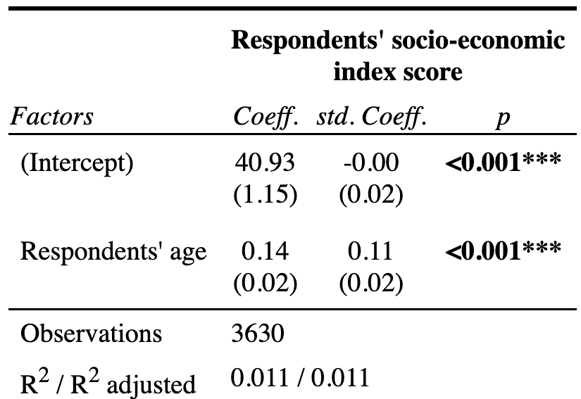
- Run a linear regression model (model 2) using:
- Outcome variable: sei10
- Factor variable 1: age
- Factor variable 2: educ
Code (-5): | model2 <- lm(sei10 ~ age + educ, data = gss)  tab_model(model2, show.std = T, show.ci = F, collapse.se = T)
Table (5 points): | 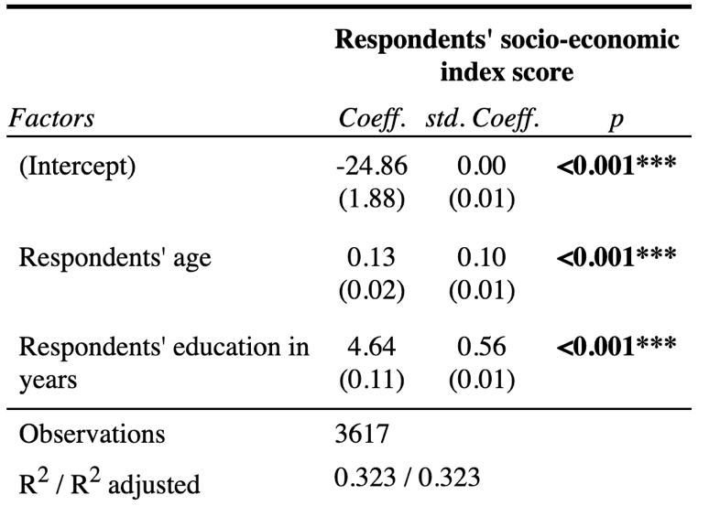

- Run a linear regression model (model 3) using:
- Outcome variable: sei10
- Factor variable 1: age
- Factor variable 2: educ
- Factor variable 3: prestg10
Code (-5): | model3 <- lm(sei10 ~ age + educ + prestg10, data = gss)  tab_model(model3, show.std = T, show.ci = F, collapse.se = T)
Table (5 points): | 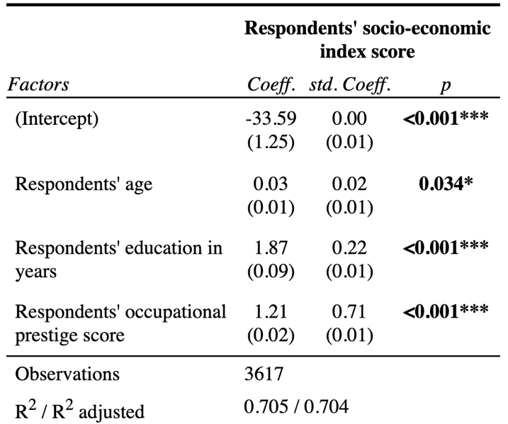

- Run a linear regression model (model 4) using:
- Outcome variable: sei10
- Factor variable 1: age
- Factor variable 2: educ
- Factor variable 3: prestg10
- Factor variable 4: class
Code (-5): | model4 <- lm(sei10 ~ age + educ + prestg10 + class, data = gss)  tab_model(model4, show.std = T, show.ci = F, collapse.se = T)
Table (20 points): | 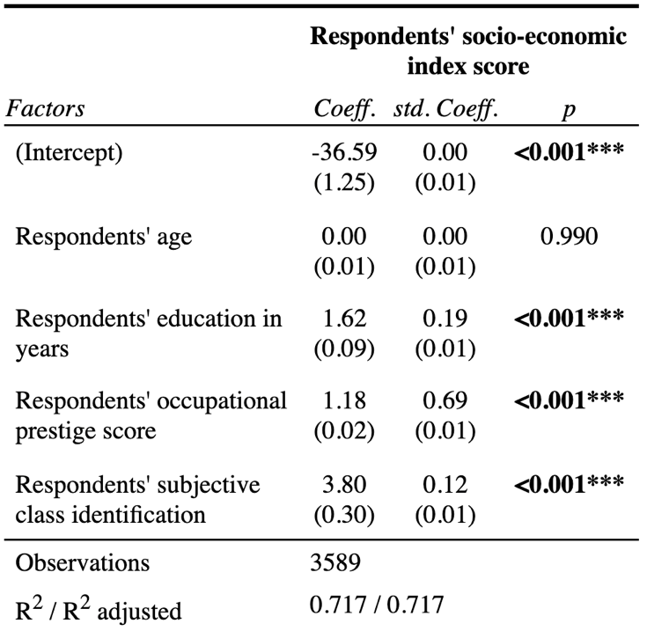
Interpretation (50 points): | First paragraph: The significance levels  Respondents' education in years, respondents' occupational prestige score, and respondents' subjective class identification have statistically significant associations with respondents' socio-economic index score since their p-values are less than 0.05.  Respondents' age is not a statistically significant factor of respondents' socio-economic index score since the p-value is greater than 0.05.  Second paragraph: The explanation of coefficients  One additional year of respondents' education is associated with 1.62 points higher predicted socio-economic index score.  One additional point of respondents' occupational prestige score is associated with 1.18 points higher predicted socio-economic index score.  One additional category of respondents' subjective class identification is associated with 0.12 points higher predicted socio-economic index score.  Third paragraph: The explanation of standardized coefficients  The largest standardized association with respondents' socio-economic index score is for respondents' occupational prestige score (std. Coeff=0.69), followed by respondents' education in years (std. Coeff=0.19), and respondents' subjective class identification (std. Coeff=0.12).  Fourth paragraph: The explanation of adjusted R-squared  The adjusted R-squared value indicates that the model, which includes respondents' education in years, respondents' occupational prestige score, respondents' subjective class identification, and respondents' age, accounts for 71.7% of the variation in respondents' socio-economic index score.

