SAMPLE RStudio lab assignment: correlation

Assignment instructions
In this assignment, you will conduct a small quantitative study of your own using the GSS. You choose the question, make the hypothesis, and produce the results.
- Choose one of the six options below.
- Explain how its concept connects the two variables and write your hypothesis.
- Test your hypothesis with a correlation table and a scatterplot graph.
- Explain what your result means for the concept.
- Discuss the ethical issues in your own study.

- Choose one option
Each option gives you a sociological concept and two continuous variables from the Variables in GSS page. Choose one option and use it for the whole assignment.
Option | Concept and core idea | Variable 1 and variable label | Variable 2 and variable label
7 | Household economy: Families pool workers and income | hompop  Number of persons in household | earnrs  Number of family members who earned money last year
- Research design: Complete this section before you run any code.
  - Write the option number you chose.
Option number: | 7 (not one of the six options in the assignment).
  - Copy the information of the two variables from the Variables in GSS page.
Variable name | Variable label | Variable type | Question wording and response categories (min/max)
hompop | Number of persons in household | Continuous | How many people do live in your household?  (Min: 1, Max: 14)
earnrs | Number of family members who earned money last year | Continuous | How many persons in the family, including yourself, earned any money last year from any job or employment?  (Min: 0, Max: 3)

  - Explain your option’s concept in your own words, explain why it suggests your two variables are related, and write your hypothesis.
1. Concept: | Household economy: families pool their members’ work and income to meet shared needs, so a household works as one economic unit rather than as separate individuals.
2. Hypothesis: | I expect to find a positive and strong correlation between number of persons in household and number of family members who earned money last year.
3. Reasoning: | When more people live in a household, there are usually more adults who can work, such as adult children, grandparents, or other relatives. Families with tight budgets may also live together so that more people can bring in money. Both reasons suggest that larger households should have more earners.

- Analysis
  - Create a correlation analysis table using your two variables and interpret it using the interpretation template from the lecture page:
Code (-5): | tab_corr (gss[c("hompop", "earnrs")],  p.numeric = T, triangle="lower")
Table: | 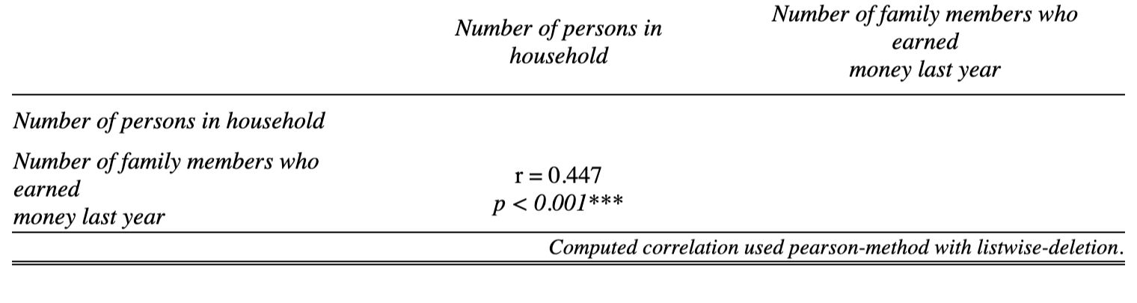
Interpretation: | There is a statistically significant correlation between number of persons in household and number of family members who earned money last year since the p-value is less than 0.05.  This correlation is positive and moderate since the r-value is 0.447.

  - Create a scatterplot graph using your two variables.
Code (-5): | scatterplot(gss, "hompop", "earnrs")
Graph: | 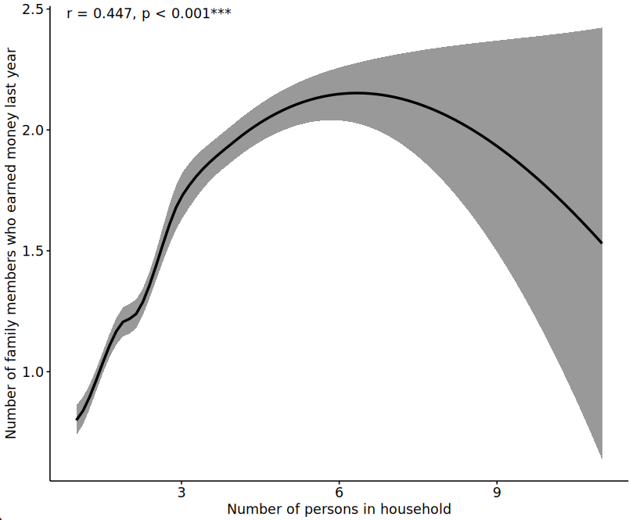

- What your result means
Write a short paragraph (150 words minimum) that answers three questions:
- Was your hypothesis supported, partly supported, or not supported? Address both direction and strength (mention your r-value and p-value).

- Look at your scatterplot graph. Does the line keep going in the same direction, or does it level off or change direction? At what values?

- What do the r-value, p-value, and the shape together tell you about the concept? Where does the concept fit your data well, and where does it not?
A hypothesis that is not supported can still earn full points. You are graded on your reasoning, not on whether your hypothesis was right.
Answer: | My hypothesis was partly supported. As I expected, the correlation between number of persons in household and number of family members who earned money last year is positive and statistically significant (r = 0.447, p < 0.001), but it is moderate rather than strong.  The scatterplot graph shows that the line rises from less than one earner in one-person households to about two earners in households of six, but then it turns down, falling to about 1.5 earners in the largest households. Because the line bends, a single straight-line r-value cannot be strong.  This shape fits the household economy idea only up to a point. In small and mid-sized households, each additional person is often a working adult who pools their pay. In very large households, the additional members could be more likely to be children, retirees, or caregivers, who add to the household’s size but not to its earners. The concept explains paid work in households of up to about six people better than in larger ones.

- Ethics in your study
  - Responsible reporting: You wrote your hypothesis before running any code. Imagine that a researcher studying your topic changed the hypothesis after seeing the output, or reported only the results that “worked.” Who could be misled, and how? Name a specific group of readers or a real decision connected to your topic. (75 words minimum)
Answer: | If I had changed my hypothesis from “strong” to “moderate” after seeing the output, the household economy idea would look like a better predictor than it is. Agencies that plan housing or benefits might then assume that bigger households always have more earners, and overlook very large households, which in my data tend to have fewer earners, often because they include children, retirees, or caregivers who rely on a single paycheck. Reporting my result as it came out shows readers how much the concept actually explains.

  - Who is missing: Reread the question wording of your two variables. Who could not answer one of them, or whose experience does the question not capture? How does this limit what your result can say about your topic? (75 words minimum)
Answer: | The earnrs variable counts only family members who earned money from a job, so unpaid work such as caregiving, housework, and childcare is not counted, and that work is often done by women. A household where one person works for pay and another cares for children full-time counts as having one earner. The two questions also count different groups: hompop counts everyone in the household, including roommates, while earnrs counts only family members. My result therefore describes how families share paid work, not all the work that keeps a household going.

