**Goal**: Develop a software (graphical user interface) and hardware platform for researchers to perform human subject studies involving administering rapid acceleration/deceleration events while on a treadmill. This software is called Treadmill Rapid Accel/Decel/Stim Control Software (TRADSCS).

The TRADSCS GUI was developed using C++17 and the Qt Application Development Framework. It was compiled using GCC 8.2. It can run on Windows 8, Windows 10, and Linux.

The TRADSCS graphical user interface (GUI) allows the user to provide a set of parameters that control how rapid the treadmill accelerates and decelerates. Each row of a parameter constitutes a Trial which includes an acceleration speed, acceleration time, deceleration speed, and deceleration time. Multiple trials; called a Run, can be set. These Runs can be loaded from a CSV file (delimited by ‘_’) at startup, after a Run is complete, or any time in the middle of a Run. This ability permits the researcher to quickly run a subject through a series of trials without having to stop and reconfigure the software for the next Trial or Run.

The software retrieves real-time feedback of the speed of the treadmill from a custom build tachometer. The tachometer is Arduino based and connects to the system via serial-over-USB.

The GUI also provides visual cues for the participant that inform them of how they should behave while on the treadmill.

The software setup process begins with the Network Screen. The interaction between TRADSCS and the treadmill occurs through a TCP connection with the Bertec Treadmill software. This connection is made at the Network Screen shown below:

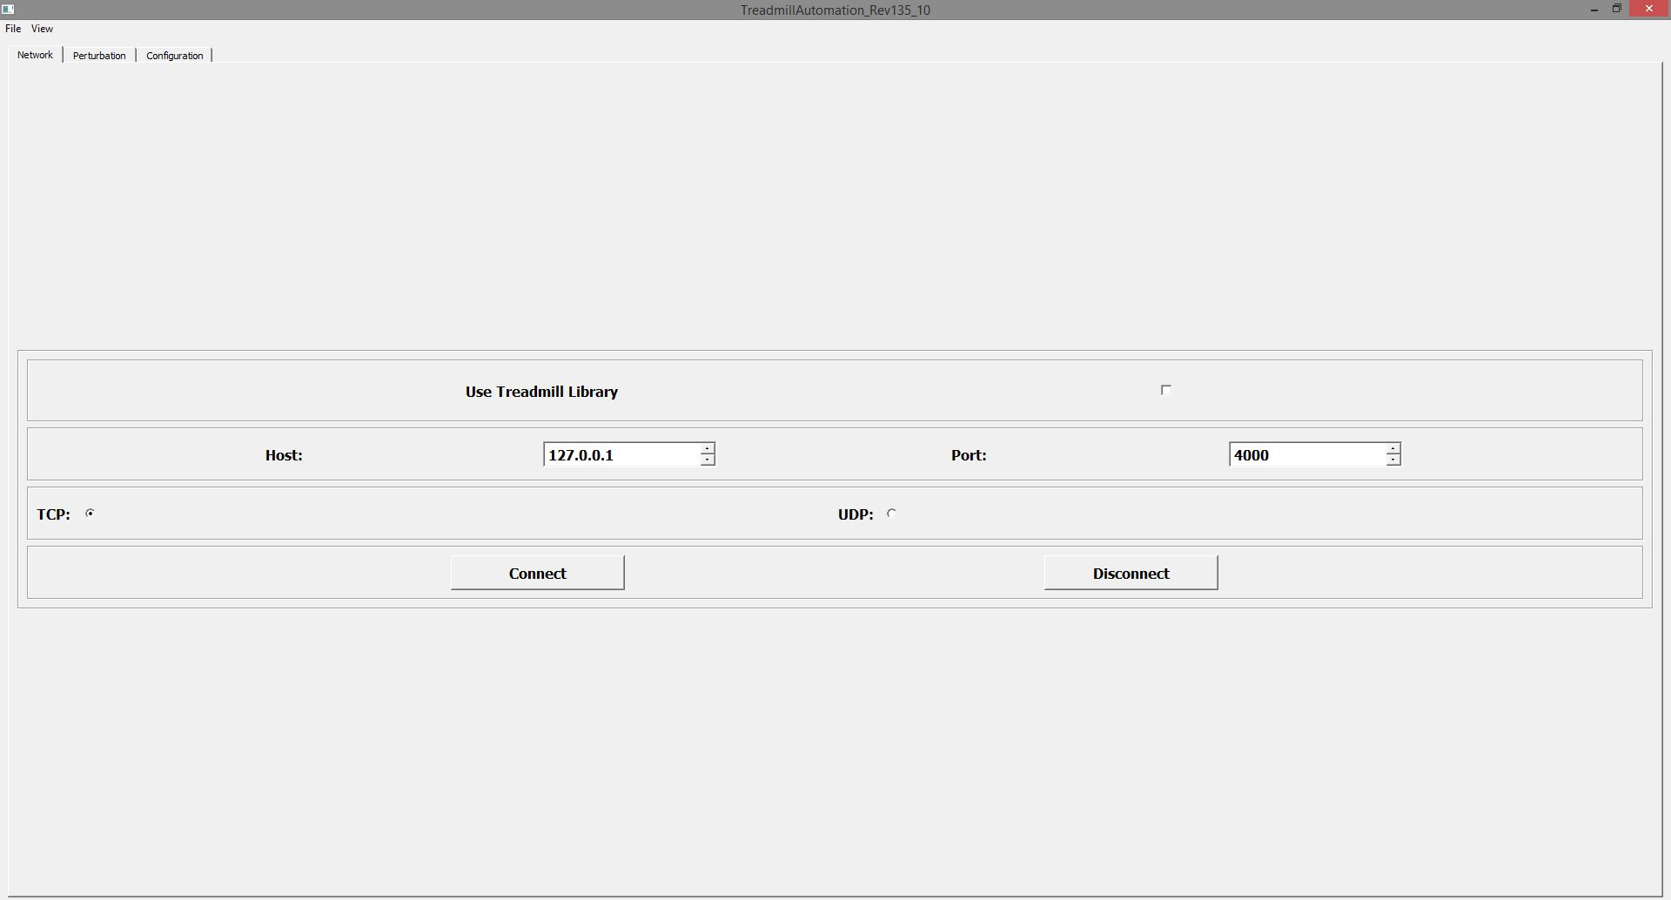

After the connection is made, the user proceeds to the main screen where they can click the load button. The Load button prompts the user to select a Run Profile that the user has created.

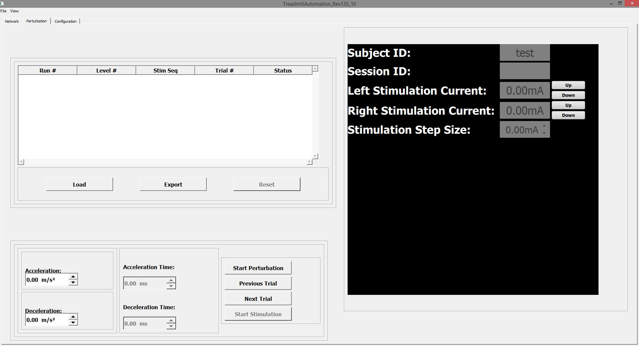

The screen below shows the main window after a Run Profile has been loaded. The Subject and Session ID are indicated at the right and the Run Profile is shown as a spreadsheet on the left. Each Run # and Trial # correspond to an acceleration/deceleration and acceleration time / deceleration time pair that is stored in a local database. The Acceleration Level, Deceleration Level, Acceleration Time, and Deceleration Time are shown in the lower left corner (see below). The control buttons are depicted in the lower right corner (see below).

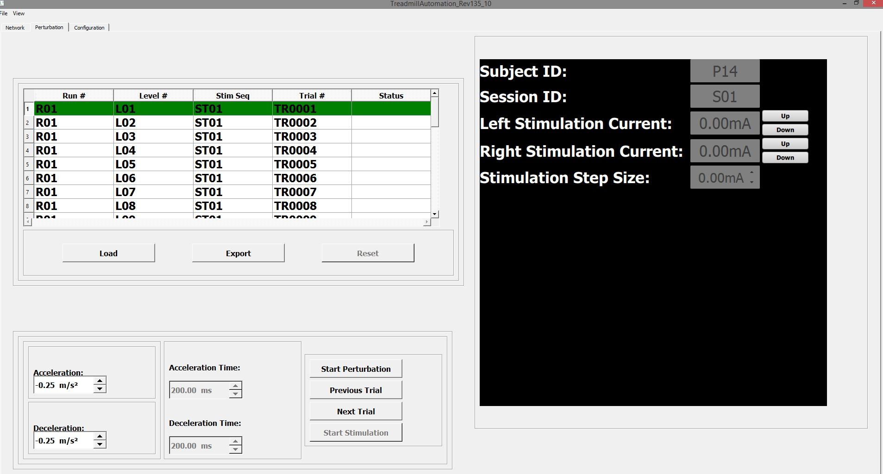

After a trial has been run, the word Complete is displayed under the Status column. The user then clicks the Next Trial button and the next trial is highlighted (shown below). The user has the ability to advance a trial or back up to a previous trial.

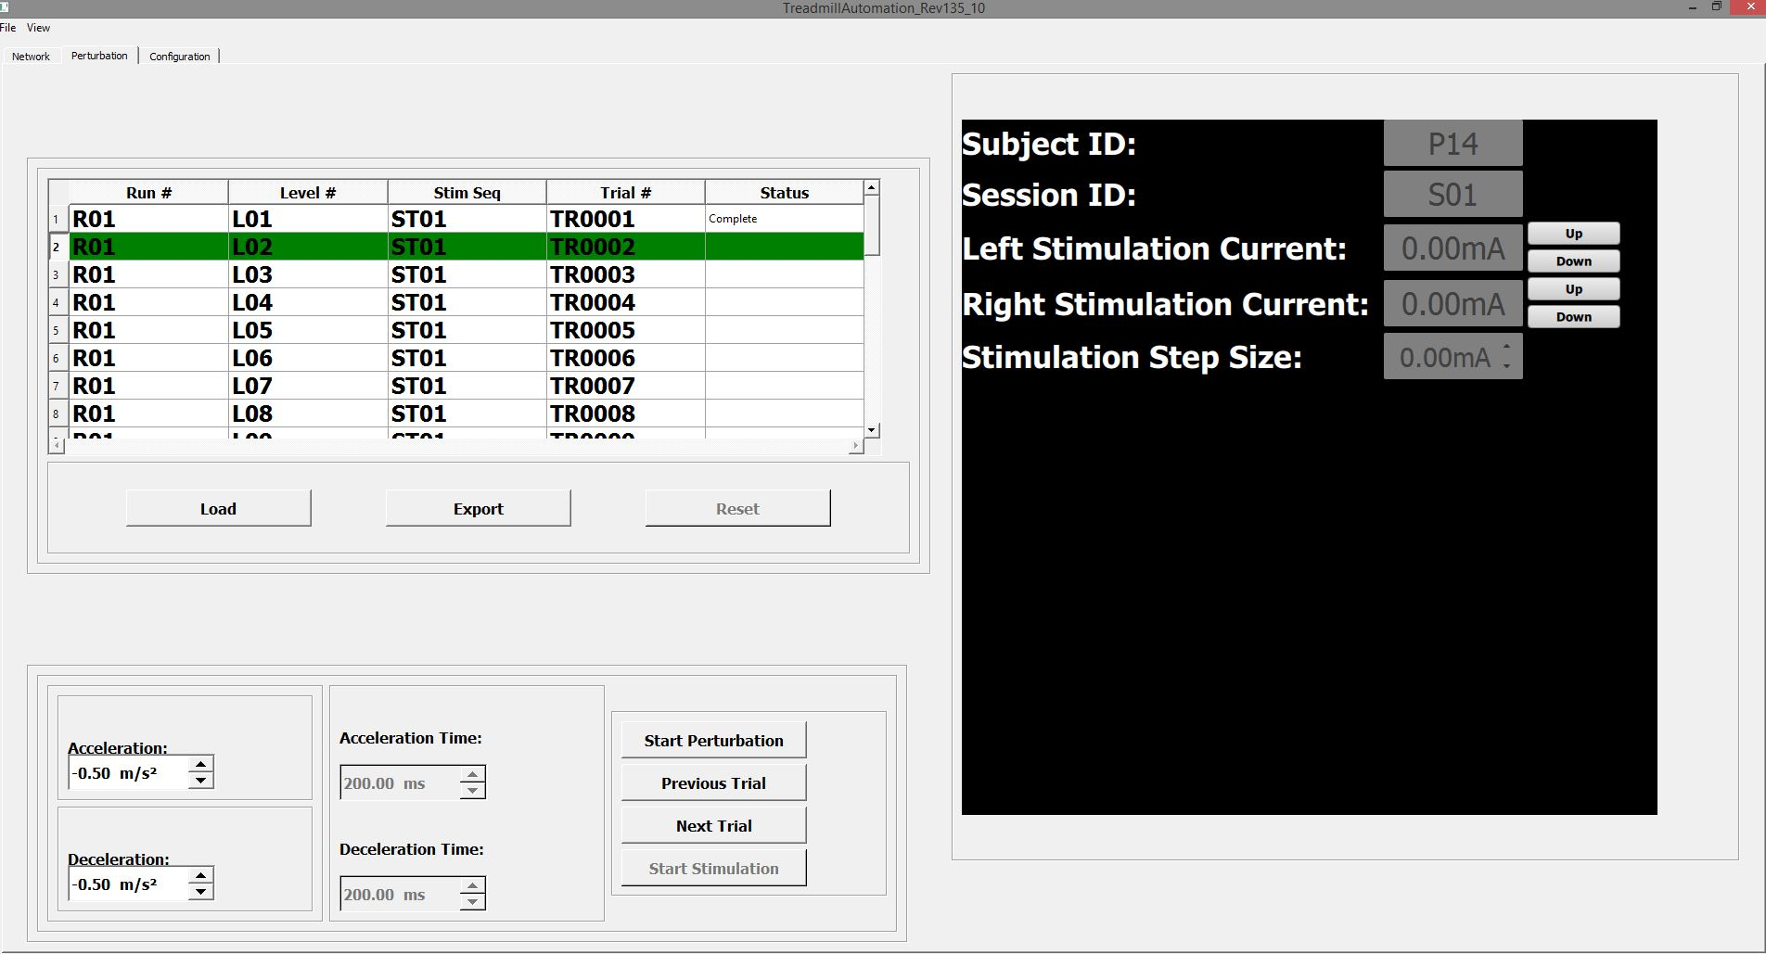

After a run is complete, the entire Run Profile can be exported to a CSV file.

The Configuration Screen is shown below. In future versions of the software, the user will be able to monitor EMG, treadmill force plate data, and provide a small electrical stimulation to the study participant in order to elicit a reflex.

