**Github repo:** [**https://github.com/ttfo/FarmManager-sbs19016.git**](https://github.com/ttfo/FarmManager-sbs19016.git)

**NOTE**: Postman collection is available for testing in the above repo under the README.md file

The application runs on top of [Spring Boot](https://spring.io/projects/spring-boot) as a [Gradle Project](https://docs.gradle.org/current/userguide/what_is_gradle.html) and employs Java version 8 as base language.

The application can be run in Eclipse via the main method in FarmManagerSbs19016Application.java

The application itself consists of two packages:

* package **ie.cct.Animals**:

in this package we have the overall ‘animal’ structure, with an abstract class (‘Animal’) and 3 sub-classes, one for each animal type as per CA requirements (‘Chicken’, ‘Cow’, ‘Pig’);

* package **ie.cct.FarmManagersbs19016**:

in this package we have the main method and all the main functionalities of the application in FarmController.java.

**End-points**

1. [GET] Endpoint to retrieve information of all livestock in JSON format.

This was not required in CA, but it is helpful for testing.

[**http://localhost:8080/get-livestock**](http://localhost:8080/get-livestock)

Example of response:

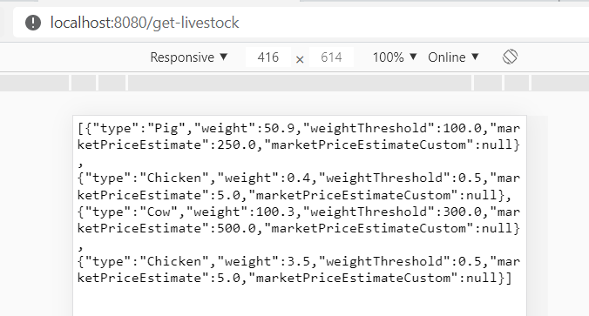

1. [POST] Endpoint to add 1 animal to the existing livestock.

Accepts “Chicken”, “Cow” and “Pig” as values for attribute “type”.

[**http://localhost:8080/add-animal**](http://localhost:8080/add-animal)

Example of request and response:

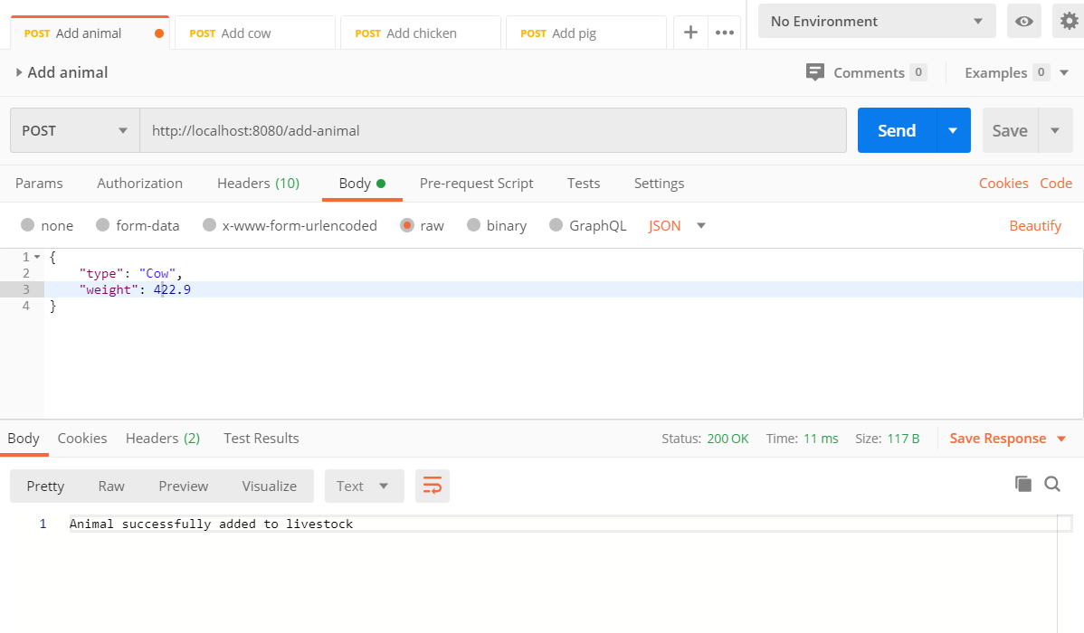

Individual endpoints for each animal type are also provided for the same purpose, e.g.

[**http://localhost:8080/add-pig**](http://localhost:8080/add-pig)

1. [GET] Endpoint to retrieve avg. weight by animal type.

<http://localhost:8080/avg-weight>

[GET] http://localhost:8080/animals-ready-to-sell (count of animals that meet min weight requirements and can be sold)

[GET] http://localhost:8080/farm-stock-value (value of owned livestock)

[GET] http://localhost:8080/farm-stock-value-hyp?cow=950&pig=420&chicken=6 (hyp value of owned livestock)