Updating ENG 21 & 22 SLO

- From the home screen, click ‘ENG 21/22’ located below the news and information table

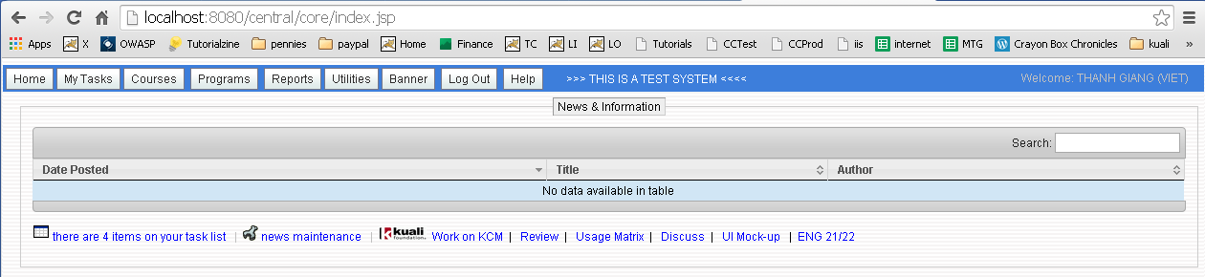

- Review the list of courses where ENG 21/22 are included. ‘Last Date’ refers to the date it was last touched, imported from Banner or approved.
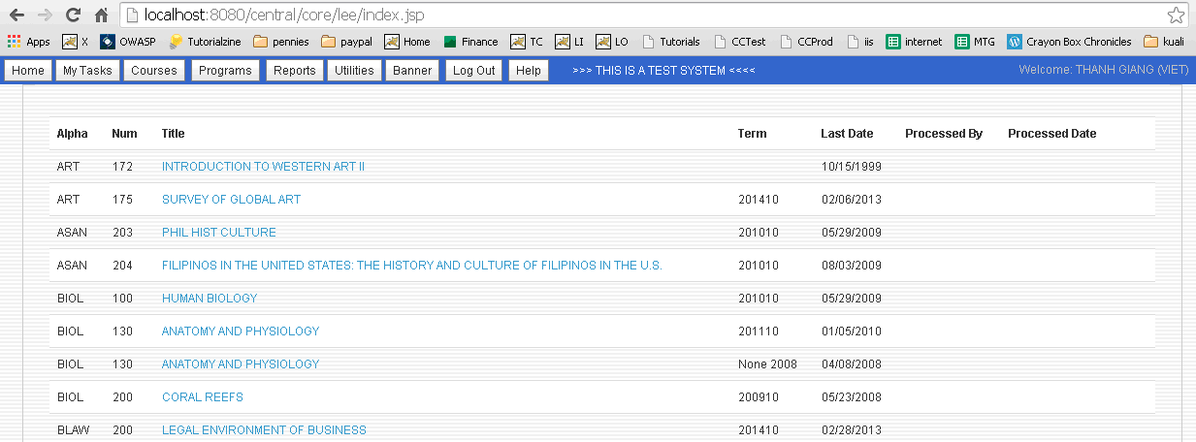

- Select a course (click link under title column) to work on. There are 3 options.
  - Cancel takes you back to the list of courses
  - Review and Continue takes you to the confirmation screen
  - Mark as done is used when no update or change is necessary

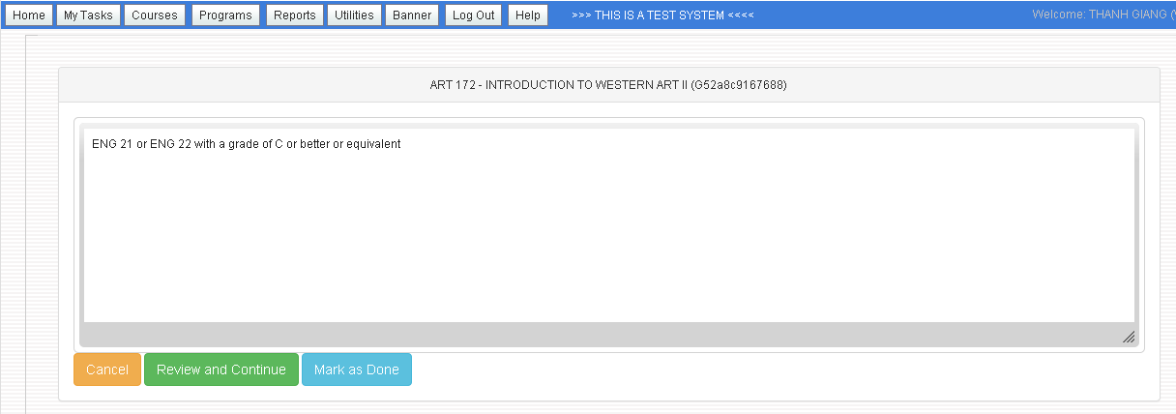

- Following is the confirmation screen from ‘Review and Continue’. Click ‘Update’ to save your work or ‘Cancel’ to abort.

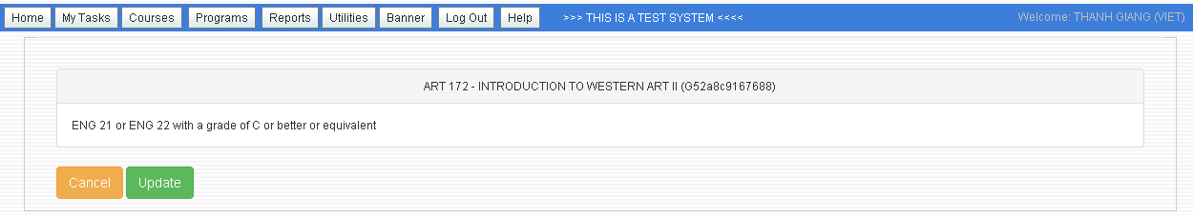

- If you click ‘Update’, the following screen appears. ‘Preview Outline’ displays the updated course outline. ‘Back to List’ returns you to the list of courses.

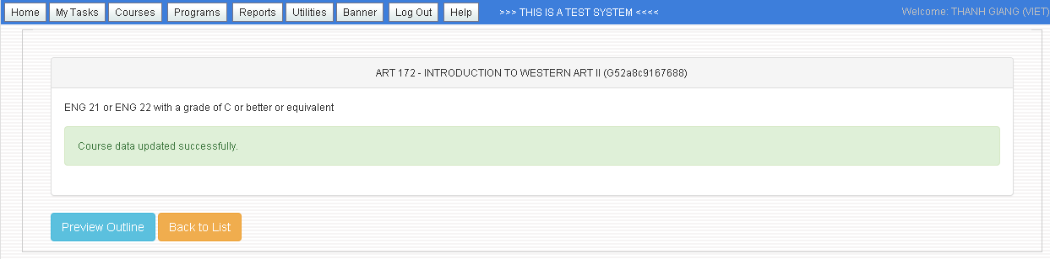

NOTE:

Verify that each course update generates the correct output. It’s important since this process circumvents the normal workflow.

