Curriculum Central (CC)

Installing SQL Server

- 01_dotnetfx.exe
- 02_jdk-1_5_0_09-windows-i586-p.exe
- 03_apache-ant-1.7.0-bin.zip
- 04_SQLEXPR_TOOLKIT.EXE
  - NOTE: during install, unhide properties
    - Install using admin privileges
    - Install using default instance (MSSQLSERVER) and not SQLEXPRESS
    - Install as mixed authentication
  - This is needed for DTS wizard
- 05_SQLEXPR_ADV.EXE
  - connect to SQL Server Configuration Manager
    - Under protocals, disable shared memory
    - enable named pipes and tcp/ip
    - change TCP/IP uses port 1433

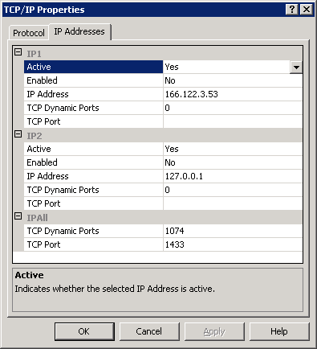

- log on to SQL using local service
- restart SQL

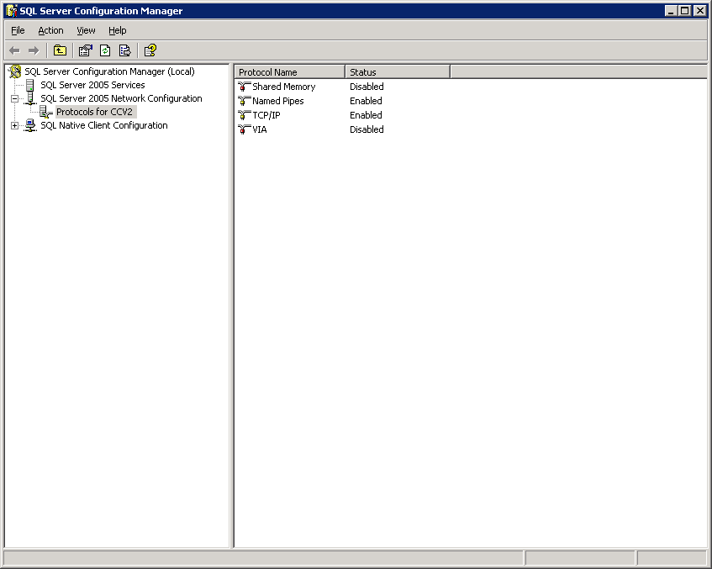

- connect to SQL Server Management Studio Express admin
  - give ccusr access to top level security
  - add ccusr to SQL Server
  - give access to CCV2

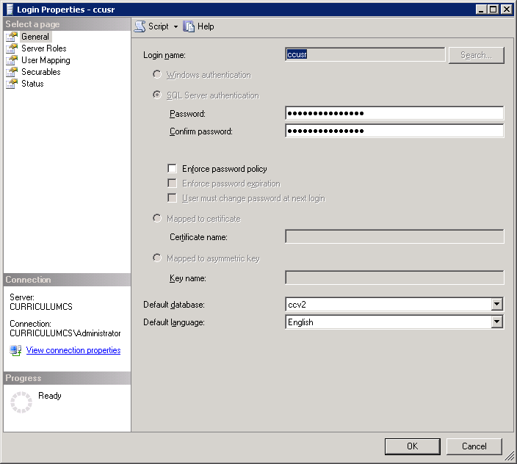

  - got to CCv2 and grant access to ccusr

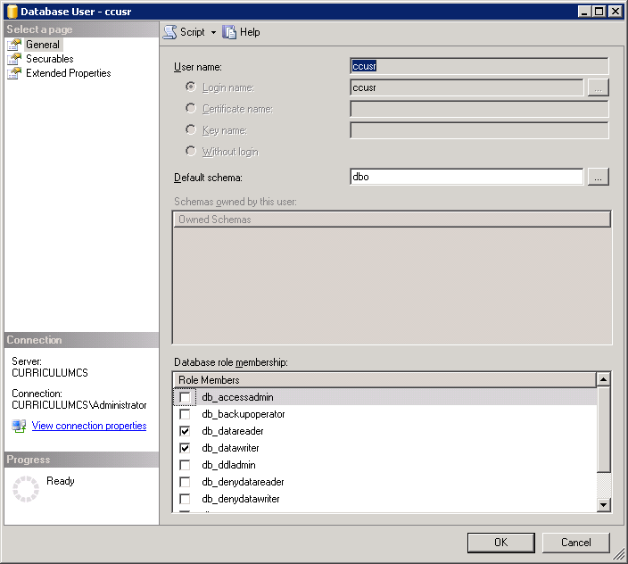

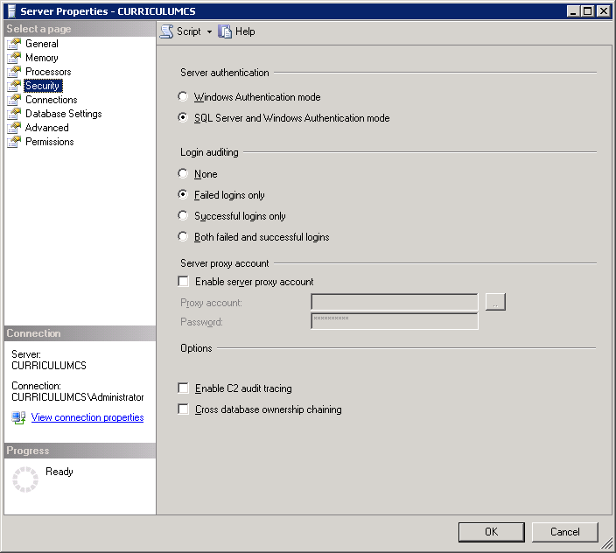

Installing Tomcat

- 06_tomcat.zip (this is a wrapped up of apache-tomcat-6.0.29-windows-x86.zip)
- c:\tomcat\bin\service.bat install Tomcat5
- create monitor as C:\tomcat\bin\tomcat5w.exe //MS//Tomcat5

Installing Text Editor

- 07_textpad.zip
- 08_textpad_samples.zip

- uninstall this file into the textpad sample folder

Installing Winzip

- 09_WinZip.zip

Installing Development Environment

- Development
- Ant in root drive under \ant
- Class Path
    - .;d:\tomcat\common\lib\servlet-api.jar;d:\tomcat\server\lib\catalina-ant.jar;d:\j2sdk\bin;d:\tomcat\webapps\central\WEB-INF\lib\central.jar;d:\ant\lib\junit.jar;
- ANT_HOME
    - d:\ant
- CATALINA_HOME
    - d:\tomcat
- JAVA_HOME
    - d:\j2sdk
- Folder structure
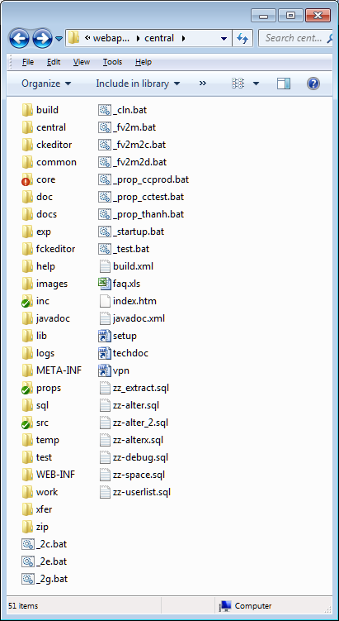
  - Central & Docs contains specific work in progress
  - Test contains experimental work
  - Work contains backup (outdated; using SVN)
  - Zip contains jars for current and past work

Curriculum Central (CC)

Installing SQL Server

- dotnetfx.exe
- SQLEXPR_TOOLKIT.EXE
  - This is needed for DTS wizard
- SQLEXPR_ADV.EXE
  - connect to SQL Server Configuration Manager
    - Under protocals, disable shared memory
    - enable named pipes and tcp/ip
    - change TCP/IP uses port 1433

- log on to SQL using local service
- restart SQL

- connect to SQL Server Management Studio Express admin
  - give ccusr access to top level security
  - add ccusr to SQL Server
  - give access to CCV2

  - got to CCv2 and grant access to ccusr

