Road Defect Detection Method Based on CBAM and Data Augmentation

Zhaoyang Sun 1,a*
1Schoo of Artificial Intelligence and Data Science
Hebei University of Technology
Tianjin, China
* Corresponding author: 13081082468@163.com

Abstract—Road defect detection is of great importance for driving safety. In recent years, several deep learning methods have been proposed for automatic road defect recognition; however, their detection accuracy still has room for improvement. In this paper, we propose an improved approach based on the YOLOv8n network, where the Convolutional Block Attention Module (CBAM) is integrated to enhance feature representation. In addition, multiple data augmentation strategies—including horizontal flipping, random rotation, random brightness and contrast adjustment, and random scaling—are employed to improve model robustness. We evaluate the proposed method on the Road Damage Dataset (Kaggle). Experimental results demonstrate that our method achieves an mAP@0.5 of 58%, which is significantly higher than the baseline YOLOv8n model (55.8%).
Keywords- Road defect detection; Data augmentation; Convolutional Block Attention Module; YOLOv8n

Introduction
Road-defect detection is critical to driving safety: defects shorten pavement life and raise crash risk and costs. From 2015–2030, road injuries are projected to cost the global economy USD 1.8 trillion (≈0.12% of world GDP), much of it linked to poor road conditions [4]. Manual inspection is slow and subjective, whereas intelligent detection provides faster, more accurate identification, reducing misses, extending service life, and lowering risk [5,6,7]. Deep learning now dominates the task but still struggles in complex scenes and diverse defect types; attention- and fusion-based Transformers, CNN–Transformer hybrids, and diffusion-style multi-scale models each help yet face limits in low light, adverse weather, stability, or generalization [8,9,10]. Accuracy and robustness therefore remain open challenges.
We adopt lightweight YOLOv8n [1] and integrate CBAM [2] to highlight salient features while keeping the decoupled head unchanged. Concretely, CBAM is inserted after two high-channel C2f blocks (output ≥224), using SE-style channel attention (r=32) and a 7×7 spatial kernel. To enhance generalization, we apply four augmentations with explicit ranges: horizontal flip (p=0.5), rotation (±10°, p=0.5), brightness/contrast (±0.2/±0.2, p=0.5), and scale (±10%, p=0.5). Training uses YOLOv8n pretrained weights (imgsize 1280, batch 4, 100 epochs) with Ultralytics’ default optimizer/schedule. Prior studies indicate attention and multi-scale modules improve YOLOv8 for road damage [11,12]. Our ablations find CBAM most effective on high-channel C2f, with tuned threshold and r, and on the Road Damage Dataset (Kaggle) [3] our model attains 58% mAP@0.5 vs. 55.8% for the baseline, confirming the approach’s effectiveness.
The rest of the paper covers related work (Sec. 2), methodology (Sec. 3), experiments (Sec. 4), conclusions (Sec. 5), and future directions (Sec. 6).

Related Work

Principles and Applications of YOLOv8
YOLOv8 offers variants from nano (YOLOv8n) to extra-large (YOLOv8x) [1]. YOLOv8n has the fewest parameters and smallest size, making it ideal for resource-constrained, real-time, edge deployments while retaining solid accuracy.
Proposed by Ultralytics in 2023, YOLOv8 unifies classification, detection, and instance segmentation, with open docs/code [1]. It uses a lighter backbone and an anchor-free head, organized into backbone–neck–head for multi-level extraction, multi-scale fusion, and final classification/box regression—delivering faster inference and better accuracy/generalization than prior YOLO versions.
Applications confirm its versatility: waste recognition reaches 95.3% mAP, surpassing YOLOv5 [13]; an improved YOLOv8-bird with receptive-field attention, refined fusion, and a new loss attains 94.6% precision and 94.8% mAP@0.5 on PYL-5-2023 [14]; and integration into real-time video platforms enables automatic bird detection and species recognition [15].
In summary, YOLOv8 achieves a balance between accuracy and efficiency through structural optimization and anchor-free strategies, and has demonstrated strong performance in diverse applications such as waste classification and bird species recognition. These results highlight its versatility and scalability, providing a solid foundation for its application in complex tasks like road defect detection.

Principles and Applications of the Convolutional Block Attention Module (CBAM)
CBAM is a lightweight attention module that strengthens CNN feature representations with minimal overhead. It stacks two parts: (i) channel attention, which uses global max/avg pooling and a small MLP to weight semantically important channels; and (ii) spatial attention, which generates a 2D map to emphasize key regions and suppress background. Cascading the two enhances both semantic and spatial cues [2].
CBAM has shown clear gains across tasks. In fire/smoke detection, adding CBAM to YOLOv8 improved accuracy by ~2.3% and robustness in complex scenes [16]. For miners’ unsafe-behavior recognition, a CBAM-based multimodal fusion model (CBAM-MFFAR) reached 95.8% accuracy on NTU60, outperforming prior methods by 2-14 points [17]. In image deraining, CBAM improved localization/restoration of raindrop regions, yielding +1.5% PSNR and +0.3% SSIM on DID-MDN versus conventional baselines [18].
Medical imaging results also highlight CBAM’s adaptability: integrating it into an EfficientNetV2 histopathology classifier sharpened focus on tumor regions, achieving 99.01% accuracy and 98.31% F1 on BreakHis at 400×, surpassing mainstream models [19]. These findings underscore CBAM’s cross-task generalization and support its use in road defect detection.

Methodology

Model Architecture

Baseline Network and Injection Strategy
In this study, YOLOv8n is adopted as the baseline, keeping the Backbone–Neck–Head structure and the decoupled detection head unchanged (i.e., input/output tensor shapes, loss functions, and inference interfaces remain the same, as shown in Fig. 1). On this basis, we perform a non-intrusive attention injection by wrapping each C2f module into a C2fWithCBAM, whose forward operation is defined as:
(1)
while preserving the original tensor dimensions.
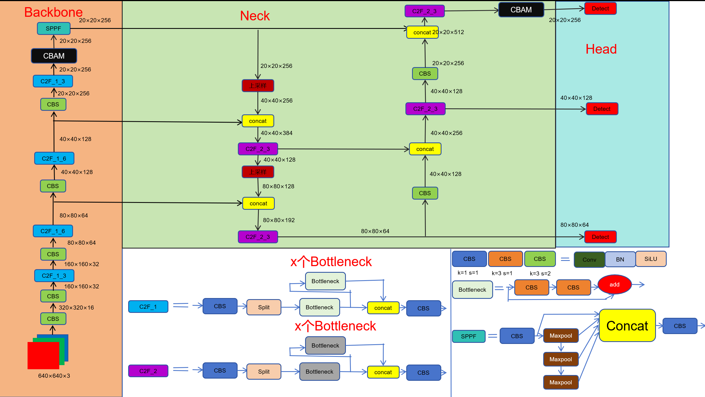
Fig. 1 Improved YOLOv8n Network Architecture
To balance performance gain and computational cost, a selective channel-based injection strategy is adopted: CBAM is applied only when the output channel size (with =224 yielding the best results in our experiments; default setting: =224,only_high_channels=True). This design ensures that attention modules primarily act on high-channel semantic layers (e.g., mid-to-deep layers of the Backbone/Neck), thereby enhancing discriminative capacity under controllable computational cost. Notably, setting the threshold too low may introduce attention into shallow or low-channel layers prematurely, causing the model to overemphasize background noise and reducing focus on key semantic features, which degrades performance. Selective injection into high-channel layers effectively avoids this issue, improving model robustness in complex backgrounds.

Design of the Attention Module (SE-CAM + SAM)
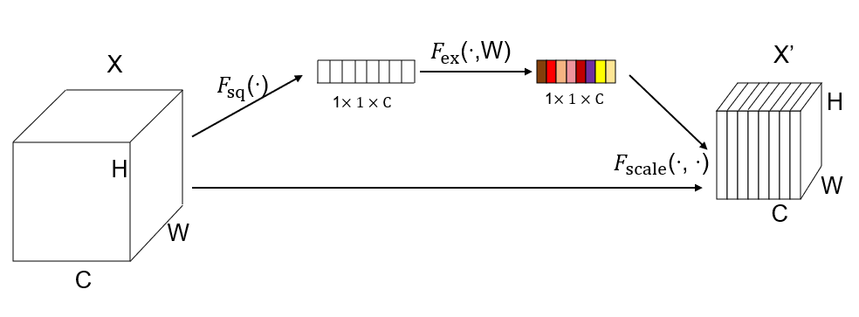
Fig. 2 SE Module
The attention module adopted in this study is denoted as CBAM (SE-CAM + SAM), which consists of the following components:

Channel Attention (SE-CAM):
We employ the Squeeze-and-Excitation (SE) mechanism. Given an input feature , global average pooling (GAP) is first applied to obtain . Two successive 1×1 convolutions (equivalent to an MLP with reduction ratio , where the best performance in this study was achieved at ) followed by a Sigmoid activation generate the channel weight vector . The input is then recalibrated as:
(2)
(This implementation is consistent with the SE module illustrated in Fig. 2.)

Spatial Attention (SAM):
Following the original CBAM implementation [2], given the intermediate feature map (the output of SE-CAM), we compute channel-wise average and max pooling, and . These are concatenated along the channel dimension to obtain [; ] . The result is passed through a k×k convolution (k=7 in this work) followed by a sigmoid activation, producing the spatial attention map . Finally, the recalibrated output is obtained as:
(3)
(This process corresponds to the CBAM module in Fig. 3 and the spatial attention in Fig. 4.)
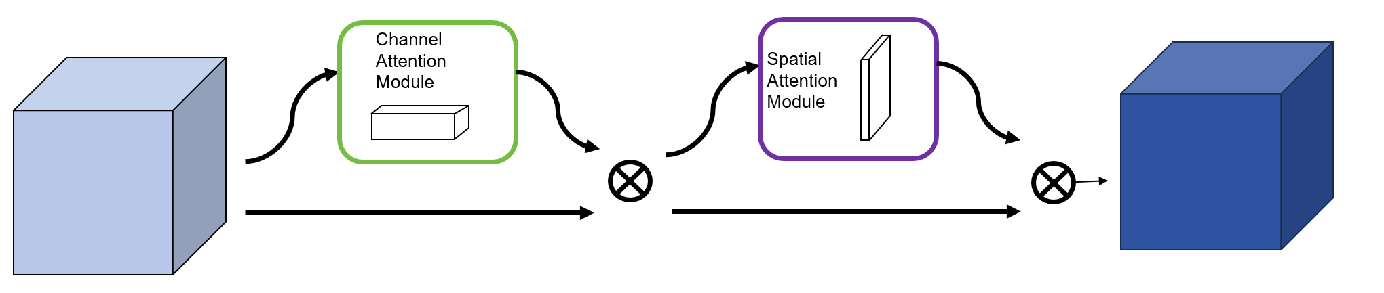
Fig. 3 CBAM Module
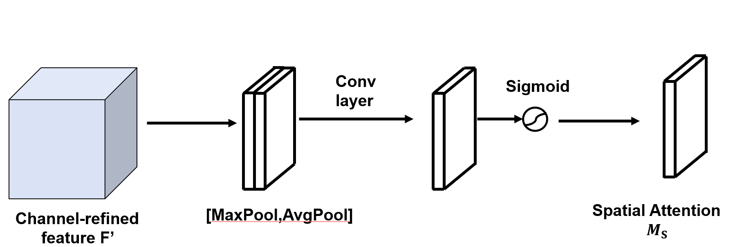
Fig. 4 Spatial Attention Module

Differences from the original CBAM and motivations:
In the original CBAM, channel attention combines both GAP and GMP branches, sharing an MLP before summation and Sigmoid activation. In contrast, our implementation replaces channel attention with SE (GAP only). The motivations are threefold:
Lower computation and parameter cost: The SE module requires approximately parameters; removing the GMP branch further reduces FLOPs and memory usage, making it more suitable for high-resolution and high-channel layers.
Ease of implementation and integration: In the Ultralytics framework, SE is readily available via 1×1 convolutions, enabling direct encapsulation with C2f while preserving strict I/O consistency.
Improved training stability: In complex backgrounds and small-object scenarios (e.g., fine road cracks), SE-CAM effectively suppresses redundant channels and mitigates the amplification of spurious noise peaks.
Meanwhile, the spatial attention of the original CBAM (Avg/Max → Concat → Conv7×7 → Sigmoid) is retained to ensure pixel-level enhancement of salient regions. As a result, the overall design can be regarded as “SE replacing CAM + original SAM”, with the topology consistent with Figs. 3 and 4.

Data Augmentation
In road defect detection tasks, the limited number of original samples and the large variations in acquisition environments often lead to overfitting and insufficient generalization. To address this issue, we introduce data augmentation strategies during training. By applying synchronized transformations to both images and bounding boxes, more diverse and representative training samples are generated, thereby enhancing the robustness and generalization capability of the model.
Data augmentation was implemented using the Albumentations library. All annotations follow the YOLO format (center coordinates and width/height normalized to [0,1]), with strict alignment maintained between images and labels during transformations. Augmented samples were saved in the training directory with the prefix aug_ to distinguish them from the original data. The specific augmentation operations are as follows:
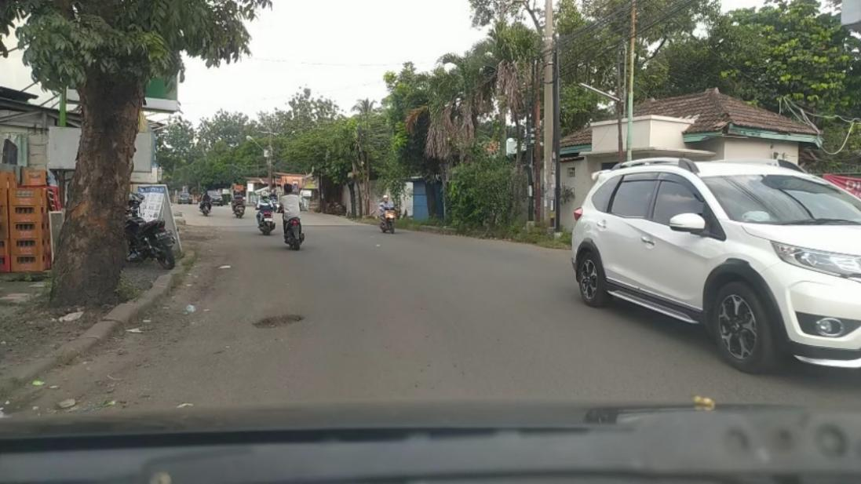
Fig. 5 Example of an Original Image from the Dataset
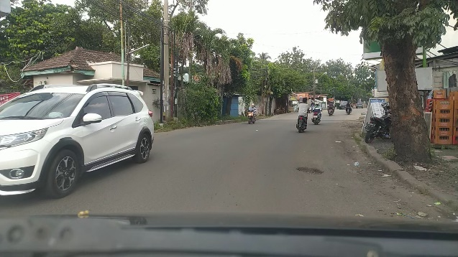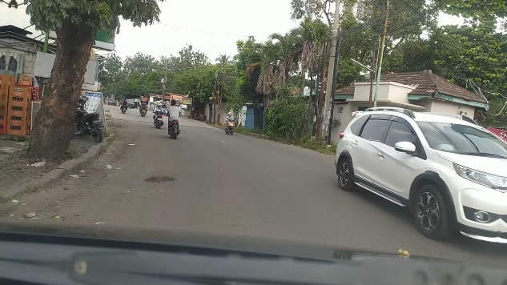
(a) (b)
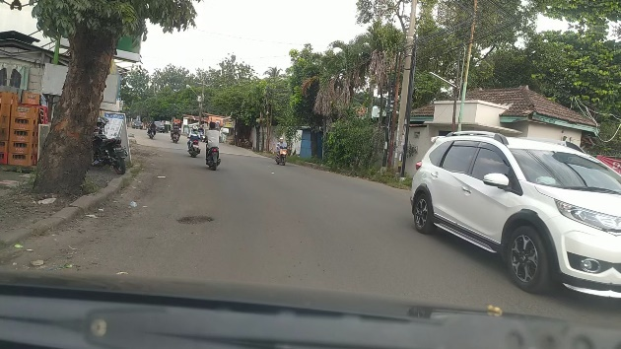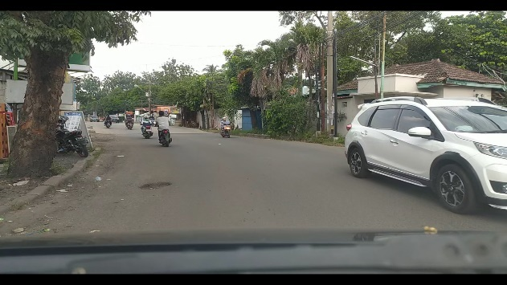
(c) (d)
Fig. 6 Examples of data augmentation results

Horizontal Flip
With a probability of 0.5, images and their bounding boxes are flipped horizontally. This simulates variations in driving direction and improves the model’s ability to learn orientation-invariant representations of road defects (see Fig. 6(a)).

Random Rotation
With a probability of 0.5, images and bounding boxes are randomly rotated within ±10°. This simulates camera angle deviations and device tilts, enhancing the model’s robustness to cracks and potholes appearing in different orientations (see Fig. 6(b)).

Random Brightness & Contrast
With a probability of 0.5, brightness and contrast are randomly adjusted within a range of ±0.2. This simulates natural lighting variations (e.g., shadows, strong light, nighttime), improving the model’s adaptability to complex illumination conditions (see Fig. 6(c)).

Random Scale
With a probability of 0.5, images and objects are scaled within a range of ±10%. This changes the relative size of targets in the image, simulating defects at different capture distances and enhancing the model’s sensitivity to scale variations (see Fig. 6(d)).
In summary, the proposed data augmentation strategies expand the sample space across four dimensions—orientation, angle, illumination, and scale—effectively enhancing the model’s robustness and detection accuracy in complex scenarios.

Experiments

Experimental Setup

Dataset
The experiments in this study use the Road Damage Dataset [3], which is specifically designed for pavement defect detection. The dataset contains real-world road images collected from various cities in Indonesia using dashboard cameras and roadside surveillance devices, covering diverse environments and traffic conditions. In total, it comprises ≈3,322 road-scene images at ~1080p (e.g., 1920×1080) resolution, each annotated with typical pavement defects in YOLO format (normalized x,y,w,h with class labels). Four defect categories are included: Class 0: Pothole, Class 1: Lateral Crack, Class 2: Longitudinal Crack, and Class 3: Alligator Crack.
To quantify class balance, we counted 6,999 labeled instances across the four classes in the curated dataset: pothole 2,657 (≈38.0%), lateral crack 2,156 (≈30.8%), longitudinal crack 1,222 (≈17.5%), and alligator crack 964 (≈13.8%), indicating a moderate imbalance toward potholes and lateral cracks.
For reliable evaluation, the dataset was split into train/val/test = 8:1:1 with a fixed random seed (42) to ensure reproducibility. We adopted the following pre-processing pipeline before training:
(i) keep only valid image–label pairs and harmonize file extensions;
(ii) reorganize files into a YOLO directory structure (images/labels/{train,val,test}) and generate a data.yaml with class names;
(iii) apply data augmentation to the training set only (Albumentations) with explicit ranges—HorizontalFlip (p=0.5), Rotate (±10°, p=0.5), RandomBrightnessContrast (±0.2/±0.2, p=0.5), RandomScale (±10%, p=0.5)—while preserving YOLO boxes; augmented samples are saved with the prefix aug_;
(iv) keep YOLO-style labels (normalized coordinates) without filtering (min_area=0, min_visibility=0), and rely on the Ultralytics dataloader for standard resize to 1280 and input normalization during training/evaluation.
This configuration provides a clear description of dataset size, classes, distribution, and preprocessing so that subsequent experiments are fully reproducible.

Hyperparameters
Table 1 Hyperparameters
Name | Value | Name | Value
epochs | 100 | only_high_channels | True
imgsize | 1280 | high_ch_threshold | 224
batch | 4
Table 1 summarizes the key hyperparameters used in our experiments. The model was trained for 100 epochs with a batch size of 4 and an input image size of 1280. YOLOv8n pretrained weights were used as initialization, and the dataset configuration was specified in the data.yaml file. To evaluate the effectiveness of CBAM, selective attention injection was enabled only for high-channel layers, with the threshold set to 224 and the channel reduction ratio r=32.

Hardware Information
The experiments were conducted on a workstation equipped with a 13th Gen Intel(R) Core(TM) i9-13900HX processor (24 cores) and an NVIDIA GeForce RTX 4060 Laptop GPU with 15.9 GB of memory and CUDA support.

Comparison of Different Models

Baseline (YOLOv8n) , mAP@0.5 = 0.558. （validation）

Baseline + Aug (flip, rotation ±10°, brightness/contrast ±0.2, scale ±10%), 0.578.（validation）

Baseline + CBAM (inserted after high-channel C2f, output ≥224; SE r=32; SAM 7×7), 0.565. （validation）

Baseline + Data Augmentation + CBAM (same CBAM settings; channel threshold = 224), 0.580. （validation）
Validation shows a consistent ranking Baseline < CBAM < Aug < Aug+CBAM, indicating both augmentation and structural modification help; augmentation yields the larger standalone gain, and the combination is best overall. We also varied CBAM settings: smaller r retained redundancy, larger r lost useful cues; a low channel threshold injected attention too early (amplifying shallow noise), while a very high threshold limited it to few deep layers. We therefore adopt r = 32 and threshold = 224 as a good cost–performance trade-off in subsequent experiments.

Experimental Results
Table 2 Comparison of mAP@50 on the Validation Set among the Three Models
mAP50(val) | Baseline | Baseline+Aug | Baseline+CBAM | Baseline+Aug+CBAM
all | 55.8% | 57.8% | 56.5% | 58%
pothole | 0.66 | 0.677 | 0.631 | 0.676
lateral_crack | 0.583 | 0.613 | 0.618 | 0.635
longitudinal_crack | 0.375 | 0.405 | 0.396 | 0.41
alligator_crack | 0.615 | 0.618 | 0.616 | 0.601
According to Table 2, the baseline achieves 55.8%, which rises to 56.5% with CBAM alone, to 57.8% with augmentation alone, and reaches 58% when both are combined. By category (see Table 2), pothole remains relatively stable, with CBAM alone slightly below the baseline (0.631) but the combined model returning close to the augmented level (0.676). For lateral and longitudinal cracks, attention brings clear benefits: lateral improves from 0.583 → 0.618 → 0.635 (baseline → CBAM → aug+CBAM), and longitudinal peaks with augmentation plus CBAM (0.41). For alligator cracks, the best accuracy appears with augmentation alone (0.618), while CBAM slightly reduces performance when combined (0.601), suggesting texture complexity leaves room for further optimization. In summary, although Baseline+Aug+CBAM may not yield the lowest training losses, it delivers the best overall detection performance on the validation set—especially for fine-grained crack defects—confirming the effectiveness of combining data augmentation with attention mechanisms. Moreover, CBAM and each augmentation strategy were individually validated: ablation experiments (Baseline+CBAM vs. Baseline+Aug) isolate their effects and demonstrate their respective contributions.

Conclusion
Automatic road-defect recognition is vital for traffic safety and maintenance, yet complex surfaces and varying illumination still limit deep learning accuracy. We propose a lightweight YOLOv8n enhanced with CBAM placed after high-channel C2f layers, coupled with data augmentation (horizontal flip, random rotation, brightness/contrast adjustment, random scaling) to boost robustness. On the Road Damage Dataset (Kaggle) [3], our method attains 58% mAP@0.5 vs. 55.8% for the YOLOv8n baseline, confirming the effectiveness of attention mechanisms and the role of augmentation in generalization; related studies report similar gains from lightweight attention and diverse augmentations under challenging conditions. Overall, the approach improves road-defect detection accuracy and offers a practical reference for future lightweight detection frameworks.

Discussion
Although our method improves road-defect detection, three areas need further work. First, replacing YOLOv8’s default CIOU with SIOU—intended for elongated, irregular defects—reduced performance, suggesting IoU-based losses (GIoU, DIoU, CIOU) remain inadequate for thin, complex targets [20]; geometry-aware losses or regression strategies are needed to speed convergence and improve localization. Second, inserting CBAM after high-channel C2f layers helps, but outcomes are highly sensitive: conservative compression keeps redundancy, aggressive compression removes useful cues, and applying attention too early amplifies shallow-layer noise while too late weakens its effect; their coupled tuning shows nonlinear interactions, so robust CBAM settings warrant automated search or theoretical analysis. Third, practical deployment is not covered: real-time feasibility, end-to-end FPS/latency, memory, and hardware requirements remain open; future work should benchmark across input resolutions and batch sizes on GPU/CPU/edge devices, report FPS/latency with accuracy, and explore accelerations (mixed precision, layer fusion, pruning/quantization, TensorRT) to close the research-to-deployment gap.

References
- Ultralytics. (2025) YOLOv8 models documentation. Available at: https://docs.ultralytics.com/zh/models/yolov8.
- Woo, S., Park, J., Lee, J., Kweon, I.S. (2018) Convolutional block attention module. In: European Conference on Computer Vision (ECCV 2018). Munich, Germany, pp. 3–19.
- Kaggle. (2025) Road damage dataset. Available at: https://www.kaggle.com/datasets/alvarobasily/road-damage/data.
- Rathee, M., Bačić, B., Doborjeh, M., et al. (2023) Automated road defect and anomaly detection for traffic safety: A systematic review. Sensors, 23(12): Art. No. 5656.
- Zhou, Y., Zhang, L., Wang, H., et al. (2022) Review of intelligent road defects detection technology. Sustainability, 14(10): Art. No. 6306.
- Li, T., Li, G., Chen, H., et al. (2024) Road defect identification and location method based on an improved ML-YOLO algorithm. Sensors, 24(21): Art. No. 6783.
- Wang, J., Liu, F., Zhang, H., et al. (2024) Road defect detection based on improved YOLOv8s model. Scientific Reports, 14(1): Art. No. 16758.
- Zuo, C., Huang, L., Zhao, Y., et al. (2025) Pavement-DETR: A high-precision real-time detection transformer for pavement defect detection. Sensors, 25(8): Art. No. 2426.
- Yang, L., Xu, H., Zhang, Q., et al. (2025) An efficient fusion detector for road defect detection. Scientific Reports, 15(1): Art. No. 27959.
- Wang, X., Gao, H., Jia, Z., et al. (2025) Diffusion-based road defect detection model integrating edge information and efficient multi-scale convolution. Applied Soft Computing, 152: Art. No. 113332.
- Wu, Y., Sun, Z., Guo, X., et al. (2025) Research on the improved YOLOv8-based road damage detection model. In: Proceedings of the 5th International Symposium on Computer Technology and Information Science (ISCTIS 2025). Xi’an, China, pp. 1–6.
- Zeng, K., Fan, R., Tang, X., et al. (2025) Efficient and accurate road crack detection technology based on YOLOv8-ES. Autonomous Intelligent Systems, 5(1): Art. No. 4.
- Rastari, M.A.M., Rahman, A., Noor, S., et al. (2024) Recycle waste detection and classification model using YOLO-V8 for real-time waste management. In: 2024 IEEE International Conference on Artificial Intelligence in Engineering and Technology (IICAIET 2024). Kota Kinabalu, Malaysia, pp. 1–6.
- Ma, J., Xu, L., Chen, H., et al. (2024) An improved bird detection method using surveillance videos from Poyang Lake based on YOLOv8. Animals, 14(23): Art. No. 3353.
- Yakubu, I., Audu, M.M., Zayyanu, Y., et al. (2025) Unmanned aerial vehicle (UAV)-based computer vision model for real-time birds detection in rice farm. Open Journal of Physical Science, 6(1): pp. 1–13.
- Liu, Z., Wang, J., Li, Y., et al. (2023) YOLOv8 for fire and smoke recognition algorithm integrated with the convolutional block attention module. Open Journal of Applied Sciences, 14(1): pp. 159–170.
- Wang, Y., Zhang, F., Liu, M., et al. (2024) Convolutional block attention module–multimodal feature-fusion action recognition: enabling miner unsafe action recognition. Sensors, 24(14): Art. No. 4557.
- Jiang, P., Zhang, J., Chen, J., et al. (2025) Enhanced rain removal network with convolutional block attention module (CBAM): a novel approach to image de-raining. EURASIP Journal on Advances in Signal Processing, 2025(1): Art. No. 9.
- Sengodan, N. (2024) Breast cancer histopathology classification using CBAM-EfficientNetV2 with transfer learning. arXiv preprint, arXiv:2410.22392.
- Zheng, Z., Wang, P., Liu, W., Li, J., et al. (2020) Distance-IoU loss: Faster and better learning for bounding box regression. In: Proceedings of the AAAI Conference on Artificial Intelligence (AAAI 2020), 34(7): pp. 12993–13000.

