Tyler Thatcher

Homework 5

12/12/2018

Homework 5 Write-Up

**Question 1:**

**A:**

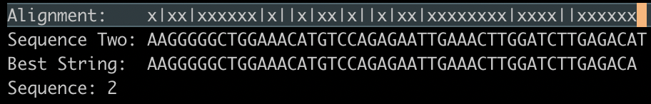

* Sequence one is the entire DENV genome. This is how all sequences are aligned to the DENV genome.

**B:**

* **1000**

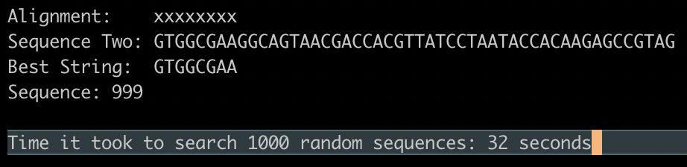

* **10000**

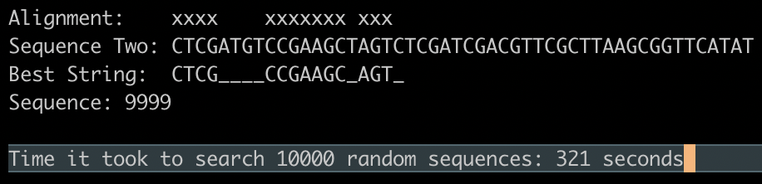

* **100000**
* Based on the previous times, the time it would take to do 100000 should be around 3200 seconds or 54 minutes.
* **1000000**
* Based on the previous times, it seems that this is linear time, so it would be around 32000 seconds or 540 minutes.

**Question 2:**

* Because of the time, I did not get any results for either A or B. I started to code the hash table but ended up not having time. The time it should take to do these alignments should be a lot faster if it was implemented correctly.