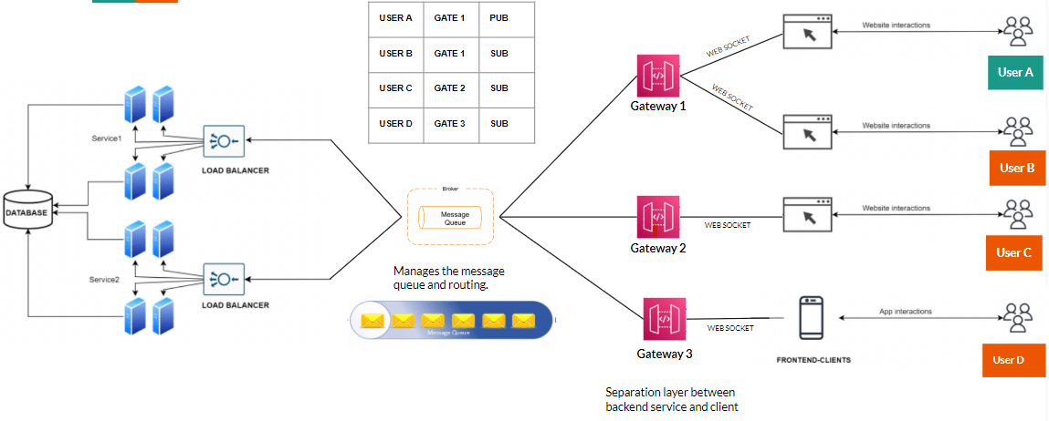
https://www.linkedin.com/posts/sudheerkonduboina_systemdesign-discord-realtimesystems-activity-7483562415607988224-u06g

