WEEK 2: LOGISTICS DATA PREPROCESSING
Data Cleaning, Normalization, Visualization and Validation
Project Report
Dataset: Simulated Logistics Dataset (500 records)
Tools: Python, Pandas, NumPy, Scikit-learn, Matplotlib, Seaborn

1. Introduction
This project focuses on preparing logistics data for analysis. The workflow includes data generation, inspection, cleaning, normalization, visualization and validation.

2. Dataset Description
A simulated logistics dataset was generated using Python with 503 initial rows and 8 columns. It contains order IDs, shipping modes, regions, actual and scheduled shipping days, order quantity, sales and delivery status. The dataset was created for practice and is not a downloaded public dataset.

3. Data Inspection
The raw dataset was inspected using Pandas. Missing values, duplicate records, data types and numeric summaries were checked. The initial dataset contained 10 missing Sales values, 5 missing Shipping_Mode values and 3 duplicate rows.

4. Data Cleaning
Duplicate rows were removed. Missing Sales values were filled using the median, while missing Shipping_Mode values were filled using the mode. Outliers in Shipping_Days_Actual were identified using the Interquartile Range (IQR) method and capped.

5. Data Normalization
Min-Max normalization was applied to Shipping_Days_Actual, Shipping_Days_Scheduled, Order_Quantity and Sales using Scikit-learn's MinMaxScaler. This scales the selected values to a range between 0 and 1.
Formula: X_scaled = (X - X_min) / (X_max - X_min)

6. Data Visualization
Three visualizations were created to examine missing values, delivery comparisons and shipping modes.

Missing Values
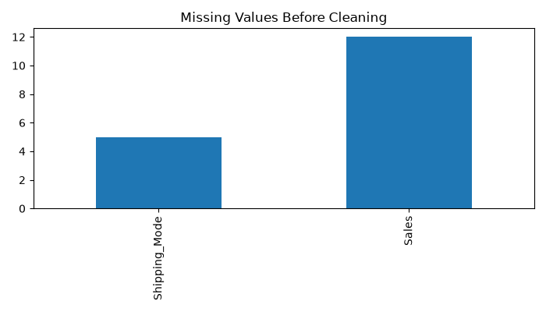

Delivery Comparison
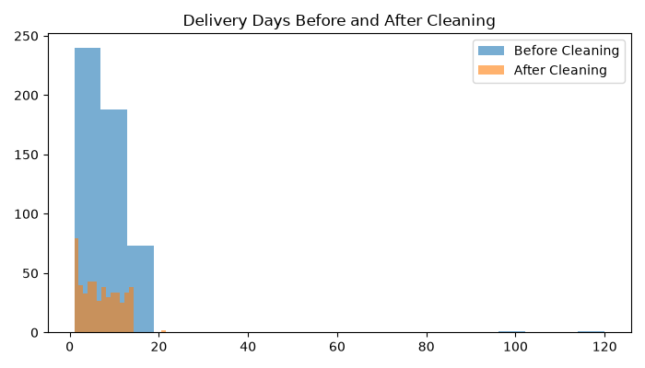

Shipping Modes
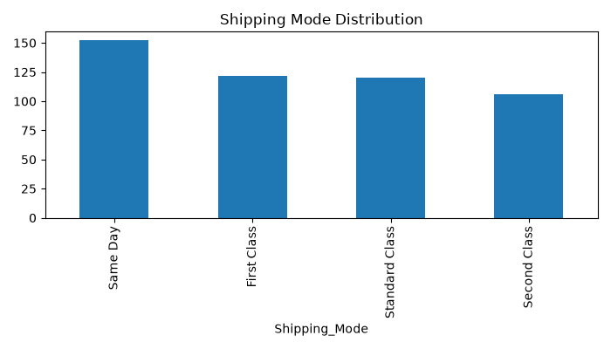

7. Data Validation
The final cleaned dataset contains 500 rows and 8 columns. Validation confirmed zero missing values and zero duplicate rows. The minimum Shipping_Days_Actual value was 1 and the maximum was 21.5 after outlier treatment. The validation script reported that the dataset was clean.

8. Conclusion
The project successfully demonstrated a complete logistics data preprocessing workflow. The cleaned dataset is more consistent and ready for further analysis. The project also provided practical experience with Python data-processing and visualization libraries.

9. Project Files
Python scripts: dataset generation, inspection, cleaning, normalization, visualization and validation.
CSV files: raw, cleaned and normalized logistics datasets.
PNG files: missing values, delivery comparison and shipping modes.

