WEEK 3: ADVANCED DATA ANALYSIS AND VISUALIZATION IN LOGISTICS
Prepared by: T Thitiksha Ritu
B.E. Information Science and Engineering
BMS College of Engineering

1. Introduction
Logistics management involves planning and controlling the movement of goods from one location to another. Data analysis helps organizations understand delivery performance, transportation costs and operational efficiency. This project uses Python to analyze a simulated logistics dataset and present meaningful insights through visualizations.

2. Objectives
- Analyze delivery time and transportation costs.
- Understand shipment patterns across different regions.
- Identify relationships between numerical logistics variables.
- Visualize logistics performance using Python.
- Develop recommendations to improve operational efficiency.

3. Dataset Description
The project uses a simulated dataset containing 600 records and 11 columns. The dataset includes shipment distance, weight, volume, shipping mode, scheduled delivery time, actual delivery time, transportation cost, fuel cost, region and delivery status.

3.1 Data Preparation
The dataset was generated using Python, NumPy and Pandas. A fixed random seed was used to make the simulation reproducible. The generated data represents hypothetical logistics operations and does not represent actual company records.

4. Tools and Technologies
- Python
- Pandas and NumPy
- Matplotlib
- Seaborn
- Visual Studio Code

5. Methodology
- Generated a simulated logistics dataset.
- Loaded and explored the dataset using Pandas.
- Examined data types, missing values and descriptive statistics.
- Calculated correlations between numerical variables.
- Created visualizations using Matplotlib and Seaborn.
- Analyzed results and developed recommendations.

6. Exploratory Data Analysis

6.1 Dataset Overview
Total records: 600
Total columns: 11
Total missing values: 0
Average delivery time: 3.02 days
Median transportation cost: 2712.07
Average delivery distance: 501.59 km

6.2 Delivery Status Distribution
- Early: 434 shipments (72.33%)
- Delayed: 114 shipments (19.00%)
- On Time: 52 shipments (8.67%)

7. Analytical Findings

7.1 Average Delivery Time by Region
- East: 3.07 days
- North: 2.98 days
- South: 2.91 days
- West: 3.08 days

7.2 Transportation Cost by Shipping Mode
- Express: 2717.34
- Same Day: 3154.81
- Standard: 2243.13

7.3 Average Transportation Cost by Region
- East: 2635.86
- North: 2615.73
- South: 2642.71
- West: 2797.2
The region with the highest average transportation cost is West.

7.4 Distance and Transportation Cost
The correlation between distance and transportation cost is 0.784. This indicates the strength and direction of the linear relationship between these variables.

7.5 Delayed Shipments
There are 114 delayed shipments out of 600 total shipments.

8. Data Visualizations

Figure 1: Delivery Time Distribution
A histogram with a density curve shows how delivery times are distributed. It helps identify common delivery durations and the spread of delivery performance.
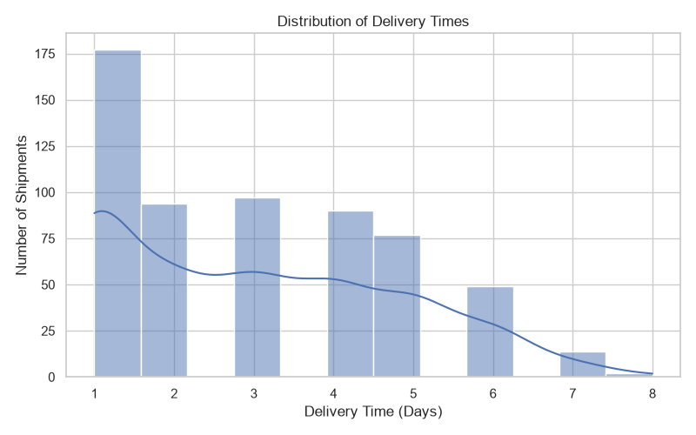

Figure 2: Transportation Cost by Shipping Mode
A boxplot compares transportation costs across shipping modes. It helps identify differences in cost levels and variation.
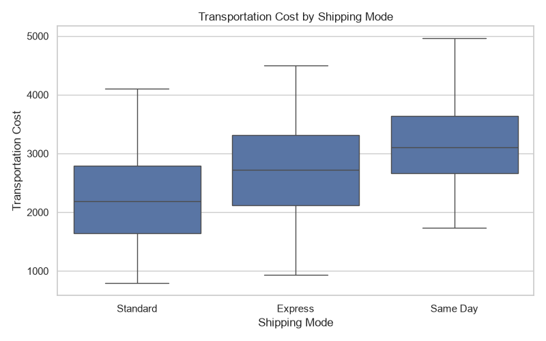

Figure 3: Distance vs Transportation Cost
A scatterplot displays the relationship between shipment distance and transportation cost, with shipping modes shown separately.
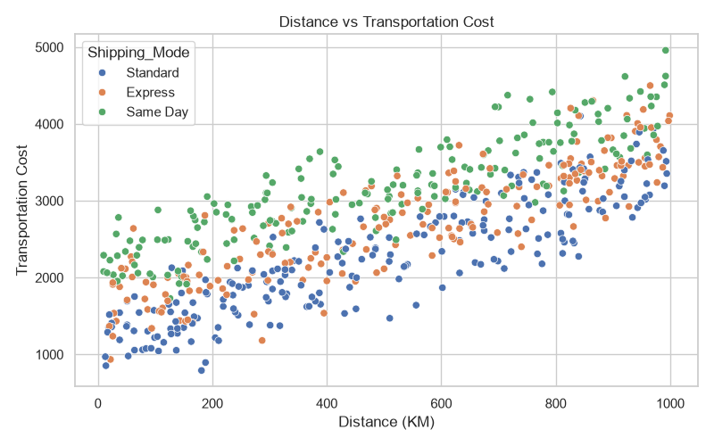

Figure 4: Correlation Heatmap
A heatmap summarizes correlations between numerical variables. It helps identify positive and negative relationships.
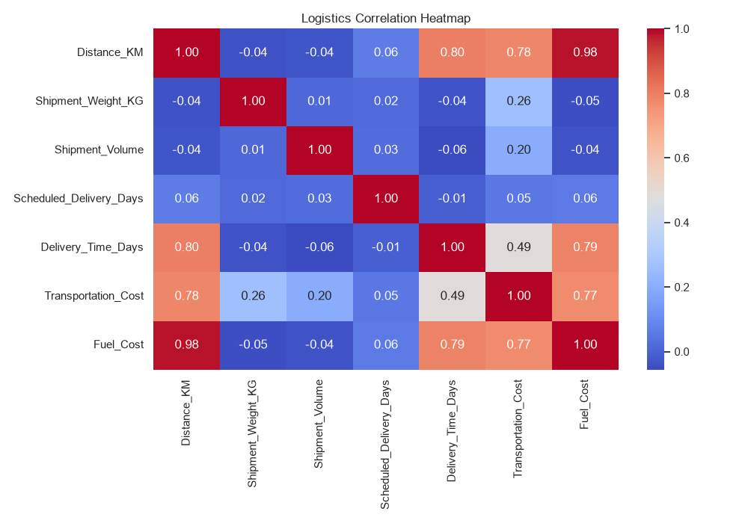

Figure 5: Delivery Status by Region
A countplot compares delivery status across regions and helps identify differences in shipment outcomes.
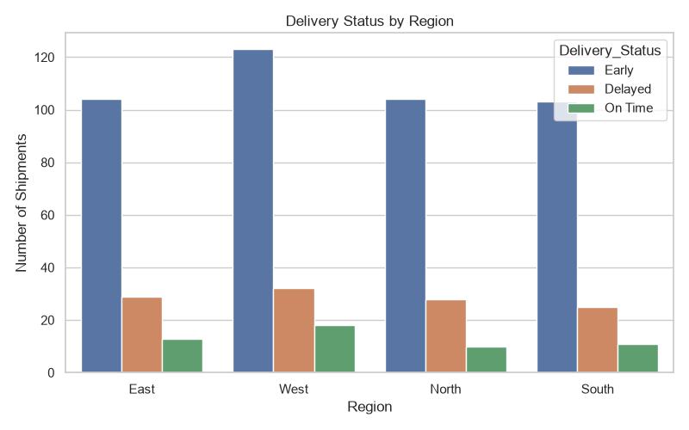

9. Recommendations
- Monitor delivery delays regularly across regions.
- Use transportation cost analysis to support budget planning.
- Review long-distance shipments to understand their cost impact.
- Compare shipping modes before selecting a delivery method.
- Use data visualization dashboards for continuous performance monitoring.

10. Limitations
This project uses simulated data rather than real company logistics records. The relationships in the dataset were designed for learning and analysis. Therefore, the findings demonstrate analytical methods and should not be treated as verified real-world operational results.

11. Conclusion
This project demonstrated how Python can be used for advanced data analysis and visualization in logistics. Pandas and NumPy supported data exploration and statistical analysis, while Matplotlib and Seaborn were used to create meaningful visualizations. The analysis helped examine delivery performance, transportation costs and relationships between logistics variables. These techniques can support informed decision-making and operational improvement.

12. Python Scripts Used
- generate_dataset.py
- data_analysis.py
- correlation_analysis.py
- data_visualization.py
- analytical_insights.py
- create_report.py

