Call for Pilots Manual: Work Strand 1 - Connecting Existing Local Digital Twins
November 2025

Lead author:
Technopolis Consulting Group Belgium

Contributing authors:
Tallinn University of Technology
Centre for Studies and Expertise on Risks, the Environment, Mobility and Urban Planning
European Network of Living Labs
Open & Agile Smart Cities
FIWARE Foundation

Disclaimer
Funded by the European Union. Views and opinions expressed are however those of the author(s) only and do not necessarily reflect those of the European Union or European Commission. Neither the European Union nor the granting authority can be held responsible for them.
Abbreviations and acronyms
Abbr. | Description | Abbr. | Description
AI | Artificial Intelligence | GA | Grant Agreement
ALTAI | AI HLEG's trustworthy AI assessment list | GDPR | General Data Protection Regulation
CA | Consortium Agreement | IDSA | International Data Spaces Association
Cerema | Centre d'études et d'expertise sur les risques, l'environnement, la mobilité et l'aménagement (Centre for Studies and Expertise on Risks, the Environment, Mobility and Urban Planning) | IEC | International Electrotechnical Commission
CfP | Call for Pilots | ISO | International Organization for Standardization
CFS | Certificate on Financial Statements | KPI | Key Performance Indicator
DA | Data Act | LDT | Local Digital Twin
DEP | Digital Europe Programme | LDT CitiVERSE EDIC | CitiVERSE European Digital Infrastructure Consortium
DGA | Data Governance Act | LDT4SSC | Local Digital Twins for Smart Sustainable Communities project
DS4SSCC | Data Space for Smart and Sustainable Cities and Communities project (preparatory action) | LIST | Luxembourg Institute of Science and Technology
DS4SSCC-DEP | Deployment project for the European data space for smart communities project (deployment action) | MIMs Plus | Minimal Interoperability Mechanisms
DSSC | Data Spaces Support Centre | OASC | Open & Agile Smart Cities
EC | European Commission | OCD | Ownership Control Declaration
ECA | European Court of Auditors | OCT | Overseas Countries and Territories
EDIC | EU Digital Infrastructure Consortium | OLAF | European Anti-Fraud Office
EEA | European Economic Area | PDF | Portable Document Format
EIF | European Interoperability Framework | PIC | Participant Identification Code
ENoLL | European Network of Living Labs | SIMPL | EU programme for Smart Middleware Platform, comprising of SIMPL Open, SIMPL Labs and SIMPL Live
EU | European Union | SME | Small and medium-sized enterprise
FAQ | Frequently Asked Questions | TalTech | Tallinn University of Technology
Fiware | FIWARE Foundation | TEF | Testing and Experimentation Facility (CitCom.ai)
FRAIA | Fundamental Rights and Algorithm Impact Assessment | TGB | Technopolis Consulting Group Belgium

Glossary
Term | Description
LDT4SSC Consortium | The LDT4SSC consortium includes a total of 10 partners: OASC, FIWARE, TalTech, ENoLL, Technopolis Consulting Group Belgium (TGB), Kereval (KEREVAL), The Luxembourg Institute of Science and Technology (LIST), Cerema, Libelium (LIBELIUM LAB) and UGent-IDLab (UGent).
Eligibility Check Grid | The checklist is used by the LDT4SSC consortium to check Call for Pilots applications against a set of defined eligibility criteria (legal, financial, technical, ethical).
Ethical Board | The Ethical Board comprises a distinct group of experts that is established to assess ethical issues in the LDT4SSC Project. They will be asked to propose mitigation measures when ethical issues are identified.
Evaluation Committee | The Evaluation Committee covers a dedicated group of experts from LDT4SSC partners and external stakeholders who are responsible for evaluating the Call for Pilots applications. The intention is to have different Evaluation Committees nominated to evaluate the different Call for Pilots which happens across three waves
Evaluation Team | The Evaluation Team is made up of selected people from the LDT4SSC project partners who have been assigned responsibility for organising the whole evaluation process and running the pre-screening of applications. Similarly, the Evaluation Team is tasked to provide both the final ranking and selection of the pilots.
Third-party | A third party is, by definition, anyone not directly involved in the grant: neither the contracting authority nor the beneficiary (including coordinator, co-beneficiaries if any or affiliated entities if any)
Lead Partner | A Lead partner represents the legal entity that is responsible for the pilot implementation and carries out the coordination of the concerned pilot. It is preferred that the lead partner is a local or regional public administration in the EU Member States.
Pilot Consortium | A Pilot Consortium refers to a collaboration of two or more participating organisations teaming up to jointly implement a project or an activity within a project.
Steering Committee | The committee responsible for making decisions regarding third-party funding, based on the evaluations conducted by the Evaluation Committee(s) and the Ethical Board. It consists of one representative from each private entity in the LDT4SSC consortium.

Table of contents
Executive summary 7
1. Introduction 8
1.1. About the Local Digital Twins for Smart and Sustainable Communities 8
2. Call for pilots framework 10
2.1. Aim of the calls for pilots 10
2.2. Scope of Work Strand 1 11
2.3. Specific targets for Work Strand 1 13
2.4. Consortia eligibility 14
2.5. Financial framework 16
2.5.1. Form of grant, maximum grant amount and reimbursement rate 16
2.5.2. Co-funding model 16
2.5.3. Eligibility of costs 17
Personnel costs 18
Subcontracting costs 18
Purchase costs 18
Indirect costs 18
Ineligible costs 18
2.5.4. Reporting 19
Pilot Deliverables 19
2.5.5. Payment procedures 20
2.5.6. Certificate of financial statement 21
2.6. Non-Technical Framework for Work Strand 1 21
2.7. Technical framework for Work Strand 1 22
2.8. Description of requirements & recommendations 24
Pilot Details 24
Relevance 25
Implementation 26
Impact 28
2.9. Ethical and data protection framework 29
2.9.1. Compliance with relevant legislation 30
2.9.2. Complaints and appeals 30
2.9.3. Confidentiality, privacy notice and usage of applicants’ data 31
2.9.4. Dissemination of results and Intellectual Property 31
3. Call for Pilots Process 32
3.1. Call for pilots timeline 32
3.2. Documents for submission 33
3.3. Where to apply and how 34
4. Call for Pilots Evaluation 34
4.1. Evaluation process 34
Pre-screening of the applications through eligibility check 34
Evaluation by Evaluation Committee and Ethical Board 36
Decision communication 39
Contract negotiation and signing 39
Final preparations 40
Project start 40
4.2. Checklist 40
5. Applicants support 41
5.1. Support during the application phase 41
5.1.1. The LDT4SSC Pilot Helpdesk 41
5.1.2. Confidentiality and data protection 42
6. Training and supporting activities 42
7. Monitoring and assessment 42
8. Annex 1 - Required Documents 44
8.1. Financial form 44
8.2. Commitment letter template 44
8.3. Ethics and data protection self-assessment template 44
9. Annex 2 - Information for context 44

List of Figures
Figure 1. From DS4SSCC to LDT4SSC: LDT4SSC Smart Communities Ecosystem 9
Figure 2. LDT4SSC three Work Strands across five Open Calls 11
Figure 3. Functional scope of a Data Space vs. of a Digital Twin 12
Figure 4. Meta-architecture for LDTs and Value-added services 24
Figure 5. LDT4SSC logo to be displayed by pilots
in their communication 32
Figure 6. Consistent use of the EU logo to be displayed by pilots
in their communication 32
Figure 7. Expected piloting process for all five calls 34
Figure 8. Monitoring and assessment framework 43
Figure 9. LORDIMAS 6 stages of Digital Maturity 45
Figure 10. Data governance – A Pilot’s strategy throughout political,
technical, legal and organisational aspects 47

List of Tables
Table 1. LDT4SSC partners 10
Table 2. Timeline for Call For Pilots for Work Strand 1 33
Table 3. Eligibility Check Grid for Work Strand 1 (legal, financial, technical, ethical) 35
Table 4. Evaluation criteria 37
Table 5. Preliminary ranking by Evaluation Committee for one pilot 39
Table 6. Checklist for applicants before Submission 40

Executive summary
This manual serves as a comprehensive guide for the Call for Pilots (CfP): Work Strand (WS) 1 – Connecting Existing Local Digital Twins, for the Local Digital Twins for Smart and Sustainable Communities (LDT4SSC), funded by the European Union. The objective of the LDT4SSC project is to build a robust, scalable ecosystem of local digital twins and stimulate the market for innovative, Artificial Intelligence (AI)-driven Local Digital Twin (LDT) services. The project also seeks to address barriers to AI adoption in Europe, such as limited investment, regulatory complexity, and gaps in expertise. It supports the development of advanced AI-driven digital twin solutions by pooling public sector demand and ensuring a fair, competitive environment for innovators.
This document provides a comprehensive description of the overall CfP process, covering the scope of the call, its framework, the financial, ethical, and technical specifications, and the support to applicants. It further sets out the timeline, the evaluation, and the journey towards contract signing. This document also includes several Annexes covering all the information relevant to announcing the Call and supporting documentation for the CfP application. Parts of this document build on the CfP Manual of the European data space for smart communities project (DS4SSCC-DEP), adapted to the context of LDT4SSC.
This CfP is part of a total of five open calls foreseen in the LDT4SCC project and will cover three WS. WS1: Interconnecting existing LDTs to create a federated European Union (EU) wide network supporting seamless data exchange; WS2: Creating new LDTs based on common urban challenges like mobility, energy, air-quality and waste management to foster replicable solutions; and WS3: Advanced AI-based tools and innovative open-source components to enhance LDT capabilities with immersive and predictive services. The implementation of the pilots in each call is envisioned to last between 12 and 18 months.
The WS1 call is aimed at the following stakeholders: Public administrations at local, regional and national levels, serving the needs of local communities, together with their partners such as businesses, technology developers, research institutions and academia, and non-governmental organisations. The total EU funding available for the pilots in this call amounts to at least €5,1 million. The following financial rules apply:
- The maximum grant awarded per third-party across pilots is €500,000;
- The maximum cumulative grant per consortium is €1,000,000;
- Applicants are required to cover at least 50% of total pilot costs.
The call for pilots manual is structured as follows:
- Chapter 1 provides the Executive Summary and Introduction to the project and open calls.
- Chapter 2 outlines the broader framework for the open call, by providing the scope for the Work Strand and the objectives. It further describes who can apply, the financial framework, the non-technical framework and the technical framework for the pilots.
- Chapter 3 covers the process and timeline for the open call as well as instructions on how to apply.
- Chapter 4 covers the evaluation framework and selection criteria.
- Chapter 5 explains the support infrastructure available for applicants.
- Chapter 6 and 7 provide an overview on training and supporting activities as well as the monitoring framework.
- Lastly, the Annex includes the different documentation part of the application package, covering the Call for pilots Manual, the Application Form, the Financial Form, the Ethics and Data Protection Template and the Letter of Commitment template.

Introduction

About the Local Digital Twins for Smart and Sustainable Communities

The LDT4SSC project is funded by the Digital Europe Programme and has the following key objectives:
- Connecting existing LDTs from cities and communities to create a federation of LDTs across the EU. Reinforced interoperability through the aggregation of LDTs at a larger scale (cross-sectors, cross-cities and cross-borders) will help in scaling up European common data sets and open-source solutions. It will also facilitate less advanced cities and communities joining the existing EU LDT ecosystem.
- Expanding existing local LDTs with new open-source LDT services based on shared needs of cities and communities. These services should aim to improve decision-making processes and citizen interaction, reduce risks, costs, downtime and enhance resilience and sustainability of LDT platforms while enabling new value creation.
- Complementing the EU LDT Toolbox launched under the Digital Europe Work Programme 2021-22 with additional AI-based and innovative services (e.g. for adaptable multi-sector considerations, advanced simulation and modelling approaches including bottom-up self-organised models). The AI services will be developed and tested within existing cities/communities and be replicable in other contexts.
These objectives form the foundation of an LDT ecosystem that empowers communities to collaborate effectively while advancing Europe’s digital transformation.
This project seeks to build a robust, scalable network of Local Digital Twins (LDTs) and stimulate the use of innovative, data-driven and AI-driven LDT services. It builds on- and integrates- outputs from related EU-funded projects and initiatives, such as the deployment project for the European data space for smart communities (DS4SSCC-DEP), the EU LDT Toolbox, CitiVerse EDIC projects Living-in.EU, CitCom.ai, and the Smart Middleware Platform (SIMPL) leveraging existing knowledge, tools, and stakeholder networks. By doing so, this project contributes directly to the Digital Europe Programme’s (DEP) objectives of enhancing technological sovereignty, promoting ethical AI, and fostering an inclusive digital market, while integrating ongoing initiatives including the Networked Local Digital Twins towards the CitiVERSE European Digital Infrastructure Consortium (LDT CitiVERSE EDIC), as well as supporting policy goals like the New European Bauhaus, the Green Deal, and the Digital Decade. The figure below shows how LDT4SSC is positioned in the wider network of initiatives and the evolution from the Data Space for Smart and Sustainable Cities and Communities project (DS4SSCC) to LDT4SSC. Together, these efforts will establish a resilient LDT infrastructure that enables European communities to optimise urban services, share resources, and tackle shared challenges such as climate change, air quality, waste, and energy efficiency.
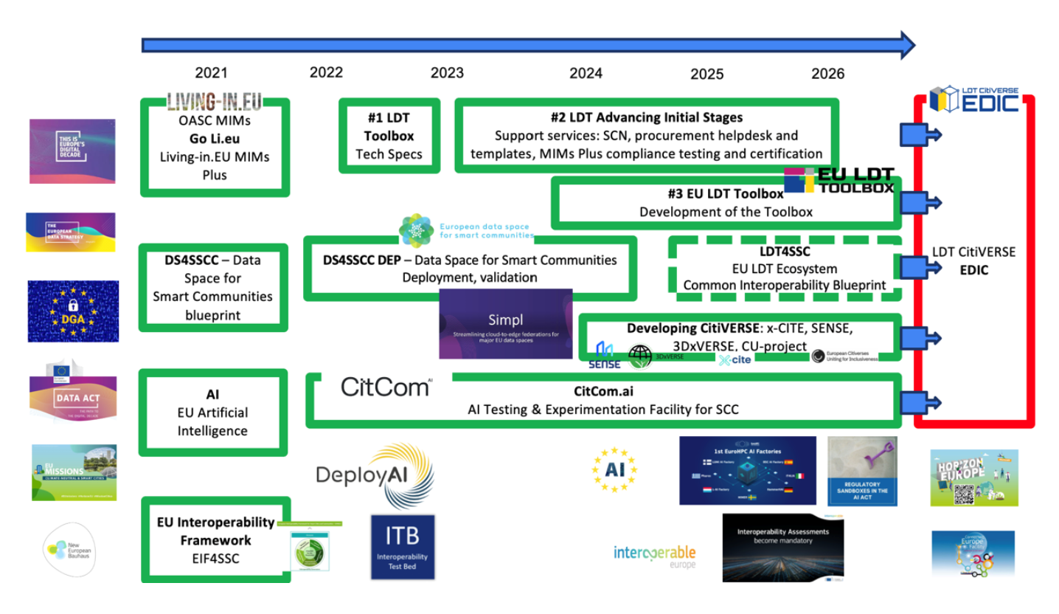

Figure 1. From DS4SSCC to LDT4SSC: LDT4SSC Smart Communities Ecosystem
The project also addresses broader barriers to AI adoption in Europe, which include limited investment, regulatory complexity, and gaps in expertise. By pooling public sector demand and ensuring a fair, competitive environment for innovators, it supports the development of advanced AI-driven digital twin solutions. This approach benefits both the public and private sectors, aligns with the European Union EU priorities for ethical AI and open standards, and reduces reliance on foreign technologies.
The LDT4SSC project is implemented by 10 partners, outlined in Table 1.

Table 1. LDT4SSC partners
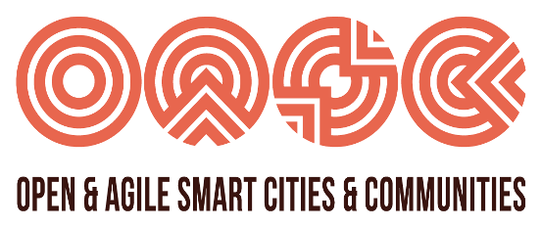 |  | 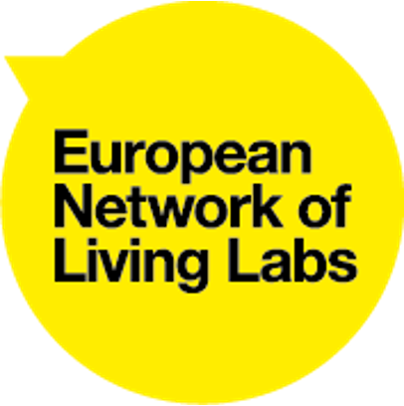 |  | 
 | 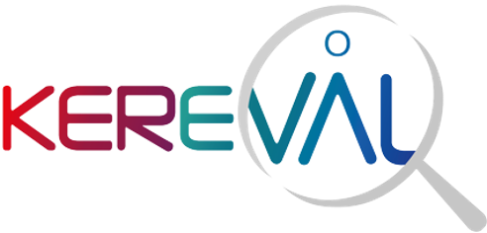 |  |  | 
In close alignment with the LDT CitiVERSE EDIC, the project accelerates the deployment of interoperable digital infrastructures across Member States, fostering a cross-border collaboration. In doing so, it contributes to the DEP’s vision of a resilient, unified digital landscape.

Call for pilots framework

Aim of the calls for pilots
The aim of the open calls for pilots is to engage European local and regional authorities and its various stakeholders, ranging from public administrations at local, regional and national levels, businesses, technology developers, suppliers, research institutions, and academia to participate in building a networked ecosystem of LDTs. The calls are designed to ensure transparency, equal treatment, and compliance with EU standards, including legal, financial, ethical, and technical requirements.
The Open Calls are structured around three specific Work Strands (WS), outlined below, each targeting a key aspect of the LDT ecosystem.
Ultimately, the calls aim to select high-quality pilot projects that can contribute to creating an interconnected LDT ecosystem, promote collaboration among stakeholders, and accelerate the deployment and adoption of advanced digital twin services across Europe.
Work Strand 1 (WS1) focuses on interconnecting existing LDTs to create a federated EU-wide network supporting seamless data exchange and interoperability;
Work Strand 2 (WS2) aims at creating new LDTs based on common urban challenges like mobility, energy, and sustainability to foster replicable solutions;
Work Strand 3 (WS3) develops advanced AI-based tools and innovative open-source components to enhance LDT capabilities with immersive and predictive services.
Together, these strands support scalable, sustainable, and inclusive digital transformation aligned with European policies and market development.

WS1: Technical Interconnection of Existing LDTs
Linking and scaling digital twins that are already in place.

WS3: Adding New Advanced AI-Based Tools to the LDTs Toolbox
Integrating AI-driven, value-added services to enhance existing LDTs.

WS2: Creation of LDTs Based on Common Needs
Addressing shared urban or regional challenges (e.g., cross-border traffic, air pollution).

2 Open Calls
2 Open Calls
1 Open Call

Figure 2. LDT4SSC three Work Strands across five Open Calls

This document focuses on the technical specifications for Work Strand 1, explained in the following section.

Scope of Work Strand 1
WS1 is dedicated to connecting and federating LDTs across cities, communities and regions to create a unified, interoperable and reusable EU LDT ecosystem. In doing so, WS1 will support communities in accessing a comprehensive set of technical open specifications and open-source software components to interconnect their LDTs through Data Spaces, with most solutions expected to align with the SIMPL framework where appropriate. These efforts are expected to draw on the European Data Space for Smart and Sustainable Cities and Communities (DS4SSCC) as well as relevant thematic data spaces such as those for tourism, mobility and other domains, with which data exchange is envisaged.
By leveraging standards, pilots will break down silos, scale up EU-wide datasets and onboard less-advanced communities into the LDT network. The goal is hence to enhance decision-making (particularly in key EU policies(like mobility, energy efficiency, or environmental), reduce redundancies and foster a collaborative data economy, ultimately laying the foundation for a resilient, interconnected digital infrastructure that supports Europe’s green and digital ambitions.
Through real-world use cases —such as cross-border traffic management or multi-city resource optimisation— it is expected that WS1 will transform fragmented local initiatives into a cohesive, replicable,scalable and reusable federation of LDTs, driving collective innovation and efficiency.

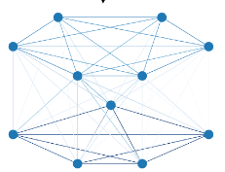Figure 3. Functional scope of a Data Space vs. of a Digital Twin
Scope of a Local Digital Twin

Knowledge models
Data
(Incl. IoT)
Context
Brokers
Identity
ETL
Code
Visualisation
Tools
Data
Services
Policy

Catalog

Data
Services
Policy
Identity
Data
Catalog
Scope of a Data Space (basis for a data governance)
Context
Brokers

Once a pilot project has clearly defined its non-technical dimensions, it should also specify its technical aspects. This step should be based on a solid understanding of both the LDT and the Data Space. An LDT enables functions such as data analysis and visualisation, while a Data Space facilitates data collaboration by managing data “transactions” -going beyond simple cataloguing or contractual arrangements for data sharing (see Figure 2).
This document does not aim to completely and unambiguously define a “Local Digital Twin”, as this field is continuously evolving. Many architectures and reference implementations already exist. For more information, a comprehensive overview of literature and evolutions in the field can be found by consulting the MIMs Plus 8 Working Group on Local Digital Twins’ documentation. What follows is a practical example for the sake of this Call for Pilots:
Figure 3 describes common LDT components:
- The core of a Digital Twin is built around a context broker, specifying the function for contextual information on where the data was collected, and a knowledge meta-model, the latter linking the various domain-specific knowledge data models that the Digital Twin manages.
- Other additional software components offering:
  - Integration of data (Extract - Transform - Load, ETL),
  - Management of access rights to the digital twin's data and services (Identity, Authorisation),
  - Production of visualisations,
  - etc.
Digital Twins are further supplied with data from the context broker and complemented by a Business Intelligence (BI) layer, which enables the generation of tangible results for end-user data analysis. Same goes for the scope of the data space, the green-dotted line around the Context Broker means that it is not a mandatory component of a data space.
While not essential to the core functioning of the Digital Twin, the scope components shown with dotted lines (Policy and Catalog) play a key role in enabling interconnection with other Digital Twins:
- Policy describes the obligations and rights of both the data producer and the user. These are typically formulated using Open Digital Rights Language (ODRL). Such specifications are then interpreted by the authorisation component (such as Open Policy Agent).
- Catalog: A solution that enables the cataloguing of one’s own data (by exposing its metadata) and the consumption of data from other catalogues to support interconnection, ideally using well-established standards such as DCAT.
Figure 3 (left) shows that interconnecting data spaces with LDTs involves all dimensions of contractual data management. Data spaces seeking to interconnect with LDTs must manage Identity (using Verifiable Credentials), implement specific Policies, and provide Data, Data Services, and Catalogs. The green dotted lines indicate that integrating a context broker is not mandatory, but it is recommended for effective interconnection with Digital Twins.

Specific targets for Work Strand 1
While overarching considerations ensure cohesion across the LDT4SSC initiative, each of the three WS defines its own specific targets to reflect the different stages of LDT maturity, technical complexity and strategic focus within Europe’s digital transformation. These tailored objectives help ensure that each Strand engages the appropriate mix of stakeholders, technical expertise and use cases to align pilot ambitions with the distinct goals of the respective Strand.
WS1 focuses on federation and interoperability, requiring pilots to prioritise cross-border data exchange and the creation of shared data spaces —demanding a baseline of digital maturity and collaboration among multiple public authorities. Ensuring that pilots meet this baseline helps reduce the risk of misaligned expectations, inefficient use of resources and solutions that fall short of addressing the specific challenges within each focus area.

WS1 Specific Targets
To connect LDTs from cities and communities that already have an LDT in place;
To create an EU federation of LDTs, which focuses on creating a strong foundation for interoperability across existing LDTs;
To foster a unified data ecosystem that enhances decision-making particularly for key EU policies and reduces redundancies;
To connect public authorities that are willing to share data, models and services with other data platforms (LDT, open data platforms, data lakes, data warehouse, etc.) and/or data spaces;
To support seamless data exchange and integration, both within individual communities and across regional networks;
To foster a unified data ecosystem that enhances decision-making and reduces redundancies;
To foster the development of skills among all pilot members including companies offering technical solutions for a better interconnection, a better maturity of components and documentations.

The first Open Call (WS1) targets communities that already operate Local Digital Twins (LDTs), aiming to interconnect them and lay the foundation for a broader LDT ecosystem. Pilots selected in the second and third rounds will be encouraged to integrate with this ecosystem while developing new LDT or AI-based services.
To qualify, pilot projects must demonstrate a strong commitment to sharing both data and services through LDT interconnection; for example, enabling one authority’s twin service to be used by another. Achieving this requires effective data sharing, enrichment, and the adoption of common data governance practices. Through such collaboration, communities and local authorities can collectively enhance the efficiency, interoperability, and impact of their public services, as well as providing evidence of compliance with key EU policies on sustainability and environmental friendliness for cities.
Pilot projects may achieve this interconnection by deploying or joining an already existing data space. The results are to be open-source,replicable and shareable within the LDT CitiVERSE EDIC.

Consortia eligibility
The Open Call aims to address a diverse variety of local and regional communities. Accordingly, participation is open, but not limited, to:
- Public administrations at local and regional levels,
- Public administrations at national level, European Digital Infrastructure Consortia (EDICs) such as the LDT CitiVERSE EDIC,
- Businesses, technology developers, and suppliers,
- Research institutions and academia,
- Non-governmental organizations (NGOs), non-profit organisations and other civil society actors.
Each pilot consortium must comprise at least two local and regional authorities drawn from two different eligible countries. Eligible countries include:
- EU Member States, including their outermost regions, (together with their overseas countries and territories (OCTs)),
- Non-EU countries (Norway, Iceland, Liechtenstein)
- Listed European Economic Area (EEA) countries and DEP Associated countries.
Additionally, in order to ensure replicability and scalability potential of the pilot, each consortia is required to involve at least one additional partner drawn from one of the following categories:
- Private entity (e.g., service provider)
- Private association (with legal status)
- Trusted third party
- Private representative of a use-case sector.
Member(s) of the LDT4SSC Consortium are not allowed to be part of the pilot consortia.
Owing to security considerations, restrictions apply to the composition of pilot consortia:
- Entities must not be under the control of an ineligible country. Where there is a risk of such control, the entity will be required to provide a guarantee, which will be subject to assessment.
- All participants, with the exception of entities already validated as public bodies by EU Member States, must complete an Ownership Control Declaration (OCD). This must be self-declared at the proposal stage, and, in the case of a successful award, the official OCD must be submitted within 14 days of notification.
- Should an assessment reveal that a consortium member is controlled by an ineligible country, participation will be conditional on the submission and acceptance of an adequate guarantee. These guarantees will be examined on a case-by-case basis, taking account of the specific legal and factual circumstances.
- Participation is restricted to entities established in eligible countries, whether acting as beneficiaries, affiliated entities, associated partners, subcontractors, or recipients of financial support to third parties.
- All project activities, including subcontracted work, must also take place within eligible countries.
- Participants from DEP-associated countries (with the exception of EEA members) are required to provide an appropriate guarantee, approved by their country of establishment, in order to comply with the provisions of this Call for Pilots Manual.
- While consortia may, in principle, be led by any eligible partner, preference is given to EU local and regional authorities as Lead Partners. Where this is not the case, additional eligibility checks will be applied, covering ownership control, solvency, and state aid compliance. These checks may delay the commencement of the pilot or affect pre-financing arrangements.
- The grant agreement (GA) will be signed exclusively with the Lead Partner, who will hold primary responsibility for project implementation. Consortium partners are, in turn, required to conclude a Consortium Agreement (CA) among themselves.
Applicants should further note that no organisation (legal entity) may be awarded more than one grant as Lead Partner under this framework. Where multiple applications from the same organisation are shortlisted in the respective Open Calls, only the highest-ranked proposal will be retained for funding.
The organisation’s role as a Lead Partner will be checked in each final ranking process to determine whether it had already been awarded funding in previous calls. For this purpose, public administrations or universities will be treated as a single organisation represented by one legal entity, irrespective of the functional independence of their departments or units.
Final checks during the ranking phase will verify participation using, inter alia, the organisation’s national registration number (e.g. VAT, national code, social security number, Participant Identification Code (PIC)), its legal name, and the name of its legal representative.
Organisations (legal entities) can be involved in multiple grants under this framework, however, organisations can at most be acting as Lead Partner in one pilot throughout the entire open calls.

Financial framework

Form of grant, maximum grant amount and reimbursement rate
Financial support will be provided in the form of grants, reimbursed on the basis of actual eligible costs incurred and reported through interim and final reporting. Indirect costs will be calculated as a flat rate of 7% of eligible direct costs, in line with the rules of the DEP.
The total EU funding available for the pilots amounts to €17 million (85% of the total budget of the LDT4SSC project). In accordance with the Call document, the project will allocate at least 5.1 million (30% of the total budget for pilots) to Work Strand 1.
The following financial rules apply:
- The maximum grant awarded per third-party across pilots is €500,000 (across multiple consortia and awarded pilot projects). Any expenses exceeding the maximum grant must be covered entirely by the pilot consortium members through their own resources;
- The maximum cumulative grant per consortium is €1,000,000;
- Applicants are required to cover at least 50% of total pilot costs.

Consortia applying to the CfP must provide a detailed budget, presented in euros. Applicants based in non-EU countries are required to apply the conversion rates published in the C Series of the Official Journal of the European Union. Responsibility for any exchange rate risk lies entirely with the applicants; further provisions will be outlined in the GA.
The budget must be properly balanced, with total income (requested EU contribution plus own co-financing) matching total expenditure. Expenditure should refer exclusively to the estimated costs necessary for the implementation of the pilot.

Co-funding model
The EU contribution for WS1 amounts to at least €5.1 million, to be distributed across approximately 5-7 selected consortia.
The co-funding model ensures that EU support covers up to half of the eligible expenses. Applicants demonstrate their capacity to sustain at least 50% of the pilot costs through their own resources as direct co-financing. This approach guarantees shared investment and responsibility between the EC and the participants, fostering stronger commitment and enhancing the sustainability of the pilot actions. Applicants are therefore expected to clearly outline their funding strategy when submitting proposals.
The co-financing must be a dedicated, auditable cost, explicitly indicated in the pilot budget and documented in accordance with normal accounting practices. Only direct monetary contributions or monetised resources included in the budget are eligible. In-kind contributions not monetised in the budget are not admissible.
All costs must be actual, incurred during the pilot period, and in full compliance with applicable regulations, including state aid rules and the prevention of double funding.
Participating local and regional administrations as well as any other member of the consortium contributing financially to the pilot activities are required to demonstrate their capacity to provide at least 50% of co-financing with a Letter of Commitment.

Eligibility of costs
Eligible direct costs must be clearly attributable to the pilot and directly linked to its implementation. To qualify, costs must:
- Be incurred by the beneficiary during the pilot period, excluding costs related to final reports and audit certificates;
- Be included in the estimated overall budget attached to the GA;
- Be necessary for the execution of the pilot;
- Be identifiable and verifiable, recorded in the beneficiary’s accounting system in accordance with national accounting standards and the beneficiary’s usual cost-accounting practices;
- Comply with applicable tax and social legislation;
- Be reasonable, justified, and adhere to principles of sound financial management, including economy and efficiency.
Additional considerations include:
- Value-added tax (VAT) is eligible where it is non-recoverable under national legislation and paid by a taxable person, in line with Article 13(1) of Council Directive 2006/112/EC;
- Costs must be necessary and proportionate, avoiding excessive or unnecessary expenditure;
- Accounting and auditing procedures must allow reconciliation between declared costs and supporting documentation;
- Documentation justifying costs must be retained for five years following the closure of the project.
According to DEP rules, eligible direct costs comprise Personnel, Subcontracting, and Purchase Costs, while indirect costs are eligible at a flat rate of 7% of total direct costs.
Cost category
A. Personnel costs
B. Subcontracting costs
C. Purchase costs | C.1 Travel and Subsistence
 | C.2 Equipment
 | C.3 Other Goods, Works, and Services
D. Indirect costs (=7%*(A+B+C))
Total eligible costs (A+B+C+D)

Personnel costs
This category covers salaries and associated costs (social security, taxes, other statutory contributions) for personnel employed by the beneficiary, including seconded staff. Time spent on the pilot must be documented through a time-recording system (e.g., timesheets).

Subcontracting costs
Subcontracting is permitted only for specific action tasks defined in the pilot and must be included in the estimated budget. Subcontracts must follow competitive procedures to ensure best value for money and avoid conflicts of interest. Subcontracting may not cover pilot management, coordination, or tasks performed by consortium members.

Purchase costs
This category includes costs for goods, works, or services necessary for pilot implementation, subdivided as follows:
C.1 Travel and Subsistence – Eligible travel and subsistence costs for personnel or explicitly budgeted experts related to pilot activities.
C.2 Equipment – Depreciation or rental costs of equipment used exclusively for the pilot, calculated according to national or institutional accounting practices.
C.3 Other Goods, Works, and Services – Additional costs such as dissemination, communication, and audit certificates.

Indirect costs
Indirect costs, which cannot be attributed directly to the pilot but are necessary for its administration, are limited to a flat rate of 7% of total direct costs (Personnel + Purchase + Subcontracting). This may include overheads such as utilities and office expenses. No supporting documentation is required for indirect costs.

Ineligible costs
Costs are not eligible if they:
- Represent capital returns, debt service, provisions for future losses, interest, doubtful debts, or currency exchange losses;
- Constitute excessive or reckless expenditure;
- Include deductible VAT;
- Are incurred after suspension of the pilot.
Additionally, the following are out of scope: infrastructure costs, sub-grants or prizes, and large research infrastructure.

Reporting
The Lead Partner of the Consortium is responsible for submitting both the interim and final reports on behalf of the consortium. The interim report should be prepared at the halfway point of the pilot’s duration, while the final report should be submitted within 30 days of the pilot’s conclusion.
The interim reporting package must include:
- A Technical Report outlining the activities carried out by consortium members, the use of resources, and providing updates on risks and key performance indicators (KPIs);
- A Financial Report providing a consolidated overview for the entire consortium, including detailed information from all partners, documenting eligible costs such as actual direct costs and the 7% flat-rate for indirect costs.
The final reporting package must include:
- A Technical Report summarising the work carried out and the use of resources;
- A Financial Report containing individual financial statements from each member, similarly documenting eligible costs. All entities requesting contributions of ≥ EUR 325,000 must submit a Certificate on Financial Statements (CFS). For further details regarding the CFS, please refer to Section 2.4.6.
Pilot consortia are required to comply with contractual obligations under the Grant Agreement (GA), including provisions on Conflict of Interest (Article 12), Confidentiality and Security (Article 13), Ethics (Article 14), Visibility (Article 17.2), Rules for Implementation (Article 18), Information (Article 19), and Record-keeping (Article 20). Further details are provided in the Annotated Grant Agreement.

Pilot Deliverables
Applicants are expected to submit a workplan revolving around the LDT4SSC pre-defined Pilot Deliverables (PD). No additional deliverables are required.
Nr. | PD Title | PD scope | Expected due date
PD1 | Data Management Plan & Ethics | Defining data handling, storage, sharing and preservation practices, together with the ethical principles and compliance measures governing all data use. | M1-2
PD2 | Interoperability Self-assessment | Complete the LDT4SSC Interoperability Self-Assessment tool. A score above three at the end is a condition for payment. | 1. M1-2  2. second reporting period
PD3 | Pilot Scope & Architecture | Defines the pilot by outlining its priority use cases, key stakeholders, and functional requirements, and sets out the high-level system architecture needed. This includes identifying technical requirements and specifications, data sources and models, relevant standards, and the component framework necessary to develop an interoperable LDT aligned with the LDT4SSC blueprint. In the case of use of proprietary components, applicants are expected to provide a clear development plan describing how the solution can be deployed using purely open-source technology | Provide due date
PD4 | Governance Scheme | Operating and legal conditions for the solution and sharing of data and data models. Terms and conditions for sustainability, replication, scalability and sharing (legal clauses, contracts used, etc.). | Provide due date
PD5 | Communication, Dissemination, and Exploitation Report | Reports on the engagement strategy by detailing stakeholder engagement activities alongside communication, dissemination and marketing actions to support project visibility and involvement. Provide a cost benefit analysis across social, environmental, organisational, and economic dimensions to substantiate your exploitation strategy. | Provide due date

Payment procedures
Payment of the grant will be made in three instalments by Technopolis Consulting Group Belgium (TGB, the Party responsible for the Funding Support) to the Pilot Lead only, who will be solely responsible for distributing the grant among the consortium, as follows:
- Pre-financing (30%): Paid within 30 days of the GA signature to provide the consortium with initial resources to start project activities.
- Interim payment: Following the first reporting period, an interim payment may be made subject to a satisfactory interim evaluation. This payment will only be made if the eligible costs reported at that stage exceed the amount of pre-financing already received.
The total disbursed at this stage (pre-financing plus interim) will not exceed 85% of the total eligible costs. Payment will be made within 30 days of a positive evaluation and after the Party responsible for the Funding Support has received the corresponding funds.
- Final payment (remaining balance): payment of the remaining eligible costs, paid after successful completion of the pilot and approval of the final report, bringing total disbursement to 100% of the grant. Payment will be made after the Party responsible for the Funding Support (TGB) has received the final payment from the Coordinator of the LDT4SSC project.
The financing remains the property of the Party responsible for the Funding Support (TGB) until the payment of the balance. In the case of any risk related to co-financing (50%) not being met during the grant awarding and/or any reporting stage(s), the consortium receives no pre-financing but gets reimbursed according to actual costs incurred at the end of the pilot, being certified by an external auditor.

Certificate of financial statement
In the event of an award, the Party responsible for the Funding Support (TGB), the EC, the European Anti-Fraud Office (OLAF), and the European Court of Auditors (ECA) reserve the right to conduct audits and checks on all aspects related to the grant, in accordance with Article 15 of the GA signed by the LDT4SSC project with the EC.
Awarded organisations requesting contributions of ≥ EUR 325,000 are required to submit a Certificate on Financial Statements (CFS) by an independent auditor with the final report. The CFS enables the granting authorities, TGB, OASC, EC, OLAF, and ECA, to verify that the costs declared in the financial statements are eligible. Please note that this threshold is determined in accordance with EC regulations and may be subject to change should these regulations be revised.
Costs incurred for producing the CFS are considered eligible and should be included under the cost category C3, “Other goods, works and services”. Applicants are therefore advised to account for CFS-related expenses in their pilot budget estimates

Non-Technical Framework for Work Strand 1
This section describes the technical and non-technical frameworks that define the LDT4SSC vision for the pilot project. These frameworks provide the foundation for the requirements and recommendations presented later (see ‘Description of requirements & recommendations’). While this section does not list specific requirements, pilots must ensure alignment with the frameworks outlined here. In essence, it translates the project’s objectives and intended positioning into a guiding context for all pilot activities.
The non-technical framework builds on existing and ongoing initiatives of the EU Smart communities ecosystem and is aligned and contributes to the European objectives regarding interoperability, digitalisation and the environment (Twin Transition, New European Bauhaus (NEB), Digital Decade, Green Deal, Data Strategy for a digital single market, Mission on Climate, Neutral and Smart Cities, Nature Restoration, Law, Soil Deal Mission, Restore our Ocean and Waters Mission). The overarching aim is to demonstrate interoperable, replicable, scalable, and sustainable digital solutions that can be replicated across Europe.
The approach to interoperability in the LDT4SSC project follows a ‘by-design’ principle, meaning that the ability of systems to exchange and use data with other systems is embedded from the outset rather than added later as an afterthought. In practical terms, this means that technical, organisational, semantical and legal choices are made from the outset to facilitate the smooth exchange of data and services with other systems or actors.

Solutions are expected to be designed for large-scale and cross-sector uptake, with clear pathways for scaling and integration into broader EU initiatives such as the LDT CitiVERSE EDIC and the LDT Toolbox Marketplace.This openness will enhance visibility, reduce duplication, and accelerate adoption. The LDT4SSC project invites cross-border and cross-sectoral pilot initiatives to help implement and validate an interoperable ecosystem of LDTs in Europe. To enable replicability and scalability of pilot projects, these pilots will contribute to and operationalisation of the technical and non-technical LDT4SSCC interoperability blueprint, which addresses: technical interoperability guidelines, legal compliance and governance structures, viable business model strategies, value creation and economic sustainability, mechanisms for decision-making and coordination, transition strategies for future integration with the EDIC LDT CitiVERSE.

Operationally speaking, this is made possible by pilots having methodological rigour. LDT4SSC, building on the DS4SSCC initiative, proposes a development methodology with four stages: (1) Explore, (2) Validate, (3) Define and (4) Implement across three thematic dimensions: governance, value creation and technical implementation. The LDT4SSC consortium supports pilots in the operational implementation of this method with a set of activities and workshops. This methodology covers various topics, namely:
- Define data governance across its four dimensions -political, technical, legal and organisational- to to facilitate the sustainability of the pilots project;
- Have responsible digital practices (ethics, eco-design of digital services, web-accessibility considerations, etc.) to create LDTs and services that are environmentally and socially responsible;
- Perform a cost-benefit analysis to get a comprehensive assessment of the digital solution indicating its financial as well as socio-environmental utility relative to a baseline situation;
- Design a business model to ensure the economic sustainability of the service after the pilot project;
- And assess and measure impact including economic impact as well as social and environmental impacts.
Following these steps and carrying out the proposed activities significantly increases the chances of success for the pilot project and sustainability.

Selected pilots will be part of a European-scale initiative aligned with the EU Green Deal priorities and New European Bauhaus, targeting practical use cases addressing critical societal challenges through digitally-enabled innovation.

Technical framework for Work Strand 1
The technical framework for pilots in the LDT4SSC project builds on existing and ongoing initiatives of the EU Smart communities ecosystem, also described in the project Knowledge Hub. This underlines the LDT4SSC ambition to consolidate the existing architectures and best-practices into a clear and actionable Interoperability Blueprint. This blueprint will be updated to reflect the learnings of the pilots and can serve as a tool to facilitate and speed up the go-to-market for future digital twin developments.
From this prior work, the LDT4SSC project recognises that an overarching meta-architecture is emerging for European LDTs and that it will allow a fair level-playing field for technology providers and procurers alike. This meta-architecture, as shown in Figure 3, has interoperability at its core and will stimulate a strong and dynamic innovative market fueled by the public sector:
- Data systems and Platforms that are set up within local ecosystems are augmented with Trust Frameworks, Publication and Discovery Services, as well as Access and Usage Policies to make up a Data Space (DSSC Data Space Blueprint v2, DS4SSCC-DEP Blueprint).
- Data Spaces (DSs) become interconnected, through, among other mechanisms, Data Connectors (see the IDSA Data Connector report).
- These local or regional DSs are expected to be federated in European Data Spaces, through for example the SIMPL, funded through DIGITAL Europe.
- On top of these Data Spaces, LDTs are developed using components from the EU LDT Toolbox and other components available through various suppliers.
- Within the Testing and Experimentation Facilities (TEFs) advanced AI and Machine Learning tools and models are made available to further increase the effectiveness of the services developed within the LDTs.
- Interoperability is built into these value-added services, thanks to the MIMs Plus and the EIF. This way, these can benefit other communities. They are therefore fed back into the LDT Toolbox Marketplace (repository) and disseminated.
- These value-added services and the underlying connectivity, infrastructure and interoperability are guaranteed by the European Digital Infrastructure Consortium (EDIC) –in this case specifically, the LDT CitiVerse EDIC (See section 2.5 for further information on how operations are sustained).

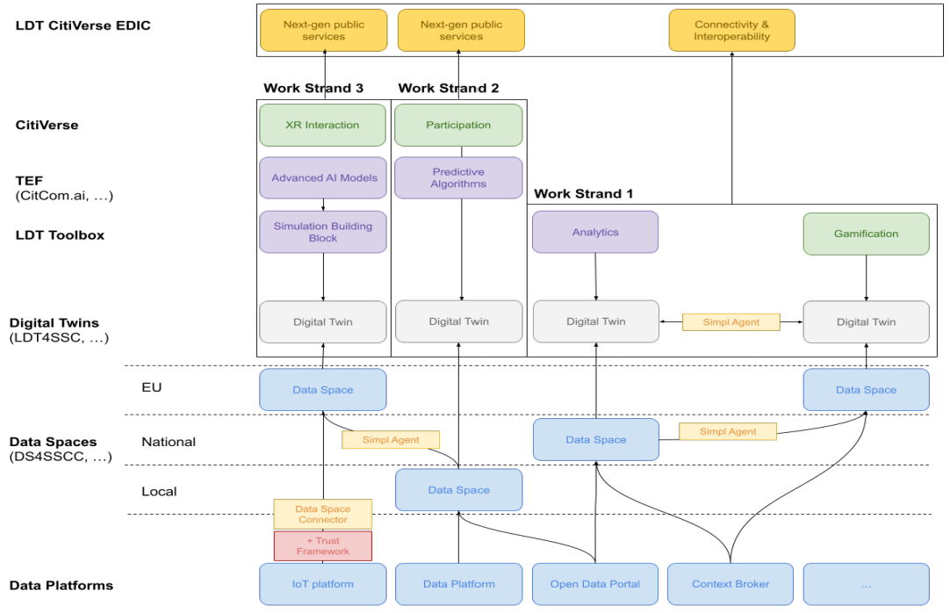

Figure 4. Meta-architecture for LDTs and Value-added services

Description of requirements & recommendations
The LDT4SSC initiative invites applicants to submit their project proposal using the official Application Form. The form is structured into four sections (Pilot Details, Relevance, Implementation, and Impact) each containing specific questions to guide applicants in describing their project.
To support the completion of the form, applicants are encouraged to consult the Requirements (Rq) and Recommendations (Rc) provided for each of these four dimensions. While the form itself offers space and instructions for outlining the pilot project, the accompanying guidance clarifies what is expected in each section and helps applicants prepare a complete and well-aligned submission.

Pilot Details

Rq1 | Each pilot must include at least two public authorities operating ‘digitally mature’ LDTs to be interconnected. These LDTs must already provide digital and data services within their respective cities or communities. ‘Digitally mature’ means having an existing LDT (can be supported by a DS) with at least descriptive-level capabilities (see explanation under Annex 2) and dynamic data integration.
Rq2 | Pilots must include at least two cross-sectoral use cases, each featuring one shared service.  - The developed services integrate datasets from two or more sectors (e.g. mobility, energy…); or  - The LDTs provide data services that span at least two sectors within a single use case.  Describe these and specify the data-based services to be delivered.
Rq3 | For each pilot member operating an LDT to be interconnected, provide a high-level description of the existing LDT and its main capabilities. Specify which dynamic data sources are currently integrated and what digital or data services are offered within the city or community. Where available, include a public reference (e.g., URL link) to the platform; if not publicly accessible, provide representative screenshots of the platform’s front-end.
Rq4 | For each pilot member operating an LDT to be interconnected, provide a high-level description of the current architecture covering technical and functional aspects. Provide a diagram for each aspect. Specify the main tools, standards, and software components used, and illustrate the data lifecycle (from collection to use and sharing).
Rq5 | Describe the current data governance (see explanation under Annex 2) scheme of each pilot site and the target data governance scheme of the pilot consortium across the political, technical, legal, and organisational dimensions.
Rq6 | Describe project management and coordination, including resource allocation. Provide an overview of the project teams, their collaboration approach, and any planned recruitment. If additional skills or resources are needed, explain how they will be secured through consortium partners, subcontractors, or other means, and specify the roles or profiles involved. Each participating public authority must ensure both technical capacity (e.g., designated technical staff for implementation and continuity) and political support.
Rq7 | Describe whether AI and/or XR technologies are used in the services, how, for what purpose, and how ethical/legal considerations are managed.
Rc1 | For each local authority/government involved in the pilot, please give the score obtained at the LORDIMAS digital maturity assessment (see explanation in Annex 2).  The pilot lead is recommended to be at the ‘Digitally Optimised’ stage assessment, while all other participating authorities should be at least at the ‘Moderate’ stage in the LORDIMAS self-assessment upon application.  All public authorities participating as pilot members are recommended to reach the ‘Digitally Optimised’ stage in the assessment, or to demonstrate further progress if they have already attained this level by the end of the project.

Relevance
Rq8 | Describe how the pilot addresses local and European priorities as well as the objectives of the LDT4SSC initiative and its ecosystem (for example, by advancing shared knowledge, tools, or methodologies).. . The use cases should align with the European Green Deal Objectives or the New European Bauhaus priorities, or tackling key challenges identified by LDT4SSC)  (see explanation under Annex 2).
Rq9 | Describe the political endorsement (see Letter of Commitment) of your pilot, specifying the type and extent of support. Where available, reference published or online materials (with links) or attach supporting documents that substantiate this endorsement .
Rq10 | Pilots must actively engage end-users.  Describe the end-users of the services developed in the two use cases and how they will be engaged throughout the project lifecycle through workshops, consultations, or other participatory activities. List the involved and expected stakeholders across the four Quadruple Helix categories outlining their roles, responsibilities, and engagement approach.  Each pilot must involve at least three of the four Quadruple Helix stakeholder groups (public sector, private sector, academia/research, and civil society) in these engagement processes.
Rq11 | Explain the broader applicability and relevance of your pilot –how its approach and/or results could be transferred to other EU communities.
Rq12 | Describe which EU technology stacks (SIMPL, DSSC, …) and infrastructure providers (LDT CitiVERSE EDIC, Gaia-X, …) are likely to be involved in the interconnection of LDTs.

Implementation
Rq13 | The project description should adopt the following phases: Explore, Validate, Define and Implement, and cover the following key activities:  - Define data governance (including legal management of interoperability);  - Design a Business Model to ensure the sustainability of the service after the pilot project;  - Draft a contract among the consortium stakeholders to enable management;  - Perform a Cost-Benefit analysis to measure the impact of the solution in relation to the objectives set at the outset (to resolve the use case);  - Defend a responsible use of digital technology (eco-design/frugal AI, etc.);  - Assess and measure impacts (including economic impact as well as social and environmental impacts).
Rq14 | Describe how the pilot consortium will technically interconnect their LDTs, specifying the tools, software, and standards selected for each component (e.g. data catalogue, management system, identity and authorisation mechanisms (IAM), data policies, connectors, and knowledge models). Demonstrate integration with the SIMPL Data Space Governance Authority Agent that is required to be used.
Rq15 | For each use case, provide 2 draft diagrams: one of the intended technical, and one of the intended functional architectures. The first showing the interconnection of LDTs, and the second illustrating the pilots’ data lifecycle.
Rq16 | Describe how pilot members will adopt common data descriptions and define the shared data models that will enable semantic interoperability across the interconnected LDTs.  - All data collected and shared within the pilot ecosystem should be mapped to a Linked Data Ontology (MIM1) to ensure semantic consistency (like NGSI-LD or SPARQL, etc.)
Rq17 | Specify what data, assets, or services will be shared, the sectors involved, and the main providers and beneficiaries.
Rq18 | Indicate which MIMs Plus (MIM0–MIM8) the project will engage with (e.g., contribute to, implement, or comply with) and provide a brief justification for this choice —such as existing capabilities, planned developments, or limitations. For each selected MIM Plus, estimate the current and planned level of compliance (e.g., Initial, Partial, or Full). The pilot must engage with at least the five foundational MIMs Plus.
Rc2 | Pilots are encouraged to use open-source technical components to promote transparency, reduce costs, and foster community collaboration. Any enhancements or customisations developed during the pilot should likewise be shared back with the open-source community to support collective progress and reusable innovation.
Rc3 | Pilots are encouraged to include in their consortium agreement provisions for the non-exclusive transfer of Intellectual Property or exploitation rights, as well as clear rules for protecting and sharing know-how among consortium members and beyond.
Rc4 | Pilots are strongly encouraged to establish, as appropriate to their project scope:  - A data catalogue using the W3C Data Catalog Vocabulary (DCAT) for semantic interoperability.  - A data management system (e.g., context broker) capable of handling contextualised metadata descriptions (ontologies) such as JSON-LD, RDF, or NGSI-LD for semantic and technical interoperability.  - An identity and access management system based on OAuth2, OpenID Connect, or W3C Verifiable Credentials for legal and organisational interoperability.  - An ODRL-based data policy to support legal interoperability.
Rc5 | Pilots are encouraged to pursue alignment with the forthcoming LDT Toolbox as its specifications become available.
Rc6 | Describe if and how the pilot's project will comply with the following frameworks: Gaia-X trust framework, IDSA specification, DSBA recommendation, DSSC Blueprint, DS4SSCC-DEP Blueprint.

Impact
Rq19 | Explain the ambition and rationale for interconnecting the LDTs across pilot members, detailing how shared data and services will improve governance, efficiency, and innovation within and across pilots.
Rq20 | Describe the tangible benefits and long-term impacts expected for the participating of communities, outlining the immediate value proposition, sustainability potential, and measurable indicators to track progress.
Rq21 | Describe the wider socio-economic and environmental effects of your pilot beyond their direct scope, explaining how the eco-design approach contributes to these broader impacts and long-term sustainability.
Rq22 | All pilot activities must include a contractual framework that guarantees the sustainability of the digital twins (legal clauses that guarantee for instance the right to use the data, to manage Intellectual Property or the analyses carried out, the post-pilot exploitation rights, etc.)
Rq23 | Describe the main expected outputs of the project (e.g. services, tools, data models, or other assets) and specify their intended level of openness or accessibility after the pilot end (e.g., Open Source, Limited Access, or Proprietary).  - Note that created or adapted data models should be published in open repositories under an open licence, and developed services shared through the LDT Toolbox Marketplace for reuse by others.  - Note that pilots are expected to maintain regular documentation and updates for the Knowledge Hub.  - Note that the inclusion of proprietary components must be justified and accompanied by a plan demonstrating how an equivalent solution can be achieved with open-source technologies.
Rq24 | Outline your strategy for maintaining and expanding the developed services and pilot activities beyond the project’s duration, explaining how results will be sustained and scaled up after the pilot phase.
Rc7 | Pilots are advised to record all relevant baseline data, including socio-economic, environmental, and organisational aspects, before starting the project to enable meaningful comparisons in the final Cost-Benefit Analysis.
Rc8 | Pilots are advised to assess their level of maturity in eco-design thanks to the General policy framework for the ecodesign of digital services version 2024 at least for the 30 highest-priority criteria at the start of the pilot implementation and then towards the end.

Ethical and data protection framework
The development and use of LDTs within local and regional authorities are grounded in the principles of transparency and trustworthiness. Consequently, it is essential that their implementation adheres to strong ethical standards.
The ethical practices required from the pilot consortia draw on recognised frameworks and guidelines, including ALTAI (AI HLEG's trustworthy AI assessment list), Fundamental Rights and Algorithm Impact Assessment (FRAIA) and International Organization for Standardization (ISO)/International Electrotechnical Commission (IEC) standards on ethical and societal concerns.
In addition, the LDT4SSC project has established an Ethical Board that participates in the evaluation of CfP proposals and oversees pilot implementations. Ethical aspects are also integrated into the Pilot Support activities through targeted training and mentorship.
WS1 follows the 'Ethics and Data Protection By Design' approach for the CfP process. It sets several checkpoints with the pilot consortia to raise awareness on ethical and legal challenges and to assess each consortium’s capacity to address them effectively. The checkpoints include:
- Before the submission of application: In connection to open calls, interested applicants will receive guidance on ethics and data protection during organised sessions. This information will help applicants in identifying ethical and legal challenges and mitigating these upfront. The applicants will also need to complete the Ethics and Data Protection Self-Assessment and submit this together with the main application document.
- During the evaluation of applications: The Ethical Board will compare ethical self-assessment with proposed work package structures presented in the application (see also Evaluation Process overview).
- At the start of pilot projects: Following the announcement of the selected pilots, representatives from the Ethical Board will contact the pilot consortium to discuss ethical needs and provide feedback to mitigate any concerns. For example, they may ask to allocate more time or resources to an ethical aspect that requires attention. This type of feedback should then be accounted for prior to the pilot’s start.
The LDT4SSC consortium is responsible for providing overall guidance and monitoring of the project, the CfP procedure and the evaluation. While identifying potential issues falls within the remit of the Ethical Board, the responsibility for the actual work carried out in the pilots, including identifying and mitigating ethical and legal challenges, is beyond the direct control and responsibility of the project consortium.
While it is useful to define common principles, these alone cannot guarantee trustworthy or ethical practices. It is therefore recommended (and in some cases required) that LDT implementations set up mechanisms for oversight, as well as collaborate with a broader LDT community of experts to resolve any ethical issues upfront. Afterall, fair, compliant, and trustworthy access to- control over- and (re)use of- data can only be reached by interdisciplinary efforts and involvement of a broad community of experts and stakeholders.

Compliance with relevant legislation
While ethics go beyond compliance with existing regulation, it is worthwhile to point out that the pilots need to take all required steps to guarantee compliance with the provisions of the relevant EU regulations, inter alia:
- General Data Protection Regulation (GDPR)
- ePrivacy Directive
- Data Governance Act (DGA)
- Data Act (DA)
- The Interoperable Europe Act, and
- AI Act.
Applicants shall comply with applicable data protection legislation including but not limited to the GDPR and any national implementing laws, regulations, and secondary legislation, in each case as amended, supplemented or replaced from time to time. As a reminder, the GDPR guarantees that the processing of personal data is carried out respecting fundamental rights and freedoms, as well as the dignity of the data subject with particular reference to confidentiality, personal identity, and the right to data protection.

Complaints and appeals
While the LDT4SSC consortium is responsible for evaluating the proposals and in later stages pilots’ performance, approved pilot project consortia are responsible for the complaints and appeals stemming from the implementation of their LDTs. We encourage all affected stakeholders to directly contact the pilot consortia for any complaints. If necessary, the LDT4SSC consortium will remain available for support through the info@ldt4ssc.eu helpdesk email address. Complaints regarding ethical issues will be handed over to the Ethical Board for discussion and proposing further action steps.

Confidentiality, privacy notice and usage of applicants’ data
The processing of personal data by the LDT4SSC Consortium adheres to GDPR and its Article 5 principles, ensuring lawfulness, correctness, and confidentiality. Personal data will be processed by the LDT4SSC Consortium members and external evaluators responsible for the evaluation process and selection of the pilots. The applicant warrants and represents that, in providing personal data in connection with the proposal, the data subjects have consented to the provision of their personal data and the processing of it by the designated LDT4SSC consortium members, and that the organisation provides the personal data in accordance with applicable law.
Personal data (e.g., email addresses) can also be used for collecting feedback from applicants. Public sharing of data encompasses, among other things, the disclosure of CfP outcome to the LDT4SSC project’s web page (https://ldt4ssc.eu/). This includes aggregated level statistics such as the number of applicants, applicants per country, the sectors covered. Information on each funded activity, including participant information and abstracts of the activity proposal, may be made available for publication purposes as currently expected:
- Details to be made publicly available before the end of the pilot: pilot title, names of the Lead Partner and other beneficiaries, short description (as provided by the applicant in the application template).
- Details to be made publicly available after pilot completion: pilot title, names of the Lead Partner and other beneficiaries, awarded funding, updated short pilot description and main pilot results (as provided in the Final Report).
The evaluation and selection of applications will be performed under the appropriate ethical conduct and will respect the confidentiality of the information received. The LDT4SSC consortium will treat any proposal, related information and documents confidentially. Personal data will be processed in accordance with the consortium’s Privacy Statement (confirmed by the Ethical Board), or as otherwise indicated throughout the proposal form (e.g., applicants, pilot title, summary description etc.).
The LDT4SSC Consortium members will not be able to discuss in detail or contribute directly to the development of the pilot proposal. Selected Evaluation Committee members evaluating the applications are also obliged to sign the Non-Disclosure Agreement and the Conflict of Interest Statement provided by the Ethical Board.

Dissemination of results and Intellectual Property
By default, LDT4SSC follows the principle of openness to also foster reusability and accelerate research and development of LDTs around Europe, while remaining closed to safeguard privacy and Intellectual Property. Consequently, the default approach of the project is open source also for the piloting results. For specific rights and obligations concerning Intellectual Property Rights of the use and dissemination of results generated by pilot teams through funding obtained via the CfP, the LDT4SSC project will refer to the GA signed with the pilots.
Regarding the dissemination and use of results funded by the CfP, recipients must credit the LDT4SSC project with proper citation, and display the LDT4SSC logo and EU flag. This includes consistent use of the EU flag and citation throughout the pilot, stating: "This project has received co-funding from the European Union’s Digital Europe Programme under grant agreement No. 101226211".


Figure 5. LDT4SSC logo to be displayed by pilots
in their communication


Figure 6. Consistent use of the EU logo to be displayed by pilots
in their communication

Call for Pilots Process

Call for pilots timeline
The open call for pilots supporting the targeted WS1 –Connecting Existing Local Digital Twins– will be launched through a single call to deploy LDTs in Smart Communities. The timings of the call have been defined based on the following rationale:
- The Open Call application period is envisioned to last 2 months from the launch. WS1 will have a single dedicated call scheduled to open on the 14th of November 2025.
- After the application deadline, the review of the pilots will take two months. This comprises the pre-screening check on eligibility as well as the evaluation by the Evaluation Committee and Ethical Board.
- Following the selection of the winning pilots, the negotiation period will last one month, followed by another month for necessary preparations before project launch. This period is meant to draw on the reviews of the Evaluation Committee and Ethical Board, as some recommendations and requests may be provided to the applicants that could imply changes to the pilot in terms of approach, process and consortium. The negotiation period is a timeframe (of 1 month) for providing feedback to applicants and for applicants to address the feedback.
- Each pilot is envisioned to last between 12 to 18 months from the starting date.
Table 2 summarises the CfP selection process for Work Strand 1.

Table 2. Timeline for Call For Pilots for Work Strand 1
Work Strand 1
 | Opening of open call | Closing of open call | Selection of pilots | Start of pilots | Closing of pilots
Open call 1 | 14 November 2025 | 15 January 2026 | 12 March 2026 | 14 May 2026 | 10 November 2027
The information on the closing of the pilots in the table, above, is sketched out based on the assumption of a duration of 18 months, although pilots can opt for a duration from 12 to 18 months.

Documents for submission
As part of the application process, the pilot applicants will be asked to provide the following documentation in order to be considered eligible:
Document type | Description
Application form | General information on consortium details, applicant details, grant allocation request, self-assessment etc.
Financial Form | Details the budget for the pilot proposal.
Letters of Commitment from the Local and Regional Authorities and any other member of the consortium contributing financially to the pilot activities | Statement of intent, affirming the entity’s engagement in the LDT4SSC project and its pilot activities.
Ethics and Data Protection Self-Assessment | Showing how the applicant will handle people’s information responsibly, fairly, and safely, while also respecting individuals’ rights.
Ownership and Control Declaration | Certifies that an applicant’s organisation is not controlled by entities from ineligible countries.
These documents are referred to in Annex 1 and are published on the project’s website.

Where to apply and how
The full application package (written in English) must be submitted via applications@ldt4ssc.eu before the specified deadline (see Chapter 3.1). The application must be filled in using the predefined templates provided on the LDT4SSC project’s website.
All the documents must be sent in PDF format, except the Financial Form, which must remain in an Excel format (.xlsx).
The proposal must be submitted by the consortium member acting as the Lead Partner who is also responsible for completing all administrative information and checking all documents. After submitting the documents, a confirmation email will be sent to the applicants verifying that the application was received and stating the time of submission.

Call for Pilots Evaluation

Evaluation process
Consortia must submit their applications to the call for pilots under Work Strand 1 by the 15th of January 2026 at 23:59 CET. After this deadline, the review period will last two months, including both the pre-screening of the applications and the evaluation by the Evaluation Committee and Ethical Board. After the ranking and selection of the pilots, which will be communicated to the applicants, the winning consortia and the selection committee will take one month to finalise contract negotiation and signing, and one additional month to prepare before project launch. The process is outlined in the following Figure.
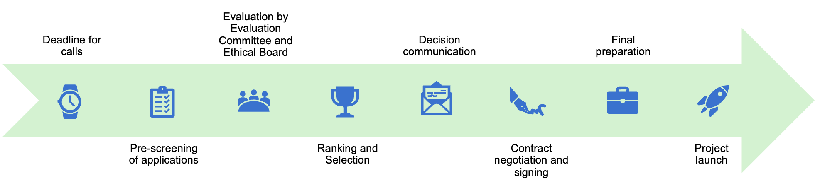

Figure 7. Expected piloting process for all five calls

The following sections outline the process for each step:

Pre-screening of the applications through eligibility check
After the deadline for the call has passed, each application will be pre-screened for an eligibility check as a first step. This will ensure that only relevant applications are considered for the evaluation of the Evaluation Committee and Ethical Board (see below).
Applications will first be anonymised and then assessed by the eligibility check grid. The criteria are listed in the table below:

Table 3. Eligibility Check Grid for Work Strand 1 (legal, financial, technical, ethical)
 | Eligibility criterion | How it’s demonstrated | How it’s assessed
General | All required documents and ownership and control declarations have been submitted in the right format (PDF & Excel) and on time.  The application files are submitted in English. | Application Form, Financial Form, Letters of Commitment, Ethics and Data Protection Self-Assessment | pass/fail
 | The proposal has been submitted using the Open Call template. This includes respecting the page limit for the proposal template. | Application Form, Financial Form, Letters of Commitment | pass/fail
 | All questions have been answered (within the character limits). | Application Form, Pilot Budget, Ethics and Data Protection Self-Assessment | pass/fail
Legal | Pilot consortium consists of at least two local or regional public administrations from two different eligible countries, together with at least one additional partner drawn from one of the following categories:  - Private entity (e.g., service provider)  - Private association (legal status)  - Trusted third party  - Private representative of a use-case sector | Application Form, Letters of Commitment | pass/fail
Financial | Pilot consortium covers at least 50% of the pilot budget as co-financing. | Applicants demonstrate their capacity to provide at least 50% co-financing in an added budget table and with the Letters of Commitment | pass/fail
 | Support requested is not higher than 1.000.000 euros per consortium. | Financial Form | pass/fail
 | Support requested is not more than 500.000 euros per third-party across pilots. | Financial Form | pass/fail
Technical and Non-Technical | Pilots must include at least two cross-sectoral use cases, each featuring one shared service.  - The developed services integrate datasets from two or more sectors (e.g. mobility, energy…); or  - The LDTs provide data services that span at least two sectors within a single use case. | Application Form | pass/fail
 | Each pilot must include at least two public authorities operating digitally mature LDTs to be interconnected. ‘Digitally mature’ means having an existing LDT (can also be supported by a data space) with at least descriptive-level capabilities (see explanation in Annex 2) and dynamic data integration. These platforms must already provide digital and data services within their respective cities or communities. | Application Form | pass/fail
Ethical | Ethics and Data Protection Self-Assessment completed and submitted. | Application Form, Ethics and Data Protection Self-Assessment | pass/fail

This eligibility check process should take no longer than 4 weeks. Applicants are encouraged to submit their applications as early as possible before the deadline.

Evaluation by Evaluation Committee and Ethical Board
Once applications have successfully passed the eligibility check, an Evaluation Team will assign expert evaluators to an Evaluation Committee based on their respective areas of expertise.
Each application will be reviewed by two external evaluators and one internal evaluator. All three evaluators will assign scores following a structured evaluation framework which is fully aligned with European priorities and upcoming policies, the Digital Europe Programme (DEP), the Mission on Climate-Neutral and Smart Cities, as well as the DS4SSCC-DEP. These will be then combined to form an aggregate score, which will determine the application’s position in the final ranking. The assessment will focus on three primary dimensions: Excellence, Impact, and Quality and Efficiency of the implementation, as shown in Table 3.

Table 4. Evaluation criteria
 | Evaluation criterion | How it’s demonstrated | Minimum pass score | Maximum pass score
1 | Excellence | 1.1 The proposal clearly defines its objectives and demonstrates strong alignment with EU priorities and LDT4SSC challenges.  1.2 The use cases are well-defined, feasible, and clearly demonstrate the added value of interconnecting LDTs and sharing services.  1.3 The technical and functional architectures are coherent, complete, and supported by appropriate standards, tools, and diagrams.  1.4 The data governance approach is robust, and ethically compliant with relevant regulations (see Section 2.9.1) (and demonstrates responsible integration of AI/XR technologies, when applicable).  1.5 The methodological approach is well-structured, and clearly describes the data lifecycle. | 3 | 5
2 | Impact | 2.1 The pilot demonstrates clear and measurable benefits for local communities, including socio-economic and environmental gains.  2.2 The proposal shows strong potential for replication across EU cities and meaningful contribution to EU LDT ecosystems and standards.  2.3 The outputs are clearly defined, of high-value, and committed to open publication of data models and services where feasible.  2.4 The pilot includes a credible plan for involving relevant stakeholders and end-users throughout the project lifecycle.  2.5 The proposal presents a realistic and well-supported plan for sustaining and scaling the pilot after project completion. | 3 | 5
3 | Quality and efficiency of implementation | 3.1 Existing community platform, digital twin, or emerging data space is sufficiently mature to reach described objectives  3.2 The consortium demonstrates strong expertise, well-defined roles, and adequate political and organisational support.  3.3 The work plan is clear, realistic, and allocates resources efficiently across tasks and partners.  3.4 The proposal provides a feasible plan for managing data, identity, access, and policies across platforms.  3.5 Risks are clearly identified with credible mitigation measures, and eco-design principles are meaningfully integrated. | 3 | 5
It is envisaged that the Evaluation Committee and Ethical Board will work in parallel to review the applications during the same timeframe. The Ethical Board’s assessment will focus on the pilots’ Ethics and Data Protection Self-Asessment and considerations regarding ethical implications of the application’s aspects. These include evaluating issues related to data governance, privacy, consent, and transparency in the collection, processing, and sharing of local data. The Ethical Board will also assess potential biases in data modeling and simulation, fairness in the representation of communities, and the risk of reinforcing social or spatial inequalities through digital replication. These assessments will be based on a review of the ethics and data form, as well as a review of the section on “Alignment with Ethical Principles” on the Application Form.
The evaluation will take place in two stages:
Stage 1. Individual Evaluation
In the first instance, evaluators will assess and score the applications individually, providing written justifications in line with a standard template. Alongside this process, selected members of the Ethical Board will review the sections that are relevant for the ethics and the accompanying Ethics and Data Protection Self-Assessment submitted by the applicants.
This draws on the evaluation framework and the evaluation criteria outlined above.
Stage 2. Consensus Group Meeting
Following the completion of individual evaluations, respective members of the given Evaluation Committee for each Work Strand and relevant Ethical Board members who reviewed the applications will convene to discuss their assessments and compare findings. The aim is to reach a consensus on comments and scores, ensuring consistency across evaluations. A moderator from the Evaluation Team will facilitate the discussion, guiding the group towards agreement and guaranteeing that the proposals are evaluated fairly and in accordance with the established criteria.
The outcome of this process will be a consolidated evaluation report, including score justifications and, where applicable, any dissenting opinions. The report is formally signed by the evaluating experts, the Ethical Board representatives involved, and the moderator. The table below visualises the template used by evaluators to assign individual scoring before drawing an aggregate average from three scores.

Table 5. Preliminary ranking by Evaluation Committee for one pilot
No. | Evaluation criteria | Content evaluated | Score
1 | Excellence |  | Out of 5
2 | Impact |  | Out of 5
3 | Quality and efficiency |  | Out of 5
 |  |  | Total out of 15

Final decision by the Steering Committee
A Steering Committee shall consist of one representative from each private entity from the LDT4SSC consortium. It is responsible for making decisions concerning the awarding of pilots in collaborations with the Ethical Board and Evaluation Committee.
While the final score is determined by the ranking of the evaluation criteria, it is expected that the Steering Committee will make the final decision based on the following considerations:
- Priority of the evaluation criteria: Proposals with an equal final score may be ranked according to the scores they were given for criterion ‘Excellence’. When these scores are equal, priority will be based on their scores for the criterion ‘Impact’.
- Recommendations from the Evaluation Committee: Specific feedback about the scope and quality of the proposed pilots should be taken into account when deciding on the final ranking.
- Geographical balance: When possible, geographical diversity should be prioritised in order to ensure that the final set of shortlisted pilots will include different areas of Europe. In the following call rounds, also previously awarded pilots’ geographical background should be considered.
- Domain-based balance: When possible, diversity of domains should be prioritised in order to ensure that the final set of shortlisted pilots will cover a variety of domains. In the following call rounds, also previously awarded pilots’ domains should be considered.
- Varying maturity levels: While all applicants must meet sufficient maturity levels for digitalisation, it should be respected that applicants with lower maturity would get a chance to participate in the piloting programme, if deemed reasonable.

Decision communication
The decision of the winning pilots will be communicated shortly after the two-month review period. Applicants will be contacted via email with the final decision and score.

Contract negotiation and signing
Drawing on the announcement about the selected pilots, the contract negotiation period starts, which is expected to last one month before project launch. This period draws on the reviews of the Evaluation Committee and Ethical Board, as some recommendations and requests may be provided to the applicants that could imply changes to the pilot in terms of approach, process and/or consortium. The negotiation period is thereby a timeframe for providing feedback to applicants and for applicants to address the feedback. It encompasses the process of negotiating, providing and checking the additional information (such as the Ownership Control Declaration (OCD), if necessary) and signing the contract.

Final preparations
Applicants will still have one month after signing and before the start of the project to finalise preparations, such as checking for capacity and resources and ensuring that they are ready in time for project launch.

Project start
Once the contract negotiation and signing is done and preparations are in place, the pilot project kicks off.

Checklist
To ensure that all necessary steps for successful application submission have been followed, applicants are recommended to run through the following pre-submission checklist (Table 7).

Table 6. Checklist for applicants before Submission
 | Activity | Yes/No
#1 | You have prepared all documents for the submission: Application Form, Financial Form, Letters of Commitment, Ethics and Data Protection Self-Assessment, Ownership Control Declaration
#2 | Your documents are in the right format (PDF & Excel) and answer within the character limits. All sentences and images exceeding the limitations will be hidden from the application for evaluation.
#3 | Your consortium has at least two local or regional public administrations from two eligible countries on board.
#4 | All partners of the pilots are from the eligible countries, and the activity of the pilot will take place in the eligible countries.
#5 | You have described at least two use cases across priority sectors in the Application Form.
#6 | Your consortium does not request more than 1,000,000 Euros and will cover at least 50% of the pilot budget.
#7 | Your pilot complies with the minimal technical and non-technical requirements as described in the technical framework.
#8 | Your LDT pilot complies with relevant regulations, such as GDPR, DGA etc.

Applicants support

Support during the application phase
The project provides a comprehensive suite of resources to support applicants to the CfP.
- The Project Website serves as the central point of reference with information provided on the following:
  - Frequently Asked Questions (FAQ) Section – the FAQ addresses frequently asked questions and helps applicants avoid common errors during proposal preparation.
  - Info sessions dedicated to the call – 1-2 information sessions will be organised to provide additional information and answer questions from applicants, one organised around the call opening, and one halfway throughout the application phase.
  - Helpdesk – applicants can submit their questions via the email address info@ldt4ssc.eu.
- The LDT4SSC Knowledge Hub provides guidance, resources, and examples from previously awarded pilots, supporting both the preparation and implementation of new proposals. It also collects and organises the project’s knowledge outputs, providing applicants and stakeholders with easy access to strategies, tools, and guidance.
- Available EC policy documents including priority areas such as the Clean Industrial Deal and New European Bauhaus initiative to define at least two relevant use sectors central in your pilot proposal.
- A matchmaking platform to be launched during the open calls to facilitate connections between stakeholders.

The LDT4SSC Pilot Helpdesk
The LDT4SSC Pilot Helpdesk (operated via the email info@ldt4ssc.eu) acts as the single entry to ensure clear, timely and accountable support to both applicants and awarded pilot consortia from application to implementation.
The Pilot Helpdesk provides practical operational support to applicants on administrative, procedural, ethical/data-protection, and technical matters relevant to the pilot application process. It also offers implementation support for example regarding reporting requirements, use of project templates, and access to mentoring opportunities.
The Helpdesk will not provide legal representation, financial audit services, or substitute formal legal or accounting advice.
All questions and answers will be published on a dedicated Pilot Support page, which will include a comprehensive FAQ section and relevant contact information.

Confidentiality and data protection
All personal data and case information processed by the Helpdesk will be handled in compliance with GDPR and the project Privacy Statement. Information shared with external evaluators, partners or third parties will be limited to what is strictly necessary and only transmitted after appropriate confidentiality safeguards are in place.

Training and supporting activities
Each pilot team is recommended to designate participant(s) to take part in training and support activities. These sessions are designed to address the specific needs of decision-makers and IT experts from local authorities, providing tailored content aligned with their roles, expertise, and knowledge levels.
For each pilot, the expected effort allocation across different roles involved in support activities should be estimated along with the corresponding budget commitment. A suggested estimated contribution is of 80-100 hours across the duration of the pilot. More specific details about the estimated effort required will be communicated closer to the beginning of the pilot launch. Training and support activities may include workshops, process support, mentoring sessions, and periodic evaluation meetings.

Monitoring and assessment
Prospective pilot consortia are expected to describe their own set of KPIs in the application form under Section 4.1. Awarded pilots will be expected to work towards these defined KPIs during their pilot lifet-time and report against them at mid-term and final reporting moments.
Upon being awarded, pilots will be expected to map their KPIs against the LDT4SSC Impact Framework with the support of the LDT4SSC Consortium. This impact framework builds on that of the DS4SSCC Impact Framework and breaks them down into outputs, outcomes and impacts :
- Outputs: products, goods and services resulting from implemented change activities by the pilots
- Outcomes: short- to medium-term effects of the pilots’ outputs, and
- Impacts: long-term effects produced as a result of the pilots’ project (directly or indirectly), and related to the pilots’ objectives.
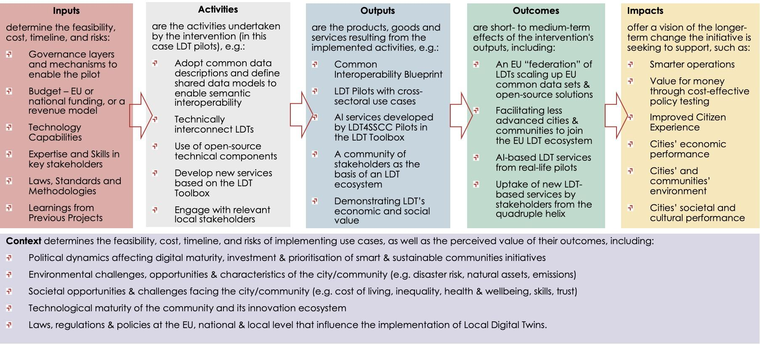

Figure 8. Monitoring and assessment framework
The list of KPIs may evolve iteratively with the lessons learned including merging and combination of KPIs to align with other parts of the project (e.g., overlaps between output indicators and performance indicators defined by the project).

Annex 1 - Required Documents
All documents listed below can be found and downloaded from the LDT4SSC website and should be emailed as an application package to applications@ldt4ssc.eu.

Financial form

Commitment letter template

Ethics and data protection self-assessment template

Annex 2 - Information for context

Information for context: in support of the requirements and recommendations additional information is provided in green boxes for context purposes.
LORDIMAS digital maturity assessment
The LORDIMAS digital maturity self-assessment is available for local, metropolitan, and regional governments. This tool focuses on multiple aspects of wider EU-led policy initiatives which are related to governance, service design, data management, interoperability, service delivery, technology and networking.
While filling in the LORDIMAS self-assessment, governments can provide their inputs for the assessment and visualise their results on an interactive dashboard in real time. In addition, the tool enables its users to:
- track their transformation progress over time,
- benchmark themselves against others,
- share best practices,
- get tailored policy recommendations.
While it is optional for pilots to fill the assessment for each local or regional government of the consortium, the score may complement the answers to the questions related to digital maturity in the application form.
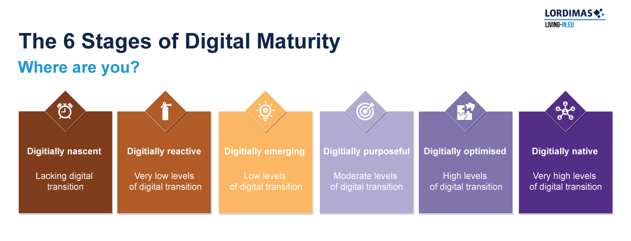

Figure 9. LORDIMAS 6 stages of Digital Maturity

Digital Twin capabilities: what is a “Descriptive LDT” ?
The Context Information Management (CIM) European Telecommunications Standards Institute (ETSI) Industry Specification Group (ISG) presents several capabilities for digital twins.
Out of these, a Descriptive Twin informs on the current state of the real-world assets. The Descriptive Twin presents past and current values of some of the real-world asset characteristics. These characteristics can be static (e.g. a building geometry) or dynamic (e.g. sensor measurements). The connection between the real-world asset and the Digital Twin is bidirectional: a change made in the Descriptive Twin is reflected (in real-time or not) onto the real world asset (actuation). The Descriptive Twin capability does not restrict to metrics collected from the real-world asset and can be augmented with computed functions (e.g. distance to a fixed point of a moving real world asset; deviation from normal of a room temperature).

European Green Deal Policy areas
- Clean energy,
- Sustainable industry,
- Building and renovation,
- Farm to fork,
- Eliminating pollution,
- Sustainable mobility,
- Biodiversity and ecosystem health and
- Sustainable finance.
New European Bauhaus initiative values
- Sustainability, from climate goals to circularity, zero pollution and biodiversity;
- Inclusion, from valuing diversity to securing accessibility and affordability;
- Aesthetics and quality of experience for people, through design and cultural benefits.
LDT4SSC key challenges
- Climate change,
- Energy efficiency,
- Mobility,
- Waste management,
- Biodiversity preservation,
- Air quality and
- Water management.

Example of a (twice!) cross-sectorial use case
A region develops an LDT to improve the management of their road infrastructures by combining data from different sectors. The LDT brings together information about the roads (e.g. their width, condition and maintenance status) with dynamic environmental data, including weather forecasts and flood risk metrics.
This combination enables the city to provide valuable digital services that cross traditional- sector boundaries. For instance:
- Road engineers can use the LDT to identify which areas require urgent repairs, especially when poor road conditions overlap with upcoming storms or flood risks. This allows maintenance efforts to be better planned and more efficient, reducing long-term damage and improving public safety.
- At the same time, the LDT provides a second data service that is useful to special convoys, heavy vehicles and emergency services as it helps in identifying the safest and most reliable roads in real time. This is particularly important during severe weather, when certain routes may become dangerous or impassable.
By connecting infrastructure and environmental data in one shared data platform, the LDT supports smarter planning, quicker response times and more resilient public services. It illustrates a clear example of how cross-sectoral data integration can lead to more informed decisions and improved outcomes for communities in multiple sectors.

Data Governance to…
- Manage the interconnection through use cases (interconnection of LDTs, etc.);
- Capitalise on all use cases;
- Involve all stakeholders for each use case, from the ideation phase to the industrialisation phase of services/digital twins, whether or not they decide to integrate AI.
The implementation of data governance requires:
- a set of common practices,
- standard processes, and
- standard contracts underlying each use case deployment.
For the creation of digital ‘Commons’ (e.g. data spaces, jointly-created digital twins, etc.), data governance also provides a framework and regulations.
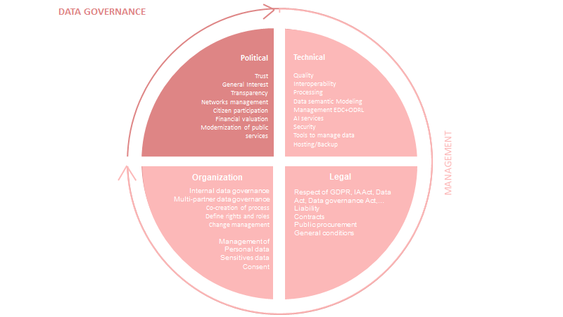

Figure 10. Data governance – A Pilot’s strategy throughout political,
technical, legal and organisational aspects
Figure 10 illustrates the scope of Data Governance across four dimensions:
- Political: this dimension covers the strategic aspects related to data governance.
- Technical: this dimension, addressed in terms of technological choices in the technical section of calls for projects, must be linked to other aspects of data governance.
It will deal with topics like how pilots will coordinate with various stakeholders, ensure the technical maintenance and development of the digital twin, etc. It will also aim at understanding the technical infrastructure and architecture.
- Legal: this dimension aims to pinpoint the several compliance and legal aspects related to governance, such as how the terms and conditions of use are defined (as previously mentioned), but also it’s about broader sections like compliance with EU regulations such as the GDPR etc. It highlights a clear issue of data governance that feeds into the services created (Digital Twins) and of contractualisation between the pilot members at the end of the pilot.
- Organisational: this dimension deals with “traditional aspects” one might consider in the scope of data governance, i.e. the management teams and several stakeholders involved, the internal processes etc.
NB: At every stage of the pilot, project-relevant questions should be raised, appropriate clauses included, and recommendations implemented. Key guidance for each stage is provided in D3.4 Non-Technical Resources for Pilots.
NB: When applying AI technologies, particular attention must be given to data governance to ensure full compliance with the AI Act.



Disclaimer
The content of this report reflects only the author’s view.
The European Commission is not responsible for any use that may be made of the information it contains.

Note that pilot consortia must ensure that their contractual obligations under Article 12 (conflict of interest), and Article 14 (ethics) among others are followed. See: Annotated Grant Agreement https://ec.europa.eu/info/funding-tenders/opportunities/docs/2021-2027/common/guidance/aga_en.pdf
See e.g., Mittelstadt 2019, https://doi.org/10.1038/s42256-019-0114-4 >.
Note that according to the EU’s AI Act, data used to build the services and solutions on the platform should be traceable to its origin and should be capable of providing full transparency, if requested.
Note that both the LDT4SSC project consortium as well as the pilot consortia must ensure that their contractual obligations under Article 13 (confidentiality and security) among others are followed. See: Annotated Grant Agreement https://ec.europa.eu/info/funding-tenders/opportunities/docs/2021-2027/common/guidance/aga_en.pdf
See further details from Annotated Grant Agreement under Article 17.2 (visibility) https://ec.europa.eu/info/funding-tenders/opportunities/docs/2021-2027/common/guidance/aga_en.pdf and https://commission.europa.eu/system/files/2021-05/eu-emblem-rules_en.pdf
https://ldt4ssc.eu/call-one/
Annotated Grant Agreement. Link.
For comprehensive information on the eligibility of costs, please consult the Annotated Grant Agreement EU Grants and the DEP MGA, particularly Art.6.
https://ec.europa.eu/info/funding-tenders/opportunities/docs/2021-2027/common/temp-form/af/ownership-control-declaration_en.docx
https://new-european-bauhaus.europa.eu/index_en
https://commission.europa.eu/topics/eu-competitiveness/clean-industrial-deal_en
The European data space for smart communities is an EU-wide action creating a cross-sectorial data space for governments on all levels and their providers to deliver the best possible services to their citizens by enabling interoperability to reach critical goals: https://www.ds4sscc.eu/
The EU Local Digital Twin (LDT) Toolbox is a flagship initiative of the European Commission that provides a modular, standards-based suite of tools designed to help cities and communities across Europe simulate, analyse, and plan urban environments more effectively: https://interoperable-europe.ec.europa.eu/collection/ldttoolbox
Living-in.EU is an EU initiative for local and regional leaders who believe that technology can help them make their town, city, or region a better place to live: https://living-in.eu/
Testing AI in Smart Cities and Communities: https://citcomtef.eu/
SIMPL is an open source, secure middleware that supports data access and interoperability in European data initiatives: https://simpl-programme.ec.europa.eu/
New European Bauhaus (NEB) is a policy and funding initiative that makes green transition in built environments and beyond enjoyable, attractive and convenient for all: https://new-european-bauhaus.europa.eu/index_en
The European Green Deal is a set of policy initiatives by the European Commission with the overarching aim of making the European Union (EU) climate neutral in 2050: https://commission.europa.eu/strategy-and-policy/priorities-2019-2024/european-green-deal_en
The Digital Decade policy programme, with concrete targets and objectives for 2030, guides Europe’s digital transformation: https://commission.europa.eu/strategy-and-policy/priorities-2019-2024/europe-fit-digital-age/europes-digital-decade-digital-targets-2030_en
Regulation (EU) 2016/679 (General Data Protection Regulation, GDPR), available at https://eur-lex.europa.eu/eli/reg/2016/679/oj/eng
Directive 2002/58/EC of the European Parliament and of the Council of 12 July 2002, available at https://eur-lex.europa.eu/eli/dir/2002/58/oj
Regulation (EU) 2022/868 of the European Parliament and of the Council of 30 May 2022, available at https://eur-lex.europa.eu/eli/reg/2022/868/oj
Regulation (EU) 2023/2854 of the European Parliament and of the Council of 13 December 2023, available at https://eur-lex.europa.eu/eli/reg/2023/2854/oj
Regulation (EU) 2024/903 of the European Parliament and of the Council of 11 April 2024, available at https://eur-lex.europa.eu/eli/reg/2024/903/o
Regulation (EU) 2024/1689 of the European Parliament and of the Council of 13 June 2024, available at https://eur-lex.europa.eu/eli/reg/2024/1689/oj
See https://knowledgehub.ldt4ssc.eu/
https://ec.europa.eu/info/funding-tenders/opportunities/docs/2021-2027/digital/guidance/list-3rd-country-participation_digital_en.pdf
ECB website https://www.ecb.europa.eu/stats/policy_and_exchange_rates/euro_reference_exchange_rates/html/index.en.html
See list of sectors here: https://single-market-economy.ec.europa.eu/sectors_en
MaturityAssessment-help | LORDIMAS_EN
https://code.europa.eu/simpl/simpl-open/development/agents/governance-authority
https://mims.oascities.org/NzWXOO1Fttw4wtqv1Wys/mim1-interlinking-data
https://living-in.eu/group/7/commitments/mims-plus-version-8-2025
Initial (1) – The solution only partially addresses this MIM Plus, with limited features or early-stage implementation. Partial (2) – The solution implements key aspects of this MIM Plus but still lacks some elements for full compliance. Full (3) – The solution fully complies with this MIM Plus, meeting all major requirements.
See https://internationaldataspaces.org/wp-content/uploads/dlm_uploads/IDSA-Data-Space-Connector-Report-1_October_2025-1.pdf
See https://data-spaces-business-alliance.eu/wp-content/uploads/dlm_uploads/Data-Spaces-Business-Alliance-Technical-Convergence-V2.pdf
See https://dssc.eu/space/BVE2/1071251457/Data+Spaces+Blueprint+v2.0+-+Home
See https://static1.squarespace.com/static/63718ba2d90d0263d7fc1857/t/6527a36ea3fd1470ffc95fec/1697096639359/D4.1_DS4SSCC_Data+Space+Blueprint+and+Priority+Data+Sets.pdf
See https://knowledgehub.ldt4ssc.eu/
The LDT4SSC Interoperability Blueprint will draw on sectoral data space blueprints and insights from the Local Digital Twin Toolbox, as well as insights from the piloting activities. This blueprint will foster the creation of interoperable Local Digital Twins across different sectors and regions, considering both technical and non-technical layers.
A comprehensive overview of available data connectors based on the IDS Reference Architecture Model: https://internationaldataspaces.org/data-connector-report/
See footnote 5: https://digital-strategy.ec.europa.eu/en/policies/simpl
The minimal interoperability mechanisms (MIMs) Plus enable a minimal but sufficient l and f interoperability for data, systems, and services specifically in the context of smart city solutions: https://living-in.eu/group/7/commitments/mims-plus-version-8-2025
See footnote 15: https://interoperable-europe.ec.europa.eu/collection/iopeu-monitoring/european-interoperability-framework-detail
See MaturityAssessment-help | LORDIMAS_EN
See section 6.2: https://www.etsi.org/deliver/etsi_gr/CIM/001_099/017/01.01.01_60/gr_CIM017v010101p.pdf
See list of sectors here: https://single-market-economy.ec.europa.eu/sectors_en
https://commission.europa.eu/strategy-and-policy/priorities-2019-2024/european-green-deal_en
See https://new-european-bauhaus.europa.eu/index_en
Letter of Commitment can be found on the Project Website at https://ldt4ssc.eu/call-one/
Financial Form Template can be found on the Project Website at https://ldt4ssc.eu/call-one/.
See Application Form at https://ldt4ssc.eu/call-one/
See https://www.arcep.fr/uploads/tx_gspublication/general_policy_framework_for_the_ecodesign_of_digital_services_version_2024.pdf for more
https://digital-strategy.ec.europa.eu/en/policies/edic
For more information on the European Green Deal see https://commission.europa.eu/strategy-and-policy/priorities-2019-2024/european-green-deal_en
To learn more about the New European Bauhaus initiative see https://new-european-bauhaus.europa.eu/index_en
https://dssc.eu/space/BVE2/1071251457/Data+Spaces+Blueprint+v2.0+-+Home
https://inventory.ds4sscc.eu/
https://interoperable-europe.ec.europa.eu/collection/ldttoolbox/discover-eu-ldt-toolbox
https://citcomtef.eu/
See https://ldt4ssc.eu/
See https://www.b2match.com/e/local-digital-twins-smart-communities
https://digital-strategy.ec.europa.eu/en/factpages/citiverse

