## Tor Thogersen

## DBA 232

## Assignment 3

1. Open a “command prompt” window

2. Execute “SQLCMD /?” to see the SQLCMD usage

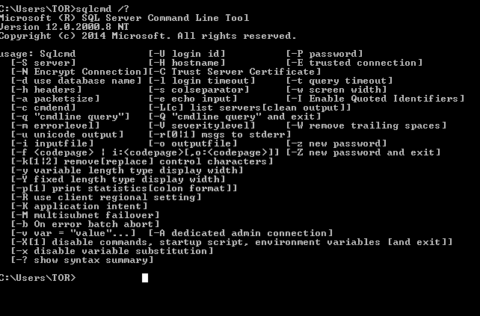

3. Write a SQLCMD statement to log on to your instance of SQL Server

Sqlcmd –S TORLAPTOP\SQL2014

USE Adventureworks2012;

GO

SELECT CusotmerID

FROM Sales. Customer;

GO

4. Change the database context to AdventureWorks2012

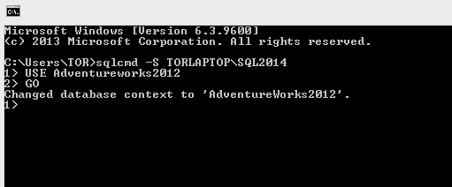

5. SELECT CustomerID FROM Sales.Customer

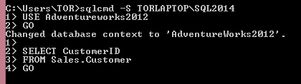

6. Verify on the screen that the data is displayed

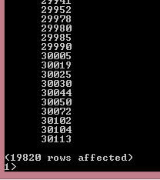

7. Terminate the session by executing “exit”

8. Submit your SQLCMD statement and screenshots