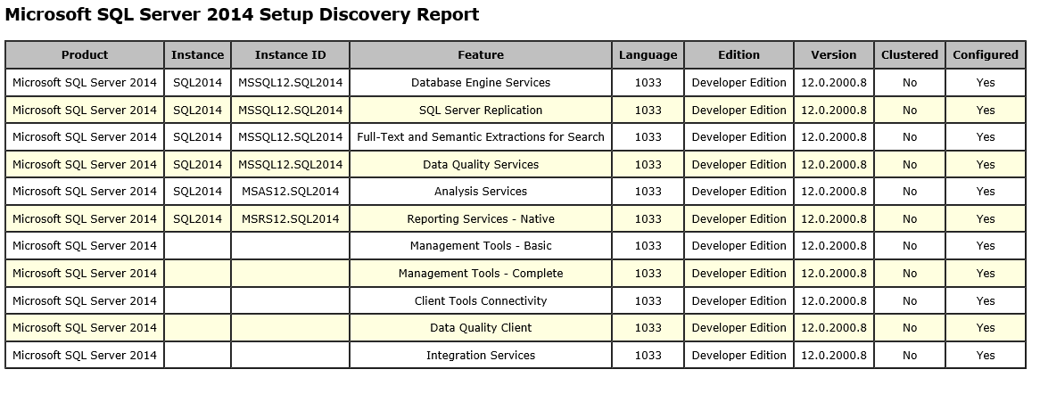

C:\Program Files\Microsoft SQL Server\120\Setup Bootstrap\SQLServer2014>Setup.exe /Action=RunDiscovery

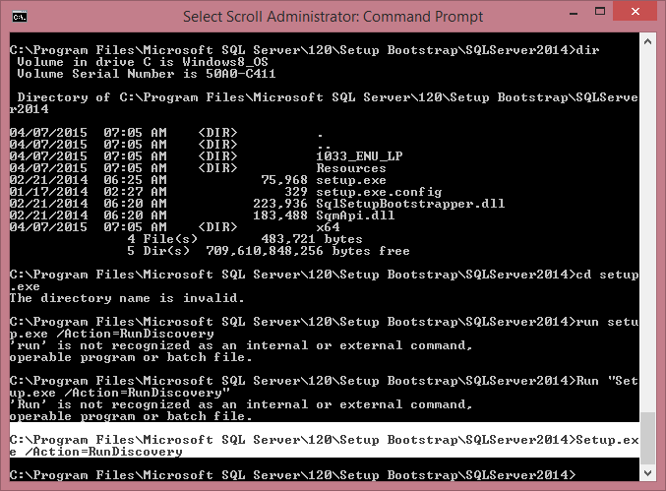

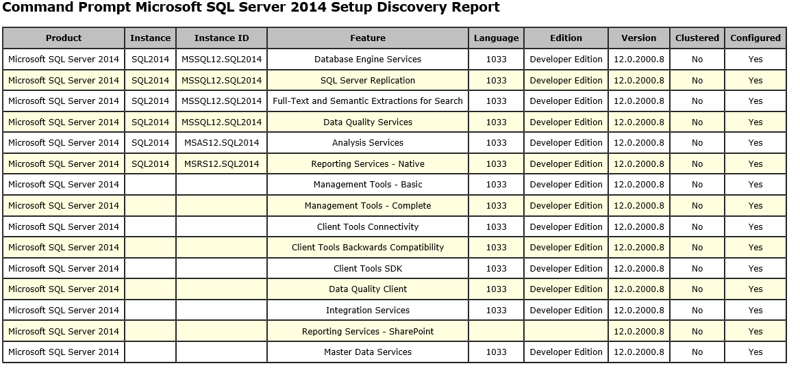

sp_helpserver and sp_server_info

