## Tor Thogersen

## DBA 232

## LAB 3

1. Run the “Create Directories” and “Create Database” scripts below.



2. Make sure that folders, C_SQL, D_SQL, E_SQL, F_SQl exist and that the MoveDB database files are located in the C:\E_SQL folder.

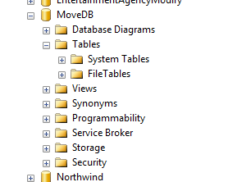

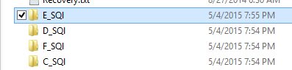

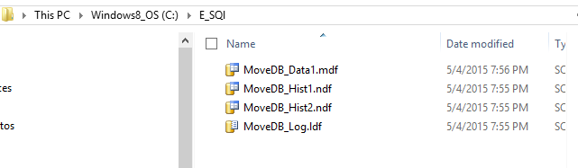

3. In SSMS, detach the MoveDB database.

USE [master]

GO

ALTER DATABASE [MoveDB] SET SINGLE_USER WITH ROLLBACK IMMEDIATE

GO

USE [master]

GO

EXEC master.dbo.sp_detach_db @dbname = N'MoveDB', @skipchecks = 'false'

GO

4. Using Windows Explorer, move the MoveDB database files from the C:\E_SQL folder to the C:\C_SQL folder.

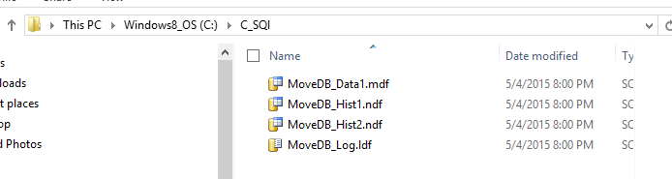

5. In SSMS, attach MoveDB database.

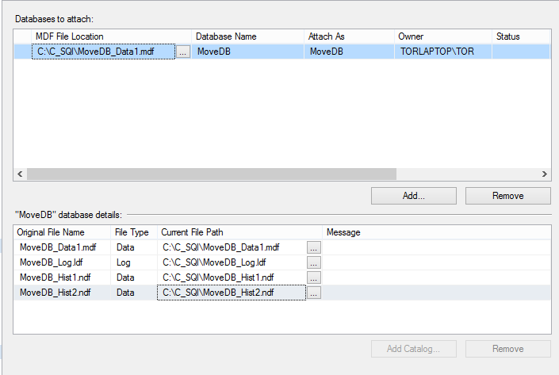

6. Refresh the databases and check the locations of the MoveDB database files.

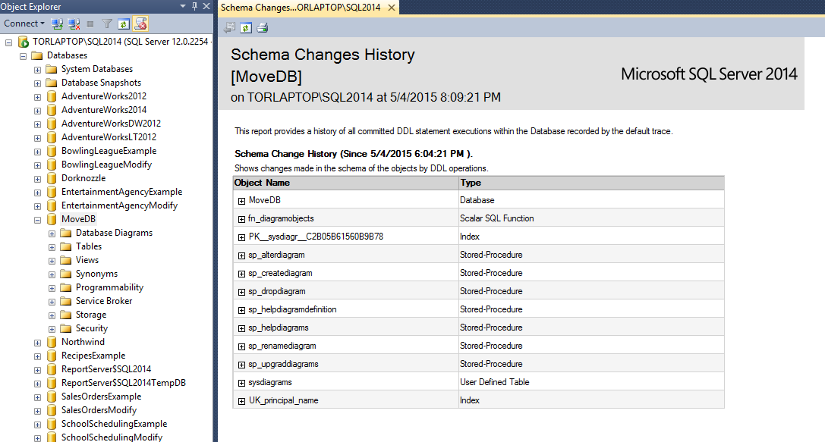

7. Submit the before and after move file location screenshots captured from within SSMS.