**Tor Thogersen**

**ISIT 334**

**Assignment 02**

Bad Chart # 1 (Pie Charts are evil page 61 to 65)

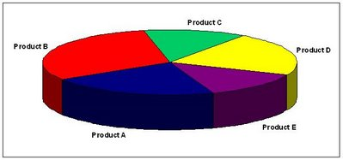

(secondtree, 2007)

The use of a pie chart violates two critical principles in chapter two.

1. Never use a pie chart, this data does not show the proper proportion for each product group or percentage or volume assigned in each section. You are unable to determine which size is the largest and by how much.
2. Golden rule violation number 2, never use 3D graphics to enhance your chart or graphic unless you’re plotting third-dimensional charts. Due to the 3D enhancement, the visual is skewed and tricks the eye from properly viewing the size and dimensions.

Bad Chart # 2 (3D – Bar Chart page 50 to 55)

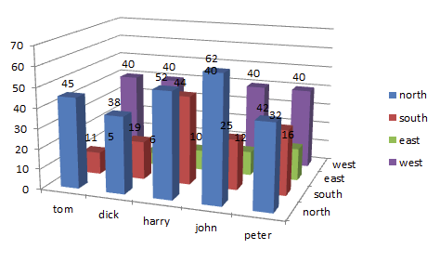

(Forbes, 2012)

This chart is trying to show a comparison of the data between different regions and a group of people.

1. They should first remove the 3D graphics, this changes the angle at which your able to proper judge the horizontal and vertical axis, due to the 3D enhancement your not able to proper or accurately decipher the volume or size properly
2. They did not use proper scaling or order for the bar chart, they need to order the chart from high to low or low to high based on the importance and hypothesis of the data.
3. Remove the x-axis labels since this information is already listed in the legend, this information causes clutter.
4. Data call out labels need to be moved to inside the body,

Good Chart # 1

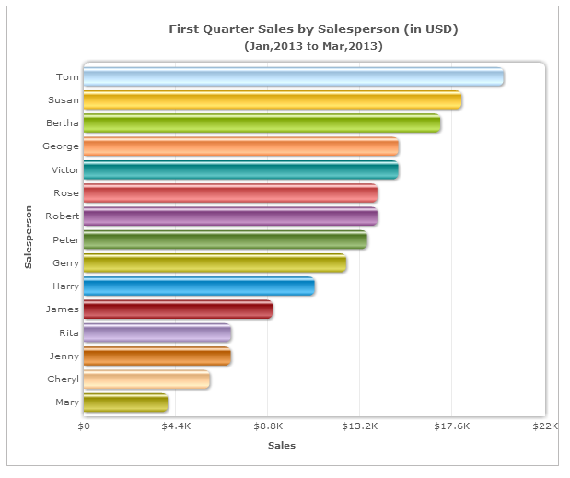

(bar-many-dataets.png , 2017)

The Authors on page 57, for showing categorical and multiple series data, recommend the Bar chart. Due to how most people will view data in a “Z” pattern, this chart is very easy to read and interpret. They have the most important or highest grossing salesperson information on top and lowest-grossing salesperson last, they also enhance the chart data by eliminating the plot lines and keeping each Salesperson on the vertical axis right aligned to the chart, keeping everything symmetrical and easy to read.

The only thing I may modify in the chart would be eliminated Horizontal and vertical titles and “$” symbol, due to the Chart Title you can assume each person listed is a salesperson and sales amount are the sales.

Good Chart #2 (Multi Series Line Chart)

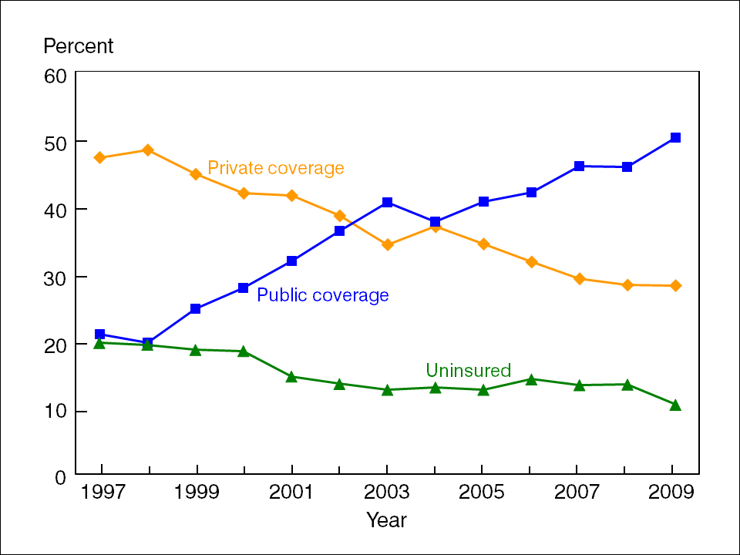

(cdc insurance data , 2010)

Overall, this chart follows the Gestalt principles for Similarity and the author's practice of reduced clutter (page 76 to 85).

I like the fact they chart is simple to understand and your able to quickly follow each line, with an understanding what each data point represents. The fact they reduce the clutter and allowed for the white spaces to show, allows the data and chart to be visually enhanced.

The book recommends on page 94 to remove the data markers, in this instance, I feel they data markers actually help delineate the data with the help of the color consistency for the line and Data labels.