**Tor Thogersen**

**ISIT 334**

**Assignment 05**

Profit and Sales for each Order Date Month. Color shows details about Profit and Sales. The data is filtered on Order Date Year, which keeps 2012. The view is filtered on Order Date Month, sum of Profit and sum of Sales. The Order Date Month filter keeps 12 of 12 members. The sum of Profit filter keeps non-Null values only. The sum of Sales filter keeps non-Null values only.

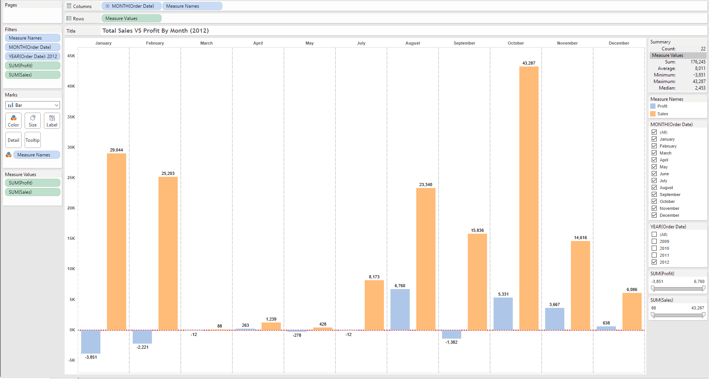

Most profitable months (2012):

* August 6,760.29
* October 5,331.42
* November 3,667.09

Least Profitable Months (2012):

* January -3,851.38
* February -2,220.62
* September -1,382.38

Profit and Sales for each Order Date Month broken down by Product Category. Color shows details about Profit and Sales. The context is filtered by Product Category, which keeps Office Supplies. The data is filtered on Order Date Year, which keeps 2012. The view is filtered on Order Date Month, the sum of Profit and sum of Sales. The Order Date Month filter keeps 12 of 12 members. The sum of Profit filter keeps non-Null values only. The sum of Sales filter keeps non-Null values only.

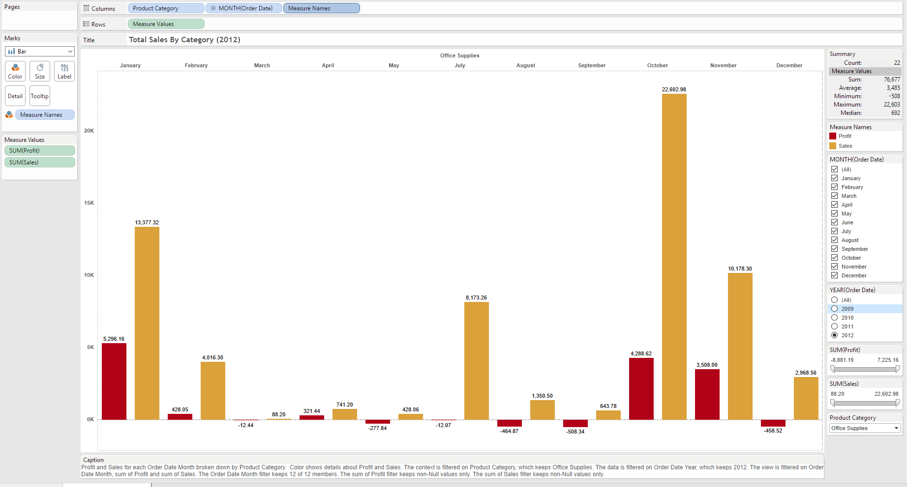

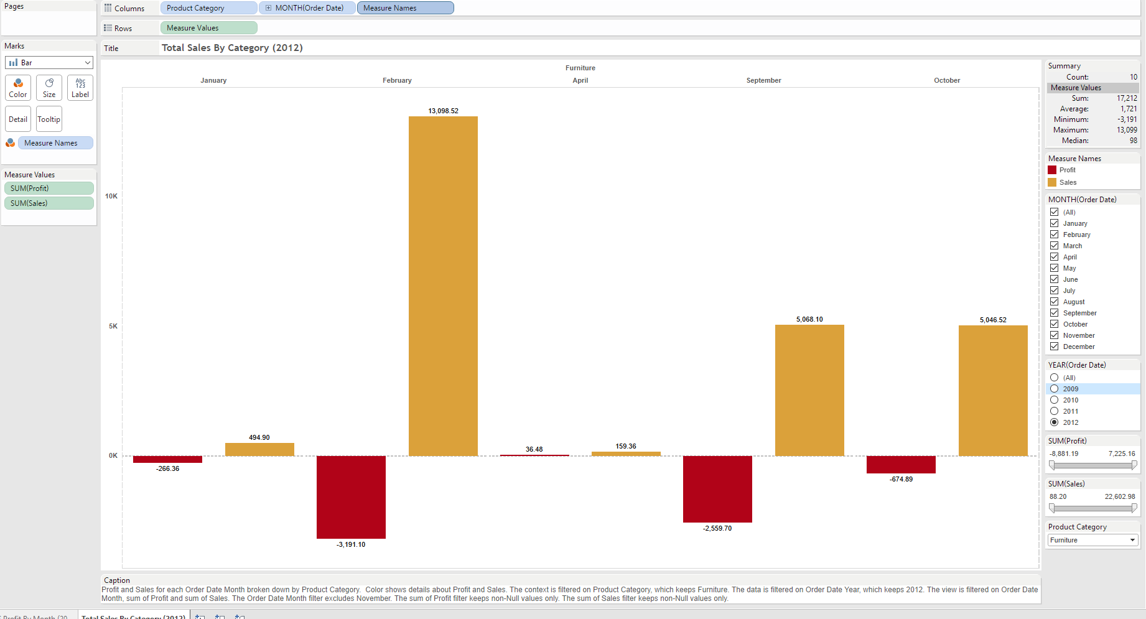

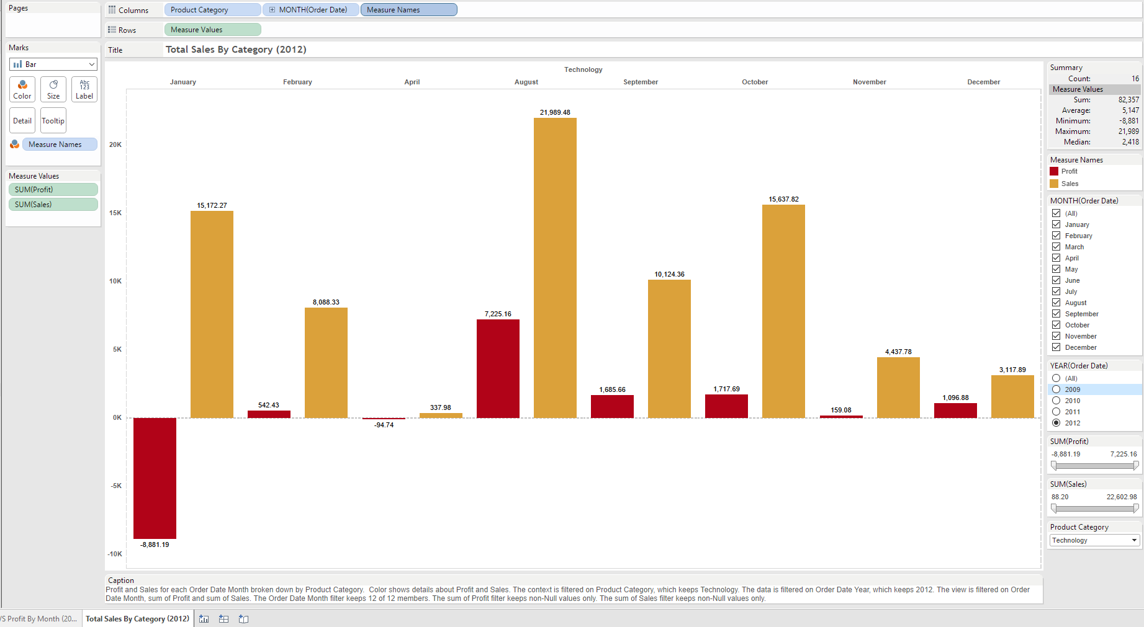

The chart below shows the break Sales vs Profit by Product Category for the 2012 Calendar year, I’ve added a filter to allow you to modify the chart based on Product Category you choose.

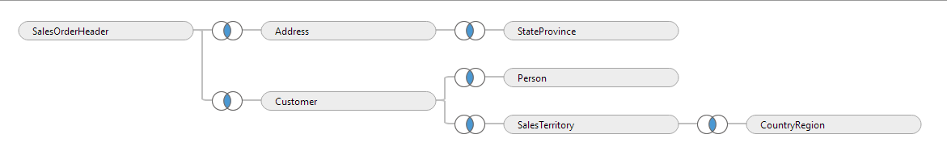

Tables I pulled from 2014 DB and Joined together to find sales orders and addresses associated with those orders

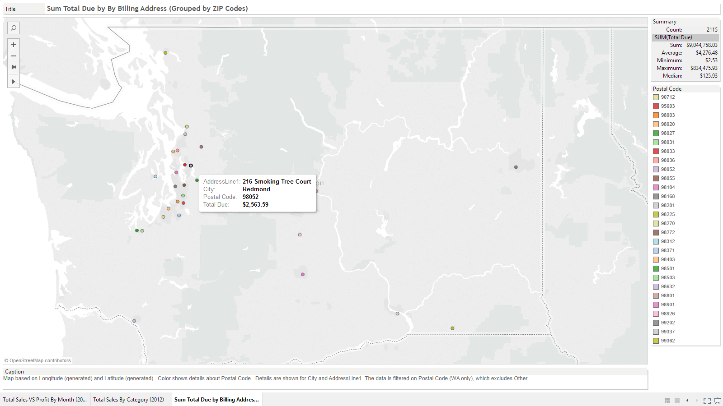

Map based on Longitude (generated) and Latitude (generated). Color shows details about Postal Code. Details are shown for City and AddressLine1. The data is filtered on Postal Code (WA only).