**Tor Thogersen**

**ISIT 334**

**Assignment 06**

1) Titanic: Create a visualization that shows the average age of Men, Women, and their fate (were they saved?). Do not include NULL values, name

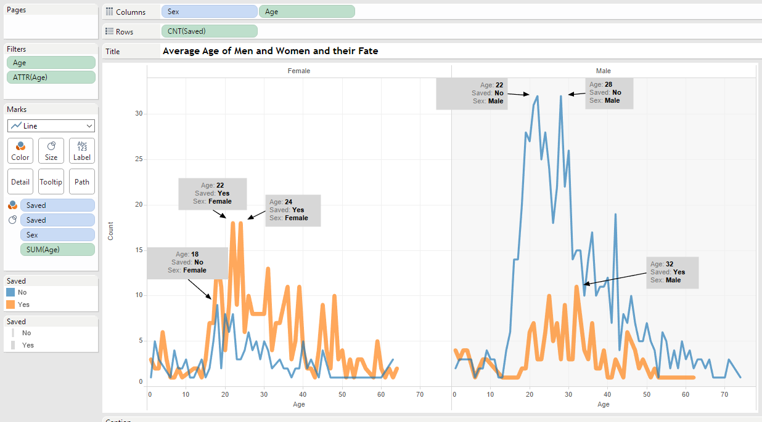

The trend of the count of Saved for Age broken down by Sex. Color shows details about Saved. Size shows details about Saved. Details are shown for Sex. The data is filtered on Age as an attribute, which keeps non-Null values only. The view is filtered on Age, which keeps non-Null values only.

I decided to use the line chart to show differences in saved vs not saved by age and gender. The data shows more women than men were saved and the average age for survivors was 32 for males and 22 to 24 females.

2) Titanic: Create a visualization that shows the breakdown of jobs.

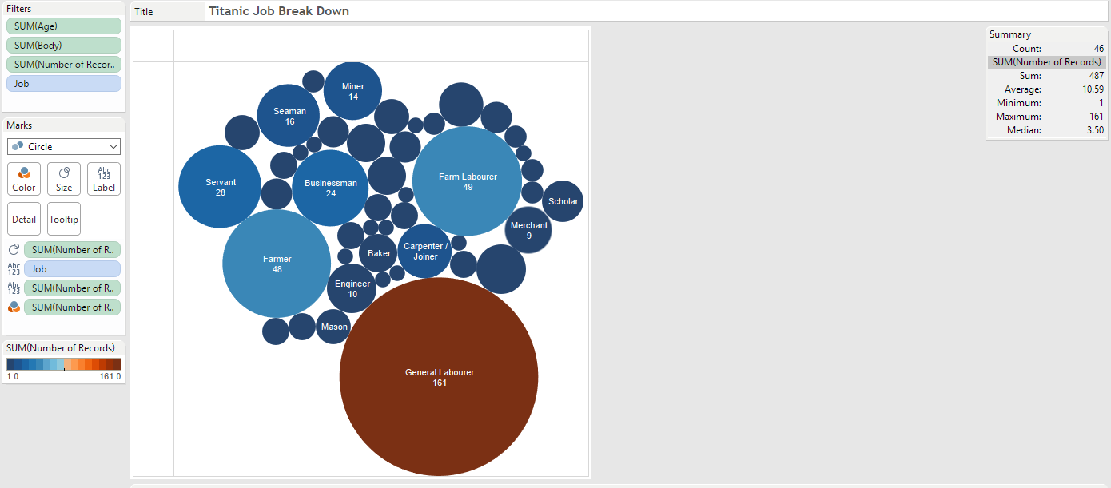

Job and sum of Number of Records. Color shows sum of Number of Records. Size shows the sum of Number of Records. The marks are labeled by Job and sum of Number of Records. The data is filtered on the sum of Age and sum of Body. The sum of Age filter keeps non-Null values only. The sum of Body filter keeps non-Null values only. The view is filtered on the sum of Number of Records and Job. The sum of Number of Records filter keeps non-Null values only. The Job filter excludes Null.

I decided to use the Bubble chart to quickly show which job category, based on my data the General Labourer was the largest working group on the titanic.

3) AdventureWorks: This is a hard one because you will need to spend some time looking at the database. Create a visualization that shows the popularity of the products based on the number of items ordered.

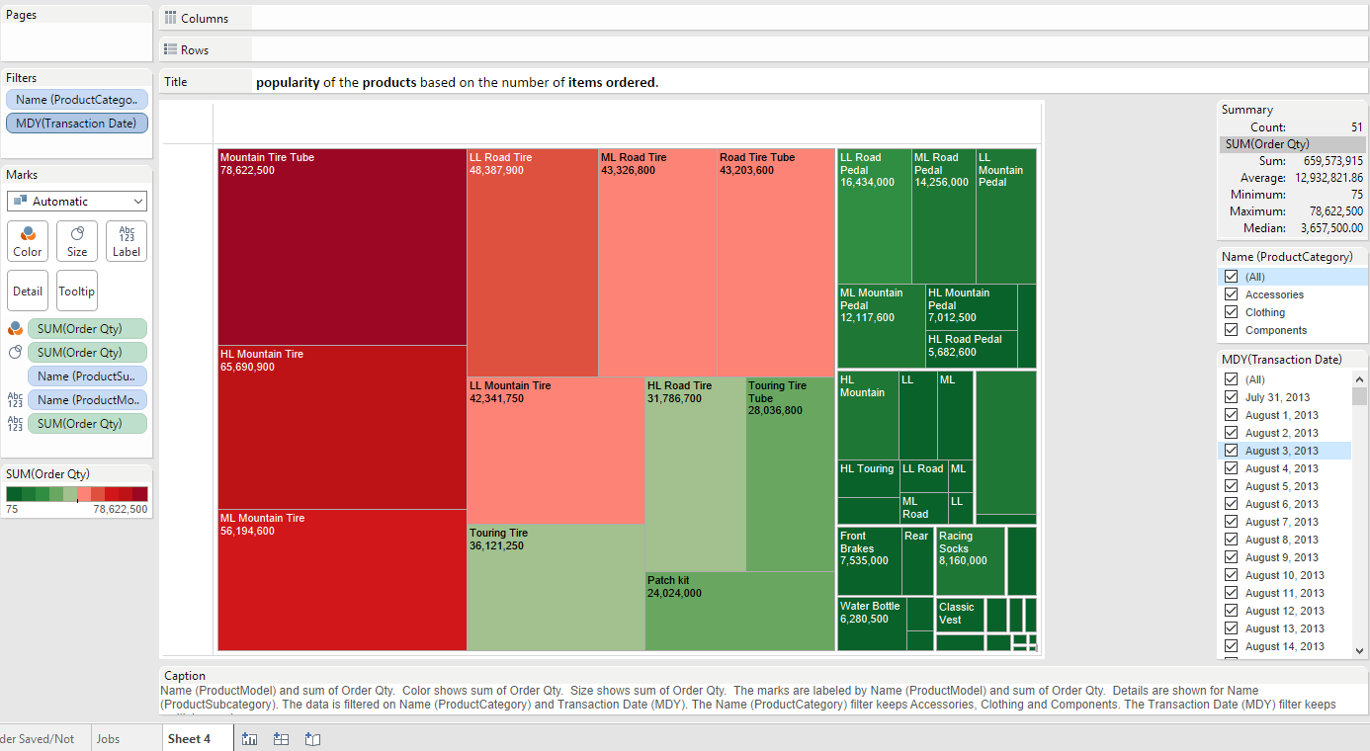

Name (ProductModel) and the sum of Order Qty. Color shows sum of Order Qty. Size shows the sum of Order Qty. The marks are labeled by Name (ProductModel) and the sum of Order Qty. Details are shown for Name (ProductSubcategory). The data is filtered on Name (ProductCategory) and Transaction Date (MDY). The Name (ProductCategory) filter keeps Accessories, Clothing, and Components. The Transaction Date (MDY) filter keeps multiple members.

I decided to use the Tree Map with color heat model to show top selling items by orders, I’ve added filters so you can change the categories based on department, currently, the chart shows all products and all dates.

4) AdventureWorks: use the view Sales.vIndividualCustomer to show where customers are located based on zip code.

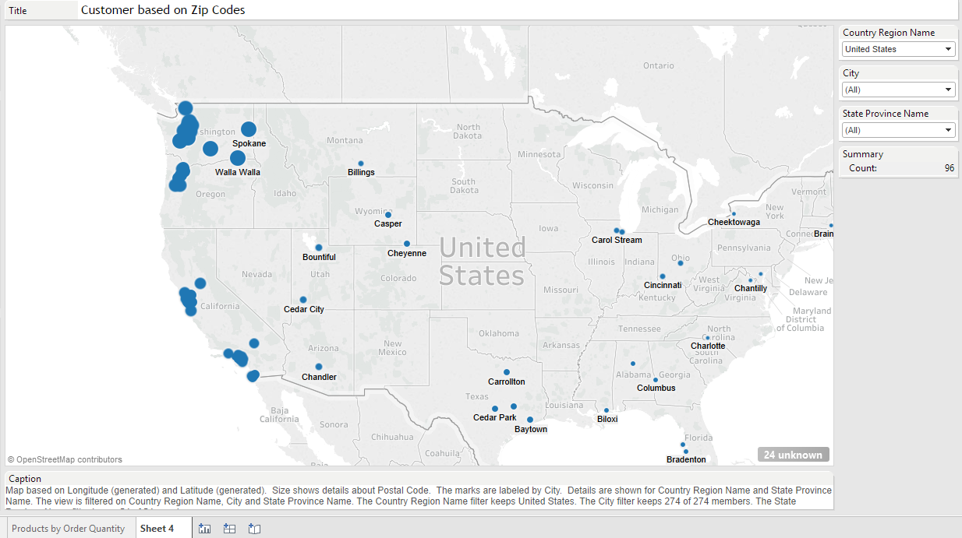

Map based on Longitude (generated) and Latitude (generated). Size shows details about Postal Code. The marks are labeled by City. Details are shown for Country Region Name and State Province Name. The view is filtered on Country Region Name, City, and State Province Name. The Country Region Name filter keeps 6 of 6 members. The City filter keeps 274 of 274 members. The State Province Name filter keeps 54 of 54 members.

Based on the data for the USA, our largest customer base in located in the west coast, specifically in Pacific Northwest.

5) AdventureWorks: pretend I'm the CEO of AdventureWorks; I really don't know much about the data we have, and can't really give you direction on how to find the information. In a meeting, I mention it would be nice to know more about the staff in regards to how long they have worked at AdventureWorks.  As the designer/analyst, you need to come up with something that can show this in a way that tells a story or shows something insightful (other than just a list of employees and how long they have worked for the company). Obviously, you will use the HumanResources.Employee table, but feel free to join in other tables that you feel add value to the story.

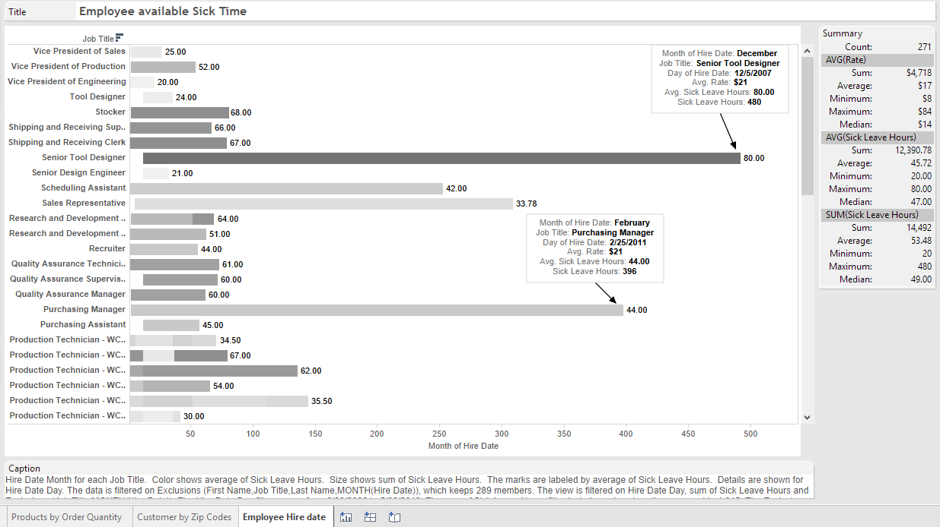

Hire Date Month for each Job Title. Color shows an average of Sick Leave Hours. Size shows sum of Sick Leave Hours. The marks are labeled by an average of Sick Leave Hours. Details are shown for Hire Date Day. The data is filtered on Exclusions (First Name, Job Title, Last Name, MONTH(Hire Date)), which keeps 289 members. The view is filtered on Hire Date Day, sum of Sick Leave Hours and Exclusions (Job Title, MONTH(Hire Date)). The Hire Date Day filter ranges from 6/30/2006 to 5/30/2013. The sum of Sick Leave Hours filter includes values less than or equal to 1,015. The Exclusions (Job Title, MONTH(Hire Date)) filter keeps 123 members.