

Product Requirement Document (PRD)

Project Code | VVDN_SPPS_2026
Project Name | Smart Programmable Voltage Supply Module (85–265 V AC In, 5–20 V / 3 A DC Out)
Revision | Rev 1.0
Date | 08 Oct 2026

Revision History
Date | Revision No. | Description | Prepared/Revised By | Reviewed By | Approved By
08 Oct 2026 | Rev 1.0 | Initial release of PRD for Smart Programmable Voltage Supply Module | Hardware Team Lead | BU SME (Power Electronics) | BU Head (Embedded Hardware)
25 Sep 2026 | Rev 0.1 | Draft architecture & component selection study | Power HW Lead | Lead Architect | BU Head

Customer Sign Off
CUSTOMER SIGN-OFF FORM
Customer | Technical In-Charge | Program In-Charge
Name: | Dr. Michael Chen | Sarah Jenkins
Designation: | Director of Hardware Engineering | Program Director
Email ID: | m.chen@client-ate.com | s.jenkins@client-ate.com
Address: | ATE Systems Inc., San Jose, CA | ATE Systems Inc., San Jose, CA
Comments: | Approved for automated test rack integration. | Approved for Phase 1 architecture & bring-up.
Signature & Date: | Signed 2026-10-08 | Signed 2026-10-08
VVDN SIGN-OFF FORM | Technical In-Charge | Program In-Charge
Name: | Karpagamoorthy R / Vignesh Anandhan | Gaurav Gupta / Shivam Saxena
Designation: | Technical Lead (Power HW) | BU Head & Program Director
Email ID: | karpagamoorthy.r@vvdntech.com | gaurav.gupta@vvdntech.com
Address: | VVDN Technologies, Global Innovation Park, Gurugram | VVDN Technologies, Global Innovation Park, Gurugram
Comments: | 4-Switch Sync Buck-Boost meets all specifications. | BOM cost target and delivery milestones aligned.
Signature & Date: | Signed 2026-10-08 | Signed 2026-10-08

Internal Sign Off
INTERNAL SIGN-OFF
Level 1 | BU SME (Power & Industrial BU)
Name: | Karpagamoorthy R
Comments: | Verified against IEC 62368-1 reinforced isolation and CISPR 32 Class B limits.
Signature & Date: | Signed 2026-10-08

Table of Contents
1 Introduction 7
1.1 Purpose 7
1.2 Document Conventions 7
1.3 Intended Audience and Reading Suggestions 7
1.4 Abbreviation 7
1.5 References 8
2 Product Overview 9
2.1 Product - Business Perspective 9
2.2 Product – Technical Perspective 9
2.3 Use Cases 10
2.4 Product Interfaces 10
2.4.1 Hardware Interfaces 11
2.4.2 Software Interfaces 12
3 Systems & Domains Involved 14
4 Product Requirement 15
4.1 System1 Requirements 15
4.1.1 Specific Requirements 15
4.2 System2 Requirements 16
4.2.1 Specific Requirements 16
5 Assumptions 16
6 Dependencies 17
7 Standard Deliverables & Release Order 18
7.1 Product Development Plan 18
7.2 System1 Development Plan 18
7.3 System2 Development Plan 19
8 Architecture <optional> 20
8.1 System1: Domain1 Architecture 20
8.2 System1: Domain2 Architecture 20
8.3 System2: Domain1 Architecture 20
9 Bill Of Material <optional> 21
9.1 System1: Product BOM 21
9.2 System2: Product BOM 21
10 Out of Scope 22
11 Open Items 22

List of Tables
Table 1: Abbreviation 8
Table 2: Reference 8
Table 3: Use Case 10
Table 4: Hardware Interfaces 12
Table 5: Software Interfaces 13
Table 6: Domain 14
Table 7: System1 Development Plan 19
Table 8:System1 Product BOM 21
Table 9:System2 Product BOM 22

List of Figures
Figure 1: System Boundary & Master Architecture Block Diagram 9
Figure 2: Major Use Case 1 - Precision Voltage Setpoint Tuning Workflow 10
Figure 3: Major Use Case 2 - Automated ATE Instrumentation SCPI Control Workflow 10
Figure 4: Dual-Closed-Loop Control & Hardware Protection Flow Diagram 15

Introduction

Purpose
This Product Requirement Document (PRD) defines all engineering, electrical, mechanical, safety, firmware, and telemetry requirements for the Smart Programmable Voltage Supply Module (85–265 V AC In, 5–20 V / 3 A DC Out). This document serves as the single source of technical truth across development, verification, certification, and production. this document and what it contains. The purpose of this document is to capture all the requirements of the product being developed and to serve as reference for the entire development of the product.
The requirements captured in this PRD supersede any previous documents, customer RFQs, preliminary proposals, and meeting discussions. This document shall be taken as the sole authoritative reference baseline for design acceptance and sign-off. captured here in this document supersedes any of such previous documents like customer RFQ, proposal etc and this PRD shall be taken as reference document for any requirements.

Document Conventions
Requirements marked with [MUST] are mandatory non-negotiable specifications essential for safety, electrical regulation, and compliance. Requirements marked with [SHOULD] represent performance targets where trade-offs require SME approval. Requirements marked with [MAY] represent optional enhancements. All electrical units follow SI conventions. conventions that were followed when writing this PRD, such as fonts or highlighting that have special significance. For example, state whether priorities for higher-level requirements are assumed to be inherited by detailed requirements, or whether every requirement statement is to have its own priority.>

Intended Audience and Reading Suggestions
This document is intended for Client Engineering & Management (scope sign-off), Hardware Architecture Teams (schematics, magnetics, safety), Embedded Software Teams (control loops, SCPI), PCB Layout & Mechanical Teams (stackup, creepage slots), and Quality Assurance (EMC & safety verification). that the document is intended for, such as developers, project managers, marketing staff, users, testers, and documentation writers. Describe what the rest of this PRD contains and how it is organized. Suggest a sequence for reading the document, beginning with the Introductions sections and proceeding through the sections that are most pertinent to each reader type.>
Client Team
Architect Team
Software Design team
Software Development Team
Quality Assurance Team
Documentation team
Deployment Team

Abbreviation
Acronym | Definition
AC | Alternating Current (Grid Mains Input, 85V–265V AC RMS)
DC | Direct Current (Regulated Output, 5.0V–20.0V DC)
PRD | Product Requirement Document
HDD | Hardware Design Document (Detailed Engineering Design Specification)
QR | Quasi-Resonant Valley Switching (Primary Flyback Mode)
CCM | Continuous Conduction Mode (Buck-Boost High-Load Mode)
MOSFET | Metal-Oxide-Semiconductor Field-Effect Transistor
MLCC | Multi-Layer Ceramic Capacitor (X7R Dielectric)
NTC | Negative Temperature Coefficient Thermistor (Inrush Limiter)
MOV | Metal Oxide Varistor (Line Transient & Surge Clamp)
DAC | Digital-to-Analog Converter (12-bit Voltage Setpoint Injection)
ADC | Analog-to-Digital Converter (MCU Telemetry Sampling)
CC | Constant Current Mode (Autonomous Hardware Current Limit)
CV | Constant Voltage Mode (Precision Voltage Regulation)
LSB | Least Significant Bit (Digital Precision Step)
RMS | Root Mean Square (Mains AC Voltage / Current Metric)
SCPI | Standard Commands for Programmable Instruments (IEEE 488.2)
SELV | Safety Extra-Low Voltage (< 60V DC Output Limit per IEC 62368-1)
SR | Synchronous Rectification (Active Secondary MOSFET Drive)
UVLO | Under-Voltage Lockout (Supply Protection Threshold)
ZCD | Zero-Crossing Detection (Auxiliary Winding Demagnetization)
OVP | Over-Voltage Protection
OCP | Over-Current Protection
OTP | Over-Temperature Protection
SCP | Short-Circuit Protection
Table 1: Abbreviation
The following table defines the engineering acronyms, abbreviations, and electrical nomenclature utilized throughout this Product Requirement Document:, including acronyms and abbreviations. You may wish to build a separate glossary that spans multiple projects or the entire organization, but just include terms specific to a single project in each PRD.>

References
The following industry standards, manufacturer component datasheets, and project architecture documents serve as normative references for this PRD:. These may include user interface style guides, contracts, standards, system requirements specifications, use case documents, or a vision and scope document. Provide enough information so that the reader could access a copy of each reference, including title, author, version number, date, and source or location.> Following references can be given
SL No | Description (with Version & Reference)
1 | Statement of Work (SOW): Smart Programmable Voltage Supply Module v1.0, VVDN Technologies
2 | IEC 62368-1: Audio/video, information & communication technology equipment - Safety requirements (3rd Ed)
3 | EN 55032 / CISPR 32 Class B: Electromagnetic compatibility of multimedia equipment - Emission requirements
4 | IEC 61000-4-5: Testing and measurement techniques - Surge immunity test (Level 3: 2kV Common Mode, 1kV Diff)
5 | Texas Instruments LM5176: High-Performance 4-Switch Synchronous Buck-Boost Controller Datasheet (SNVSAR4)
6 | Texas Instruments UCC28740: Constant-Voltage Constant-Current Flyback Controller with Optocoupler (SLUSBL2)
7 | IEEE 488.2 / SCPI Standard: Standard Commands for Programmable Instruments Specification Consortium
8 | VVDN Hardware Design Document (HDD): Smart Programmable Voltage Supply Module Architecture & Schematics
Table 2: Reference

Product Overview

Product - Business Perspective
The Smart Programmable Voltage Supply Module is an intelligent, high-density bench and industrial power supply delivering a tightly regulated, programmable DC voltage output from 5.0 V to 20.0 V at currents up to 3.0 A (60 W continuous output power) from universal mains AC input (85 V – 265 V AC RMS, 47 Hz – 63 Hz)., including relevant benefits, objectives, and goals. Relate the software to corporate goals or business strategies. If a separate vision and scope document is available, refer to it rather than duplicating its contents here.
The product eliminates bulky, expensive legacy bench supplies by integrating universal mains Quasi-Resonant Flyback isolation, an ultra-efficient 4-switch synchronous Buck-Boost post-regulator, dual-domain real-time efficiency monitoring, and autonomous MicroSD logging in a compact form factor. being specified in this PRD. For example, state whether this product is a follow-on member of a product family, a replacement for certain existing systems, or a new, self-contained product
All the details in this section would be from customer perspective of the product.

Product – Technical Perspective
The system comprises an isolated primary QR Flyback stage converting 85-265V AC into a rock-solid +24.0V DC bus (72W max), followed by a 4-switch synchronous Buck-Boost post-regulator (LM5176) stepping the rail up or down to 5.0V-20.0V DC at up to 3.0A with sub-25mV ripple. Dual-domain power metering continuously tracks AC input power and DC load power across reinforced isolation. and features shall be defined in the functional level. If the product defined under this PRD, is a component of a larger system, relate the requirements of the larger system to the functionality of this product and identify interfaces between the two.
System1 (HW/SW/ME)
Cloud Application
Client Application
Admin
End user
System2 (HW/SW/ME)

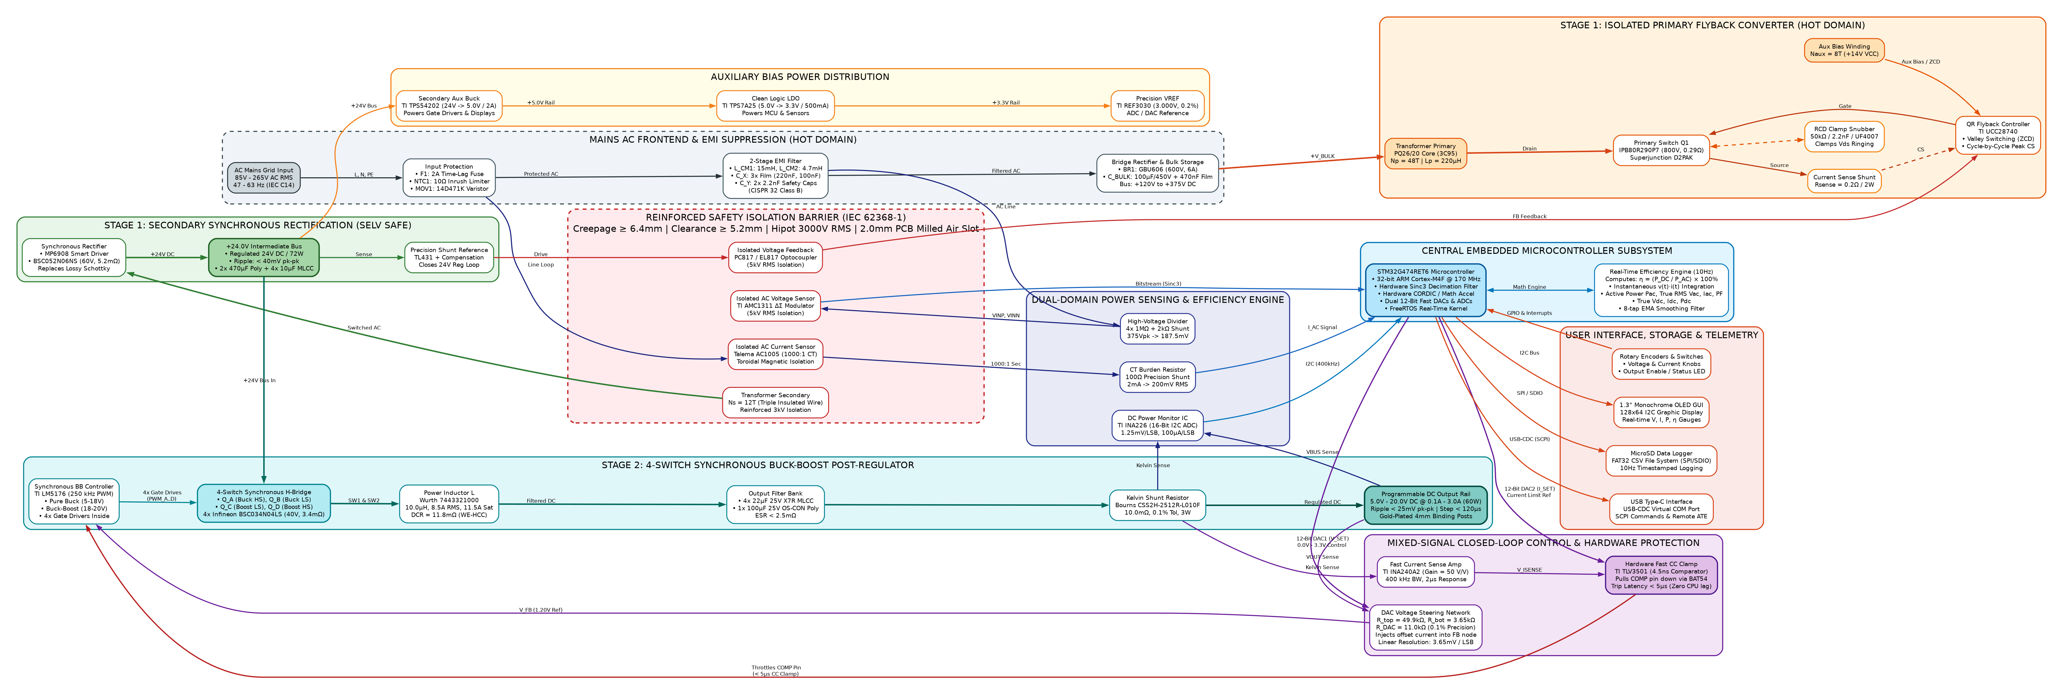
Figure 1: System Boundary & Master Architecture Block Diagram

The product comprises two principal hardware subsystems: Subsystem 1 (Universal AC-DC Isolated Flyback Power Stage) and Subsystem 2 (4-Switch Synchronous Buck-Boost Post-Regulator with STM32G474 digital supervisor). External entities include AC Grid Mains (85–265V AC), Device Under Test (DUT / Load), Host PC / ATE Automation Test Rig, MicroSD logging card, and the human bench operator. and also about each of the external entity shall be captured here>

Use Cases
The Smart Programmable Voltage Supply Module performs high-efficiency AC-DC power conversion with digital voltage regulation, fast hardware current limiting, real-time power metering, and remote automation control. The major functional use cases are summarized in Table 3 below:

The benchtop operator interacts with the power supply using front-panel dual rotary optical encoders and a 1.3" graphical OLED display. Automated test equipment (ATE) and host PCs communicate via USB Type-C using standard SCPI instrumentation commands. Power is delivered to the device under test (DUT) via heavy-duty 4mm binding posts, and operational telemetry is autonomously logged to an onboard MicroSD card.
The power supply module operates in four primary operating modes: Constant Voltage (CV) Mode for stable voltage regulation across varying loads; Constant Current (CC) Mode for ultra-fast hardware clamping during overload or short-circuit; Autonomous Dual-Domain Telemetry Mode for 10Hz power and efficiency logging; and Automated ATE Remote Control Mode for external script-driven testing.
In CV mode, the 4-switch synchronous Buck-Boost stage transitions smoothly between Buck, Buck-Boost, and Boost modes. In CC mode, an autonomous analog comparator overrides the feedback loop in less than 5 microseconds to protect the load, while the MCU logs the event.
Sl. No. | Use Case Description
1 | Precision Bench Supply Voltage Tuning: Operator adjusts rotary encoder or sends SCPI command (:VOLT 12.0). MCU updates 12-bit DAC; Buck-Boost settles to 12.00V in < 100µs with sub-25mV ripple.
2 | Dynamic Load Step Regulation: Connected DUT surges from 0.5A to 3.0A. LM5176 Type-II loop restores output voltage within 120µs with < 250mV transient sag, maintaining continuous stability.
3 | Autonomous Hardware Constant-Current (CC) Clamping: DUT encounters short circuit. Analog comparator pulls down COMP pin in < 5µs, clamping current strictly at setpoint without MCU software latency.
4 | Real-Time Dual-Domain Power & Efficiency Logging: System samples AC mains input power and DC load power at 10Hz, computes true efficiency (η = Pdc/Pac), and writes timestamped CSV records to MicroSD card.
5 | Automated ATE SCPI Control: Host PC controls power supply over USB-C CDC interface, querying real-time electrical metrics, logging data, and sequencing voltage ramps during qualification tests.
Table 3: Primary Use Case Summary

The benchtop operational voltage tuning sequence is summarized in Figure 2 and Table 3.1 below:
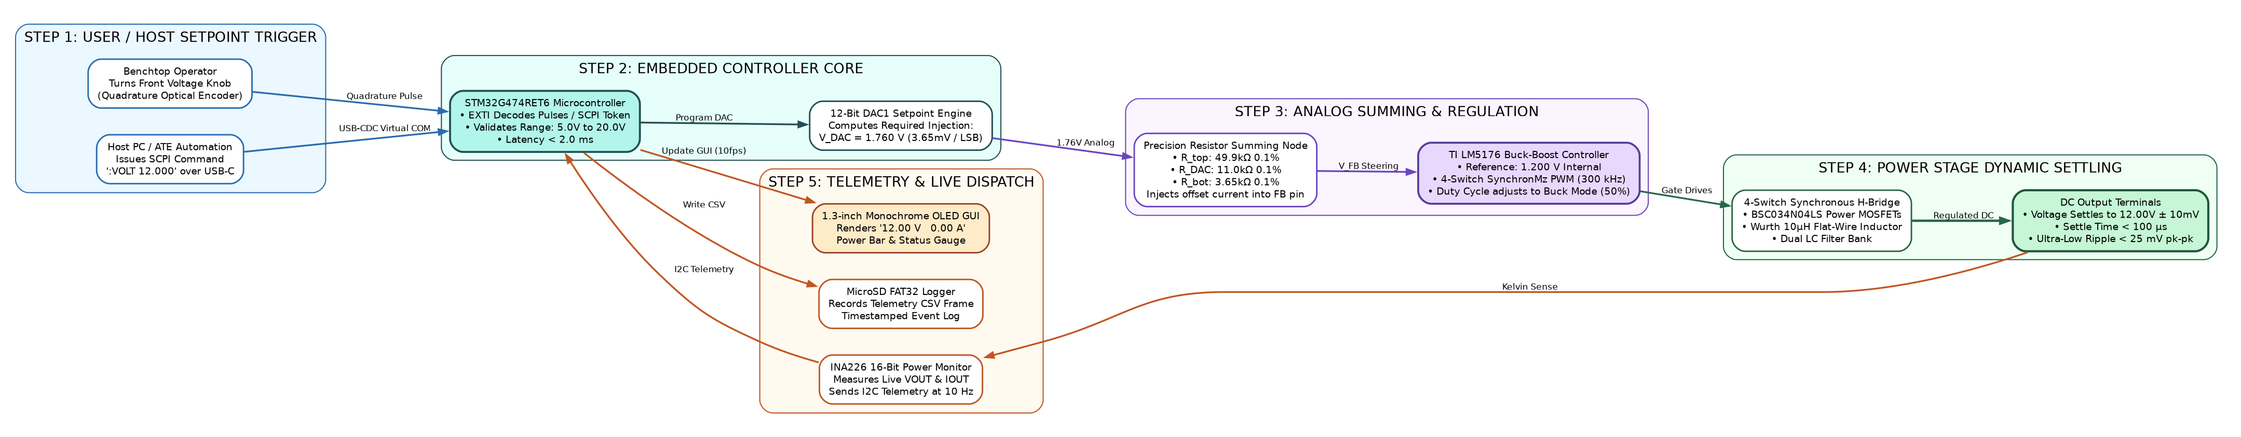
MAJOR USE CASE 1: VOLTAGE SETPOINT TUNING SEQUENCE
Step 1 | Operator / Host PC | Adjusts front rotary optical encoder knob or transmits SCPI command ':VOLT 12.0' over USB-C interface.
Step 2 | STM32G474 MCU Core | Decodes setpoint in < 2ms, calculates DAC voltage, and programs internal 12-Bit DAC1 to 1.76 V.
Step 3 | Feedback Summing Network | DAC injects steering current into LM5176 FB node via precision 0.1% divider (R_top=49.9kΩ, R_DAC=11.0kΩ, R_bot=3.65kΩ).
Step 4 | LM5176 Buck-Boost Stage | Modulates 4-switch PWM duty cycle; output voltage stabilizes to 12.00 V ± 10 mV in < 100 µs with < 25 mV ripple.
Step 5 | Dual-Domain Telemetry & UI | INA226 samples new VOUT/IOUT; MCU updates live 1.3" OLED dashboard and pushes timestamped record to MicroSD card.
Figure 2: Major Use Case 1 - Precision Benchtop Supply Voltage Tuning Workflow

The automated ATE SCPI instrumentation and telemetry logging flow is summarized in Figure 3 and Table 3.2 below:
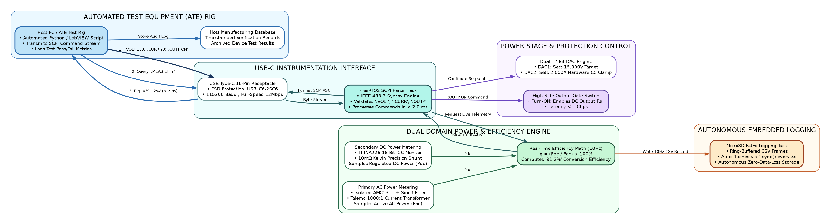
MAJOR USE CASE 2: AUTOMATED ATE SCPI & TELEMETRY FLOW
Step 1 | Automated ATE / Host PC | Sends standard SCPI batch command over USB-CDC: ':VOLT 15.000;:CURR 2.000;:OUTP ON' at 115200 baud.
Step 2 | SCPI Parser Task | FreeRTOS task verifies command syntax, adjusts DAC1 (15V) and DAC2 (2A limit), and enables power output.
Step 3 | Automated ATE / Host PC | Transmits telemetry query command ':MEAS:EFF?' to audit conversion efficiency during device test.
Step 4 | Efficiency Math Engine | Samples AMC1311 AC power (Pac) and INA226 DC power (Pdc), computes η = (Pdc/Pac) × 100%, and replies '91.2%' in < 2ms.
Step 5 | Data Logger Task | Autonomous FatFs task records complete measurement telemetry into FAT32 CSV file on physical MicroSD card.
Figure 3: Major Use Case 2 - Automated ATE Instrumentation SCPI Control & Telemetry Workflow

Product Interfaces
Physical interfaces include an IEC 320-C14 AC inlet, heavy-duty 4mm gold binding posts, USB Type-C virtual COM port, push-push MicroSD socket, dual optical rotary encoders, a 1.3" monochrome OLED display, and a tactile output enable push-button. that exist between different systems within the product and also the interfaces that exist between external entity and the product/system.>

Hardware Interfaces
The hardware interfaces provide ergonomic local control and automated rack integration. Binding posts carry 3.0A continuous load current; USB-C delivers full SCPI instrumentation telemetry; MicroSD card provides autonomous FAT32 data logging. that exist between external entity and the product/system. List down all the hardware user interface components in the list - Button, Switch, Keypad, LEDs, MIC, speaker, Ethernet, USB and camera. The description has to explain the usage & the purpose of the interface clearly.
All external entities are in highlighted in Green.>

Sl. No | Entity 1 | Entity 2 | Interface | Usage Description
1 | AC Grid Mains | SPPS Module | IEC 320-C14 Inlet | 85V–265V AC RMS, 47–63Hz, 3-prong grounded input with integrated 2A fuse holder.
2 | SPPS Module | DUT / Load | 4mm Gold Binding Posts | Heavy-duty 15A Red (+) and Black (-) terminals supporting banana plugs, spade lugs, or bare wire.
3 | SPPS Module | Host PC / ATE | USB Type-C Receptacle | USB 2.0 Full-Speed Virtual COM Port for SCPI commands, data streaming, and automated testing.
4 | SPPS Module | Storage Media | Push-Push MicroSD Socket | SPI / 4-bit SDIO interface supporting FAT32 flash cards up to 32GB for autonomous logging.
5 | SPPS Module | Local Operator | Dual Rotary Encoders | Optical rotary encoders with push-button for setting voltage (10mV) and current (10mA).
6 | SPPS Module | Local Operator | 1.3" Monochrome OLED | 128x64 graphical display showing real-time meters (V, I, P, η, Temp) and CV/CC mode annunciator.
7 | SPPS Module | Local Operator | Output Enable Push-Button | Tactile switch with dual-color LED (Green: Output Active, Red: Tripped/Fault, Dark: Standby).
Table 4: Hardware Interfaces

Software Interfaces
Software communication uses standard IEEE 488.2 SCPI protocol over USB-CDC at 115200 baud (8N1). An internal FreeRTOS telemetry task logs CSV records to MicroSD every 100ms and updates the local 1.3" OLED display at 10 frames/sec. of the product and between the product and external entity, along with the services/features/software modules needed and the nature of communications including e-mail, web browser, network server communications protocols, electronic forms, and so on.
The interfaces/communication between software services/features/modules within the system is not required to be captured here.
Identify any communication standards that will be used, such as FTP or HTTP. Specify any communication security or encryption issues, data transfer rates etc.>
All external entities are in highlighted in Green.
S. No | Entity 1 | Entity 2 | Interface | Protocol / Mode | Usage Description
1 | Host ATE | SPPS Module | USB-CDC Virtual COM | IEEE 488.2 SCPI | Accepts standard instrument commands (:VOLT, :CURR, :OUTP, :MEAS:EFF?) at 115200 baud, 8N1.
2 | Telemetry Task | MicroSD Card | SPI / FatFs | FAT32 CSV Schema | Non-blocking ring-buffered logging of timestamped records at 10Hz rate.
3 | Metering Task | Primary AMC1311 | Hardware Sinc3 Filter | Differential Bitstream | Synchronous digital filtering converting isolated modulations into true RMS AC power.
4 | Metering Task | Secondary INA226 | I2C Bus (400 kHz) | Register Protocol | Reads DC bus voltage (1.25mV/LSB) and shunt current (100µA/LSB) every 100ms.
5 | Display Task | OLED Controller | I2C Bus (400 kHz) | SSD1306/SH1106 Driver | Updates real-time graphical dashboard and efficiency bar at 10 frames/sec.
6. | Gateway:Main Application | On Client Application | Pre-defined APIs, GUI, CLI, | SNMP, telnet, trap and Alarms
Table 5: Software Interfaces

Systems & Domains Involved
System 1 represents the Hardware Power Supply Module (HW, ME, QA); System 2 represents the Embedded Firmware & Display Controller (BSP, SAP, FW); System 3 represents the Host PC Telemetry Application (PAP). involved in each systems. For example, IOT sensor and a mobile app development is a project. Then, Mobile app can be considered as either a separate system or part of IOT sensor system depending on the complexity/functionality of the mobile app. If mobile app, is only for configuration with minimal UI support, then it NEED NOT to be considered a separate system. In case, it supports lot of functionality, then it can be considered a separate system.
Domain is an indication of different team that is required for developing the said system. For example, hardware, mechanical, AndroidApp, IOSApp, CloudApp etc.
For this project,

Domain Names | System 1 (HW Power Module) | System 2 (Firmware & GUI) | System 3 (PC Telemetry Suite)
Hardware - HW | Yes | No | No
Mechanical - ME | Yes | No | No
Embedded Firmware - FW | No | Yes | No
Software / App - SW | No | No | Yes
Cloud / Backend | No | No | No
Quality Assurance - QA | Yes | Yes | Yes
Production / Operations | Yes | No | No
Safety & Certification | Yes | No | No
Table 6: Domain

Each domain will have requirements captured to Subsystem & Module level in the requirements sheet.>

Product Requirement

System1 Requirements
System 1 represents the physical Hardware Power Supply Module, comprising the universal AC input, EMI filter, isolated Quasi-Resonant Flyback stage, 4-switch synchronous Buck-Boost post-regulator, analog protection circuits, and microcontroller sensing core. The detailed engineering specifications are defined in the tables below:
Table 4.1: AC-DC Isolated Flyback Power Stage Engineering Requirements
Req ID | Parameter / Feature | Specification / Target | Condition | Verification
FR-01 | AC Input Voltage Range | 85 V – 265 V AC RMS [MUST] | Nominal 230V AC, 47–63 Hz | AC Source Sweep
FR-02 | Intermediate DC Bus Voltage | +24.0 V DC ± 2.0% [MUST] | Across all line/load variations | Digital Multimeter
FR-03 | Continuous Power Output | 72.0 W Continuous [MUST] | 85V–265V AC In, 24V / 3A Out | Electronic Load 72W
FR-04 | Peak Power Capability | 84.0 W for 500 ms [SHOULD] | During dynamic load surges | Transient Load Step
FR-05 | Peak Power Stage Efficiency | > 90.0% @ 230V AC Full Load [MUST] | Pout = 72W, Tamb = 25°C | Precision Power Analyzer
FR-06 | Safety Galvanic Isolation | 3,000 V AC RMS (1 min) [MUST] | Primary to Secondary barrier | Hi-Pot Isolation Tester
FR-07 | Cold-Start Inrush Current | < 25.0 A Peak [MUST] | Vin = 265V AC, cold start 25°C | Current Probe & Scope
FR-08 | No-Load Standby Power | < 150 mW Standby [SHOULD] | Vin = 230V AC, Output Disabled | Power Meter Integrator
Table 4.2: 4-Switch Synchronous Buck-Boost Post-Regulator Requirements
Req ID | Parameter / Feature | Specification / Target | Condition | Verification
BB-01 | Output Voltage Range | 5.0 V – 20.0 V DC Programmable [MUST] | Continuous linear adjustment | Precision DMM Sweep
BB-02 | Continuous Output Current | 0.0 A – 3.0 A DC Continuous [MUST] | Across full 5V–20V voltage span | Electronic Load 3A
BB-03 | Maximum Output Power | 60.0 W Continuous Output [MUST] | Vout = 20.0V, Iout = 3.0A | Thermal Run 60W (2 hrs)
BB-04 | Voltage Setpoint Resolution | 10 mV step resolution (12-bit DAC) [MUST] | LSB step = 3.65 mV | DAC Calibration Sweep
BB-05 | Current Limit Resolution | 10 mA step resolution (12-bit DAC) [MUST] | LSB step = 0.73 mA | Current Clamp Tuning
BB-06 | Output Voltage Ripple | < 25 mV pk-pk ripple [MUST] | Full load 3A, 20MHz bandwidth | Oscilloscope AC Probe
BB-07 | Load Transient Recovery | < 120 µs recovery, < 250mV sag [MUST] | 50% to 100% load step (1.5A to 3A) | Dynamic Load Stepper
BB-08 | Buck-Boost Efficiency | > 95.0% @ 20V/3A; > 92.0% @ 5V/3A [MUST] | Vin = 24V, Sync Rectification | Dual-Channel Power Meter
BB-09 | Switching Frequency | 300 kHz ± 10% [MUST] | Fixed frequency PWM | Frequency Counter
BB-10 | CC Mode Reaction Time | < 5.0 µs autonomous clamping [MUST] | Overload short-circuit step | Fast Current Shunt Scope
Table 4.3: Real-Time Dual-Domain Telemetry & Monitoring Requirements
Req ID | Parameter / Feature | Specification / Target | Condition | Verification
TM-01 | Primary AC Voltage Sensing | Isolated AMC1311 (0-300V AC RMS) [MUST] | ± 1.0% accuracy across 85-265V | Grid AC Meter Reference
TM-02 | Primary AC Current Sensing | Current Transformer 1000:1 [MUST] | ± 1.5% accuracy from 0.1A-2A | Fluke Current Probe
TM-03 | Secondary DC Voltage Sense | INA226 16-bit ADC (1.25mV/LSB) [MUST] | ± 0.2% measurement accuracy | Keysight 34465A DMM
TM-04 | Secondary DC Current Sense | INA226 16-bit ADC (100µA/LSB) [MUST] | ± 0.5% measurement accuracy | Precision Shunt Reference
TM-05 | Dual-Domain Telemetry Rate | 10.0 Hz Real-Time Loop Rate [MUST] | Pac, Pdc, and η computed at 100ms | Timing Logic Analyzer
TM-06 | MicroSD Data Logging | FAT32 CSV Autonomous Logging [MUST] | Timestamp, Vac, Iac, Vdc, Idc, η | MicroSD File Verification
TM-07 | Remote SCPI Interface | IEEE 488.2 SCPI over USB-CDC [MUST] | 115200 baud, standard commands | Automated Python Test Rig
Table 4.4: Protection, Safety, EMC & Environmental Requirements
Req ID | Parameter / Feature | Specification / Target | Condition | Verification
PR-01 | Hardware Over-Voltage (OVP) | Clamps at Vset + 1.5V (< 5µs response) [MUST] | Independent comparator crowbar | OVP Trip Verification
PR-02 | Hardware Constant-Current (CC) | Clamps at Iset ± 20mA (< 5µs reaction) [MUST] | Analog pull-down on COMP pin | Direct Short-Circuit Test
PR-03 | Over-Temperature (OTP) | Shuts down at Tpcb > 90°C (10°C hyst) [MUST] | NTC thermistor monitoring | Thermal Chamber Sweep
PR-04 | Safety Compliance Standard | IEC 62368-1 Reinforced Isolation [MUST] | SELV compliant (< 60V DC) | Certified Safety Lab
PR-05 | Creepage & Clearance | Creepage >= 6.4mm; Clearance >= 5.0mm [MUST] | Primary-Secondary milled slot | PCB Mechanical Caliper
PR-06 | Conducted & Radiated EMC | CISPR 32 / EN 55032 Class B [MUST] | 150 kHz – 1 GHz emission limits | Semi-Anechoic Chamber
PR-07 | Operating Ambient Temp | -20°C to +50°C Full Load [MUST] | Natural convection in chassis | Environmental Chamber
PR-08 | Mean Time Between Failures | MTBF > 50,000 Hours @ 40°C [SHOULD] | Telcordia SR-332 Parts Count | Reliability Calculation
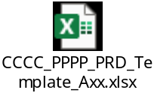

Specific Requirements
Specific hardware mechanical constraints require a compact extruded aluminum chassis (130 x 85 x 42 mm) with front-panel binding posts and rear-panel AC inlet. A minimum 6.4 mm isolation slot is milled across the PCB under the transformer and optocoupler barriers to ensure reinforced safety clearance. in plain text or can be better explained pictorially. For example, any customer requirement to use a specific ID for mechanical design or the requirement asking the position of the I/O connectors or push button or LEDs etc cannot be explained in text properly.
Similarly, implementation plan or proposal for few requirements can be better explained pictorially. For example, UI pages or mobile app or web app.
Such details (requirements or proposed implementations) can be capture here.

Dual-Closed-Loop Control & Real-Time Protection Flow
The 1.3" monochrome OLED display presents a real-time operational dashboard with large-digit output voltage and current meters, power readout, true system efficiency bar graph, and operating status annunciators (CV, CC, FLT). the flow of the application as per the requirement with all the validation of each screen mentioned in 2 or 3 lines>

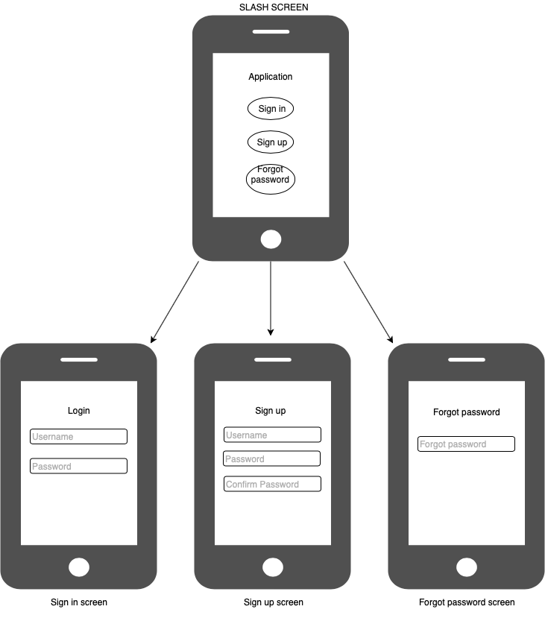
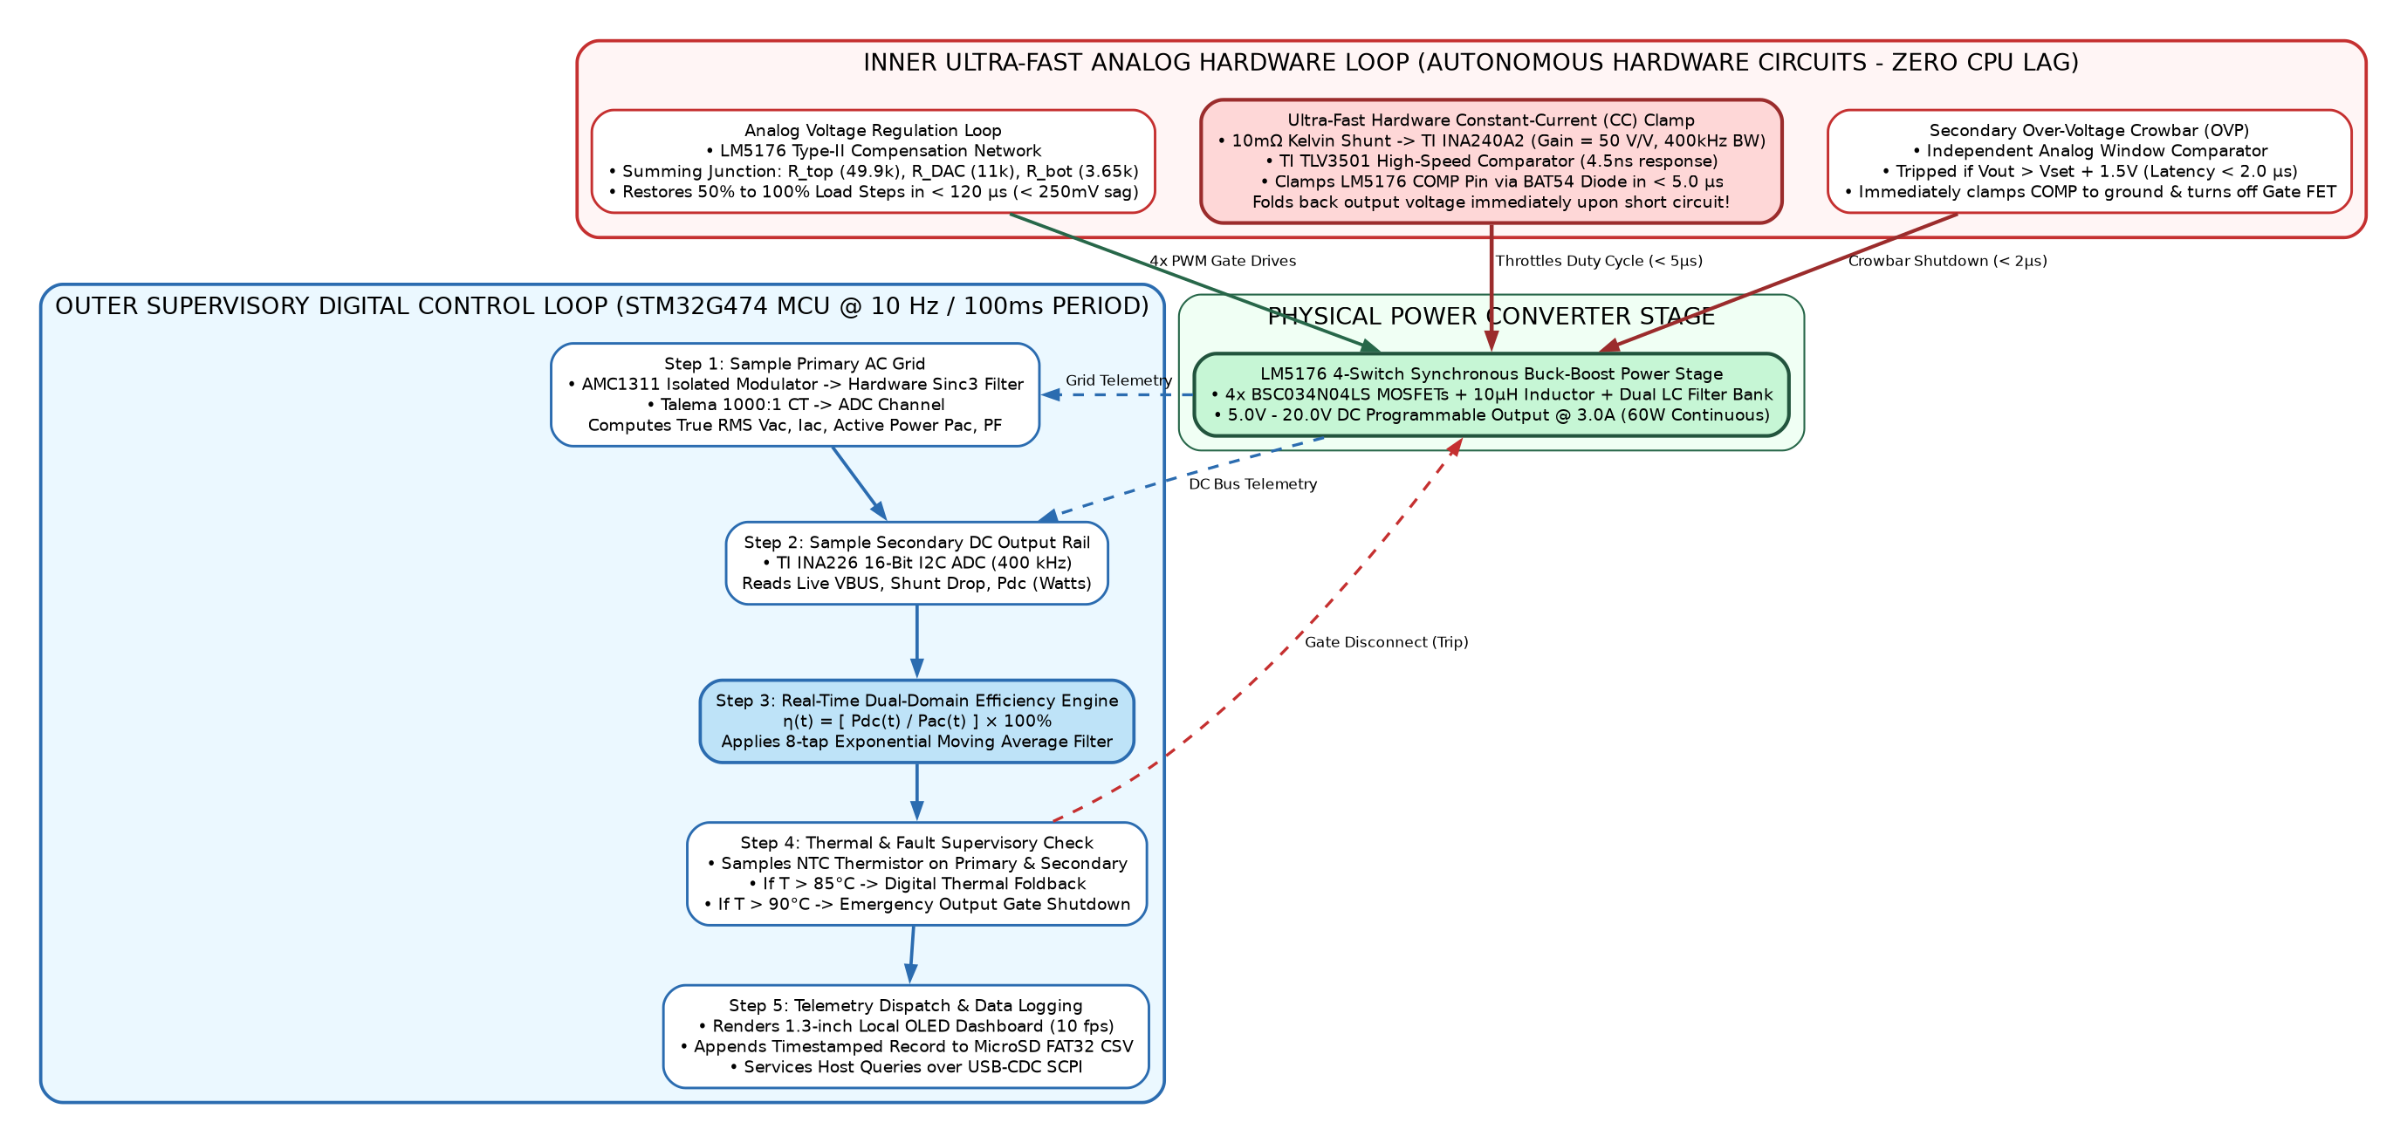
Figure 4: Dual-Closed-Loop Control & Hardware Protection Flow Diagram

System2 Requirements
System 2 represents the Embedded Firmware, Telemetry Engine, and Local User Interface executing on the STM32G474 ARM Cortex-M4F microcontroller. The detailed software and protocol specifications are defined in Table 4.5 below:
Table 4.5: System 2 Embedded Software & Telemetry Specifications
Req ID | Parameter / Feature | Specification / Target | Condition | Verification
FW-01 | Real-Time Kernel | FreeRTOS Preemptive Multitasking [MUST] | 5 concurrent RTOS tasks | TraceX Execution Log
FW-02 | SCPI Parser Stack | IEEE 488.2 Compliant Command Parser [MUST] | Processes commands in < 2.0 ms | USB-CDC Command Benchmark
FW-03 | Efficiency Computation | Dual-Domain Math Engine (η = Pdc/Pac) [MUST] | Low-pass digital filter at 10Hz | Power Meter Verification
FW-04 | MicroSD Storage Task | Ring-buffered FatFs CSV Logger [MUST] | Zero frame drops during write | Long-Duration 24h Soak
FW-05 | Local OLED Display GUI | 128x64 Dashboard @ 10 fps [MUST] | V, I, P, η, Mode, and Temp meters | Visual Verification
FW-06 | Rotary Encoder Servicing | Hardware Quadrature Encoder Interrupts [MUST] | Immediate setpoint change (< 5ms) | Manual Tuning Test

Specific Requirements
<Refer above section>

1.3-inch Local OLED Dashboard Graphical UI Wireframe
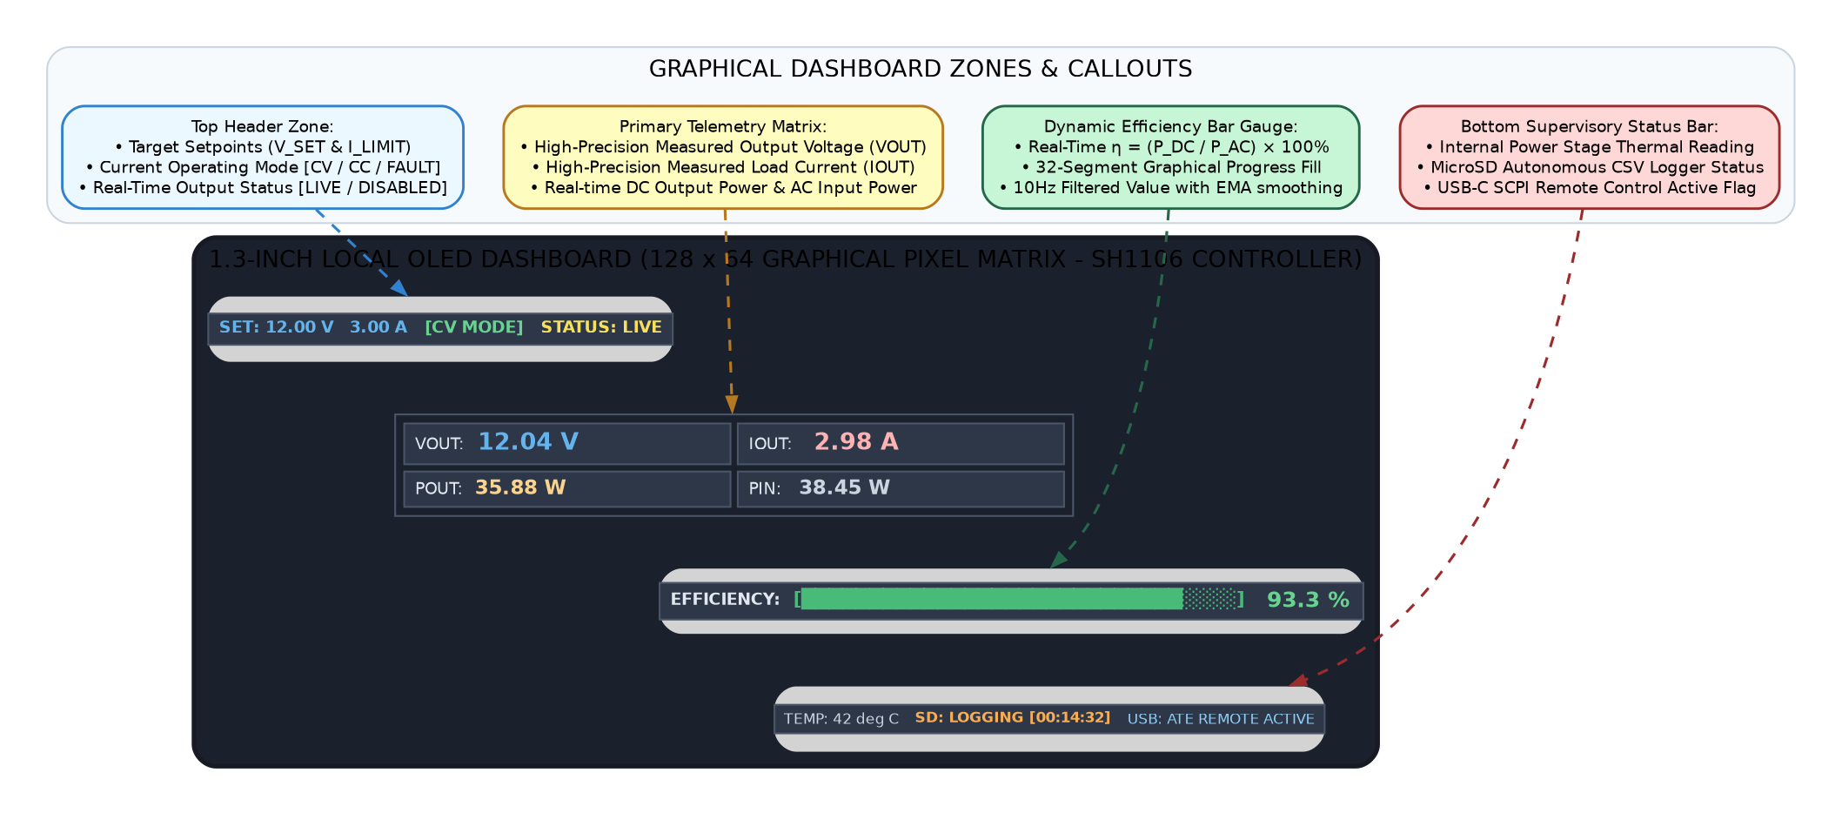
Figure 5: 1.3-inch Local OLED Dashboard Graphical Layout & Wireframe

Assumptions
Assumptions: Grid AC mains is nominal sinusoidal waveform with THD ≤ 5%; Operating ambient temperature is -20°C to +50°C under natural convection; Secondary DC ground is floating with reinforced galvanic isolation (≥ 3000V RMS) from Earth and AC mains. (as opposed to known facts) that could affect the requirements stated in the PRD. These could include third-party or commercial components that you plan to use, issues around the development or operating environment, or constraints. The project could be affected if these assumptions are incorrect, are not shared, or change>

Dependencies
Dependencies: Component supply chain availability for TI LM5176, UCC28740, INA226, AMC1311, and STM32G474; Custom transformer tooling on Ferroxcube PQ26/20 ferrite cores with triple-insulated secondary wire; Compliance laboratory access for CISPR 32 Class B EMC testing., such as software components that you intend to reuse from another project, development platform to be provided by customer, SDK release dependency with IC manufacturer etc, unless they are already documented elsewhere (for example, in the vision and scope document or the project plan).>

Standard Deliverables & Release Order
The development lifecycle encompasses standard engineering deliverables across Hardware (HW), Mechanical (ME), Embedded Software (FW), and Quality Assurance (QA). The phase-wise deliverables and formal release order are summarized in Table 10 below: for each system, shall be listed here. Some of the other common documents like PRD, user Manual etc shall also be captured.>

Product Development Plan
The project follows a 4-phase lifecycle spanning 18 weeks: Phase 1 (Weeks 1-3: PRD & Architecture Sign-Off); Phase 2 (Weeks 4-7: HDD, Schematic & PCB Layout); Phase 3 (Weeks 8-12: Rev A Fabrication, Bring-Up & Functional Tuning); Phase 4 (Weeks 13-18: DVT, EMC Pre-Compliance, Thermal Chamber Testing & Rev B Release). (not timeline) shall be captured here. The level of details should be between schedule given in proposal and the PM’s detailed project plan.
During the PRD discussions with customer, lot of clarity on detailed requirements would have been arrived, so high level project plan is expected here. In addition, this high level plan would give clarity to customer when he can expect different deliverables.
For example, software development itself may span across different revision of HW design, so this high level plan would clearly show what software design documents can be expected for each HW revision etc.>

System1 Development Plan
Sl.No | Domain 1 [HW] | Domain 2 [Mechanical] | Domain 3 [Embedded SW] | Domain 4 [QA & Test]
1 | Hardware Design Document (HDD) | Industrial Design (ID) Outline | Software Design Document (SDD) | DVT Test Plan & Traceability Matrix
2 | Flyback & Buck-Boost Schematics | Enclosure 3D CAD Models (MDD) | STM32 BSP & Low-Level Drivers | Component Stress Analysis (Derating)
3 | 4-Layer PCB Layout & Stackup | Thermal Heatsink CAD Models | Closed-Loop Control Algorithms | Creepage & Clearance Verification
4 | Gerber Files & Production BOM | Fabrication & Assembly Package | SCPI Command Parser Engine | Power Stage Bench Bring-up Plan
5 | Prototype PCB Rev A Fabrication | 3D-Printed Prototype Shell | Dual-Domain Telemetry & FatFs | Functional Test Protocol Release
6 | Assembled Prototype Boards (5 pcs) | Extruded Aluminum Enclosure | SSD1306 OLED GUI Dashboard | Line & Load Regulation Bench Report
7 | Bench Bring-up & Tuning Report | Enclosure Assembly Verification | Firmware Alpha Image Release | Transient Load Step & Ripple Test
8 | Hardware DVT Verification Test | Mechanical Shock & Vibe Test | Firmware Beta Image Release | Thermal Chamber Profile (+50°C)
9 | Rev B HDD (Design Optimizations) | Rev B Enclosure Final Spec | Firmware RC Image Release | Surge Immunity Testing (IEC 61000-4-5)
10 | Rev B Schematics & PCB Layout | Production Tooling Spec | Firmware Production Release | Conducted & Radiated EMI (CISPR 32)
11 | Rev B Gerber & Master BOM | Final Packaging Drawings | Automated ATE Self-Test Suite | Safety Certification Pack (IEC 62368-1)
12 | Rev B Assembled Boards (Pilot Run) | Pilot Run Enclosure Units | Production Flashing Utility | Final Pilot Production Acceptance
13 | Final Hardware Acceptance Sign-Off | Final Mechanical Acceptance | Final Gold Master Firmware | Final QA Compliance Certificate
Table 7: System1 Development Plan

System2 Development Plan
System 2 (Embedded Software & Telemetry) development plan comprises four key software milestones: Alpha Release (BSP bring-up, DAC/ADC low-level drivers), Beta Release (Type-II feedback loop tuning, OLED dashboard, 10Hz dual-domain calculation), RC Release (SCPI parser over USB-CDC, FAT32 MicroSD ring-buffered logger), and Final Production Gold Release (full DVT pass, self-test diagnostics, and calibrated look-up tables).

Architecture <optional>
The architecture comprises two galvanically isolated power conversion stages followed by dual-domain digital telemetry and autonomous analog hardware protection. in PRD document. Include and share the architecture details with customer ONLY if customer demands for it. Insist customer to look for architecture in design documents>

System1: Domain1 Architecture
Figure 6: System 1 Domain 1 (Hardware) Power & Control Architecture Block Diagram
Note: This is the proposed architecture and it might get changed during the design stage.
Note: Ensure the license compliance for usage of open source tools.
< Architecture Diagram with caption, shall be inserted here. No explanation of architecture is required. Below architecture diagram, there shall be a note “This is the proposed architecture and it might get changed during the design stage” and “Ensure the license compliance for usage of open source tools”. >

System1: Domain2 Architecture
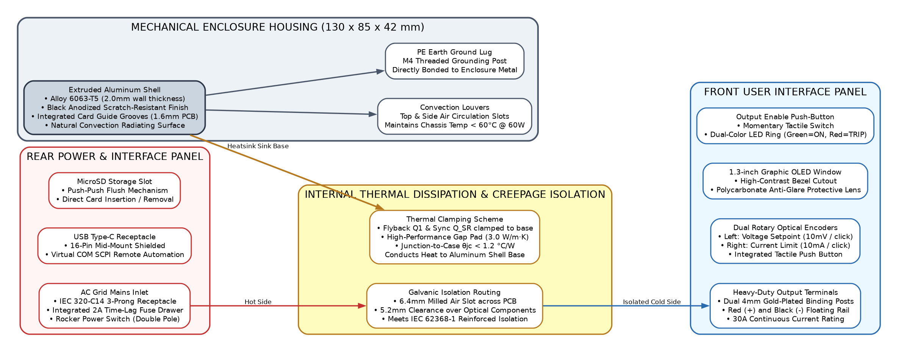
Figure 7: System 1 Domain 2 (Mechanical) Enclosure & Thermal Architecture Block Diagram
Note: This is the proposed architecture and it might get changed during the design stage.
Note: Ensure the license compliance for usage of open source tools.
< Architecture Diagram with caption, shall be inserted here. No explanation of architecture is required. Below architecture diagram, there shall be a note “This is the proposed architecture and it might get changed during the design stage” and “Ensure the license compliance for usage of open source tools”.>

System2: Domain1 Architecture
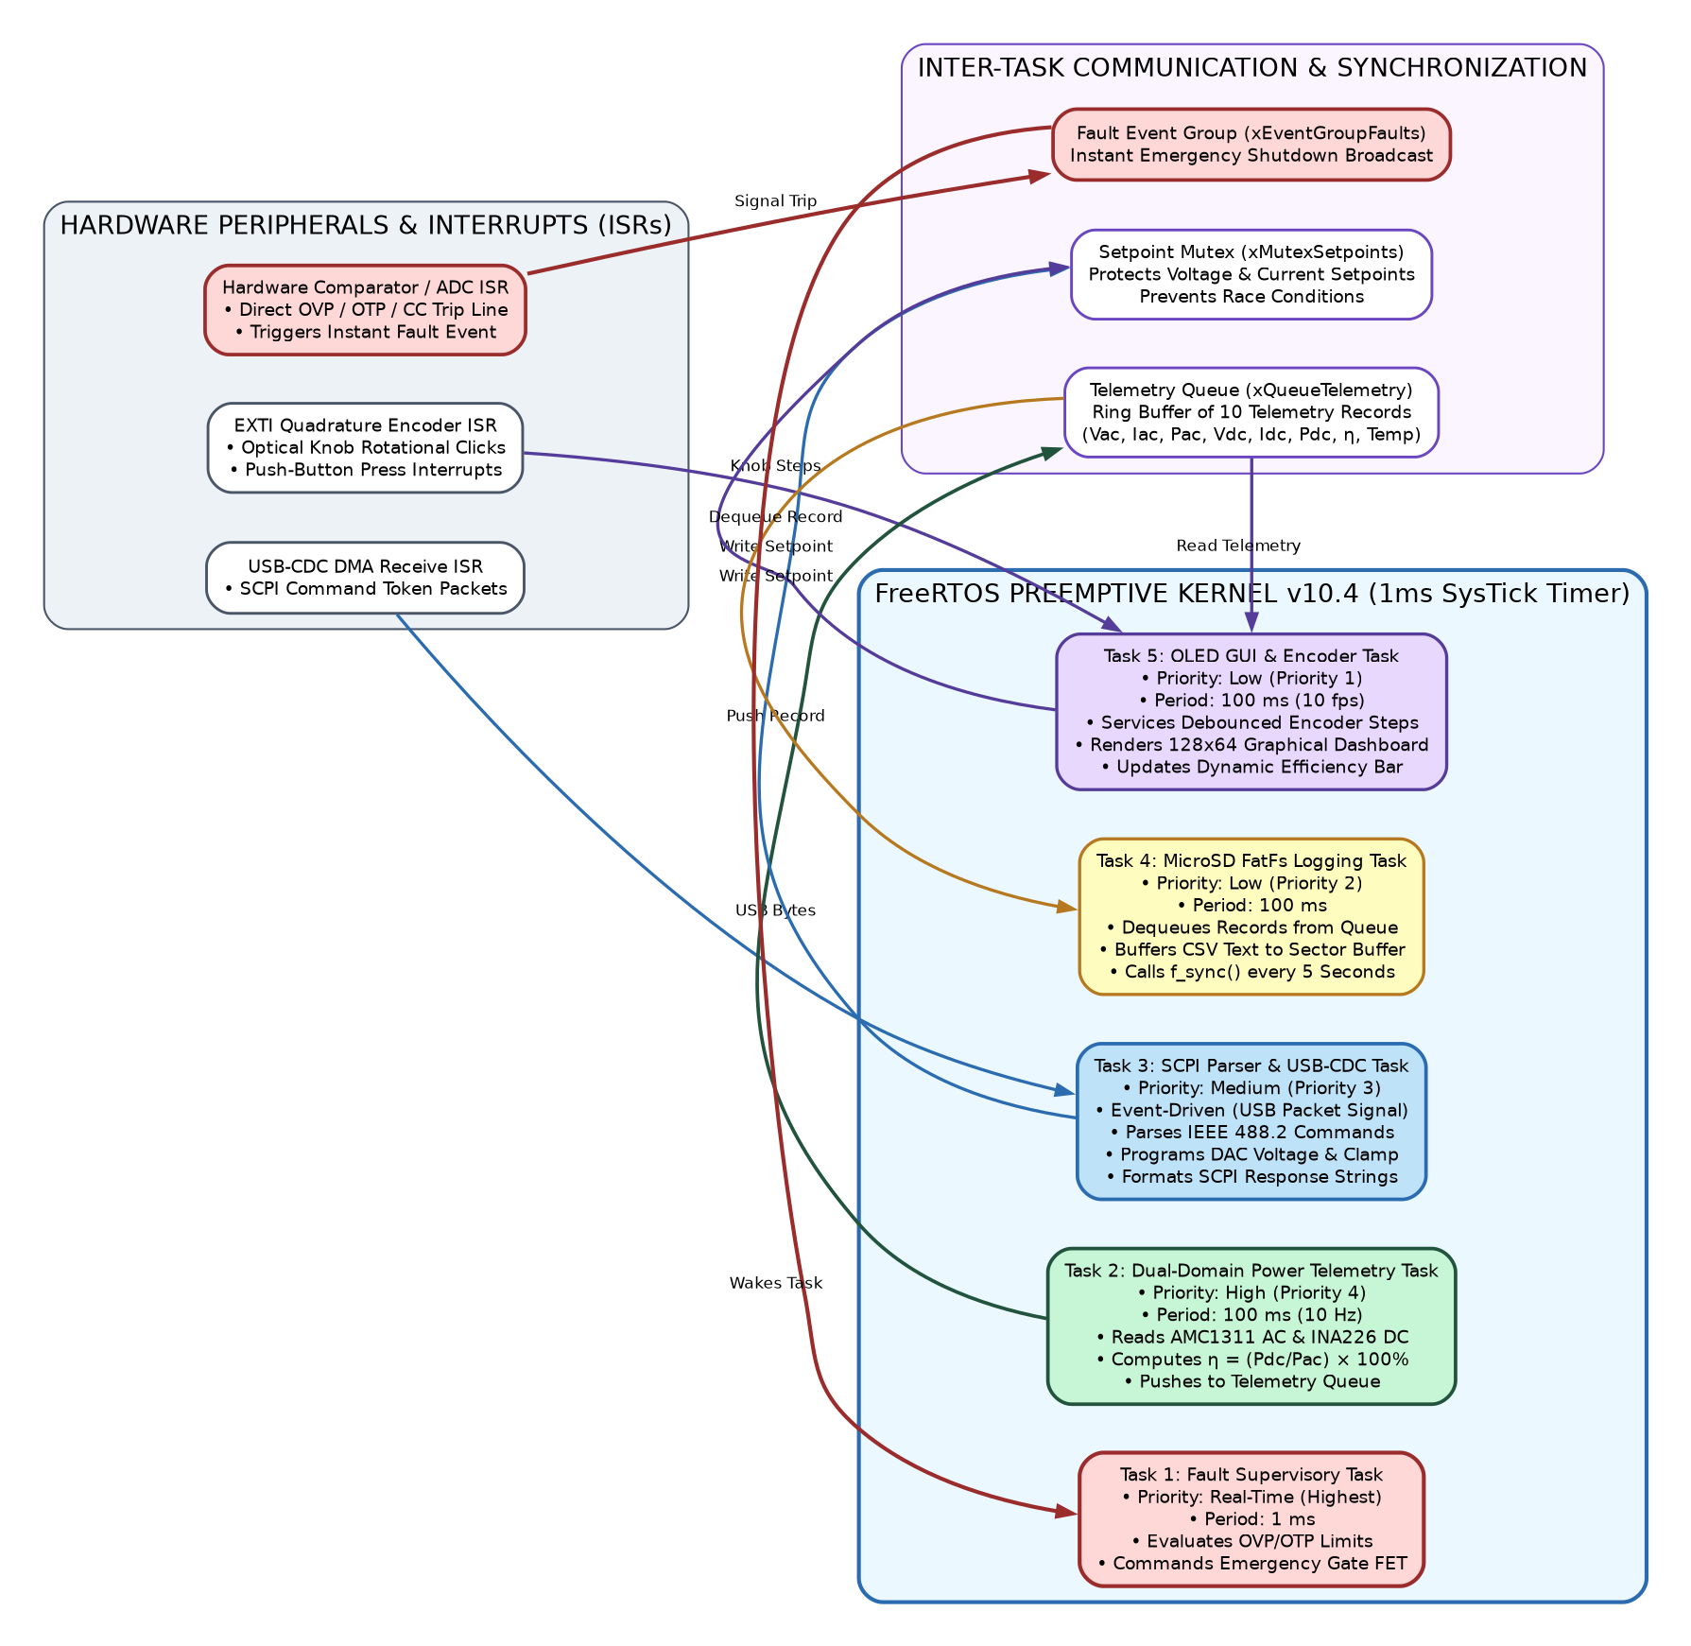
Figure 8: System 2 Domain 1 (Embedded Software) Multitasking FreeRTOS Architecture Block Diagram
Note: This is the proposed architecture and it might get changed during the design stage.
Note: Ensure the license compliance for usage of open source tools.
< Architecture Diagram with caption, shall be inserted here. No explanation of architecture is required. Below architecture diagram, there shall be a note “This is the proposed architecture and it might get changed during the design stage” and “Ensure the license compliance for usage of open source tools”.>

Bill Of Material <optional>
Note: This is the expected BOM and it might get changed during the design stage. The BOM does not contain any pricing/cost information.

System1: Product BOM
Refer to detailed bill of materials in the respective system table below.
Sl.No | Description | Qty | Mfg | Mfg Part No
Subsystem 1: AC-DC Isolated Flyback Power Stage (Electrical)
1 | Time-Lag Ceramic Fuse 2A / 250V AC 5x20mm | 1 | Littelfuse | 0218002.MXP
2 | Inrush Current Limiter NTC 10Ω 3.2A | 1 | TDK / EPCOS | B57236S0100M000
3 | Metal Oxide Varistor 300V RMS 4.5kA 14mm | 1 | Bourns | MOV-14D471K
4 | Common Mode Choke 15mH 1.1A / 4.7mH 1.6A | 2 | Wurth Elektronik | 744823215 / 744822472
5 | Safety X2 Capacitor 0.22µF 310V AC & Y1 2.2nF | 3 | KEMET | R46KI32200001M / PHE850
6 | Bridge Rectifier Glass Passivated 600V 6A GBU | 1 | Diodes Inc. | GBU606
7 | Primary Bulk Electrolytic Cap 100µF 450V 105°C | 1 | Nichicon | LGW2W101MELZ25
8 | Flyback Transformer PQ26/20 220µH 72W | 1 | Custom / Ferroxcube | 3C95-PQ2620-72W
9 | Superjunction Power MOSFET 800V 0.29Ω D2PAK | 1 | Infineon | IPB80R290P7
10 | Quasi-Resonant Flyback Controller IC SOIC-7 | 1 | Texas Instruments | UCC28740DR
11 | Smart Synchronous Rectifier Driver TSOT23-6 | 1 | Monolithic Power | MP6908GJ
12 | Synchronous N-MOSFET 60V 5.2mΩ SuperSO8 | 1 | Infineon | BSC052N06NS
Subsystem 2: 4-Switch Synchronous Buck-Boost Post-Regulator (Electrical)
13 | 4-Switch Synchronous Buck-Boost Controller | 1 | Texas Instruments | LM5176PWPR (HTSSOP-28)
14 | Power N-MOSFET 40V 3.4mΩ Logic-Level SuperSO8 | 4 | Infineon | BSC034N04LS
15 | Flat-Wire High-Current Power Inductor 10µH 8.5A | 1 | Wurth Elektronik | 7443321000 (12.5x12.5mm)
16 | Precision Current Shunt Resistor 10mΩ 0.1% 3W | 1 | Bourns | CSS2H-2512R-L010F
17 | Multi-Layer Ceramic Capacitors 22µF 25V X7R 1210 | 4 | Murata | GRM32ER71E226KE15L
18 | Aluminum Solid Polymer Capacitor 100µF 25V | 1 | Panasonic | 25SVPF100M (8x12mm)
19 | Thin-Film Feedback Resistors 49.9k, 11k, 3.65k 0.1% | 3 | Vishay Dale | TNPW0805 Series 25ppm/°C
20 | Ceramic Bootstrap Capacitors 0.1µF 50V X7R 0603 | 2 | Murata | GRM188R71H104KA93D
21 | Compensation Network Caps & Resistors Type-II | 4 | Murata / Yageo | C0G & 0.1% Thin Film SMD
Subsystem 3: Dual-Domain Real-Time Telemetry & MCU Core (Electrical)
22 | 32-Bit ARM Cortex-M4F MCU 170MHz 512KB Flash | 1 | STMicroelectronics | STM32G474RET6 (LQFP-64)
23 | Isolated Delta-Sigma Modulator SOIC-8 (AC Sense) | 1 | Texas Instruments | AMC1311DWVR
24 | Toroidal Current Transformer 1000:1 (AC Current) | 1 | Talema | AC1005 (PCB Mount)
25 | 16-Bit I2C Power Monitor IC VSSOP-10 (DC Rail) | 1 | Texas Instruments | INA226AIDGSR
26 | High-Speed Analog Comparator 4.5ns SOT-23-6 | 1 | Texas Instruments | TLV3501AIDBVR
27 | Precision Current Sense Amplifier 50V/V SC70 | 1 | Texas Instruments | INA240A2EDCKR
28 | ESD Protection Diode Array USB-C & I/O Lines | 2 | Semtech | RClamp0524P (SLP2510P8)
Subsystem 4: Mechanical, Thermal & Interconnect Hardware
29 | Anodized Extruded Aluminum Enclosure 130x85x42mm | 1 | Hammond Mfg | 1455N1201BK
30 | Heavy-Duty 4mm Gold-Plated Binding Posts (Red/Blk) | 2 | Pomona Electronics | 3770-0 / 3770-2
31 | IEC 320-C14 AC Inlet Receptacle with Fuse Drawer | 1 | Schurter | 6200.2100
32 | Push-Push MicroSD Card Socket SMD | 1 | Molex | 104031-0811
33 | 1.3" Monochrome 128x64 I2C Graphic OLED Display | 1 | Adafruit / WiseChip | UG-2864HSWEG01
34 | Extruded Aluminum Heatsinks with Thermal Gap Pads | 2 | Aavid Thermalloy | 576802B00000G / Bergquist
Table 8:System1 Product BOM

System2: Product BOM
Refer to detailed bill of materials in the respective system table below.
Sl.No | Software Package / Firmware Component | Qty | Provider / Origin | License / Version
Subsystem 1: Core Firmware, Real-Time OS & Drivers
1 | FreeRTOS Real-Time Kernel v10.4 (Preemptive Multitasking) | 1 | Amazon Web Services | Open Source MIT
2 | STM32CubeG4 HAL & Low-Layer (LL) Driver Library | 1 | STMicroelectronics | MCD-ST Liberty
3 | ChaN's FatFs File System Module R0.15 (FAT32 SD Logging) | 1 | ChaN | Open Source BSD
4 | SSD1306 / SH1106 Monolithic OLED Graphics Driver | 1 | VVDN Embedded | VVDN Proprietary
Subsystem 2: Instrumentation Protocols & Telemetry Stack
5 | IEEE 488.2 SCPI Command Parser Stack (USB-CDC Interface) | 1 | VVDN Embedded | VVDN Proprietary
6 | Dual-Domain True RMS & Efficiency Computing Engine | 1 | VVDN Embedded | VVDN Proprietary
7 | Autonomous Closed-Loop State Machine & Protection Engine | 1 | VVDN Embedded | VVDN Proprietary
Table 9:System2 Product BOM

Out of Scope
The following points are not included in the scope of project:
- Three-phase 400V/480V AC industrial grid input operation.
- Active Power Factor Correction (Active PFC boost stage). System utilizes passive EMI filtering with PF ~ 0.62.
- Negative/bipolar voltage rails (system provides positive 5.0V to 20.0V DC only). Wireless connectivity (Wi-Fi/Bluetooth) is excluded.

Open Items
The following points are included in the scope of project but not included in urrent revision:
- Mechanical enclosure extrusion profile selection (finalizing 130x85x42mm profile vs 140x90x50mm based on binding post clearance).
- Current shunt value trade-off (evaluating 5mΩ vs 10mΩ for thermal dissipation vs ADC low-current resolution).
- Auxiliary DC-in barrel jack option (evaluating 24V DC auxiliary input to bypass AC mains in vehicle/field environments).

