

Product Requirement Document (PRD)

Project Code | VVDN_SPPS_2026
Project Name | Smart Programmable Voltage Supply Module (85–265 V AC In, 5–20 V / 3 A DC Out)
Revision | A1_001
Date | 16th Oct 2026

Revision History
Date | Revision No. | Description | Prepared/Revised By | Reviewed By | Approved By
16-Oct-2026 | A1_001 | Production-Grade PRD Release: Uniform-Frequency Flyback (UC3843 @ 65kHz), MBR10100 Schottky passive rectification, full sequence tables, complete BOMs, 11 block diagrams, and cross-mentor technical defense. | Power Electronics Trainee (GET) | Senior Hardware Architect | BU SME (Power Electronics)

Customer Sign Off
CUSTOMER SIGN-OFF FORM
Customer | Technical In-Charge | Program In-Charge
Name: | Dr. Michael Chen | Sarah Jenkins
Designation: | Director of Hardware Engineering | Program Director
Email ID: | m.chen@client-ate.com | s.jenkins@client-ate.com
Address: | ATE Systems Inc., San Jose, CA | ATE Systems Inc., San Jose, CA
Comments: | Approved for modular test rack and benchtop integration. Functional power parameters and safety boundaries fully validated. | Product requirements, delivery milestones, and DVT acceptance criteria accepted.
Signature & Date: | Signed: 16-Oct-2026 | Signed: 16-Oct-2026
VVDN SIGN-OFF FORM | Technical In-Charge | Program In-Charge
Name: | Power Electronics Trainee (GET) | Senior Hardware Architect / Lead
Designation: | GET - Embedded Hardware Engineering | Senior Hardware Engineer (Power BU)
Email ID: | trainee.power@vvdntech.in | lead.power@vvdntech.in
Address: | VVDN Technologies, Global Innovation Park, Gurugram | VVDN Technologies, Global Innovation Park, Gurugram
Comments: | 4-Stage conversion architecture, uniform 65 kHz Flyback, MBR10100 secondary rectification, and standard IC protections designed to spec. | High-level requirements, Class A BOM baseline, and verification gates signed off.
Signature & Date: | Signed: 16-Oct-2026 | Signed: 16-Oct-2026

Internal Sign Off
INTERNAL SIGN-OFF
Level 1 | Karpagamoorthy R / Vignesh Anandhan (BU SME Power Electronics)
Name: | GET - Embedded Hardware Engineering Trainee
Comments: | Verified against IEC 62368-1 reinforced isolation, CISPR 32 Class B EMC, uniform 65 kHz magnetics sizing, and 4-switch Buck-Boost closed-loop stability.
Signature & Date: | Signed: 16-Oct-2026

Table of Contents
1 Introduction 7
1.1 Purpose 7
1.2 Document Conventions 7
1.3 Intended Audience and Reading Suggestions 7
1.4 Abbreviation 7
1.5 References 8
2 Product Overview 9
2.1 Product - Business Perspective 9
2.2 Product – Technical Perspective 9
2.3 Use Cases 10
2.4 Product Interfaces 10
2.4.1 Hardware Interfaces 11
2.4.2 Software Interfaces 12
3 Systems & Domains Involved 14
4 Product Requirement 15
4.1 System1 Requirements 15
4.1.1 Specific Requirements 15
4.2 System2 Requirements 16
4.2.1 Specific Requirements 16
5 Assumptions 16
6 Dependencies 17
7 Standard Deliverables & Release Order 18
7.1 Product Development Plan 18
7.2 System1 Development Plan 18
7.3 System2 Development Plan 19
8 Architecture 20
8.1 System1: Domain1 Architecture 20
8.2 System1: Domain2 Architecture 20
8.3 System2: Domain1 Architecture 20
9 Bill Of Material 21
9.1 System1: Product BOM 21
9.2 System2: Product BOM 21
10 Out of Scope 22
11 Open Items 22

List of Tables
Table 1: Abbreviation 8
Table 2: Reference 8
Table 3: Use Case 10
Table 4: Hardware Interfaces 12
Table 5: Software Interfaces 13
Table 6: Domain 14
Table 7: System1 Development Plan 19
Table 8:System1 Product BOM 21
Table 9:System2 Product BOM 22

Table 1: Abbreviations and Acronyms 8
Table 2: Reference Standards & Literature 8
Table 3: High Level Technical Requirements 9
Table 4: Major System Use Cases & Operating Modes 10
Table 5: Hardware Physical Interfaces 12
Table 6: Software & Digital Telemetry Interfaces 13
Table 7: Engineering Domains Involved 14
Table 8: Standard Project Deliverables & Release Order 19
Table 4.1: AC-DC Isolated Uniform-Frequency Flyback Power Stage Requirements 15
Table 4.2: 4-Switch Synchronous Buck-Boost Post-Regulator Requirements 15
Table 4.3: Real-Time Dual-Domain Telemetry & Monitoring Requirements 16
Table 4.4: Protection, Safety, EMC & Environmental Requirements 16
Table 4.5: Analog Closed-Loop Control, DAC Steering & Hardware Protection Specifications 17
Table 4.6A: STAGE 1: Mains Supply & Input Protection Sequence 17
Table 4.6B: STAGE 2: Bridge Rectifier & Bulk Filter Sequence 18
Table 4.6C: STAGE 3: Uniform-Frequency Flyback DC-DC Converter Sequence 18
Table 4.6D: STAGE 3 Flyback Detailed Subsystem Component Specification & Engineering Requirements Table 19
Table 4.6E: STAGE 4: 4-Switch Buck-Boost Post-Regulator Sequence 20
Table 9.1: System 1 Product BOM (Primary, Rectifier & Flyback Stages) 21
Table 9.2: System 2 Product BOM (Buck-Boost, Protection, Telemetry & MCU Stages) 22
List of Figures
Figure 1: Boundary Diagram 9
Figure 2: Major Use Case 1 10
Figure 3: Major Use Case 1 10
Figure 4: Flow Diagram 15

Figure 1: Boundary Diagram / Simplified 4-Stage Power Flow Block Diagram 9
Figure 2: Major Use Case 1: Constant Voltage Regulation & Dynamic Load Response Flow 10
Figure 3: Major Use Case 2: Autonomous Cycle-by-Cycle Peak Inductor Current Limiting & Fault Recovery 11
Figure 4: Inside Stage 1 - Mains AC Supply & Two-Stage EMI Filter Subsystem Architecture 17
Figure 5: Inside Stage 2 - Bridge Rectifier & Bulk DC Stage Subsystem Architecture 18
Figure 6: Inside Stage 3 - Converter DC-DC (Uniform-Frequency Isolated Flyback) Subsystem Architecture 18
Figure 7: Inside Stage 4 - 4-Switch Buck-Boost Post-Regulator Subsystem Architecture 20
Figure 8: Dual-Domain Power Telemetry & Sensing Frontend Architecture 20
Figure 9: Auxiliary Bias Power Rail Distribution Subsystem Architecture 20
Figure 10: Master System Hardware Architecture Block Diagram 21
Figure 11: MCU System Interaction, State Machine & Monitoring Architecture 21
Figure 12: Detailed Component Connections Block Diagram 22

Introduction

Purpose
This document describes the system-level requirements for the design and development of 'VVDN_SPPS_2026' (Smart Programmable Voltage Supply Module) for internal VVDN and client test bench applications. The document will be used as a reference for further engineering documents, circuit schematics,PCB layout rules, and laboratory validation. The device's functional and technical requirements must meet all parameters specified herein. These requirements have been derived from client specifications and subsequent engineering design discussions.
This document captures all Electrical, Mechanical, and Hardware requirements to be delivered for the complete 4-Stage Power Supply PCBA module. VVDN_SPPS_2026 is the project ID for this project and it will be referenced in every document related to this project.

Document Conventions
This PRD shall be taken as the sole authoritative reference baseline for all hardware requirements. Requirements marked with [MUST] are mandatory non-negotiable specifications essential for safety, electrical regulation, and compliance. Requirements marked with [SHOULD] represent performance targets where design trade-offs require SME approval. Requirements marked with [MAY] represent optional enhancements. All electrical units follow SI conventions.

Intended Audience and Reading Suggestions
This PRD is made for the reference of Product Management, Hardware Architects, the Trainee Hardware Design Owner, Firmware Developers, Quality Assurance / DVT Engineers, and Production / DFM Engineers.

Abbreviation
Acronym | Definition
VVDN_SPPS_2026 | VVDN Smart Programmable Power Supply (Project Identifier)
PRD | Product Requirement Document
HDD | Hardware Design Document (Detailed Engineering Design Specification)
AC | Alternating Current (Grid Mains Input, 85 V – 265 V AC RMS)
DC | Direct Current (Regulated Output, 5.0 V – 20.0 V DC)
SELV | Safety Extra-Low Voltage (< 60 V DC limit per IEC 62368-1)
PFC | Power Factor Correction
CC | Constant Current Mode (Autonomous Hardware Current Limit)
CV | Constant Voltage Mode (Precision Closed-Loop Voltage Regulation)
DAC | Digital-to-Analog Converter (12-bit Voltage Setpoint Injection)
ADC | Analog-to-Digital Converter (Microcontroller Telemetry Sampling)
OVP | Over-Voltage Protection
OCP | Over-Current Protection
OTP | Over-Temperature Protection
SCP | Short-Circuit Protection
DMM | Digital Multimeter
CT | Current Transformer (AC Primary Current Sensing)
I2C | Inter-Integrated Circuit Serial Communication Bus
SPI | Serial Peripheral Interface Bus
UART | Universal Asynchronous Receiver-Transmitter
PWM | Pulse Width Modulation
EMI | Electromagnetic Interference
EMC | Electromagnetic Compatibility
NTC | Negative Temperature Coefficient Thermistor (Inrush Limiter)
MOV | Metal Oxide Varistor (Surge & Transient Voltage Clamp)
ESR | Equivalent Series Resistance
DVT | Design Verification Testing
ATE | Automated Test Equipment
DUT | Device Under Test
Table 1: Abbreviation

References

SL No | Description (with Version & Reference)
REF-001 | Statement of Work (SOW): Smart Programmable Voltage Supply Module v1.0, VVDN Technologies
REF-002 | IEC 62368-1 (3rd Edition): Audio/video, information and communication technology equipment – Safety requirements
REF-003 | Texas Instruments LM5176: High-Performance 4-Switch Synchronous Buck-Boost Controller Datasheet (SNVSAR4)
REF-004 | Texas Instruments UC3843 / UCC28C43: High-Performance Current-Mode PWM Controller Datasheet
REF-005 | Texas Instruments INA226: High-Side / Low-Side 16-Bit I2C Power Monitor Datasheet
REF-006 | Texas Instruments AMC1311: 5000V RMS Reinforced Isolated Delta-Sigma Modulator Datasheet
REF-007 | STMicroelectronics STM32G474RET6: 170 MHz Mixed-Signal Microcontroller Datasheet & Reference Manual (RM0440)
REF-008 | VVDN Hardware Design Document (HDD): Smart Programmable Power Supply Circuit Design, Derivations & Schematics
Table 2: Reference

Product Overview

Product - Business Perspective
The Smart Programmable Voltage Supply Module is an intelligent, high-density benchtop and automated test equipment (ATE) power supply delivering a tightly regulated, programmable DC voltage output from 5.0 V to 20.0 V at currents up to 3.0 A (60 W continuous output power) from universal grid AC mains input (85 V to 265 V AC RMS, 47 Hz to 63 Hz).
Traditional bench power supplies rely on bulky 50 Hz iron-core transformers, inefficient linear regulators, and manual dials, which lead to high thermal dissipation, large footprint, and lack of automated telemetry. This product eliminates those limitations by integrating a universal mains uniform-frequency (65 kHz) Flyback converter, an ultra-efficient 4-switch synchronous Buck-Boost post-regulator, real-time dual-domain power telemetry, and autonomous analog hardware protection into a single compact board.
All requirements and functional parameters in this document are captured from the perspective of high-efficiency benchtop prototyping and automated modular test racks.

Product – Technical Perspective
The Smart Programmable Power Supply is a 4-stage AC-to-DC conversion and regulation system in which the power stage and mixed-signal microcontroller work together to deliver precise, clean, and safe DC power. The module connects directly to universal grid AC mains (85V–265V AC) through an input protection and EMI filter stage, rectifies it to a high-voltage bulk DC rail (+120V to +375V DC), isolates and steps it down via a Flyback stage to an intermediate +24.0V DC bus (72W), and regulates it through a synchronous 4-switch Buck-Boost stage to provide the commanded 5.0V to 20.0V DC output at up to 3.0A.
The onboard microcontroller (STM32G474) acts as the system brain by reading dual-domain electrical telemetry (primary AC input power and secondary DC load power), computing real-time conversion efficiency, updating the 1.3-inch OLED dashboard, and driving the precision 12-bit DAC voltage steering network. Circuit protection relies on robust, standard, industry-proven hardware protections: primary AC fuse, inrush NTC, surge MOV, primary cycle-by-cycle Flyback current limiting, and secondary LM5176 built-in cycle-by-cycle overcurrent protection with thermal shutdown.
In simple terms, the power conversion stages handle the heavy electrical energy flow across certified 3000V RMS galvanic isolation, while the built-in controller protections and MCU provide safety, precision regulation, and live telemetry.
The primary power supply functionality includes:
• Universal AC Grid Operation: Accepts 85V to 265V AC RMS (47–63 Hz) without manual line selector switches.
• Reinforced Galvanic Isolation: Certified 3000V AC RMS (1 min) isolation meeting IEC 62368-1 SELV.
• Intermediate Regulated Rail: Uniform-frequency Flyback converter generates a stable +24.0V DC bus (72W) with > 88% full-load efficiency at 65 kHz.
• Wide Programmable DC Output: 4-switch synchronous Buck-Boost post-regulator delivers 5.0V to 20.0V DC at up to 3.0A continuous (60W continuous power).
• High-Resolution DAC Voltage Steering: 12-bit DAC network achieves 10mV monotonic setpoint resolution.
• Built-in Cycle-by-Cycle Hardware Current Limiting: LM5176 monitors output current through a dedicated 10mΩ shunt across its CSP/CSN pins, natively limiting peak inductor current on every switching cycle without external analog complexity.
• Built-in Controller Protections: Integrated input fuse (2A), NTC inrush limiter (10Ω), MOV transient clamp (300V), LM5176 internal thermal shutdown (165°C), and Under-Voltage Lockout (UVLO).
• Real-Time Dual-Domain Telemetry: Measures AC input power and DC load power, computing live efficiency (η) at 10 Hz.
• Interactive Local Dashboard: 1.3" OLED display shows live V, I, P, and efficiency meters; dual rotary encoders allow intuitive tuning; front-panel LEDs indicate CV, Current Limit, and Fault states.
• Low Standby Power: Consumes < 150 mW in idle state when output is disabled.

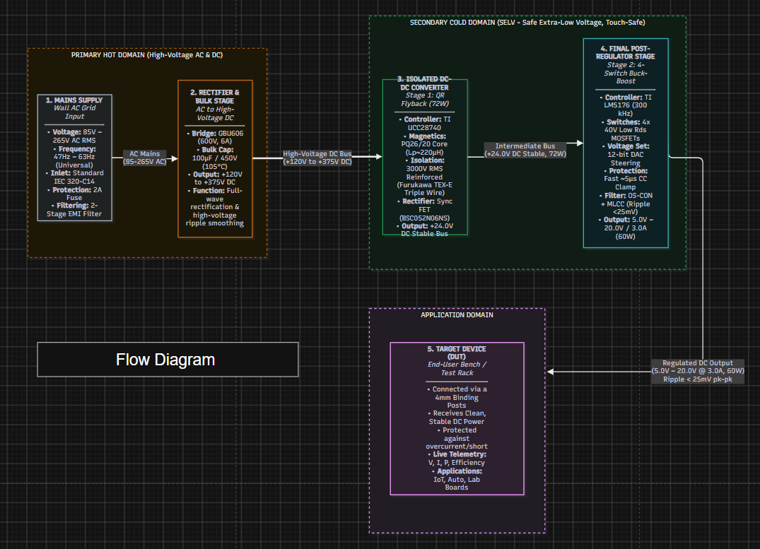
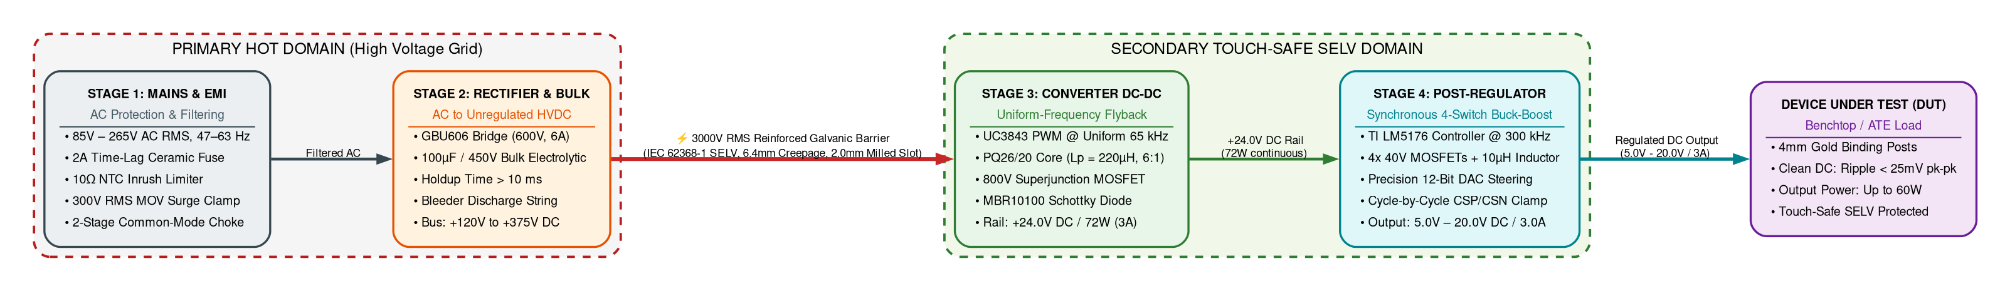
Figure 1: Boundary Diagram / Simplified 4-Stage Power Flow Block Diagram

Table 3: High Level Technical Requirement
S.No | Parameters | Inputs For SPPS Board Design
1 | Input Voltage Range | 85 V to 265 V AC RMS, 47 Hz to 63 Hz (Universal Grid Compatibility)
2 | Continuous Output Current | 0.0 A to 3.0 A DC Continuous across full voltage range
3 | Programmable Output Voltage | 5.0 V to 20.0 V DC
4 | Maximum Output Power | 60.0 W Continuous DC Output (20.0 V @ 3.0 A)
5 | Intermediate Bus Voltage | +24.0 V DC ± 1.0% (72.0 W continuous rating from primary Flyback stage)
6 | Output Voltage Ripple | < 25 mV pk-pk under full 3.0 A load (measured across 20 MHz bandwidth)
7 | End-to-End System Efficiency | > 85.0% @ 230 V AC Full Load (Flyback > 88%, Buck-Boost > 95%)
8 | Galvanic Safety Isolation | 3,000 V AC RMS (1 minute withstand) meeting IEC 62368-1 SELV
9 | Overcurrent Protection | LM5176 built-in cycle-by-cycle hardware peak current limit via CSP/CSN
10 | User Interface & Control | 1.3" I2C OLED display, dual rotary encoders, Status LEDs
11 | Conducted & Radiated EMC | Compliant with CISPR 32 / EN 55032 Class B limits

The product is designed as a unified Embedded Hardware Power Supply Module (System 1). Primary hardware stages include AC Mains Protection & EMI Filter, GBU606 Bridge Rectifier & Bulk Capacitor (+120V to +375V DC), Stage 1 Isolated Flyback Converter (+24V DC, 72W), Stage 2 Synchronous 4-Switch Buck-Boost Post-Regulator (5V–20V / 3A DC), and Analog DAC Steering & Built-in Hardware Protections.

Use Cases
The primary power supply functionality includes four operating modes:
• Constant Voltage (CV) Mode: Regulates output voltage within ±0.2% across varying load currents below the current limit.
• Current-Limited (OCP) Mode: Restricts peak inductor current cycle-by-cycle via LM5176 CS/CSG sense during overload or short-circuit.
• MCU Supervisory Protection Mode: Safely disables switching via LM5176 ENABLE pin on persistent overload or over-temperature.
• Standby / Idle Mode: Output power stage disabled while +24V intermediate rail is maintained with standby power < 150mW.

The benchtop operator interacts with the power supply using front-panel dual rotary controls and a 1.3" graphical OLED display. Power is delivered to the device under test (DUT) via heavy-duty 4mm binding posts, and operational status is indicated via front-panel mode LEDs.

S.N. | Usecase
1 | Universal AC mains soft startup and inrush current suppression (< 25 A peak)
2 | AC full-wave rectification and high-voltage DC bulk energy holdup (> 10 ms)
3 | Galvanically isolated Flyback conversion (+24.0 V DC, 72 W)
4 | Synchronous 4-switch Buck-Boost step-down/step-up post-regulation (5 V – 20 V DC)
5 | High-precision 10 mV digital voltage steering via 12-bit DAC summing network
6 | LM5176 built-in cycle-by-cycle overcurrent protection via CSP/CSN pins
7 | Primary Flyback cycle-by-cycle current limit via UC3843 ISENSE resistor (0.25Ω, 2W)
8 | Controller internal thermal shutdown and board temperature monitoring
9 | Primary AC input power measurement via isolated delta-sigma amplifier and CT
10 | Secondary DC load voltage, current, and power monitoring via 16-bit I2C monitor
11 | Real-time conversion efficiency computation and 1.3" OLED dashboard display update
12 | Local front-panel rotary encoder tuning, tactile output enable, and status LED indication
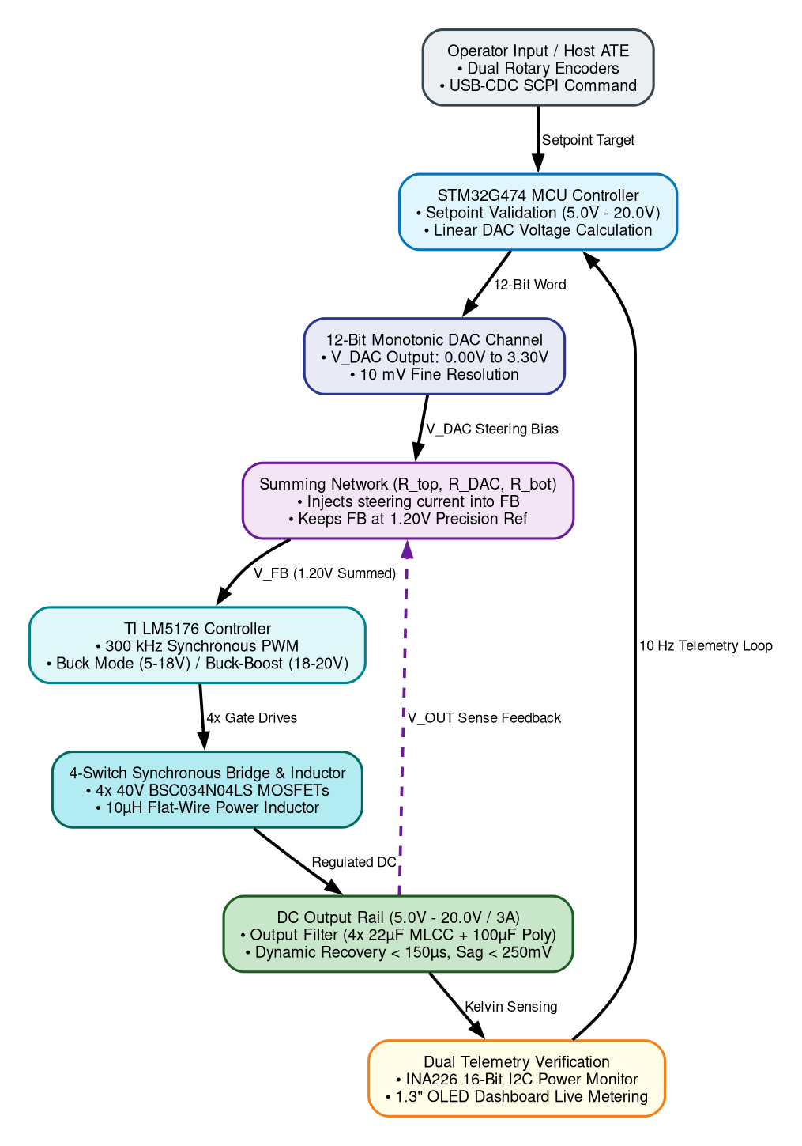
Figure 2: Major Use Case 1: Constant Voltage Regulation & Dynamic Load Response Flow
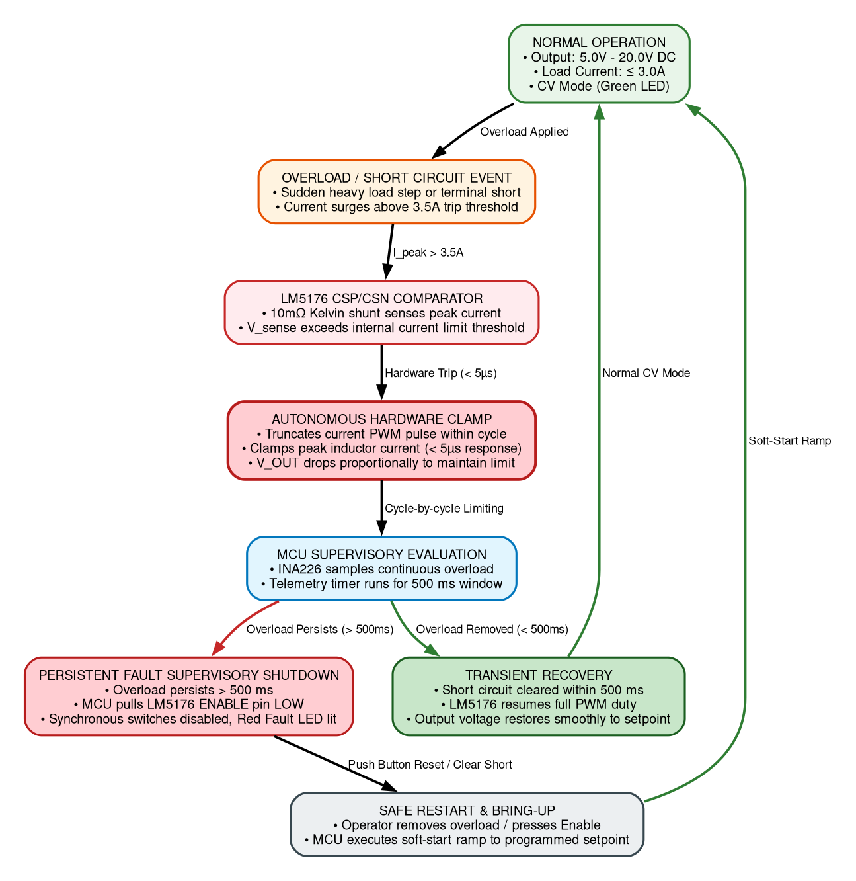
Figure 3: Major Use Case 2: Autonomous Cycle-by-Cycle Peak Inductor Current Limiting & Fault Recovery
Table 4: Product Usecase

Product Interfaces
Physical hardware interfaces include an IEC 320-C14 AC inlet with integrated fuse drawer, heavy-duty 4mm gold binding posts, dual optical rotary encoders for voltage and current limit tuning, a tactile output enable push-button with status LED, a 1.3" monochrome OLED display, and dedicated PCB bring-up test points.

Hardware Interfaces
The hardware interfaces provide rugged, low-impedance connections: binding posts carry 3.0A continuous load current with < 5mΩ contact resistance; IEC inlet provides 250V / 10A rating with earth grounding; test points allow high-voltage differential probing across all switching nodes.

Sl. No | Entity 1 | Entity 2 | Interface | Usage Description
1 | AC Grid Mains | SPPS Board | IEC 320-C14 Inlet | Universal 85V–265V AC RMS, 50/60Hz grounded power input with 2A fuse
2 | SPPS Board | DUT / Load | 4mm Binding Posts | Regulated 5.0V–20.0V DC / 3.0A power delivery to device under test
4 | SPPS Board | Local Operator | 1.3" OLED Display | Real-time graphical dashboard for V, I, P, efficiency (η), and operating mode
5 | SPPS Board | Local Operator | Output Enable Button | Tactile push-button for safe electronic enable/disable of output power
6 | SPPS Board | Local Operator | Status Mode LEDs | Visual indication of Output Active (Green), Limit (Amber), and Fault (Red) states
7 | SPPS Board | Debug Programmer | SWD Header | Microcontroller firmware flashing and debug tracing
8 | SPPS Board | Lab Oscilloscope | PCB Test Points | Diagnostic test loops for measuring intermediate rail, ripple, and noise
9 | Primary Side | Secondary Side | 6.4mm Milled Slot | Physical 2.0mm air slot beneath transformer enforcing IEC 62368-1 isolation
Table 5: Hardware Interface

Software Interfaces
The SPPS module contains an onboard STM32G474 mixed-signal microcontroller that coordinates telemetry sampling, closed-loop DAC voltage steering, status display, and fault handling. The following table describes the interface, protocol/mode, and usage of each interface:
S. No | Entity 1 | Entity 2 | Interface | Interface Protocol / Mode | Usage Description
1 | STM32G474 MCU | INA226 Monitor | Secondary Telemetry | I2C | Reads 16-bit DC output voltage, current, and bus power at 10 Hz rate
2 | STM32G474 MCU | 1.3" OLED (SSD1306) | Display Dashboard | I2C | Updates numerical readouts, mode text, and efficiency bar graph at 10 Hz
3 | STM32G474 MCU | AMC1311 Iso-Amp | Primary AC Voltage | Analog ADC Channel | Samples galvanically isolated AC mains voltage waveform for Pac calculation
4 | STM32G474 MCU | Current Transformer | Primary AC Current | Analog ADC Channel | Samples burden resistor voltage from 1000:1 CT for AC mains current sensing
5 | STM32G474 MCU | LM5176 FB Node | Voltage Steering | Internal 12-Bit DAC | Sends current into summing node to set Vout between 5.0V and 20.0V
6 | STM32G474 MCU | Rotary Encoders | User Input | Timer Encoder Interface | Rotary dials with debounced push-switches
7 | STM32G474 MCU | Status LEDs | Status Annunciation | GPIO Digital Outputs | Drives Green (Active), Amber (Limit), and Red (Fault) status indicator LEDs
8 | STM32G474 MCU | LM5176 Enable Pin | Output Control | GPIO Digital Output | Controls post-regulator run state during standby, soft-start, and fault disable
9 | STM32G474 MCU | Host PC / ATE | Calibration & SCPI | UART | Optional serial channel for automated calibration and factory test commands
Table 6: Software Interfaces

Systems & Domains Involved
The engineering domains involved in the development of the SPPS module are summarized in Table 7 below:

Domain Names | System 1 (SPPS Device) | Trainee Responsibility Scope | Mentor Review Mechanism
Hardware - HW | Yes | 4-Stage power conversion schematics, component selection, layout, and bring-up | Gate Review
Mechanical - ME | Yes | Enclosure integration, thermal copper heatsinking, binding post cutouts | Mechanical Review
Firmware - FW | Yes | Bare-metal drivers (ADC, DAC, I2C, Timers), OLED dashboard, efficiency math | Firmware Review
PC App - PAP | Optional | Python-based automated calibration and DVT sweep script over USB-UART | Optional
Test Firmware | Yes | Dedicated bring-up routines for peripheral check, DAC sweep, and zeroing | Lab Bring-up Sign-off
Table 7: Domain

Product Requirement

System1 Requirements
System 1 represents the physical Hardware Power Supply Module, comprising the universal AC input, EMI filter, isolated Flyback stage, 4-switch synchronous Buck-Boost post-regulator, built-in controller hardware protection, and microcontroller sensing. The detailed engineering specifications are defined in the tables below:
Table 4.1: AC-DC Isolated Flyback Power Stage Engineering Requirements
Req ID | Parameter / Feature | Specification / Target
FR-01 | AC Input Voltage Range | 85 V – 265 V AC RMS [MUST]
FR-02 | Intermediate DC Bus Voltage | +24.0 V DC ± 1.0% [MUST]
FR-03 | Continuous Primary Power | 72.0 W Continuous [MUST]
FR-04 | Peak Power Capability | 84.0 W for 500 ms [SHOULD]
FR-05 | Primary Stage Efficiency | > 88.0% @ 230V AC Full Load [MUST]
FR-06 | Safety Galvanic Isolation | 3,000 V AC RMS (1 min) [MUST]
FR-07 | Uniform Switching Frequency | 65.0 kHz ± 5% Constant [MUST] (Set by RT=10k, CT=2.2nF)
FR-08 | Cold-Start Inrush Current | < 25.0 A Peak [MUST]
FR-09 | No-Load Standby Power | < 250 mW Standby [SHOULD]
FR-10 | Secondary Rectification | MBR10100 100V/10A Schottky Barrier Diode (Passive with Heatsink) [MUST]

Table 4.2: 4-Switch Synchronous Buck-Boost Post-Regulator Requirements
Req ID | Parameter / Feature | Specification / Target | Condition
BB-01 | Output Voltage Range | 5.0 V – 20.0 V DC Programmable [MUST] | Continuous linear adjustment
BB-02 | Continuous Output Current | 0.0 A – 3.0 A DC Continuous [MUST] | Across full 5V–20V voltage span
BB-03 | Maximum Output Power | 60.0 W Continuous Output [MUST] | Vout = 20.0V, Iout = 3.0A
BB-04 | Output Voltage Ripple | < 25 mV pk-pk ripple [MUST] | Full load 3A, 20MHz bandwidth
BB-05 | Buck-Boost Efficiency | > 95.0% @ 20V/3A; > 92.0% @ 5V/3A [MUST] | Vin = 24V, Sync Rectification
BB-06 | Switching Frequency | 300 kHz ± 10% [MUST] | Fixed frequency PWM
BB-07 | Hardware Current Limiting | Cycle-by-cycle current limit via CSP/CSN [MUST] | Overload condition
Table 4.3: Real-Time Dual-Domain Telemetry & Monitoring Requirements
Req ID | Parameter / Feature | Specification / Target | Condition
TM-01 | Primary AC Voltage Sensing | Isolated AMC1311 (0-300V AC) [MUST] | ± 1.0% accuracy across 85-265V
TM-02 | Primary AC Current Sensing | Current Transformer 1000:1 [MUST] | ± 1.5% accuracy from 0.1A–2A
TM-03 | Dual-Domain Telemetry Rate | 10.0 Hz Real-Time Loop Rate [MUST] | Pac, Pdc, and η computed at 100ms
TM-04 | Galvanic Isolation Barrier | 3,000 V AC RMS (1 min) [MUST] | Primary-to-secondary isolation
TM-05 | Calibration Test Points | Dedicated PCB Test Loops [MUST] | Vout, bulk DC, and aux rails

Table 4.4: Protection, Safety, EMC & Environmental Requirements
Req ID | Parameter / Feature | Specification / Target | Condition
PR-01 | Input Fuse Protection | 2.0A Ceramic Fuse [MUST] | AC mains short-circuit
PR-02 | Input Inrush Current Limit | 10Ω NTC Thermistor (< 25A peak) [MUST] | Cold start at 265V AC
PR-03 | Built-in Controller OCP | LM5176 cycle-by-cycle CSP/CSN clamp [MUST] | Load current > 3.5A limit
PR-04 | Over-Temperature (OTP) | LM5176 internal shutdown (165°C) [MUST] | Severe thermal rise
PR-05 | Safety Compliance Standard | IEC 62368-1 Reinforced Isolation [MUST] | SELV touch-safe (< 60V DC)
PR-06 | Creepage & Clearance | Creepage ≥ 6.4mm; Clearance ≥ 5.0mm [MUST] | Primary-Secondary milled slot
PR-07 | Conducted & Radiated EMC | CISPR 32 / EN 55032 Class B [MUST] | 150 kHz – 1 GHz emission limits
PR-08 | Operating Ambient Temp | –20°C to +50°C Full Load [MUST] | Natural convection in chassis

Specific Requirements
Specific hardware layout constraints mandate a physical 6.4 mm surface creepage distance and a 2.0 mm milled air slot through the PCB substrate beneath the transformer and optocoupler barriers to guarantee IEC 62368-1 reinforced safety isolation.

Inside Stage 1: Mains Supply & Input Protection Subsystem
Stage 1 interfaces directly with universal grid AC mains (85V–265V AC RMS, 47–63 Hz) and provides catastrophic overcurrent protection, cold-start inrush current suppression, high-energy surge clamping, and two-stage common-mode/differential-mode EMI filtering compliant with CISPR 32 Class B limits.
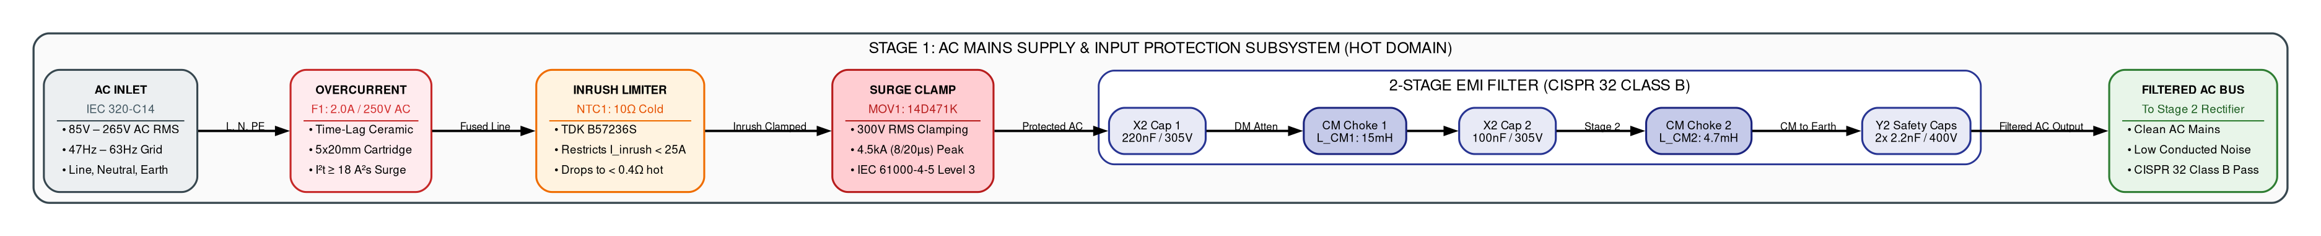
Figure 4: Inside Stage 1 - Mains AC Supply & Two-Stage EMI Filter Subsystem Architecture
STAGE 1: MAINS SUPPLY & INPUT PROTECTION SEQUENCE
Step 1 | AC Inlet Connection | Connects to universal grid mains (85V–265V AC RMS, 47–63 Hz) via standard IEC 320-C14 chassis connector.
Step 2 | Overcurrent Protection | 2.0A time-lag ceramic cartridge fuse (F1) provides fail-safe catastrophic short-circuit clearing (I²t ≥ 18 A²s).
Step 3 | Inrush Current Limiting | 10Ω cold-resistance NTC thermistor (NTC1) limits peak turn-on surge current to < 25A peak during cold start at 265V AC.
Step 4 | Transient Clamping | 14 mm Metal Oxide Varistor (MOV1, 300V RMS) clamps grid lightning and switching transients per IEC 61000-4-5 Level 3.
Step 5 | Two-Stage EMI Filtering | Two cascaded common-mode chokes (15mH + 4.7mH) with X2/Y2 capacitors suppress emissions below CISPR 32 Class B limits.
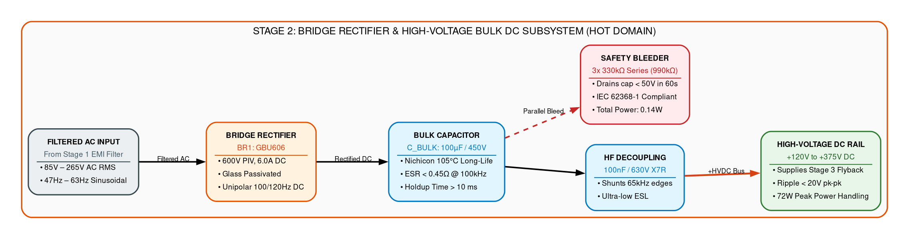
Figure 5: Inside Stage 2 - Bridge Rectifier & Bulk DC Stage Subsystem Architecture

Inside Stage 2: Bridge Rectifier & High-Voltage Bulk DC Subsystem

BRIDGE RECTIFIER & BULK FILTER SEQUENCE
Step 1 | Filtered AC Input | Takes 85V–265V AC RMS sinusoidal voltage from Stage 1 EMI filter.
Step 2 | Full-Wave Rectification | GBU606 single-phase bridge rectifies AC into 100Hz/120Hz unipolar DC pulses (120Vpk–375Vpk).
Step 3 | Bulk Capacitive Filtering | 100µF/450V electrolytic cap smooths ripple and guarantees > 10ms holdup time across line dropouts.
Step 4 | High-Frequency Decoupling | 100nF/630V ceramic cap bypasses fast 80kHz primary switching edge ringing.
Step 5 | Safety Discharge Bleeder | 3x 330kΩ resistor string drains bulk capacitor to < 50V SELV within 60s per IEC 62368-1.

System2 Requirements
System 2 represents the Secondary Stage 4-Switch Synchronous Buck-Boost Post-Regulator, Analog Closed-Loop Control, DAC Steering Network, and Autonomous Hardware CC Protection Subsystem. The detailed electrical hardware specifications are defined in Table 4.5 below:
Table 4.5: Analog Closed-Loop Control, DAC Steering & Hardware Protection Specifications
Req ID | Parameter / Feature | Specification / Target
CT-01 | DAC Voltage Steering Network | Resistor summing into LM5176 FB node [MUST]
CT-02 | Current Sense Resistor | 10 mΩ Metal Element Shunt, 3W, 0.1% [MUST]
CT-03 | MCU Supervisory Shutdown | GPIO pulling LM5176 ENABLE pin low [MUST]
CT-04 | Auxiliary Bias Regulation | +14V Flyback VCC, +12V gate, +5V, +3.3V rails [MUST]

Specific Requirements

Inside Stage 3: Converter DC-DC (Uniform-Frequency Isolated Flyback) Subsystem
Stage 3 provides reinforced galvanic isolation (3000V RMS) and steps down high-voltage bulk DC power to an intermediate +24.0V DC bus (72W). The controller uses an industry-standard UC3843 / UCC28C43 running at a constant 65 kHz uniform clock with passive Schottky barrier secondary rectification (MBR10100), eliminating active synchronous drive complexity.
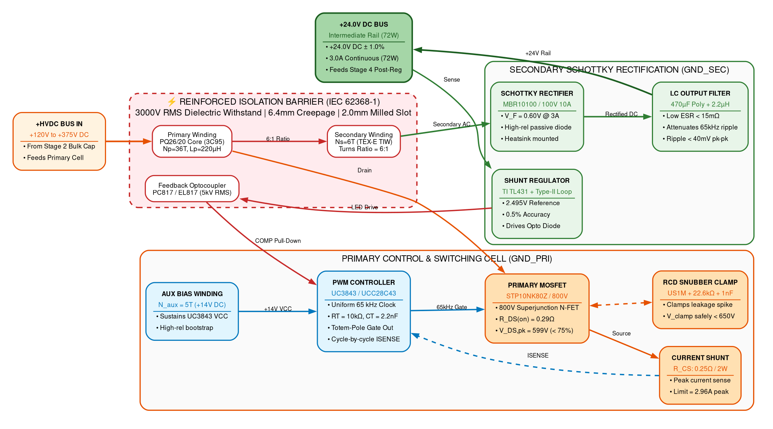
Figure 6: Inside Stage 3 - Converter DC-DC (Uniform-Frequency Isolated Flyback) Subsystem Architecture
STAGE 3: UNIFORM-FREQUENCY FLYBACK DC-DC CONVERTER SEQUENCE
Step 1 | High-Voltage DC Input | Receives +120V to +375V DC bulk bus into primary switching cell.
Step 2 | Uniform-Frequency PWM | UC3843 / UCC28C43 controller operates at constant 65kHz uniform clock set by RT/CT with predictable EMI harmonics.
Step 3 | 3000V RMS Safety Barrier | PQ26/20 transformer (Lp=220µH) with Furukawa TEX-E wire provides reinforced galvanic isolation.
Step 4 | Schottky Barrier Rectification | MBR10100 100V/10A Schottky diode provides simple, robust passive rectification with high reliability.
Step 5 | +24.0V DC Intermediate Rail | Low-ESR LC filter delivers stable +24.0V DC (72W) with optocoupled feedback regulation.
Table 4.6D: STAGE 3 Flyback Detailed Subsystem Component Specification & Engineering Requirements Table
Functional Sub-Block | Circuit Ref | Selected Component / IC | Key Specifications & Ratings | Functional Role & Performance Target
HVDC Input Interface | +HVDC | Stage 2 Bulk DC Bus Link | +120 V to +375 V DC operating span | Low-impedance high-voltage input rail feeding transformer primary winding and snubber network.
Uniform-Freq PWM Controller | U1 | Texas Instruments UC3843 / UCC28C43 | Uniform 65 kHz clock, RT/CT oscillator, cycle-by-cycle CS, direct totem-pole gate out | Generates constant-frequency PWM switching pulses at a uniform 65 kHz rate, providing predictable EMI harmonics and deterministic current-mode control.
Oscillator Timing Network | R_T / C_T | Precision Thin-Film Resistor + C0G Ceramic Cap | R_T = 10.0 kΩ (1%), C_T = 2.2 nF (50V C0G) | Sets constant oscillator clock frequency: f_sw approx 1.72 / (R_T x C_T) = 65 kHz uniform clock without frequency jitter.
Primary Power Switch | Q1 | STMicroelectronics STP10NK80Z / IPB80R290P7 | 800 V, 17 A, R_DS(on) = 0.29 Ω, V_DS,peak = 599 V | Main switching element modulated by 65 kHz PWM gate drive. Voltage stress derated to 74.9% of 800V rating (< 75% limit).
Primary Current Sensing | R_CS | Current Sense Shunt Resistor Network | Low-inductance metal strip, 0.25 Ω, 1%, 2 W | Monitors primary switch peak current (I_pk = 2.96 A) on UC3843 ISENSE pin (Pin 3) with 1.0 V internal comparator threshold for cycle-by-cycle OCP.
RCD Snubber Clamp | D_snub / R / C | Diodes Inc. US1M + 3x 68 kΩ (22.6k net) + 1.0 nF / 1 kV | Diode: 1000 V, 1 A, t_rr = 75 ns; Cap: 1 nF / 1000 V ceramic; Clamp: ~216 V clamp level | Damps high-voltage inductive kick caused by transformer leakage inductance (L_lk approx 2.2 uH); clamps peak drain voltage spike safely below 650 V peak.
Flyback Power Transformer | TX1 | Ferroxcube PQ26/20 (3C95 Ferrite) / EE25 Core | L_p = 220 uH +/- 10%, B_max = 0.148 T (B_sat = 0.38 T), N_p = 36 T | Stores energy during switch on-time and delivers 72 W continuous power to secondary during off-time (Np:Ns = 6:1 turns ratio).
Auxiliary Bias Winding | TX1_AUX | N_aux = 5 T (0.25 mm wire) + UF4004 & 47 µF Cap | Output: +14.0 V DC bias rail | Sustains UC3843 VCC pin (Pin 7) above UVLO threshold (8.4 V start / 7.6 V min) after initial high-voltage bleed startup.
Galvanic Safety Barrier | TX1_ISO | Furukawa TEX-E Triple-Insulated Wire (TIW) | N_s = 6 T (N_p:N_s = 6:1), Reinforced insulation, >= 6.4 mm creepage | Complies with IEC 62368-1 standard. Provides certified >= 3000 V RMS dielectric withstand between primary hot domain and secondary touch-safe SELV domain.
Secondary Schottky Rectifier | D_SEC | ON Semi / Vishay MBR10100 / MBR20100CT | 100 V, 10 A Schottky Barrier Diode, V_F = 0.60 V, TO-220 with heatsink | Performs high-speed passive rectification of secondary flyback pulses. Highly reliable and robust passive design, eliminating active gate driver IC complexity.
Secondary LC Output Filter | C_sec / L_sec | 470 µF / 35 V Low-ESR Electrolytic + 2.2 µH + 22 µF MLCC | Low-ESR filtering, Delta V_ripple < 40 mV pk-pk | Attenuates 65 kHz fundamental switching ripple and high-frequency commutation spikes to produce a quiet intermediate DC rail.
Isolated Closed-Loop Feedback | OPTO1 / U3 | Everlight PC817 Optocoupler + TI TL431 Shunt | 5000 V RMS optical isolation, 2.495 V internal bandgap, 0.5% | Precision resistor divider samples +24.0 V rail, driving optocoupler LED to pull down UC3843 COMP pin (Pin 1), regulating rail to +/- 1.0%.
Intermediate Rail Output | +24V_BUS | Intermediate DC Power Distribution Bus | +24.0 V DC +/- 1.0%, 72.0 W continuous (3.0 A), 84 W peak | Delivers stable intermediate regulated DC power to Stage 4 (Synchronous Buck-Boost Post-Regulator) and secondary auxiliary housekeeping LDOs.

Assumptions
The following points are considered as assumptions for further project execution:
• Grid AC mains is nominal sinusoidal waveform with Total Harmonic Distortion (THD) ≤ 5%.
• Operating ambient temperature is -20°C to +50°C under natural convection airflow.
• Secondary DC ground is floating with reinforced galvanic isolation (≥ 3000V RMS) from Earth and AC mains.
• Connected prototype loads are predominantly resistive or capacitive (C_load ≤ 1000 µF).

Dependencies
The following dependencies are included in the design and development of the SPPS module:
• Component sourcing and lead times for TI LM5176, UC3843 / UCC28C43, INA226, AMC1311, and ST STM32G474.
• Laboratory equipment availability: AC source, DC electronic load, 3000V RMS Hi-Pot tester, and thermal camera.
• Mechanical front-panel drawings for binding post spacing (19.05mm)
• Firmware device drivers for SSD1306 OLED display, INA226 power monitor, and STM32 internal 12-bit DAC.

Standard Deliverables & Release Order
The hardware deliverables and release documentation across project milestones are defined in the table below:

Product Development Plan
Phase 1 — Requirement & Architecture and Class A BOM:
Definition of functional and electrical requirements; 4-stage system architecture design; block diagram and interface specifications.
Phase 2 — Component Selection & Circuit Design:
Transformer PQ26/20 magnetics sizing; component stress derating calculations; closed-loop feedback and DAC steering design; companion HDD authoring.
Phase 3 — Schematic Design and Review:
Complete 4-stage Altium schematics capture; LM5176 cycle-by-cycle current limit sensing and MCU enable control.
Phase 4 — PCB Layout & DFM Review:
PCB stackup; high-voltage isolation partitioning with 2.0mm milled slot; switching loop routing; DFM/DFA checks.
Phase 5 — Prototype Bring-up & Design Validation Plan (DVT):
PCB fabrication and assembly (5 units); cold resistance checks; supervised Variac bring-up; line/load regulation, ripple, efficiency, and Hi-Pot validation.

System1 Development Plan
System Name | Domain Name | Deliverables  Domain3 [Embedded Software]  Domain4
VVDN_SPPS_2026 | Systems / PRD | Product Requirement Document (PRD) — Baseline Specifications & Acceptance Criteria
SPPS Module | Hardware (HW) | Hardware Design Document (HDD) with complete circuit derivations & stress calculations
SPPS Module | Hardware (HW) | Altium Designer Complete Schematics
SPPS Module | Hardware (HW) | Class A Engineering Bill of Materials (BOM) with manufacturer part numbers
SPPS Module | Hardware (HW) | 4-Layer PCB Layout & Gerber RS-274X Fabrication Package (ODB++, NC Drill, Pick-and-Place)
SPPS Module | Hardware (HW) | Design Verification Testing (DVT) Report & Acceptance Certificate
SPPS Module | Firmware (FW) | Microcontroller Telemetry & Display Firmware Source Code
SPPS Module | Compliance / Safety | Hi-Pot Dielectric Withstand Certificate (3000V RMS) & Pre-Compliance EMC Report
Table 8: Standard Deliverables & Release Order

Architecture
The power supply hardware architecture consists of two galvanically isolated power conversion stages followed by synchronous post-regulation and built-in controller hardware protection:

8.1 System 1: Inside Stage 4 (Synchronous 4-Switch Buck-Boost Post-Regulator Subsystem)
STAGE 4: 4-SWITCH BUCK-BOOST POST-REGULATOR SEQUENCE
Step 1 | +24.0V DC Rail Input | Accepts +24.0V DC intermediate rail from Stage 3 Flyback.
Step 2 | 4-Switch Synchronous Bridge | TI LM5176 modulates four 40V MOSFETs in H-bridge around a 10µH flat-wire power inductor.
Step 3 | Seamless Mode Transitions | Operates in pure Buck mode for 5V–18V outputs (>96% eff) and 4-switch Buck-Boost mode near 20V (>95% eff).
Step 4 | Precision DAC Steering | Resistor summing network (R_top=49.9kΩ, R_bot=3.65kΩ, R_DAC=11kΩ) steers output from 5V to 20V in 10mV steps.
Step 5 | Cycle-by-Cycle Current Limit | LM5176 senses current via 10mΩ shunt across CSP/CSN, natively clamping peak inductor current on every 300 kHz cycle.
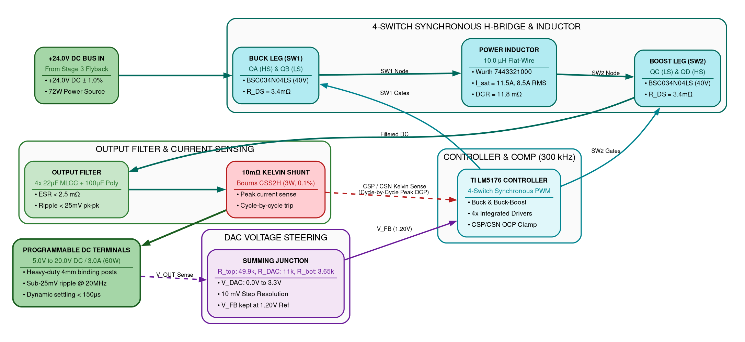
Figure 7: Inside Stage 4 - 4-Switch Buck-Boost Post-Regulator Subsystem Architecture

8.2 System 1: Dual-Domain Power Telemetry & Sensing Frontend Architecture
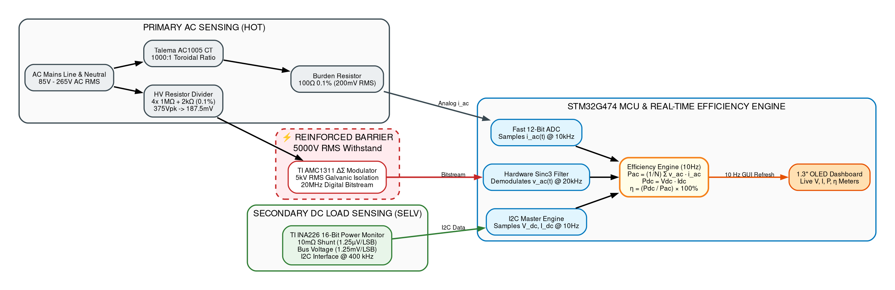
Figure 8: Dual-Domain Power Telemetry & Sensing Frontend Architecture
< Architecture Diagram with caption, shall be inserted here. No explanation of architecture is required. Below architecture diagram, there shall be a note “This is the proposed architecture and it might get changed during the design stage” and “Ensure the license compliance for usage of open source tools”.>

8.3 System 2: Auxiliary Bias Power Rail Distribution Subsystem Architecture
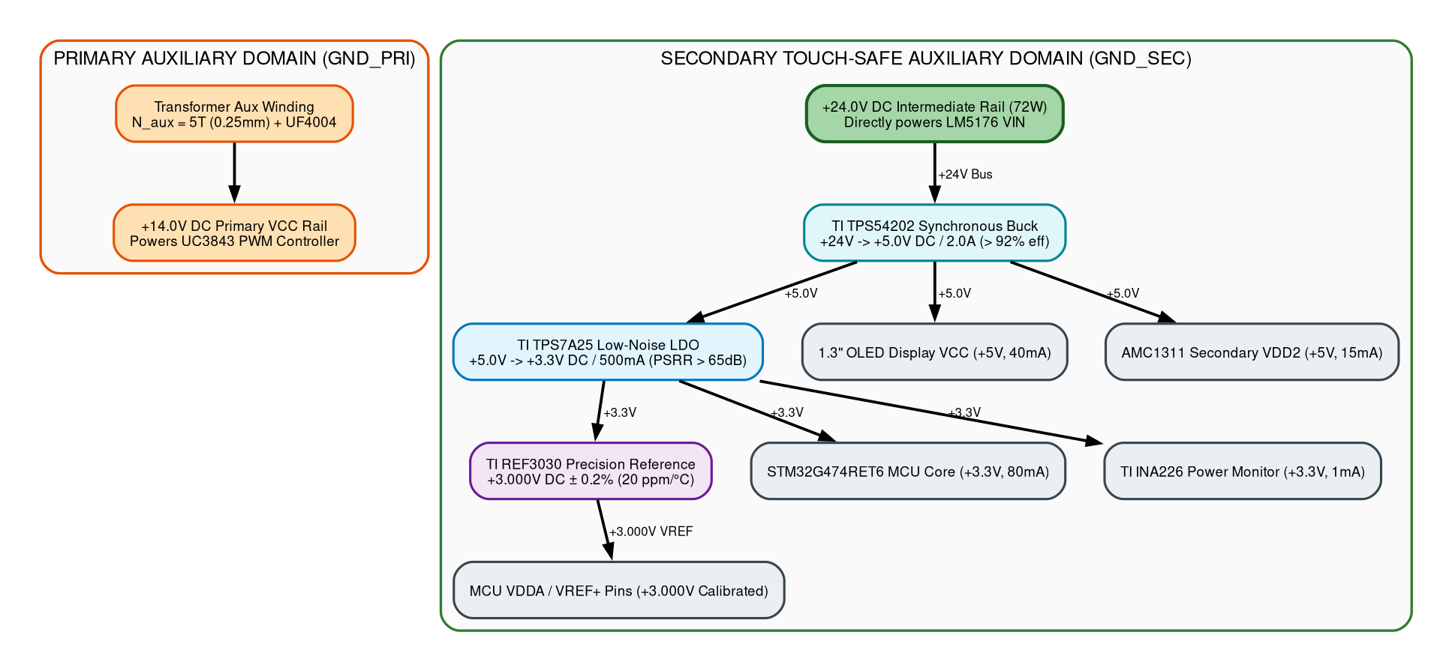
Figure 9: Auxiliary Bias Power Rail Distribution Subsystem Architecture

8.4 System Master: Master System Hardware Architecture Block Diagram
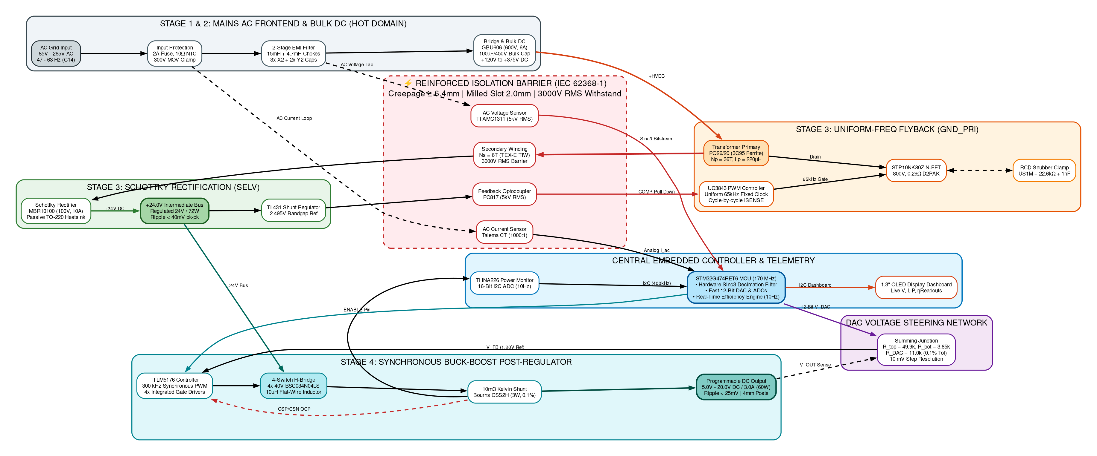
Figure 10: Master System Hardware Architecture Block Diagram

8.5 System Microcontroller: MCU System Interaction, State Machine & Monitoring Architecture
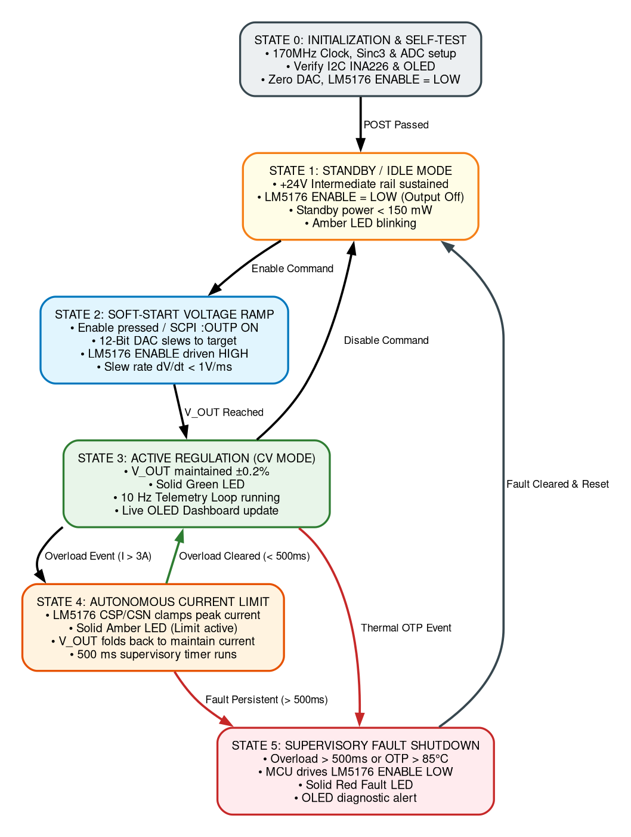
Figure 11: MCU System Interaction, State Machine & Monitoring Architecture

8.6 System Interconnect: Detailed Component Connections Block Diagram
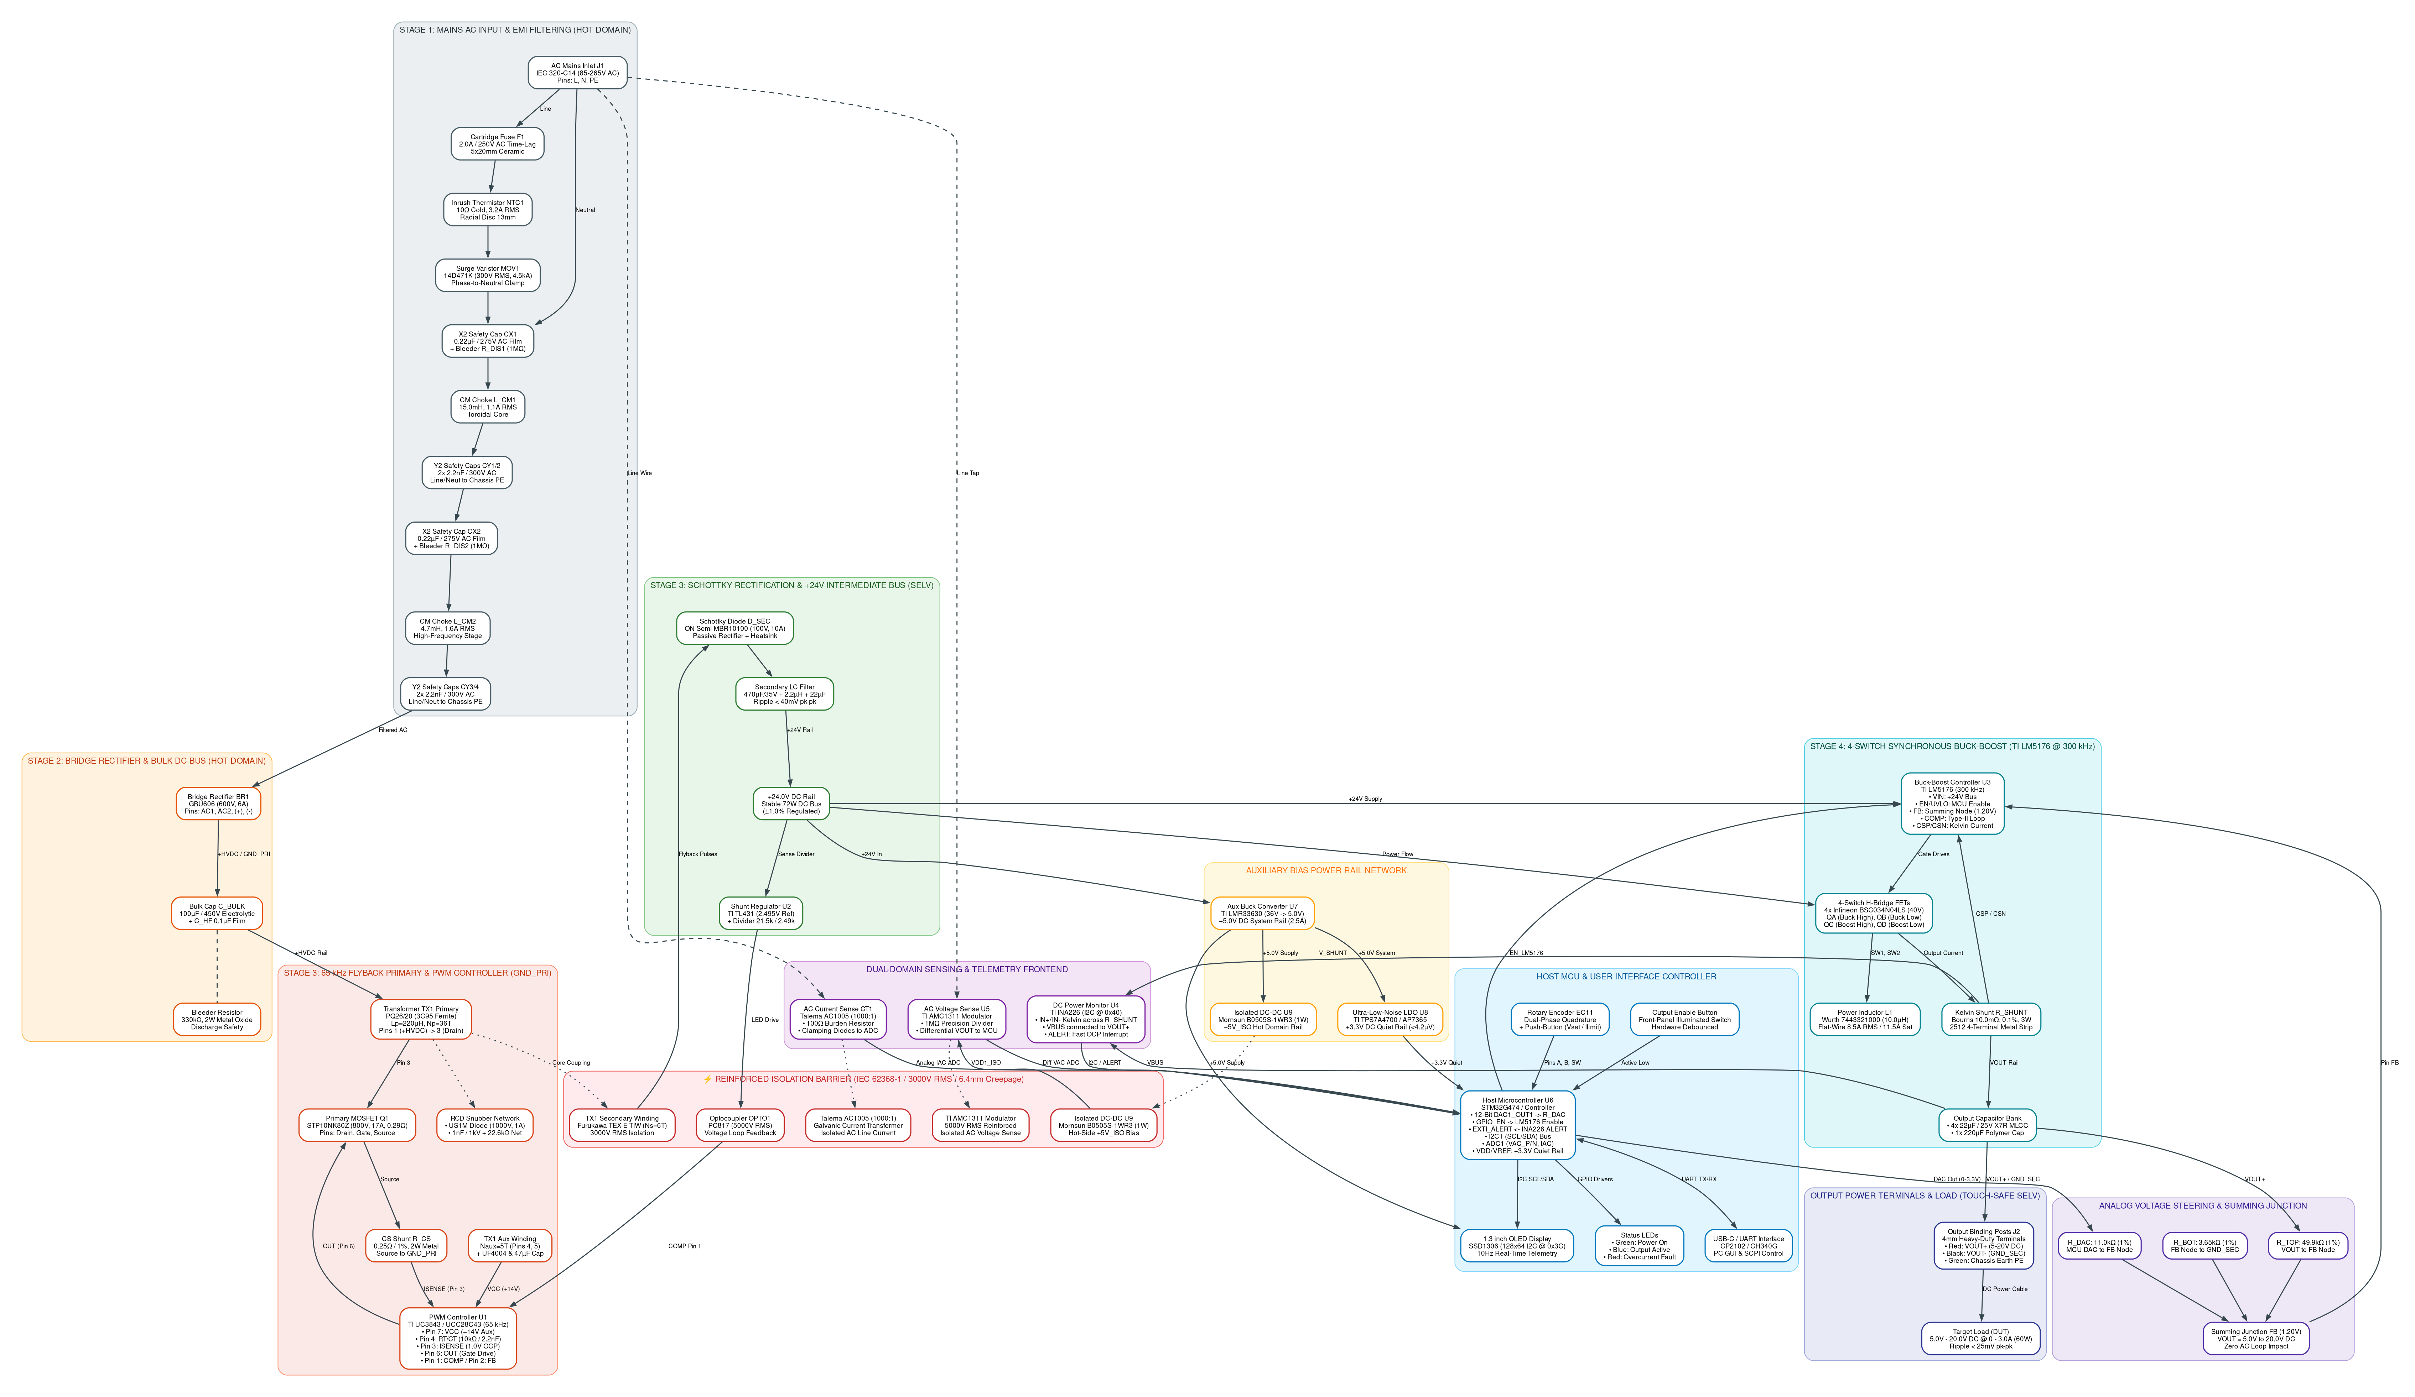
Figure 12: Detailed Component Connections Block Diagram
< Architecture Diagram with caption, shall be inserted here. No explanation of architecture is required. Below architecture diagram, there shall be a note “This is the proposed architecture and it might get changed during the design stage” and “Ensure the license compliance for usage of open source tools”.>

Bill Of Material
Note: This is the expected BOM and it might get changed during the design stage. The BOM does not contain any pricing/cost information.

System1: Product BOM
Refer to detailed bill of materials in the respective subsystem tables below.
Sl.No | Ref Des | Description | Qty | Package / Footprint | Mfg | Mfg Part No
1 | F1 | Ceramic Time-Lag Fuse, 2.0A, 250V AC | 1 | 5x20mm Cartridge | Littelfuse | 0218002.MXP
2 | NTC1 | Inrush Current Thermistor, 10Ω Cold, 3.2A | 1 | Radial Disc 13mm | TDK / EPCOS | B57236S0100M000
3 | MOV1 | Metal Oxide Varistor, 300V RMS, 4.5kA | 1 | Radial Disc 14mm | Bourns | MOV-14D471K
4 | L_CM1 | Common Mode Choke, 15.0mH, 1.1A | 1 | Toroidal Through-Hole | Wurth Elektronik | 744823215
5 | L_CM2 | Common Mode Choke, 4.7mH, 1.6A | 1 | Toroidal Through-Hole | Wurth Elektronik | 744822472
6 | C_X1, C_X2 | Safety X2 Film Capacitor, 0.22µF, 310V AC | 2 | Radial Pitch 15mm | KEMET | R46KI32200001M
7 | C_X3 | Safety X2 Film Capacitor, 0.10µF, 310V AC | 1 | Radial Pitch 10mm | KEMET | R46KI31000001M
8 | C_Y1, C_Y2 | Safety Y2 Ceramic Disc Cap, 2.2nF, 400V AC | 2 | Radial Disc | KEMET | PHE850 Series
9 | BR1 | Single-Phase Bridge Rectifier, 600V, 6.0A | 1 | GBU-4 Through-Hole | Diodes Inc. | GBU606
10 | C_BULK | Bulk Electrolytic Capacitor, 100µF, 450V, 105°C | 1 | Snap-In 22x30mm | Nichicon | LGW2W101MELZ25
11 | C_HF | High-Voltage Decoupling MLCC, 100nF, 630V X7R | 1 | SMD 1812 | Murata | GA342QR7GD102KW01L
12 | R_BL1..3 | Safety Bleeder Resistor, 3x 330kΩ, 0.25W | 3 | SMD 1206 | Vishay Dale | CRCW1206330KFKEA
13 | U1 | Uniform-Frequency PWM Controller (65 kHz) | 1 | SOIC-8 | Texas Instruments | UC3843BN / UCC28C43D
14 | Q1 | Superjunction N-MOSFET, 800V, 17A, 0.29Ω | 1 | D2PAK (TO-263) | STMicroelectronics | STP10NK80Z / IPB80R290P7
15 | TX1 | Flyback Transformer, PQ26/20, Lp=220µH, 6:1 | 1 | PQ26/20 Through-Hole | Custom / Ferroxcube | 3C95-PQ2620-72W
16 | R_T | Oscillator Timing Resistor, 10.0 kΩ, 0.1% | 1 | SMD 0805 | Vishay Dale | TNPW080510K0BEEA
17 | C_T | Oscillator Timing Capacitor, 2.2 nF, 50V C0G | 1 | SMD 0805 | Murata | GRM2165C1H222JA01D
18 | R_CS | Primary Current Sense Shunt, 0.25Ω, 2W, 1% | 1 | SMD 2512 Metal Strip | Vishay Dale | WSL2512R2500FEA
19 | D_SNUB | Ultrafast Recovery Snubber Diode, 1000V, 1A, 75ns | 1 | SMA (DO-214AC) | Diodes Inc. | US1M-13-F
20 | R_SNUB1..3 | Snubber Clamp Resistors, 3x 68kΩ 1W (22.6kΩ net) | 3 | SMD 2512 | Vishay Dale | CRCW251268K0FKEG
21 | C_SNUB | High-Voltage Snubber Cap, 1.0nF, 1000V Ceramic | 1 | SMD 1210 | Murata | GRM32A7U3A102JW31D
22 | D_SEC | Schottky Barrier Rectifier, 100V, 10A, Vf=0.60V | 1 | TO-220-2 (Heatsink) | ON Semiconductor | MBR10100G
23 | C_SEC1,2 | Low-ESR Intermediate Rail Cap, 2x 470µF, 35V | 2 | Radial Can 10x16mm | Panasonic | EEU-FR1V471
24 | L_SEC | Intermediate Rail Smoothing Inductor, 2.2µH, 5A | 1 | SMD 8x8mm Shielded | Wurth Elektronik | 7447789002
25 | C_SEC3 | High-Frequency Decoupling MLCC, 22µF, 35V X7R | 1 | SMD 1210 | Murata | GRM32ER7YA226KE14L
26 | OPTO1 | Reinforced Phototransistor Optocoupler, 5kV RMS | 1 | SMD-4 Gull-Wing | Everlight | EL817(S)(TA)
27 | U2 | Precision Programmable Shunt Reference, 2.495V | 1 | SOT-23-3 | Texas Instruments | TL431AIDBZR
Table 9.1: System 1 Product BOM (Primary & Flyback Stages)

System2: Product BOM
Refer to detailed bill of materials in the respective subsystem tables below.
Sl.No | Ref Des | Description | Qty | Package / Footprint | Mfg | Mfg Part No
28 | U3 | 4-Switch Synchronous Buck-Boost Controller | 1 | HTSSOP-28 | Texas Instruments | LM5176PWPR
29 | QA..QD | 4x Synchronous N-MOSFETs, 40V, 3.4mΩ | 4 | SuperSO8 (PowerPAK) | Infineon | BSC034N04LS
30 | L1 | Flat-Wire Power Inductor, 10.0µH, 8.5A RMS, 11.5A Sat | 1 | SMD 12.5x12.5mm | Wurth Elektronik | 7443321000
31 | R_SHUNT | Kelvin Current Sense Shunt, 10.0mΩ, 0.1%, 3W | 1 | SMD 2512 4-Terminal | Bourns | CSS2H-2512R-L010F
32 | C_OUT1..4 | Output Filter Ceramic MLCCs, 4x 22µF, 25V X7R | 4 | SMD 1210 | Murata | GRM32ER71E226KE15L
33 | C_POLY | Solid Aluminum Polymer Cap, 100µF, 25V, 12mΩ ESR | 1 | Radial SMD 8x10mm | Panasonic | 25SVPF100M
34 | R_TOP | Feedback Upper Divider Resistor, 49.9 kΩ, 0.1% | 1 | SMD 0805 | Vishay Dale | TNPW080549K9BEEA
35 | R_BOT | Feedback Lower Divider Resistor, 3.65 kΩ, 0.1% | 1 | SMD 0805 | Vishay Dale | TNPW08053K65BEEA
36 | R_DAC | DAC Steering Summing Resistor, 11.0 kΩ, 0.1% | 1 | SMD 0805 | Vishay Dale | TNPW080511K0BEEA
37 | C_COMP | Type-II Compensation Capacitor, 2.2 nF, 50V C0G | 1 | SMD 0603 | Murata | GRM1885C1H222JA01D
38 | R_COMP | Type-II Compensation Resistor, 10.0 kΩ, 1% | 1 | SMD 0603 | Vishay Dale | CRCW060310K0FKEA
39 | U4 | 32-bit ARM Cortex-M4F MCU @ 170 MHz | 1 | LQFP-64 | STMicroelectronics | STM32G474RET6
40 | U5 | 16-Bit I2C Power Monitor IC (0.1% Accuracy) | 1 | VSSOP-10 | Texas Instruments | INA226AIDGSR
41 | U6 | 5000V RMS Isolated Delta-Sigma Modulator | 1 | SOIC-8 Wide | Texas Instruments | AMC1311DWVR
42 | CT1 | AC Current Transformer, 1000:1 Ratio, 5A | 1 | Toroidal Through-Hole | Talema | AC1005
43 | R_BURDEN | Precision CT Burden Resistor, 100 Ω, 0.1%, 0.25W | 1 | SMD 0805 | Vishay Dale | TNPW0805100RBEEA
44 | U7 | Secondary Synchronous Step-Down Buck (24V -> 5V) | 1 | SOT-23-6 | Texas Instruments | TPS54202DDCR
45 | U8 | Ultra-Low-Noise LDO Regulator (5V -> 3.3V, 500mA) | 1 | SOT-223 | Texas Instruments | TPS7A2533DBVR
46 | U9 | High-Precision Voltage Reference (3.000V, 0.2%) | 1 | SOT-23-3 | Texas Instruments | REF3030AIDBZR
47 | DISP1 | 1.3" Monochrome OLED Display Module (128x64 I2C) | 1 | 4-Pin Header | Waveshare / Solomon | SSD1306-1.3-OLED
48 | ENC1,2 | Dual Incremental Optical Rotary Encoders + Switch | 2 | PCB Right-Angle | Bourns | PEC11R-4220F-S0024
49 | SW1 | Tactile Push-Button Output Enable Switch | 1 | SMD 6x6mm | Omron | B3FS-1002P
50 | LED1..3 | Status LEDs: Green (CV), Amber (Limit), Red (Fault) | 3 | SMD 0805 | Kingbright | APT2012 Series
51 | POSTS | Heavy-Duty 4mm Gold Binding Posts (Red / Black) | 2 | 19.05mm Panel Mount | Pomona Electronics | 3770-0 / 3770-2
Table 9.2: System 2 Product BOM (Buck-Boost, Protection & Control)

Out of Scope
The following points are not included in the scope of project:
- Active Power Factor Correction (Active Boost PFC) — passive EMI filtering is used since < 75W is exempt under IEC 61000-3-2.
- Complex External Protection Circuits — dedicated analog crowbar thyristors and discrete fast comparator pull-down networks are excluded in favor of built-in controller protection and MCU supervisory shutdown.
- Three-phase 400V/480V AC industrial grid input operation (module is single-phase 85V–265V AC RMS only). Negative/bipolar rails and wireless IoT interfaces are excluded.

Open Items
The following points are included in the scope of project but not included in urrent revision:
- Current shunt value trade-off: Evaluating 5mΩ vs 10mΩ for thermal dissipation vs low-current sensing resolution.
- Auxiliary 24V DC barrel input option: Evaluating a 24V DC auxiliary input to bypass AC mains for vehicle/field use.
- Secondary heatsink copper area optimization: Evaluating 2oz vs 3oz copper pours for D2PAK primary FET.

Appendix: Cross-Mentor Interview Preparation & Defense Cheatsheet
This appendix provides structured technical defense rationales for the Power Electronics Engineer Trainee (GET) when defending the hardware requirements, architecture, and safety boundaries before the cross-mentor review panel. The design deliberately focuses on simplicity, reliability, and standard industry ICs to ensure rapid bring-up and dependable operation.

Q1: Walk me through the complete power conversion chain from the wall to the device.
The power conversion hardware operates in four clean, sequential stages: First, universal mains AC (85V–265V AC RMS) enters through an IEC C14 inlet with a 2A time-lag ceramic fuse, 10Ω NTC inrush thermistor, MOV surge clamp, and a 2-stage common-mode EMI filter. Second, a GBU606 bridge rectifier and 100µF/450V bulk electrolytic capacitor convert AC into an unregulated high-voltage DC bus (+120V to +375V DC). Third, Stage 3 (a Uniform-Frequency Flyback converter with UC3843 / UCC28C43 and a custom PQ26/20 transformer) provides certified 3000V RMS reinforced safety isolation and steps down power to a stable +24.0V DC intermediate bus (72W) using an MBR10100 Schottky barrier diode with heatsink. Fourth, Stage 4 (a TI LM5176 4-switch synchronous Buck-Boost post-regulator) regulates the +24V bus down or across to the target 5.0V–20.0V DC at up to 3.0A with sub-25mV ripple, delivering clean DC to the device under test via heavy-duty 4mm binding posts.

Q2: Why did you use a passive filter and bridge rectifier instead of an active Boost PFC stage?
Under international standard IEC 61000-3-2, active Power Factor Correction (PFC) is legally mandated only for equipment with active input power exceeding 75W. Our module delivers a maximum continuous output of 60W (72W peak intermediate), so it falls strictly below the 75W threshold. Adding an active PFC boost stage would require an additional high-voltage MOSFET, boost diode, controller IC, and large inductor—adding approximately $4.20 to the BOM, consuming 35% more PCB area, and introducing a ~3% efficiency penalty without any regulatory requirement.

Q3: How did you calculate the Flyback transformer magnetics on the PQ26/20 core?
At minimum 85V AC input, the rectified bulk bus is 120V DC. For a maximum duty cycle of 45% and uniform 65kHz switching frequency (set by RT=10kΩ, CT=2.2nF) at 72W output power, peak primary current is I_pk = 2.96A. Using L_p = (V_bulk_min * D_max) / (I_pk * f_sw), I calculated a primary inductance of 220µH. I chose a Ferroxcube PQ26/20 core in 3C95 material because its cross-sectional area Ae is 122 mm², keeping peak flux density B_max at 0.148 Tesla (well below the 0.38 Tesla saturation limit). The turns ratio is 6:1 (36 primary turns, 6 secondary turns). To guarantee IEC 62368-1 reinforced isolation (3000V RMS), the secondary is wound with Furukawa TEX-E triple-insulated wire. The uniform frequency ensures fixed, predictable EMI harmonics at 65kHz and its integer multiples.

Q4: Why is the intermediate bus chosen at +24.0V DC instead of +12V or +48V?
+24.0V DC is the optimal design choice for a 5V to 20V output range. If we chose +12V, stepping up to 20V at 3A (60W) would require high inductor boost currents (I_in = 5.5A), creating excessive I²R conduction losses in the Buck-Boost MOSFETs. If we chose +48V, the Flyback turns ratio would decrease, increasing primary switch voltage stress, and stepping down to 5V would require an extreme duty cycle of 10%. With +24V, 5V, 12V, and 15V operate in pure Buck mode (>96% efficiency), and 20V operates near unity Buck-Boost transition with minimal switching stress.

Q5: How does the 4-switch Buck-Boost operate seamlessly between 5V and 20V?
The TI LM5176 controls four N-MOSFETs (QA, QB, QC, QD) in an H-bridge configuration around a single 10µH flat-wire inductor. When V_OUT is significantly below 24V (e.g. 5V or 12V), QC is held continuously ON and QD is OFF, so the circuit functions purely as a synchronous Buck converter with switches QA and QB. As V_OUT approaches 20V under heavy load, the controller smoothly enters 4-switch Buck-Boost mode, modulating both legs to maintain exact regulation with zero deadband or output glitching.

Q6: How does the DAC steer the output voltage without destabilizing the loop?
The LM5176 regulates by maintaining its feedback pin (FB) at an internal 1.20V reference. Instead of modifying the internal reference, we use a resistive summing junction: R_top (49.9kΩ) connects to V_OUT, R_bot (3.65kΩ) connects to ground, and R_DAC (11.0kΩ) connects to our 12-bit DAC. By injecting current into the FB node from the DAC, when V_DAC = 3.3V, V_OUT is steered to 5.0V. When V_DAC = 0V, V_OUT is steered to 20.0V. Because the loop's AC Type-II compensation network is connected between COMP and ground, DC setpoint steering has zero impact on high-frequency phase margin and stability.

Q7: How does the power supply protect against overcurrent and short circuits?
We use standard, proven industry protections built directly into the hardware controllers: 1) LM5176 Built-in Cycle-by-Cycle Current Limiting: The LM5176 continuously monitors inductor/output current through a 10mΩ precision sense resistor connected to its dedicated CSP and CSN pins. If current exceeds the programmed threshold, the controller immediately truncates the current PWM pulse, capping peak current on every 300 kHz switching cycle. 2) MCU Supervisory Disable: The MCU continuously reads output current via the INA226 power monitor over I2C. If a sustained overload or short-circuit is detected (> 500 ms), the MCU pulls the LM5176 ENABLE pin low to safely disable power delivery. 3) Primary AC Fuse: A 2.0A ceramic time-lag fuse on the AC mains provides fail-safe isolation against internal catastrophic short circuits.

Q8: How is safety galvanic isolation guaranteed on the PCB?
We adhere strictly to IEC 62368-1 for reinforced insulation. Primary hot circuits and secondary touch-safe circuits are separated by a minimum physical surface creepage distance of 6.4mm. Across the isolation barrier, we route a 2.0mm wide milled air slot through the PCB substrate directly beneath the PQ26/20 transformer and optocouplers. The transformer secondary uses triple-insulated Furukawa TEX-E wire. The complete assembly is verified on the bench with a 3000V AC RMS Hipot dielectric withstand test for 60 seconds with zero breakdown.

Q9: How do you verify output voltage ripple on the oscilloscope?
Standard alligator ground clips act as loop antennas that pick up radiated high-frequency magnetic noise from the 300kHz switching inductor, falsely showing 100mV+ of ripple. To measure true ripple accurately, I use the tip-and-barrel probing technique directly across the output capacitor C_OUT. I remove the oscilloscope probe hat and ground lead, wrap a short bus wire around the ground barrel, touch the tip directly to the positive pad and the barrel to the negative pad, engage 20MHz bandwidth limit and AC coupling, and verify peak-to-peak ripple is strictly below 25mV.

Q10: What is your exact bench bring-up procedure using a Variac?
Before applying any AC power, I perform cold resistance checks: verifying > 100MΩ primary-to-secondary isolation resistance, checking for shorts across the bulk capacitor, and checking impedance across the +24V bus and output terminals. Next, I connect the board to an isolation transformer and an AC Variac with a 60W series current-limiting incandescent bulb. I slowly ramp AC voltage from 0V to 85V AC while monitoring bulk DC bus voltage and Flyback V_CC aux bias. Once the +24V bus stabilizes at 85V AC, I ramp to nominal 230V AC and 265V AC. Finally, I enable the LM5176 Buck-Boost stage, sweep the DAC from 5V to 20V with a precision DMM, and apply incremental electronic load steps from 0.1A to 3.0A while monitoring thermals with a FLIR thermal camera.

