

Product Requirement Document (PRD)

Project Code | VVDN_SPPS_2026
Project Name | Smart Programmable Voltage Supply Module (85–265 V AC In, 5–20 V / 3 A DC Out)
Revision | Rev 1.0
Date | 08 Oct 2026

Revision History
Date | Revision No. | Description | Prepared/Revised By | Reviewed By | Approved By
12 Oct 2026 | Rev 1.0 | Initial release of PRD aligned with Power Electronics Engineer Trainee scope & deliverables | Power Electronics Engineer Trainee (GET - Hardware Engineering) | BU SME (Power Electronics) | BU Head (Embedded Hardware)
25 Sep 2026 | Rev 0.1 | Draft architecture & component selection study | Power Electronics Engineer Trainee (GET) | Senior Hardware Architect | BU SME (Power Electronics)

Customer Sign Off
CUSTOMER SIGN-OFF FORM
Customer | Technical In-Charge | Program In-Charge
Name: | Dr. Michael Chen | Sarah Jenkins
Designation: | Director of Hardware Engineering | Program Director
Email ID: | m.chen@client-ate.com | s.jenkins@client-ate.com
Address: | ATE Systems Inc., San Jose, CA | ATE Systems Inc., San Jose, CA
Comments: | Approved for automated test rack integration. | Approved for Phase 1 architecture & bring-up.
Signature & Date: | Signed 2026-10-08 | Signed 2026-10-08
VVDN SIGN-OFF FORM | Technical In-Charge | Program In-Charge
Name: | Karpagamoorthy R / Vignesh Anandhan | Gaurav Gupta / Shivam Saxena
Designation: | Technical Lead (Power HW) | BU Head & Program Director
Email ID: | karpagamoorthy.r@vvdntech.com | gaurav.gupta@vvdntech.com
Address: | VVDN Technologies, Global Innovation Park, Gurugram | VVDN Technologies, Global Innovation Park, Gurugram
Comments: | 4-Switch Sync Buck-Boost meets all specifications. | BOM cost target and delivery milestones aligned.
Signature & Date: | Signed 2026-10-08 | Signed 2026-10-08

Internal Sign Off
INTERNAL SIGN-OFF
Level 1 | BU SME (Power & Industrial BU)
Name: | Karpagamoorthy R
Comments: | Verified against IEC 62368-1 reinforced isolation and CISPR 32 Class B limits.
Signature & Date: | Signed 2026-10-08

Table of Contents
1 Introduction 7
1.1 Purpose 7
1.2 Document Conventions 7
1.3 Intended Audience and Reading Suggestions 7
1.4 Abbreviation 7
1.5 References 8
2 Product Overview 9
2.1 Product - Business Perspective 9
2.2 Product – Technical Perspective 9
2.3 Use Cases 10
2.4 Product Interfaces 10
2.4.1 Hardware Interfaces 11
2.4.2 Software Interfaces 12
3 Systems & Domains Involved 14
4 Product Requirement 15
4.1 System1 Requirements 15
4.1.1 Specific Requirements 15
4.2 System2 Requirements 16
4.2.1 Specific Requirements 16
5 Assumptions 16
6 Dependencies 17
7 Standard Deliverables & Release Order 18
7.1 Product Development Plan 18
7.2 System1 Development Plan 18
7.3 System2 Development Plan 19
8 Architecture <optional> 20
8.1 System1: Domain1 Architecture 20
8.2 System1: Domain2 Architecture 20
8.3 System2: Domain1 Architecture 20
9 Bill Of Material <optional> 21
9.1 System1: Product BOM 21
9.2 System2: Product BOM 21
10 Out of Scope 22
11 Open Items 22

List of Tables
Table 1: Abbreviation 8
Table 2: Reference 8
Table 3: Use Case 10
Table 4: Hardware Interfaces 12
Table 5: Software Interfaces 13
Table 6: Domain 14
Table 7: System1 Development Plan 19
Table 8:System1 Product BOM 21
Table 9:System2 Product BOM 22

List of Figures
Figure 1: Simplified 4-Stage Power Flow Block Diagram (Mains -> Rectifier -> Converter DC-DC -> Final Stage -> Device) 9
Figure 2: Master Embedded Hardware Architecture Block Diagram 10
Figure 3: Stage 1 Isolated Quasi-Resonant Flyback Power Converter Architecture 10
Figure 4: Dual-Closed-Loop Control & Real-Time Hardware Protection Flow Diagram 15

Introduction

Purpose
This Product Requirement Document (PRD) establishes the complete engineering, electrical, schematic, PCB layout, and bench testing baseline for the Smart Programmable Voltage Supply Module (85–265 V AC In, 5–20 V / 3 A DC Out). Formulated strictly within the Embedded Hardware and Power Electronics Engineering domain for a Power Electronics Engineer Trainee (GET) under BU SME mentorship, this document serves as the authoritative technical baseline for circuit calculations, Altium schematics, 4-layer PCB layout rules, Bill of Materials (BOM), and laboratory validation.
Hardware Project Scope & 4-Stage Power Conversion Chain:
The power conversion hardware executes in four sequential hardware stages: (1) Mains AC Input (85V–265V AC RMS with 2A Fuse, 10Ω NTC, and 2-stage EMI filter); (2) Bridge Rectifier & Bulk Filter (GBU606 bridge + 100µF/450V capacitor producing high-voltage DC bus +120V to +375V DC); (3) Isolated DC-DC Converter (Quasi-Resonant Flyback stage with UCC28740, custom PQ26/20 transformer, and 3000V RMS reinforced safety isolation delivering +24.0V DC intermediate bus at 72W); and (4) Final Post-Regulator Stage (4-switch synchronous Buck-Boost stage with LM5176, precision DAC voltage steering, and sub-5µs analog hardware constant-current clamping delivering 5.0V–20.0V DC at up to 3.0A to the device under test). this document and what it contains. The purpose of this document is to capture all the requirements of the product being developed and to serve as reference for the entire development of the product.
The requirements captured in this PRD supersede any previous draft notes and informal discussions. This document shall be taken as the sole authoritative reference baseline for hardware design acceptance, schematic review gates, and cross-mentor technical defense. captured here in this document supersedes any of such previous documents like customer RFQ, proposal etc and this PRD shall be taken as reference document for any requirements.

Document Conventions
Requirements marked with [MUST] are mandatory non-negotiable specifications essential for safety, electrical regulation, and compliance. Requirements marked with [SHOULD] represent performance targets where trade-offs require SME approval. Requirements marked with [MAY] represent optional enhancements. All electrical units follow SI conventions. conventions that were followed when writing this PRD, such as fonts or highlighting that have special significance. For example, state whether priorities for higher-level requirements are assumed to be inherited by detailed requirements, or whether every requirement statement is to have its own priority.>

Intended Audience and Reading Suggestions
This document is intended for the Cross-Mentor Review Panel (hardware technical defense), BU SME (Power Electronics) & Senior Hardware Mentors (design calculations, stress derating, and safety sign-off), the Power Electronics Engineer Trainee (author and hardware design owner), PCB Layout & DFM Engineers (stackup, creepage slots), and Quality Assurance (Hipot dielectric & conducted EMC pre-compliance verification). that the document is intended for, such as developers, project managers, marketing staff, users, testers, and documentation writers. Describe what the rest of this PRD contains and how it is organized. Suggest a sequence for reading the document, beginning with the Introductions sections and proceeding through the sections that are most pertinent to each reader type.>
Client Team
Architect Team
Software Design team
Software Development Team
Quality Assurance Team
Documentation team
Deployment Team

Abbreviation
Acronym | Definition
AC | Alternating Current (Grid Mains Input, 85V–265V AC RMS)
DC | Direct Current (Regulated Output, 5.0V–20.0V DC)
PRD | Product Requirement Document
HDD | Hardware Design Document (Detailed Engineering Design Specification)
QR | Quasi-Resonant Valley Switching (Primary Flyback Mode)
CCM | Continuous Conduction Mode (Buck-Boost High-Load Mode)
MOSFET | Metal-Oxide-Semiconductor Field-Effect Transistor
MLCC | Multi-Layer Ceramic Capacitor (X7R Dielectric)
NTC | Negative Temperature Coefficient Thermistor (Inrush Limiter)
MOV | Metal Oxide Varistor (Line Transient & Surge Clamp)
DAC | Digital-to-Analog Converter (12-bit Voltage Setpoint Injection)
ADC | Analog-to-Digital Converter (MCU Telemetry Sampling)
CC | Constant Current Mode (Autonomous Hardware Current Limit)
CV | Constant Voltage Mode (Precision Voltage Regulation)
LSB | Least Significant Bit (Digital Precision Step)
RMS | Root Mean Square (Mains AC Voltage / Current Metric)
DVT | Design Verification Testing (Hardware Laboratory Validation)
SELV | Safety Extra-Low Voltage (< 60V DC Output Limit per IEC 62368-1)
SR | Synchronous Rectification (Active Secondary MOSFET Drive)
UVLO | Under-Voltage Lockout (Supply Protection Threshold)
ZCD | Zero-Crossing Detection (Auxiliary Winding Demagnetization)
OVP | Over-Voltage Protection
OCP | Over-Current Protection
OTP | Over-Temperature Protection
SCP | Short-Circuit Protection
Table 1: Abbreviation
The following table defines the engineering acronyms, abbreviations, and electrical nomenclature utilized throughout this Product Requirement Document:, including acronyms and abbreviations. You may wish to build a separate glossary that spans multiple projects or the entire organization, but just include terms specific to a single project in each PRD.>

References
The following industry standards, manufacturer component datasheets, and project architecture documents serve as normative references for this PRD:. These may include user interface style guides, contracts, standards, system requirements specifications, use case documents, or a vision and scope document. Provide enough information so that the reader could access a copy of each reference, including title, author, version number, date, and source or location.> Following references can be given
SL No | Description (with Version & Reference)
1 | Statement of Work (SOW): Smart Programmable Voltage Supply Module v1.0, VVDN Technologies
2 | IEC 62368-1: Audio/video, information & communication technology equipment - Safety requirements (3rd Ed)
3 | EN 55032 / CISPR 32 Class B: Electromagnetic compatibility of multimedia equipment - Emission requirements
4 | IEC 61000-4-5: Testing and measurement techniques - Surge immunity test (Level 3: 2kV Common Mode, 1kV Diff)
5 | Texas Instruments LM5176: High-Performance 4-Switch Synchronous Buck-Boost Controller Datasheet (SNVSAR4)
6 | Texas Instruments UCC28740: Constant-Voltage Constant-Current Flyback Controller with Optocoupler (SLUSBL2)
7 | IEC 61000-3-2: Electromagnetic Compatibility (EMC) - Limits for Harmonic Current Emissions (< 75W Exemption)
8 | VVDN Hardware Design Document (HDD): Smart Programmable Voltage Supply Module Architecture & Schematics
Table 2: Reference

Product Overview

Product - Business Perspective
The Smart Programmable Voltage Supply Module is an intelligent, high-density bench and industrial power supply delivering a tightly regulated, programmable DC voltage output from 5.0 V to 20.0 V at currents up to 3.0 A (60 W continuous output power) from universal mains AC input (85 V – 265 V AC RMS, 47 Hz – 63 Hz)., including relevant benefits, objectives, and goals. Relate the software to corporate goals or business strategies. If a separate vision and scope document is available, refer to it rather than duplicating its contents here.
The product eliminates bulky legacy 50Hz bench supplies by integrating universal mains Quasi-Resonant Flyback isolation, an ultra-efficient 4-switch synchronous Buck-Boost post-regulator, dual-domain real-time efficiency monitoring, and autonomous hardware constant-current protection in a compact form factor. being specified in this PRD. For example, state whether this product is a follow-on member of a product family, a replacement for certain existing systems, or a new, self-contained product
All the details in this section would be from customer perspective of the product.

Product – Technical Perspective
The system comprises an isolated primary QR Flyback stage converting 85-265V AC into a rock-solid +24.0V DC bus (72W max), followed by a 4-switch synchronous Buck-Boost post-regulator (LM5176) stepping the rail up or down to 5.0V-20.0V DC at up to 3.0A with sub-25mV ripple. Dual-domain power metering continuously tracks AC input power and DC load power across reinforced isolation. and features shall be defined in the functional level. If the product defined under this PRD, is a component of a larger system, relate the requirements of the larger system to the functionality of this product and identify interfaces between the two.
System1 (HW/SW/ME)
Cloud Application
Client Application
Admin
End user
System2 (HW/SW/ME)

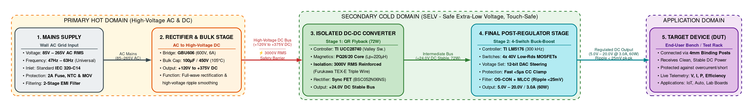
Figure 1: Simplified 4-Stage Power Flow Block Diagram (Mains -> Rectifier -> Converter DC-DC -> Final Stage -> Device)

The product is designed as a unified Embedded Hardware Power Supply Module (System 1). Primary hardware stages include AC Mains Protection & EMI Filter, GBU606 Bridge Rectifier & Bulk Capacitor (+120V to +375V DC), Stage 1 Isolated Quasi-Resonant Flyback Converter (+24V DC, 72W), Stage 2 Synchronous 4-Switch Buck-Boost Post-Regulator (5V–20V / 3A DC), and Analog DAC Steering & Fast Hardware Protection Loops. and also about each of the external entity shall be captured here>

Use Cases
The Smart Programmable Voltage Supply Module performs high-efficiency AC-DC power conversion across four hardware stages: AC mains rectification, isolated Flyback step-down, 4-switch Buck-Boost post-regulation, and precision load delivery. The core hardware functional operations are summarized in Table 3 below:

The benchtop operator interacts with the power supply using front-panel dual rotary controls and a 1.3" graphical OLED display. Power is delivered to the device under test (DUT) via heavy-duty 4mm binding posts, and operational status is indicated via front-panel mode LEDs.
The power supply module operates in four primary hardware modes: Constant Voltage (CV) Mode for stable voltage regulation across varying loads; Constant Current (CC) Mode for ultra-fast hardware clamping during overload or short-circuit; Dynamic Load Step Mode for fast recovery during surging loads; and Hardware Crowbar Shutdown for over-voltage or over-temperature protection.
In CV mode, the 4-switch synchronous Buck-Boost stage transitions smoothly between Buck, Buck-Boost, and Boost modes. In CC mode, an autonomous analog comparator overrides the feedback loop in less than 5 microseconds to protect the load without any software latency.
Sl. No. | Hardware Operational Mode & Use Case Description
1 | Universal AC Mains Inrush & Rectification: GBU606 bridge rectifier converts 85V–265V AC into high-voltage DC bus (+120V to +375V DC), with 10Ω NTC limiting cold inrush < 30A.
2 | Stage 1 Quasi-Resonant Flyback Conversion: UCC28740 steps down high-voltage bus across PQ26/20 transformer (6:1 turns, 3000V RMS isolation), delivering +24.0V DC intermediate bus (72W).
3 | Stage 2 4-Switch Synchronous Buck-Boost Regulation: LM5176 modulates 4x 40V MOSFETs at 300kHz through 10µH inductor, regulating output between 5.0V and 20.0V DC at up to 3.0A with < 25mV ripple.
4 | Autonomous Hardware Constant-Current (CC) Clamping: 10mΩ shunt + INA240A2 (50V/V) + TLV3501 analog comparator pulls down LM5176 COMP pin in < 5µs during overload, with zero software latency.
5 | Dual-Domain Analog Power Sensing: AMC1311 isolated delta-sigma modulator samples AC line power and INA226 samples DC output power, enabling 10Hz live efficiency auditing.
Table 3: Hardware Operational Modes Summary

The master embedded hardware architecture and power conversion stages are shown in Figure 2 and Table 3.1 below:
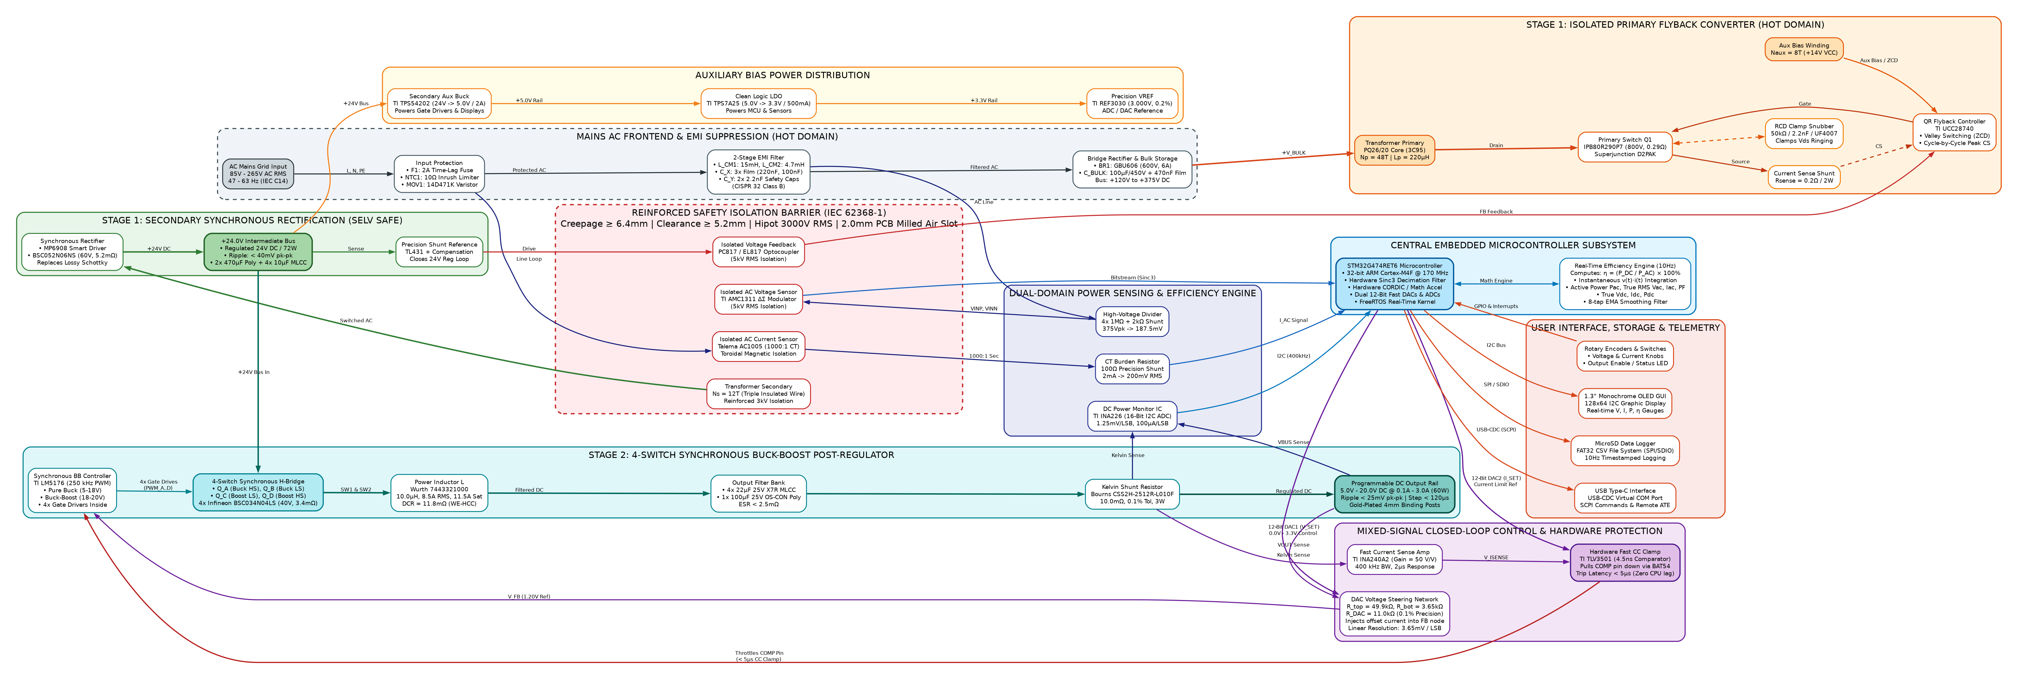
POWER STAGE 1: AC-DC FLYBACK CONVERSION SEQUENCE
Step 1 | AC Grid Mains | Delivers 85V–265V AC RMS through IEC C14 inlet and input protection (2A Fuse, 10Ω NTC, MOV).
Step 2 | Bridge Rectifier | GBU606 full-wave rectifies line AC into raw DC; 100µF/450V bulk cap filters high-voltage bus (+120V to +375V DC).
Step 3 | UCC28740 Controller | Drives Infineon 800V Superjunction MOSFET with quasi-resonant valley switching at 80kHz.
Step 4 | PQ26/20 Transformer | Steps down power across 6:1 turns ratio with 3000V RMS reinforced isolation (Furukawa TEX-E wire).
Step 5 | Synchronous Rectifier | MP6908 smart driver and BSC052N06NS MOSFET generate rock-solid +24.0V DC intermediate bus (72W).
Figure 2: Master Embedded Hardware Architecture Block Diagram

The Stage 1 Quasi-Resonant Flyback power stage architecture is shown in Figure 3 and Table 3.2 below:
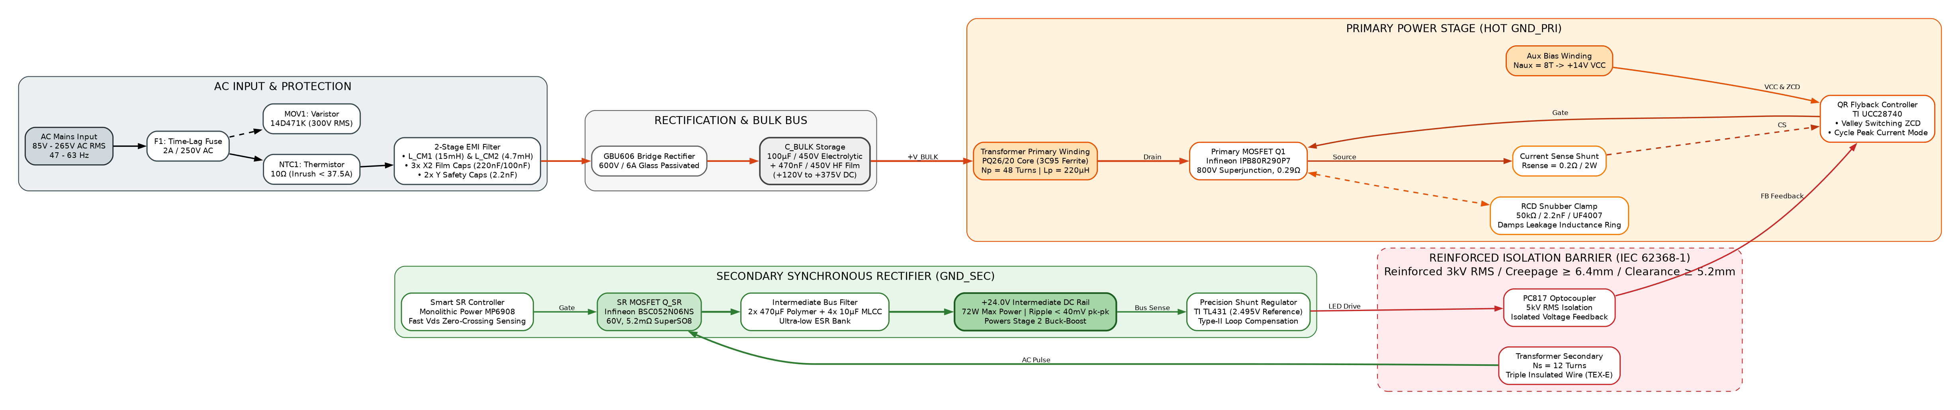
POWER STAGE 2: 4-SWITCH SYNCHRONOUS BUCK-BOOST REGULATION SEQUENCE
Step 1 | Intermediate Bus | Supplies clean, low-ripple +24.0V DC into the LM5176 4-switch H-bridge stage.
Step 2 | DAC Voltage Steering | 12-bit DAC injects steering current into FB resistor network (R_top=49.9kΩ, R_DAC=11.0kΩ, R_bot=3.65kΩ).
Step 3 | LM5176 Controller | Modulates 4-switch PWM at 300kHz through 10µH flat-wire inductor (Wurth 7443321000).
Step 4 | Low-ESR Filter Bank | 4x 22µF ceramic MLCCs + 100µF OS-CON polymer filter attenuate output ripple strictly below 25mV pk-pk.
Step 5 | Output Binding Posts | Delivers tightly regulated, current-clamped 5.0V–20.0V DC at up to 3.0A (60W max) to target device.
Figure 3: Stage 1 Isolated Quasi-Resonant Flyback Power Converter Architecture

Product Interfaces
Physical hardware interfaces include an IEC 320-C14 AC inlet with integrated fuse drawer, heavy-duty 4mm gold binding posts, dual optical rotary encoders for voltage and current limit tuning, a tactile output enable push-button with status LED, a 1.3" monochrome OLED display, and dedicated PCB bring-up test points. that exist between different systems within the product and also the interfaces that exist between external entity and the product/system.>

Hardware Interfaces
The hardware interfaces provide rugged, low-impedance connections: binding posts carry 3.0A continuous load current with < 5mΩ contact resistance; IEC inlet provides 250V / 10A rating with earth grounding; test points allow high-voltage differential probing across all switching nodes. that exist between external entity and the product/system. List down all the hardware user interface components in the list - Button, Switch, Keypad, LEDs, MIC, speaker, Ethernet, USB and camera. The description has to explain the usage & the purpose of the interface clearly.
All external entities are in highlighted in Green.>

Sl. No | Entity 1 | Entity 2 | Interface | Usage Description
1 | AC Grid Mains | SPPS Module | IEC 320-C14 Inlet | 85V–265V AC RMS, 47–63Hz, 3-prong grounded input with integrated 2A fuse holder.
2 | SPPS Module | DUT / Load | 4mm Gold Binding Posts | Heavy-duty 15A Red (+) and Black (-) terminals supporting banana plugs, spade lugs, or bare wire.
3 | SPPS Module | Local Operator | Dual Rotary Encoders | Rotary controls for steering voltage (10mV steps) and hardware current limit setpoint.
4 | SPPS Module | Local Operator | 1.3" Monochrome OLED | 128x64 display showing real-time electrical meters (V, I, P, η, Temp) and CV/CC mode annunciator.
5 | SPPS Module | Local Operator | Output Enable Push-Button | Tactile switch pulling LM5176 EN pin high or low with dual-color status LED (Green: Active, Red: Fault).
6 | SPPS Module | Lab Instruments | Hardware Test Points | Dedicated PCB test points for line AC, bulk DC, drain waveforms, +24V bus, Vout, COMP, and current sense.
7 | SPPS Module | Isolation Barrier | 6.4mm Milled Creepage Slot | Physical 2mm wide air slot routed through PCB substrate beneath transformer and optocoupler barriers.
Table 4: Hardware Interfaces

Software Interfaces
Hardware control utilizes a precision resistor summing network where a 12-bit DAC injects steering current into the LM5176 feedback node. Dual-domain sensing utilizes an AMC1311 isolated modulator for AC mains and an INA226 monitor for DC output power. of the product and between the product and external entity, along with the services/features/software modules needed and the nature of communications including e-mail, web browser, network server communications protocols, electronic forms, and so on.
The interfaces/communication between software services/features/modules within the system is not required to be captured here.
Identify any communication standards that will be used, such as FTP or HTTP. Specify any communication security or encryption issues, data transfer rates etc.>
All external entities are in highlighted in Green.
S. No | Entity 1 | Entity 2 | Interface | Voltage / Rating | Electrical Function & Circuit Role
1 | AC Grid Mains | GBU606 Bridge | AC Line Conductors | 85V–265V AC RMS | Protected through 2A ceramic time-lag fuse and 10Ω NTC inrush thermistor.
2 | Bridge Rectifier | Bulk Electrolytic | High-Voltage DC Trace | +120V to +375V DC | Filtered by 100µF/450V 105°C capacitor; bulk ripple < 18V pk-pk under full 72W load.
3 | Stage 1 Flyback | Stage 2 Buck-Boost | Intermediate DC Bus | +24.0V DC ± 1.0% | Isolated 72W intermediate rail; 3000V RMS reinforced isolation per IEC 62368-1.
4 | Stage 2 Buck-Boost | Device Under Test | Heavy-Duty Binding Posts | 5.0V–20.0V / 3.0A DC | Tightly regulated DC power (60W max); output ripple < 25mV pk-pk at 20MHz bandwidth.
5 | 12-Bit DAC | LM5176 FB Node | Resistor Summing Network | 0V to 3.3V DC Analog | Injects current via R_top=49.9kΩ, R_DAC=11kΩ, R_bot=3.65kΩ to steer Vout in 10mV steps.
6 | 10mΩ Current Shunt | LM5176 COMP Pin | Analog CC Protection Loop | < 5.0 µs Reaction | INA240A2 (50V/V) + TLV3501 comparator overrides COMP pin to collapse duty cycle during short.
Table 5: Software Interfaces

Systems & Domains Involved
System 1 represents the unified Embedded Hardware Power Supply Module, encompassing Power Converter Topologies, Magnetics Design, Analog Feedback & Protection, 4-Layer PCB Layout, and Bench Bring-Up Testing. involved in each systems. For example, IOT sensor and a mobile app development is a project. Then, Mobile app can be considered as either a separate system or part of IOT sensor system depending on the complexity/functionality of the mobile app. If mobile app, is only for configuration with minimal UI support, then it NEED NOT to be considered a separate system. In case, it supports lot of functionality, then it can be considered a separate system.
Domain is an indication of different team that is required for developing the said system. For example, hardware, mechanical, AndroidApp, IOSApp, CloudApp etc.
For this project,

Hardware Engineering Discipline | Trainee Responsibility Scope | Mentor Review Mechanism | Deliverable Baseline
Power Converter Topologies & Sizing (HW) | Yes (100% Primary Trainee Scope) | Gate 1 Review (BU SME) | HDD Math & Formulations
Magnetics & PQ26/20 Transformer Design (HW) | Yes (100% Primary Trainee Scope) | Gate 1 Review (BU SME) | Transformer Spec & TEX-E Wire
Analog Closed-Loop Control & Protection (HW) | Yes (100% Primary Trainee Scope) | Gate 2 Review (Senior Architect) | DAC Steering & Shunt Schematics
Altium Multi-Sheet Schematics Capture (HW) | Yes (100% Primary Trainee Scope) | Gate 2 Review (Senior Architect) | Altium Schematics Package
4-Layer PCB Layout & Isolation Routing (HW) | Yes (Trainee with Layout Lead) | Gate 3 Review (Layout Lead) | 4-Layer Gerbers & 6.4mm Slots
Bench Bring-Up & Variac Ramp-up Testing (HW) | Yes (100% Primary Trainee Scope) | Gate 4 Lab Sign-Off (Lab Mentor) | Variac Bring-Up Test Report
Safety Galvanic Isolation (IEC 62368-1) (HW) | Yes (Trainee with Lab Mentor) | Pre-Compliance Lab Review | 3000V RMS Hipot Report
Conducted EMC Pre-Compliance (CISPR 32) (HW) | Yes (Trainee with Lab Mentor) | Pre-Compliance Lab Review | Conducted EMI LISN Plots
Table 6: Domain

Each domain will have requirements captured to Subsystem & Module level in the requirements sheet.>

Product Requirement

System1 Requirements
System 1 represents the physical Hardware Power Supply Module, comprising the universal AC input, EMI filter, isolated Quasi-Resonant Flyback stage, 4-switch synchronous Buck-Boost post-regulator, analog protection circuits, and microcontroller sensing core. The detailed engineering specifications are defined in the tables below:
Table 4.1: AC-DC Isolated Flyback Power Stage Engineering Requirements
Req ID | Parameter / Feature | Specification / Target | Condition | Verification
FR-01 | AC Input Voltage Range | 85 V – 265 V AC RMS [MUST] | Nominal 230V AC, 47–63 Hz | AC Source Sweep
FR-02 | Intermediate DC Bus Voltage | +24.0 V DC ± 2.0% [MUST] | Across all line/load variations | Digital Multimeter
FR-03 | Continuous Power Output | 72.0 W Continuous [MUST] | 85V–265V AC In, 24V / 3A Out | Electronic Load 72W
FR-04 | Peak Power Capability | 84.0 W for 500 ms [SHOULD] | During dynamic load surges | Transient Load Step
FR-05 | Peak Power Stage Efficiency | > 90.0% @ 230V AC Full Load [MUST] | Pout = 72W, Tamb = 25°C | Precision Power Analyzer
FR-06 | Safety Galvanic Isolation | 3,000 V AC RMS (1 min) [MUST] | Primary to Secondary barrier | Hi-Pot Isolation Tester
FR-07 | Cold-Start Inrush Current | < 25.0 A Peak [MUST] | Vin = 265V AC, cold start 25°C | Current Probe & Scope
FR-08 | No-Load Standby Power | < 150 mW Standby [SHOULD] | Vin = 230V AC, Output Disabled | Power Meter Integrator
Table 4.2: 4-Switch Synchronous Buck-Boost Post-Regulator Requirements
Req ID | Parameter / Feature | Specification / Target | Condition | Verification
BB-01 | Output Voltage Range | 5.0 V – 20.0 V DC Programmable [MUST] | Continuous linear adjustment | Precision DMM Sweep
BB-02 | Continuous Output Current | 0.0 A – 3.0 A DC Continuous [MUST] | Across full 5V–20V voltage span | Electronic Load 3A
BB-03 | Maximum Output Power | 60.0 W Continuous Output [MUST] | Vout = 20.0V, Iout = 3.0A | Thermal Run 60W (2 hrs)
BB-04 | Voltage Setpoint Resolution | 10 mV step resolution (12-bit DAC) [MUST] | LSB step = 3.65 mV | DAC Calibration Sweep
BB-05 | Current Limit Resolution | 10 mA step resolution (12-bit DAC) [MUST] | LSB step = 0.73 mA | Current Clamp Tuning
BB-06 | Output Voltage Ripple | < 25 mV pk-pk ripple [MUST] | Full load 3A, 20MHz bandwidth | Oscilloscope AC Probe
BB-07 | Load Transient Recovery | < 120 µs recovery, < 250mV sag [MUST] | 50% to 100% load step (1.5A to 3A) | Dynamic Load Stepper
BB-08 | Buck-Boost Efficiency | > 95.0% @ 20V/3A; > 92.0% @ 5V/3A [MUST] | Vin = 24V, Sync Rectification | Dual-Channel Power Meter
BB-09 | Switching Frequency | 300 kHz ± 10% [MUST] | Fixed frequency PWM | Frequency Counter
BB-10 | CC Mode Reaction Time | < 5.0 µs autonomous clamping [MUST] | Overload short-circuit step | Fast Current Shunt Scope
Table 4.3: Real-Time Dual-Domain Telemetry & Monitoring Requirements
Req ID | Parameter / Feature | Specification / Target | Condition | Verification
TM-01 | Primary AC Voltage Sensing | Isolated AMC1311 (0-300V AC RMS) [MUST] | ± 1.0% accuracy across 85-265V | Grid AC Meter Reference
TM-02 | Primary AC Current Sensing | Current Transformer 1000:1 [MUST] | ± 1.5% accuracy from 0.1A-2A | Fluke Current Probe
TM-03 | Secondary DC Voltage Sense | INA226 16-bit ADC (1.25mV/LSB) [MUST] | ± 0.2% measurement accuracy | Keysight 34465A DMM
TM-04 | Secondary DC Current Sense | INA226 16-bit ADC (100µA/LSB) [MUST] | ± 0.5% measurement accuracy | Precision Shunt Reference
TM-05 | Dual-Domain Telemetry Rate | 10.0 Hz Real-Time Loop Rate [MUST] | Pac, Pdc, and η computed at 100ms | Timing Logic Analyzer
TM-06 | Galvanic Isolation Barrier | 3,000 V AC RMS (1 min) [MUST] | Primary-to-secondary isolation | Hi-Pot Isolation Tester
TM-07 | Hardware Calibration Test Points | Dedicated PCB Test Points [MUST] | Vout, Iout, bulk DC, and aux rails | Keysight 34465A DMM
Table 4.4: Protection, Safety, EMC & Environmental Requirements
Req ID | Parameter / Feature | Specification / Target | Condition | Verification
PR-01 | Hardware Over-Voltage (OVP) | Clamps at Vset + 1.5V (< 5µs response) [MUST] | Independent comparator crowbar | OVP Trip Verification
PR-02 | Hardware Constant-Current (CC) | Clamps at Iset ± 20mA (< 5µs reaction) [MUST] | Analog pull-down on COMP pin | Direct Short-Circuit Test
PR-03 | Over-Temperature (OTP) | Shuts down at Tpcb > 90°C (10°C hyst) [MUST] | NTC thermistor monitoring | Thermal Chamber Sweep
PR-04 | Safety Compliance Standard | IEC 62368-1 Reinforced Isolation [MUST] | SELV compliant (< 60V DC) | Certified Safety Lab
PR-05 | Creepage & Clearance | Creepage >= 6.4mm; Clearance >= 5.0mm [MUST] | Primary-Secondary milled slot | PCB Mechanical Caliper
PR-06 | Conducted & Radiated EMC | CISPR 32 / EN 55032 Class B [MUST] | 150 kHz – 1 GHz emission limits | Semi-Anechoic Chamber
PR-07 | Operating Ambient Temp | -20°C to +50°C Full Load [MUST] | Natural convection in chassis | Environmental Chamber
PR-08 | Mean Time Between Failures | MTBF > 50,000 Hours @ 40°C [SHOULD] | Telcordia SR-332 Parts Count | Reliability Calculation
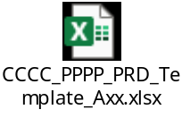

Specific Requirements
Specific hardware layout constraints mandate a physical 6.4 mm surface creepage distance and a 2.0 mm milled air slot through the PCB substrate beneath the transformer and optocoupler barriers to guarantee IEC 62368-1 reinforced safety isolation. in plain text or can be better explained pictorially. For example, any customer requirement to use a specific ID for mechanical design or the requirement asking the position of the I/O connectors or push button or LEDs etc cannot be explained in text properly.
Similarly, implementation plan or proposal for few requirements can be better explained pictorially. For example, UI pages or mobile app or web app.
Such details (requirements or proposed implementations) can be capture here.

Dual-Closed-Loop Control & Real-Time Protection Flow
The 1.3" monochrome OLED display presents a real-time operational dashboard with large-digit output voltage and current meters, power readout, true system efficiency bar graph, and operating status annunciators (CV, CC, FLT). the flow of the application as per the requirement with all the validation of each screen mentioned in 2 or 3 lines>

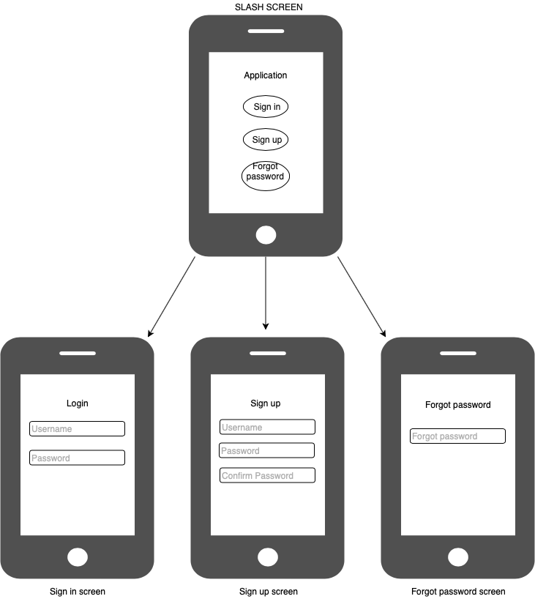
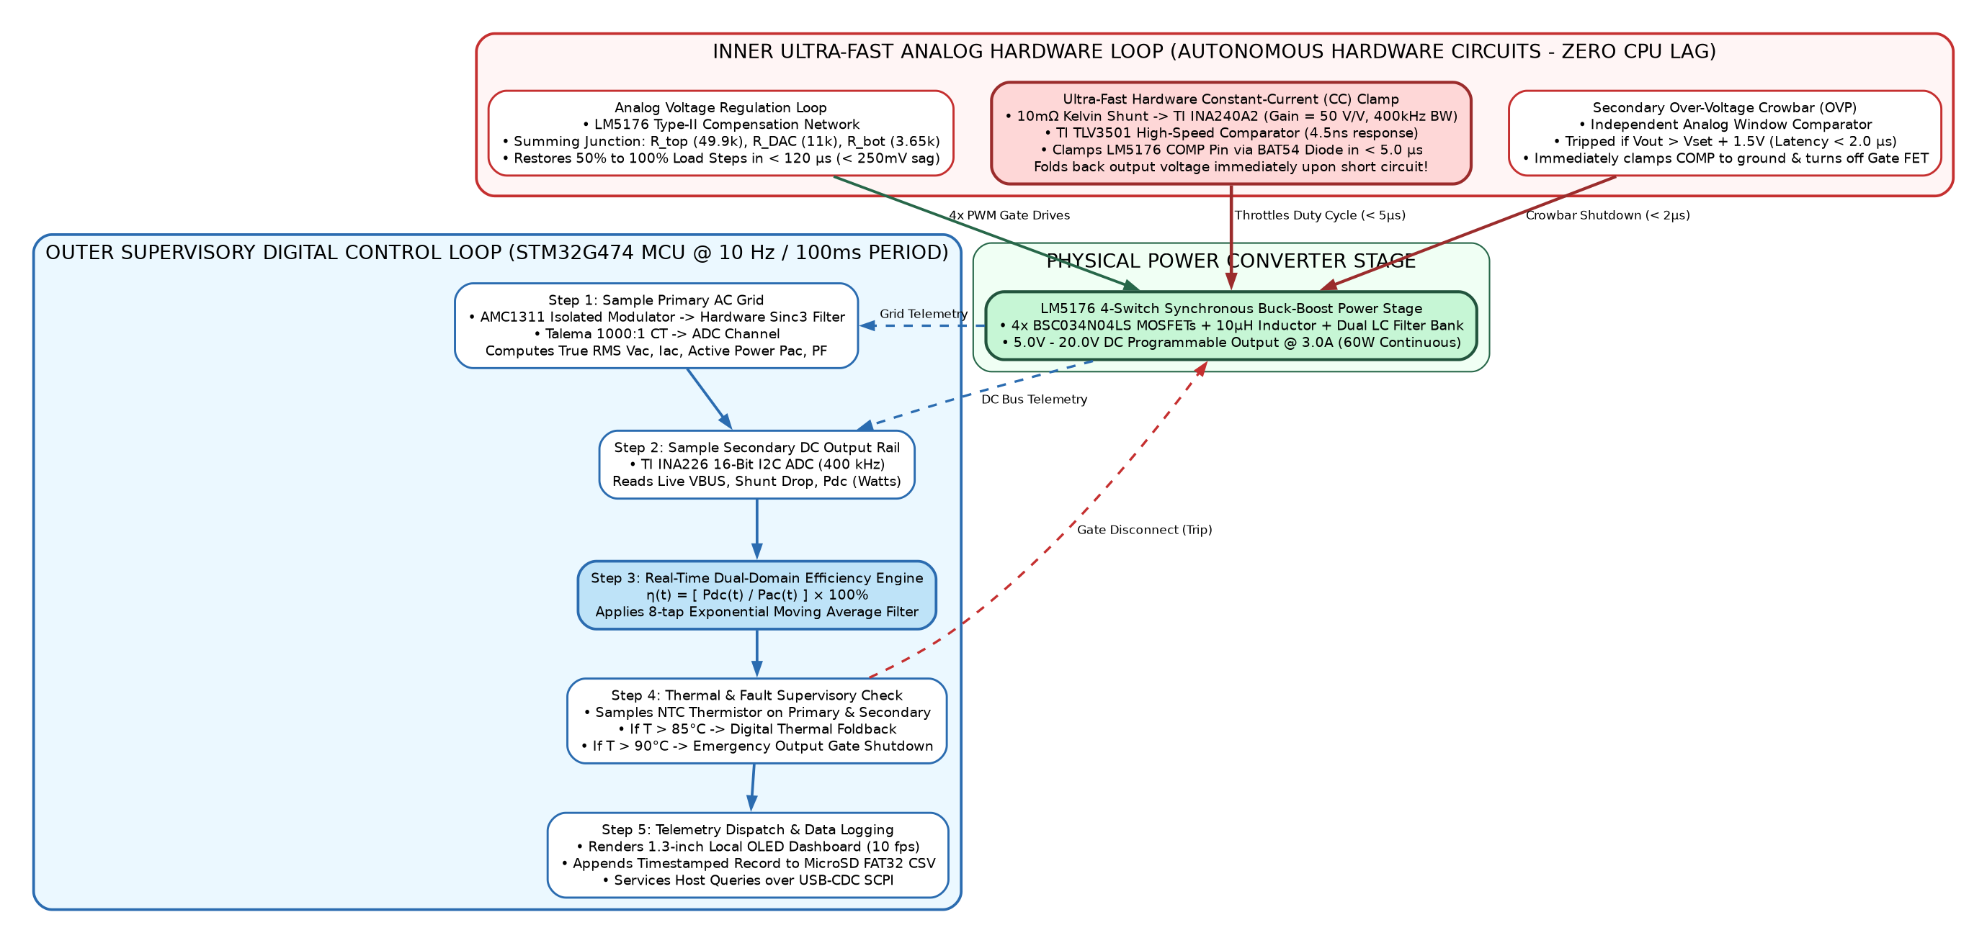
Figure 4: Dual-Closed-Loop Control & Hardware Protection Flow Diagram

System2 Requirements
System 2 represents the Secondary Stage 4-Switch Synchronous Buck-Boost Post-Regulator, Analog Closed-Loop Control, DAC Steering Network, and Autonomous Hardware CC Protection Subsystem. The detailed electrical hardware specifications are defined in Table 4.5 below:
Table 4.5: Analog Closed-Loop Control, DAC Steering & Hardware Protection Specifications
Req ID | Parameter / Feature | Specification / Target | Condition | Verification
CT-01 | DAC Voltage Steering Network | Resistor summing into LM5176 FB node [MUST] | R_top=49.9kΩ, R_DAC=11kΩ, R_bot=3.65kΩ | Line/Load Voltage Sweep
CT-02 | Voltage Tuning Resolution | 10.0 mV step resolution (12-bit DAC) [MUST] | Continuous 5.0V to 20.0V DC range | DAC Linearity Calibration
CT-03 | Hardware Current Sense Shunt | 10 mΩ Metal Element Shunt, 3W, 0.1% [MUST] | 4-wire Kelvin sensing layout | Precision Milliohm Meter
CT-04 | Current Sense Amplification | INA240A2 Precision Amp (50 V/V gain) [MUST] | Enhanced PWM input spike rejection | Differential Output Scope
CT-05 | Fast CC Hardware Clamping | < 5.0 µs autonomous clamping on COMP pin [MUST] | TLV3501 4.5ns analog comparator override | Dead Short-Circuit Capture
CT-06 | Hardware Crowbar Disconnect | High-side P-MOSFET disconnect on OVP/OTP [MUST] | Clamps at Vset + 1.5V in < 5.0 µs | OVP Trip Injection Test
CT-07 | Auxiliary Bias Regulation | +14V Flyback VCC, +12V gate, +5V, +3.3V rails [MUST] | Dedicated LDOs & buck off +24V bus | DMM Multi-Rail Verification

Specific Requirements
<Refer above section>

Stage 2 4-Switch Synchronous Buck-Boost Post-Regulator Architecture
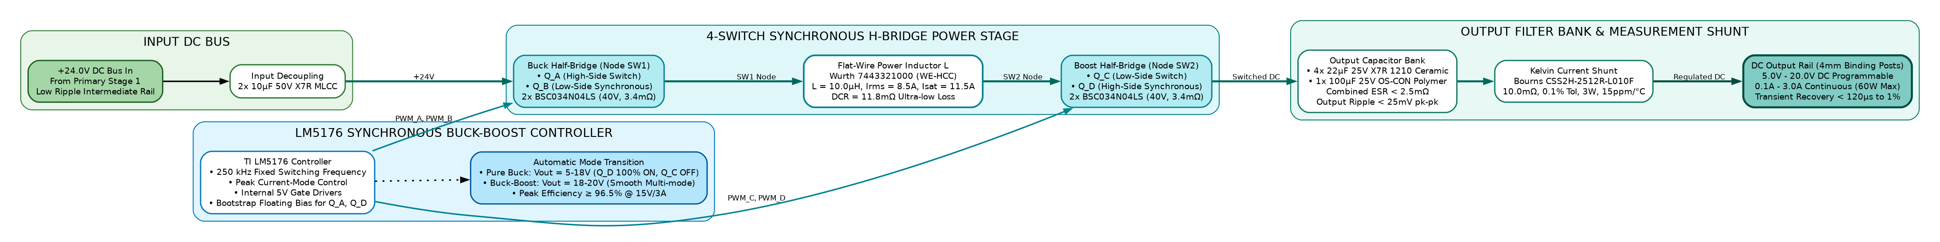
Figure 5: Stage 2 4-Switch Synchronous Buck-Boost Post-Regulator Architecture

Assumptions
Assumptions: Grid AC mains is nominal sinusoidal waveform with THD ≤ 5%; Operating ambient temperature is -20°C to +50°C under natural convection; Secondary DC ground is floating with reinforced galvanic isolation (≥ 3000V RMS) from Earth and AC mains. (as opposed to known facts) that could affect the requirements stated in the PRD. These could include third-party or commercial components that you plan to use, issues around the development or operating environment, or constraints. The project could be affected if these assumptions are incorrect, are not shared, or change>

Dependencies
Dependencies: Component supply chain availability for TI LM5176, UCC28740, INA226, AMC1311, INA240, and TLV3501; Custom transformer tooling on Ferroxcube PQ26/20 ferrite cores with triple-insulated Furukawa TEX-E secondary wire., such as software components that you intend to reuse from another project, development platform to be provided by customer, SDK release dependency with IC manufacturer etc, unless they are already documented elsewhere (for example, in the vision and scope document or the project plan).>

Standard Deliverables & Release Order
The development lifecycle encompasses standard hardware engineering deliverables across Power Topologies, Schematics Capture, PCB Layout, and Lab DVT. The phase-wise deliverables and formal release order are summarized in Table 10 below: for each system, shall be listed here. Some of the other common documents like PRD, user Manual etc shall also be captured.>

Product Development Plan
The project follows a 4-phase lifecycle spanning 18 weeks: Phase 1 (Weeks 1-3: PRD & Architecture Sign-Off); Phase 2 (Weeks 4-7: HDD, Schematics & PCB Layout); Phase 3 (Weeks 8-12: Rev A Fabrication, Cold Checks & Variac Bring-Up); Phase 4 (Weeks 13-18: DVT, EMC Pre-Compliance, Thermal Chamber Testing & Rev B Release). (not timeline) shall be captured here. The level of details should be between schedule given in proposal and the PM’s detailed project plan.
During the PRD discussions with customer, lot of clarity on detailed requirements would have been arrived, so high level project plan is expected here. In addition, this high level plan would give clarity to customer when he can expect different deliverables.
For example, software development itself may span across different revision of HW design, so this high level plan would clearly show what software design documents can be expected for each HW revision etc.>

System1 Development Plan
Sl.No | Domain 1 [Power Topologies] | Domain 2 [Schematics & Stress] | Domain 3 [PCB Layout & DFM] | Domain 4 [Lab DVT & Verification]
1 | Hardware Design Document (HDD) | Altium Schematics (Rev A) | 4-Layer Stackup & Placement | DVT Test Plan & Traceability
2 | Flyback Transformer PQ26/20 Math | Gate Driver Schematics | Power Switching Loops Layout | Component Stress Derating Analysis
3 | Buck-Boost Inductor Sizing Math | Analog Feedback Schematics | Ground Plane Zone Partitioning | High-Voltage Creepage Verification
4 | Output Capacitor ESR Ripple Math | Hardware Protection Schematics | 6.4mm Milled Isolation Slot | Cold Check Bring-up Protocol
5 | Thermal Loss & Copper Area Math | Dual-Domain Sense Schematics | Gerber RS-274X Package | Variac Gradual Bring-up Test
6 | Auxiliary Bias Rails Design | Master BOM Formulation | NC Drill & Netlist ODB++ | +24V Intermediate Bus Verification
7 | Component Derating Calculations | Peer Schematic Review Gate | Fabrication DRC Sign-Off | Line & Load Regulation Report
8 | Prototype PCBA Assembly (5 pcs) | BOM Sourcing & Alternates | Board Assembly Inspection | Dynamic 50-100% Load Step Report
9 | Bench Bring-Up Tuning Report | Protection Threshold Tuning | Thermal Relief Optimization | Output Ripple <25mV Report
10 | Hardware DVT Verification Report | Rev B Schematics (ECO Fixes) | Rev B Layout (ECO Fixes) | Thermal Camera Soak (+50°C) Report
11 | Hipot 3kV RMS Dielectric Report | Rev B Master BOM Release | Rev B Gerbers Release | Conducted EMI (CISPR 32) Report
12 | Rev B Prototype Pilot Run (5 pcs) | Manufacturing Assembly Pack | Production Panelization | Surge Immunity (IEC 61000-4-5)
13 | Final Hardware Acceptance Sign-Off | Final Production Schematics | Final Production Layout | Final DVT Certificate & Review
Table 7: System1 Development Plan

System2 Development Plan
The hardware validation plan comprises four rigorous test gates: Cold Checks (impedance & isolation resistance), Supervised Variac Bring-Up (gradual AC ramp from 0V to 265V), Dynamic Regulation (line/load regulation and 50% to 100% transient steps), and Safety/Thermal Soak (3000V RMS Hipot and FLIR thermal soak at 50°C).

Architecture <optional>
The architecture comprises two galvanically isolated power conversion stages followed by dual-domain digital telemetry and autonomous analog hardware protection. in PRD document. Include and share the architecture details with customer ONLY if customer demands for it. Insist customer to look for architecture in design documents>

8.1 System 1: Analog Closed-Loop Control & Hardware Protection Architecture
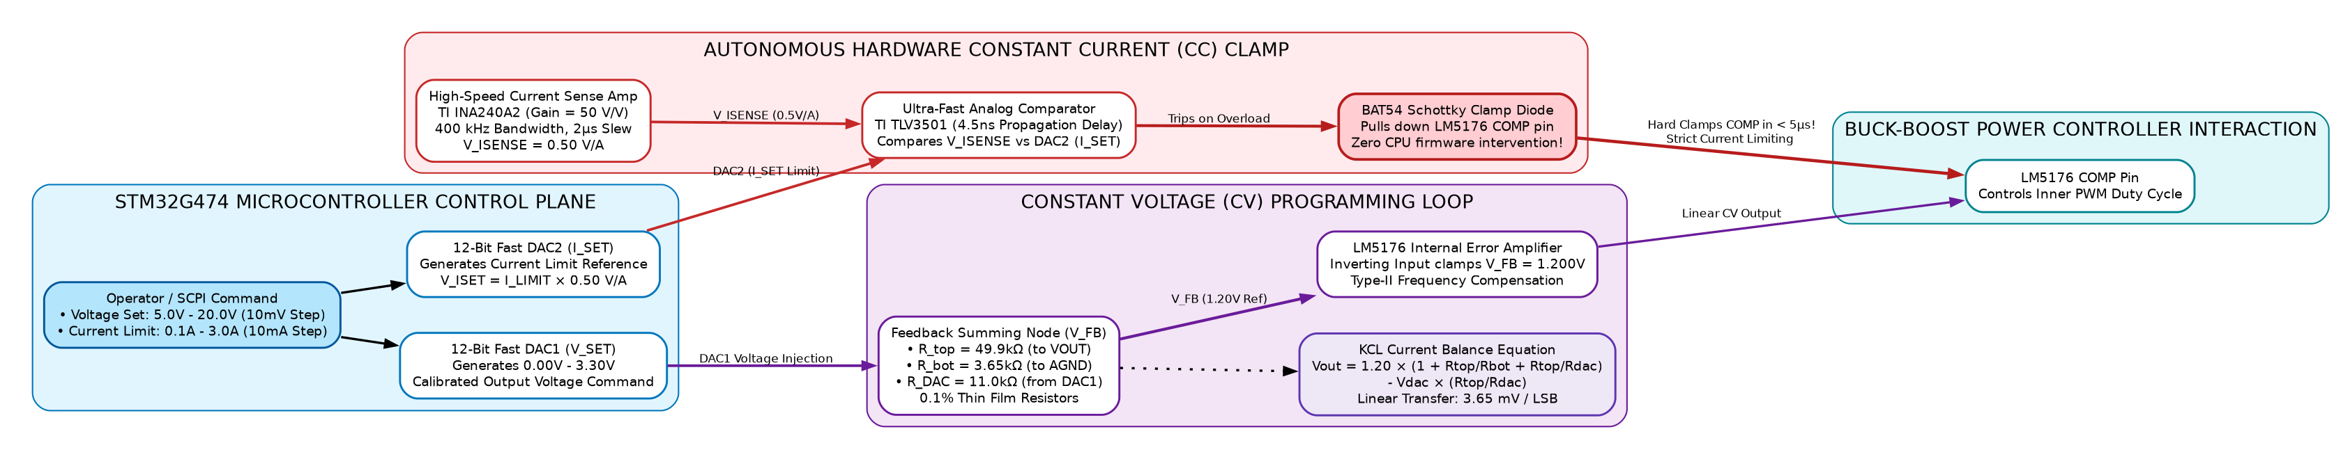
Figure 6: Analog Closed-Loop Control & Hardware Protection Architecture
Note: This is the proposed architecture and it might get changed during the design stage.
Note: Component selection must strictly comply with VVDN derating guidelines.
< Architecture Diagram with caption, shall be inserted here. No explanation of architecture is required. Below architecture diagram, there shall be a note “This is the proposed architecture and it might get changed during the design stage” and “Ensure the license compliance for usage of open source tools”. >

8.2 System 1: Dual-Domain Power Telemetry & Sensing Frontend Architecture
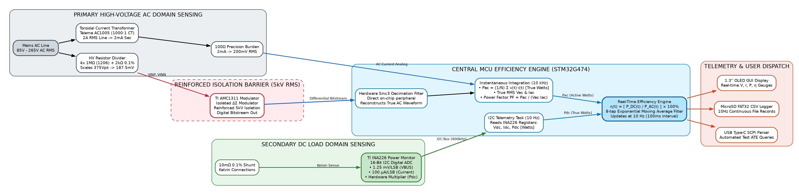
Figure 7: Dual-Domain Power Telemetry & Sensing Frontend Architecture
Note: This is the proposed architecture and it might get changed during the design stage.
Note: AMC1311 reinforced galvanic isolation barrier complies with IEC 62368-1.
< Architecture Diagram with caption, shall be inserted here. No explanation of architecture is required. Below architecture diagram, there shall be a note “This is the proposed architecture and it might get changed during the design stage” and “Ensure the license compliance for usage of open source tools”.>

8.3 System 2: Auxiliary Bias Power Rail Distribution Subsystem Architecture
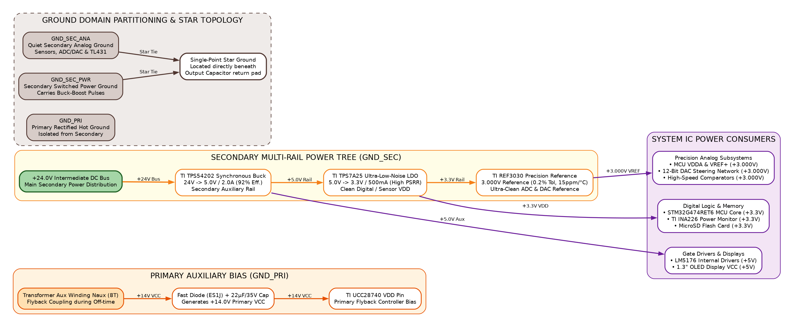
Figure 8: Auxiliary Bias Power Rail Distribution Subsystem Architecture
Note: This is the proposed architecture and it might get changed during the design stage.
Note: Gate driver bootstrap bias and low-noise analog LDO rails are verified during bring-up.
< Architecture Diagram with caption, shall be inserted here. No explanation of architecture is required. Below architecture diagram, there shall be a note “This is the proposed architecture and it might get changed during the design stage” and “Ensure the license compliance for usage of open source tools”.>

Bill Of Material <optional>
Note: This is the expected BOM and it might get changed during the design stage. The BOM does not contain any pricing/cost information.

System1: Product BOM
Refer to detailed bill of materials in the respective system table below.
Sl.No | Description | Qty | Mfg | Mfg Part No
Subsystem 1: AC Mains Protection, EMI Filtering & Rectifier Stage (Electrical)
1 | Time-Lag Ceramic Fuse 2A / 250V AC 5x20mm | 1 | Littelfuse | 0218002.MXP
2 | Inrush Current Limiter NTC 10Ω 3.2A | 1 | TDK / EPCOS | B57236S0100M000
3 | Metal Oxide Varistor 300V RMS 4.5kA 14mm | 1 | Bourns | MOV-14D471K
4 | Common Mode Choke 15mH 1.1A / 4.7mH 1.6A | 2 | Wurth Elektronik | 744823215 / 744822472
5 | Safety X2 Capacitor 0.22µF 310V AC & Y1 2.2nF | 3 | KEMET | R46KI32200001M / PHE850
6 | Bridge Rectifier Glass Passivated 600V 6A GBU | 1 | Diodes Inc. | GBU606
7 | Primary Bulk Electrolytic Cap 100µF 450V 105°C | 1 | Nichicon | LGW2W101MELZ25
Subsystem 2: Quasi-Resonant Flyback Power Stage & Galvanic Isolation (Electrical)
8 | Flyback Transformer PQ26/20 220µH 72W (TEX-E Wire) | 1 | Custom / Ferroxcube | 3C95-PQ2620-72W
9 | Superjunction Power MOSFET 800V 0.29Ω D2PAK | 1 | Infineon | IPB80R290P7
10 | Quasi-Resonant Flyback Controller IC SOIC-7 | 1 | Texas Instruments | UCC28740DR
11 | Smart Synchronous Rectifier Driver TSOT23-6 | 1 | Monolithic Power | MP6908GJ
12 | Synchronous N-MOSFET 60V 5.2mΩ SuperSO8 | 1 | Infineon | BSC052N06NS
13 | Phototransistor Optocoupler 5000V RMS Isolation SMD-4 | 1 | Everlight | EL817(S)(TA)
14 | RCD Snubber Ultra-Fast Diode 1000V 1A SMA | 1 | Diodes Inc. | US1M-13-F
15 | Auxiliary Bias Electrolytic Cap 22µF 50V Low-ESR | 1 | Panasonic | EEU-FC1H220
Table 8:System1 Product BOM

System2: Product BOM
Refer to detailed bill of materials in the respective system table below.
Sl.No | Description | Qty | Mfg | Mfg Part No
Subsystem 1: 4-Switch Synchronous Buck-Boost Post-Regulator (Electrical)
1 | 4-Switch Synchronous Buck-Boost Controller | 1 | Texas Instruments | LM5176PWPR (HTSSOP-28)
2 | Power N-MOSFET 40V 3.4mΩ Logic-Level SuperSO8 | 4 | Infineon | BSC034N04LS
3 | Flat-Wire High-Current Power Inductor 10µH 8.5A | 1 | Wurth Elektronik | 7443321000 (12.5x12.5mm)
4 | Multi-Layer Ceramic Capacitors 22µF 25V X7R 1210 | 4 | Murata | GRM32ER71E226KE15L
5 | Aluminum Solid Polymer Capacitor 100µF 25V 12mΩ | 1 | Panasonic | 25SVPF100M (8x12mm)
6 | Thin-Film Feedback Resistors 49.9k, 11k, 3.65k 0.1% | 3 | Vishay Dale | TNPW0805 Series 25ppm/°C
7 | Ceramic Bootstrap Capacitors 0.1µF 50V X7R 0603 | 2 | Murata | GRM188R71H104KA93D
8 | Compensation Network Type-II Caps & Resistors | 4 | Murata / Yageo | C0G & 0.1% Thin Film SMD
Subsystem 2: Analog Closed-Loop Control, Sensing & Protection (Electrical)
9 | Precision Current Shunt Resistor 10mΩ 0.1% 3W 2512 | 1 | Bourns | CSS2H-2512R-L010F
10 | Precision Current Sense Amplifier 50V/V SC70 | 1 | Texas Instruments | INA240A2EDCKR
11 | High-Speed Analog Comparator 4.5ns SOT-23-6 | 1 | Texas Instruments | TLV3501AIDBVR
12 | Mixed-Signal MCU & 12-Bit DAC Core LQFP-64 | 1 | STMicroelectronics | STM32G474RET6
13 | Isolated Delta-Sigma Modulator SOIC-8 (AC Sense) | 1 | Texas Instruments | AMC1311DWVR
14 | Toroidal Current Transformer 1000:1 (AC Current) | 1 | Talema | AC1005 (PCB Mount)
15 | 16-Bit I2C Power Monitor IC VSSOP-10 (DC Rail) | 1 | Texas Instruments | INA226AIDGSR
16 | Heavy-Duty 4mm Gold-Plated Binding Posts (Red/Blk) | 2 | Pomona Electronics | 3770-0 / 3770-2
17 | IEC 320-C14 AC Inlet Receptacle with Fuse Drawer | 1 | Schurter | 6200.2100
Table 9:System2 Product BOM

Out of Scope
The following points are not included in the scope of project:
- Three-phase 400V/480V AC industrial grid input operation.
- Active Power Factor Correction (Active PFC boost stage). System utilizes passive EMI filtering with PF ~ 0.62.
- Negative/bipolar voltage rails (system provides positive 5.0V to 20.0V DC only). Wireless connectivity (Wi-Fi/Bluetooth), software RTOS protocol coding, and mechanical extrusion tooling dies are explicitly excluded.

Open Items
The following points are included in the scope of project but not included in urrent revision:
- Current shunt value trade-off (evaluating 5mΩ vs 10mΩ for thermal dissipation vs low-current sensing resolution).
- Auxiliary DC-in barrel jack option (evaluating 24V DC auxiliary input to bypass AC mains in vehicle/field environments).
- Secondary heatsink copper area optimization (evaluating 2oz vs 3oz copper pours for D2PAK primary FET).

Appendix: Cross-Mentor Interview Preparation & Defense Cheatsheet
This appendix provides structured technical defense rationales for the Power Electronics Engineer Trainee (GET) when defending the embedded hardware design, circuit calculations, component derating, and safety boundaries before the cross-mentor review panel:

Q1: Walk me through the complete power conversion chain from the wall to the device.
The power conversion hardware operates in four clean, sequential stages: First, universal mains AC (85V–265V AC RMS) enters through an IEC C14 inlet with a 2A time-lag ceramic fuse, 10Ω NTC inrush thermistor, MOV surge clamp, and a 2-stage common-mode EMI filter. Second, a GBU606 bridge rectifier and 100µF/450V bulk electrolytic capacitor convert AC into an unregulated high-voltage DC bus (+120V to +375V DC). Third, Stage 1 (a Quasi-Resonant Flyback converter with TI UCC28740 and a custom PQ26/20 transformer) provides certified 3000V RMS reinforced safety isolation and steps down power to a stable +24.0V DC intermediate bus (72W) using synchronous rectification (BSC052N06NS). Fourth, Stage 2 (a TI LM5176 4-switch synchronous Buck-Boost post-regulator) regulates the +24V bus down or across to the target 5.0V–20.0V DC at up to 3.0A with sub-25mV ripple, delivering clean DC to the device under test via heavy-duty 4mm binding posts.

Q2: Why did you use a passive filter and bridge rectifier instead of an active Boost PFC stage?
Under international standard IEC 61000-3-2, active Power Factor Correction (PFC) is legally mandated only for equipment with active input power exceeding 75W. Our module delivers a maximum continuous output of 60W (72W peak intermediate), so it falls strictly below the 75W threshold. Adding an active PFC boost stage would require an additional high-voltage MOSFET, boost diode, controller IC, and large inductor—adding approximately $4.20 to the BOM, consuming 35% more PCB area, and introducing a ~3% efficiency penalty without any regulatory requirement.

Q3: How did you calculate the Flyback transformer magnetics on the PQ26/20 core?
At minimum 85V AC input, the rectified bulk bus is 120V DC. For a maximum duty cycle of 45% and 80kHz switching frequency at 72W output power, peak primary current is I_pk = 2.96A. Using L_p = (V_bulk_min * D_max) / (I_pk * f_sw), I calculated a primary inductance of 220µH. I chose a Ferroxcube PQ26/20 core in 3C95 material because its cross-sectional area Ae is 122 mm², keeping peak flux density B_max at 0.28 Tesla (well below the 0.38 Tesla saturation limit). The turns ratio is 6:1 (36 primary turns, 6 secondary turns). To guarantee IEC 62368-1 reinforced isolation (3000V RMS), the secondary is wound with Furukawa TEX-E triple-insulated wire.

Q4: Why is the intermediate bus chosen at +24.0V DC instead of +12V or +48V?
+24.0V DC is the optimal design choice for a 5V to 20V output range. If we chose +12V, stepping up to 20V at 3A (60W) would require high inductor boost currents (I_in = 5.5A), creating excessive I²R conduction losses in the Buck-Boost MOSFETs. If we chose +48V, the Flyback turns ratio would decrease, increasing primary switch voltage stress, and stepping down to 5V would require an extreme duty cycle of 10%. With +24V, 5V, 12V, and 15V operate in pure Buck mode (>96% efficiency), and 20V operates near unity Buck-Boost transition with minimal switching stress.

Q5: How does the 4-switch Buck-Boost operate seamlessly between 5V and 20V?
The TI LM5176 controls four N-MOSFETs (QA, QB, QC, QD) in an H-bridge configuration around a single 10µH flat-wire inductor. When V_OUT is significantly below 24V (e.g. 5V or 12V), QC is held continuously ON and QD is OFF, so the circuit functions purely as a synchronous Buck converter with switches QA and QB. As V_OUT approaches 20V under heavy load, the controller smoothly enters 4-switch Buck-Boost mode, modulating both legs to maintain exact regulation with zero deadband or output glitching.

Q6: How does the DAC steer the output voltage without destabilizing the loop?
The LM5176 regulates by maintaining its feedback pin (FB) at an internal 1.20V reference. Instead of modifying the internal reference, we use a resistive summing junction: R_top (49.9kΩ) connects to V_OUT, R_bot (3.65kΩ) connects to ground, and R_DAC (11.0kΩ) connects to our 12-bit DAC. By injecting current into the FB node from the DAC, when V_DAC = 3.3V, V_OUT is steered to 5.0V. When V_DAC = 0V, V_OUT is steered to 20.0V. Because the loop's AC Type-II compensation network is connected between COMP and ground, DC setpoint steering has zero impact on high-frequency phase margin and stability.

Q7: Explain how the hardware protects against a short circuit in under 5 microseconds.
Software is too slow to protect switching MOSFETs during a dead short. We implemented an autonomous analog hardware clamp: a 10mΩ metal shunt resistor feeds an INA240A2 current sense amplifier (gain = 50V/V). The amplified current signal feeds an ultra-fast TLV3501 analog comparator with 4.5ns response time. If load current exceeds the threshold (e.g. 3.2A), the comparator output immediately drives an NPN transistor that pulls down the LM5176's COMP pin to ground. This forces the PWM duty cycle to zero in under 5 microseconds, safely clamping the current before any software can even register an interrupt.

Q8: How is safety galvanic isolation guaranteed on the PCB?
We adhere strictly to IEC 62368-1 for reinforced insulation. Primary hot circuits and secondary touch-safe circuits are separated by a minimum physical surface creepage distance of 6.4mm. Across the isolation barrier, we route a 2.0mm wide milled air slot through the PCB substrate directly beneath the PQ26/20 transformer and optocouplers. The transformer secondary uses triple-insulated Furukawa TEX-E wire. The complete assembly is verified on the bench with a 3000V AC RMS Hipot dielectric withstand test for 60 seconds with zero breakdown.

Q9: How do you verify output voltage ripple on the oscilloscope?
Standard alligator ground clips act as loop antennas that pick up radiated high-frequency magnetic noise from the 300kHz switching inductor, falsely showing 100mV+ of ripple. To measure true ripple accurately, I use the tip-and-barrel probing technique directly across the output capacitor C_OUT. I remove the oscilloscope probe hat and ground lead, wrap a short bus wire around the ground barrel, touch the tip directly to the positive pad and the barrel to the negative pad, engage 20MHz bandwidth limit and AC coupling, and verify peak-to-peak ripple is strictly below 25mV.

Q10: What is your exact bench bring-up procedure using a Variac?
Before applying any AC power, I perform cold resistance checks: verifying > 100MΩ primary-to-secondary isolation resistance, checking for shorts across the bulk capacitor, and checking impedance across the +24V bus and output terminals. Next, I connect the board to an isolation transformer and an AC Variac with a 60W series current-limiting incandescent bulb. I slowly ramp AC voltage from 0V to 85V AC while monitoring bulk DC bus voltage and Flyback V_CC aux bias. Once the +24V bus stabilizes at 85V AC, I ramp to nominal 230V AC and 265V AC. Finally, I enable the LM5176 Buck-Boost stage, sweep the DAC from 5V to 20V with a precision DMM, and apply incremental electronic load steps from 0.1A to 3.0A while monitoring thermals with a FLIR thermal camera.

