

Product Requirement Document (PRD)

Project Code | <CCCC_PPPP>
Project Name | <Project Name>
Revision | <Current Revision Number>
Date | <Date of Release>

Revision History
Date | Revision No. | Description | Prepared/Revised By | Reviewed By | Approved By
 |  |  | <Author> | <BU SME> | <BU Head>

Customer Sign Off
CUSTOMER SIGN-OFF FORM
Customer | Technical In-Charge | Program In-Charge
Name:
Designation:
Email ID:
Address:

Comments:
Signature & Date:
VVDN | Technical In-Charge | Program In-Charge
Name:
Designation: | Project Owner Engineering | BU Head
Email ID:
Address: | VVDN Technologies  B-22, Infocity Sector-34,  Gurgaon-122001, Haryana, India  Tel No: +91 124 4284250  Fax No: +91 124 4284251 | VVDN Technologies  B-22, Infocity Sector-34,  Gurgaon-122001, Haryana, India  Tel No: +91 124 4284250  Fax No: +91 124 4284251
Comments:
Signature & Date:

Internal Sign Off
INTERNAL SIGN-OFF
Level 1 | BU SME
Name:
Comments:
Signature & Date:

Table of Contents
1 Introduction 7
1.1 Purpose 7
1.2 Document Conventions 7
1.3 Intended Audience and Reading Suggestions 7
1.4 Abbreviation 7
1.5 References 8
2 Product Overview 9
2.1 Product - Business Perspective 9
2.2 Product – Technical Perspective 9
2.3 Use Cases 10
2.4 Product Interfaces 10
2.4.1 Hardware Interfaces 11
2.4.2 Software Interfaces 12
3 Systems & Domains Involved 14
4 Product Requirement 15
4.1 System1 Requirements 15
4.1.1 Specific Requirements 15
4.2 System2 Requirements 16
4.2.1 Specific Requirements 16
5 Assumptions 16
6 Dependencies 17
7 Standard Deliverables & Release Order 18
7.1 Product Development Plan 18
7.2 System1 Development Plan 18
7.3 System2 Development Plan 19
8 Architecture <optional> 20
8.1 System1: Domain1 Architecture 20
8.2 System1: Domain2 Architecture 20
8.3 System2: Domain1 Architecture 20
9 Bill Of Material <optional> 21
9.1 System1: Product BOM 21
9.2 System2: Product BOM 21
10 Out of Scope 22
11 Open Items 22

List of Tables
Table 1: Abbreviation 8
Table 2: Reference 8
Table 3: Use Case 10
Table 4: Hardware Interfaces 12
Table 5: Software Interfaces 13
Table 6: Domain 14
Table 7: System1 Development Plan 19
Table 8:System1 Product BOM 21
Table 9:System2 Product BOM 22

List of Figures
Figure 1: Boundary Diagram 9
Figure 2: Major Use Case 1 10
Figure 3: Major Use Case 1 10
Figure 4: Flow Diagram 15

Introduction

Purpose
<Briefly describe the purpose this document and what it contains. The purpose of this document is to capture all the requirements of the product being developed and to serve as reference for the entire development of the product.
Explicitly mention that the requirements captured here in this document supersedes any of such previous documents like customer RFQ, proposal etc and this PRD shall be taken as reference document for any requirements.

Document Conventions
<Describe any standards or typographical conventions that were followed when writing this PRD, such as fonts or highlighting that have special significance. For example, state whether priorities for higher-level requirements are assumed to be inherited by detailed requirements, or whether every requirement statement is to have its own priority.>

Intended Audience and Reading Suggestions
<Describe the different types of reader that the document is intended for, such as developers, project managers, marketing staff, users, testers, and documentation writers. Describe what the rest of this PRD contains and how it is organized. Suggest a sequence for reading the document, beginning with the Introductions sections and proceeding through the sections that are most pertinent to each reader type.>
Client Team
Architect Team
Software Design team
Software Development Team
Quality Assurance Team
Documentation team
Deployment Team

Abbreviation
Acronym | Definition
Table 1: Abbreviation
<Define all the terms necessary to properly interpret the PRD, including acronyms and abbreviations. You may wish to build a separate glossary that spans multiple projects or the entire organization, but just include terms specific to a single project in each PRD.>

References
<List any other documents or web addresses that this PRD refers. These may include user interface style guides, contracts, standards, system requirements specifications, use case documents, or a vision and scope document. Provide enough information so that the reader could access a copy of each reference, including title, author, version number, date, and source or location.> Following references can be given
SL No | Description (with Version & External Link)
 | Statement of Work signed by Client
 | Standard compliance document
 | RFQ reference
 | PRD of any previous releases of the project
 | Design document of any previous releases of the project
 | Acceptance test plan of any previous releases of the project
 | Hyperlinks in the web
 | Minutes of Meeting
Table 2: Reference

Product Overview

Product - Business Perspective
<Provide a short description of the product being specified and its purpose, including relevant benefits, objectives, and goals. Relate the software to corporate goals or business strategies. If a separate vision and scope document is available, refer to it rather than duplicating its contents here.
Describe the context and origin of the product being specified in this PRD. For example, state whether this product is a follow-on member of a product family, a replacement for certain existing systems, or a new, self-contained product
All the details in this section would be from customer perspective of the product.

Product – Technical Perspective
< Broad view of the boundary of project and features shall be defined in the functional level. If the product defined under this PRD, is a component of a larger system, relate the requirements of the larger system to the functionality of this product and identify interfaces between the two.
System1 (HW/SW/ME)
Cloud Application
Client Application
Admin
End user
System2 (HW/SW/ME)

Figure 1: Boundary Diagram
Also, if the product comprises of developing multiple systems (say, IOT Gateway and a BLE sensor to be developed for a project, are two different systems itself), each system shall be mentioned within the product block. Each of these systems shall have a separate detailed requirement sheet (in Product Requirements section of this document) and design documents etc.
A diagram showing various systems of the product and the external entities and all the interfaces among them shall be included here>
< Small description of different systems within the product and also about each of the external entity shall be captured here>

Use Cases
<Summarize the major functions the product must perform or must let the user perform. Only a high level summary is needed here. Organize the functions to make them understandable to any reader of the PRD.
A picture of the major groups of related requirements and how they relate, such as a top level interface diagram is effective.>
<Provide the brief description about the interaction of each External entity like Admin, End user, Cloud and other application with the product >
< Provide the brief description, the different mode of operation of the product. For example, the device acts as Access Point, Mesh, Wi-Fi client mode of operation and corresponding major operation along with external entity >
< Describe the major functionality of the product, based on the mode of operation and interaction with External entities>
Sl. No. | Use Case Description
1
2
3
Table 3: Use Case

<Insert Major Use Case 1 Diagram here>
Figure 2: Major Use Case 1

<Insert Major Use Case 2 Diagram here>
Figure 3: Major Use Case 1

Product Interfaces
<Describe the physical and logical interfaces that exist between different systems within the product and also the interfaces that exist between external entity and the product/system.>

Hardware Interfaces
<Describe the physical characteristics of each interface that exist between external entity and the product/system. List down all the hardware user interface components in the list - Button, Switch, Keypad, LEDs, MIC, speaker, Ethernet, USB and camera. The description has to explain the usage & the purpose of the interface clearly.
All external entities are in highlighted in Green.>

Sl. No | Entity1 | Entity2 | Interface | Usage Description
 | Gateway | Cloud Application | WiFi | 802.11b/g/n 1x1 interface. All collected sensor data will be sent to cloud over WiFi interface
 | Gateway | MobileApp | BT | BT4.0 interface. All sensor specific configuration inside the gateway will be done through MobileApp locally
 | MobileApp | Cloud | Network | LTE/WiFi of Mobile phone. Mobile will download latest gateway image from cloud through this network interface and use it during image upgrade
 | Gateway | User/ Developer | Pairing Button | Momentary push button. This is to initiate the pairing proces
Table 4: Hardware Interfaces

Software Interfaces
<. Describe the communication between different systems of the product and between the product and external entity, along with the services/features/software modules needed and the nature of communications including e-mail, web browser, network server communications protocols, electronic forms, and so on.
The interfaces/communication between software services/features/modules within the system is not required to be captured here.
Identify any communication standards that will be used, such as FTP or HTTP. Specify any communication security or encryption issues, data transfer rates etc.>
All external entities are in highlighted in Green.
S. No | Entity1 | Entity2 | Interface | Interface Protocol/Mode | Usage Description
1. | Gateway:CloudAgent | Cloud Application | WiFi | Web Socket, SSL, FTP
2. | Gateway:Commisioning | System:MobileApp | BT | SPP
3. | MobileApp:CloudAgent | Cloud | Network | SSL, FTP
4. | Gateway:Main Application | Admin user | Wi-Fi | AP mode
5. | Gateway:Main Application | End user | Wi-Fi | Client Mode
6. | Gateway:Main Application | On Client Application | Pre-defined APIs, GUI, CLI, | SNMP, telnet, trap and Alarms
Table 5: Software Interfaces

Systems & Domains Involved
<List all the systems involved and the domains involved in each systems. For example, IOT sensor and a mobile app development is a project. Then, Mobile app can be considered as either a separate system or part of IOT sensor system depending on the complexity/functionality of the mobile app. If mobile app, is only for configuration with minimal UI support, then it NEED NOT to be considered a separate system. In case, it supports lot of functionality, then it can be considered a separate system.
Domain is an indication of different team that is required for developing the said system. For example, hardware, mechanical, AndroidApp, IOSApp, CloudApp etc.
For this project,

Domain Names | System 1 (IOT Sensor) | System 2 (Mobile App) | System n (If any)
Hardware - HW | Yes
Mechanical - ME | Yes
Board Support Package - BSP | Yes
SystemApp - SAP | Yes
MobileApp - MAP |  | Yes
CloudApp - CAP
PC App - PAP
(if any)
Table 6: Domain

Each domain will have requirements captured to Subsystem & Module level in the requirements sheet.>

Product Requirement

System1 Requirements
<Insert System1 Requirement sheet here>

Specific Requirements
<There are some requirements that cannot be captured in plain text or can be better explained pictorially. For example, any customer requirement to use a specific ID for mechanical design or the requirement asking the position of the I/O connectors or push button or LEDs etc cannot be explained in text properly.
Similarly, implementation plan or proposal for few requirements can be better explained pictorially. For example, UI pages or mobile app or web app.
Such details (requirements or proposed implementations) can be capture here.

Mobile UI Screens/Wireframes
<UI/UX design or wireframes that will define the flow of the application as per the requirement with all the validation of each screen mentioned in 2 or 3 lines>

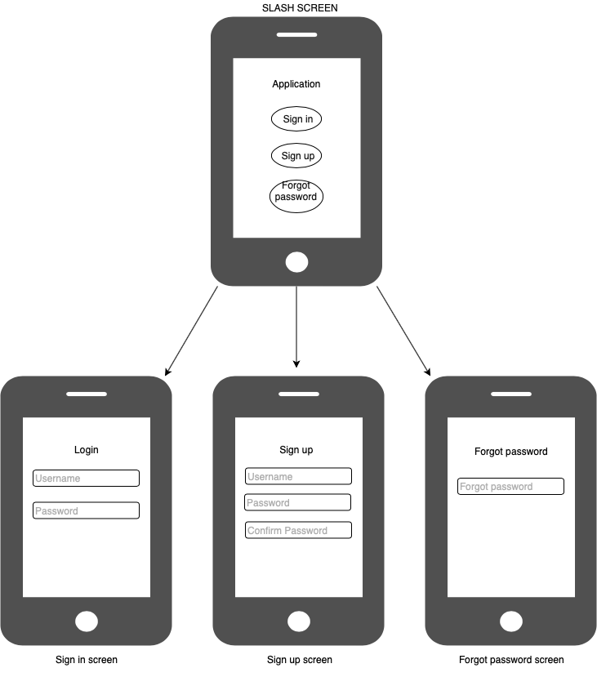
Figure 4: Flow Diagram

System2 Requirements
<Insert System2 Requirement sheet here>

Specific Requirements
<Refer above section>

Mobile UI Screens/Wireframes
<Refer above section>

Assumptions
<List any assumed factors (as opposed to known facts) that could affect the requirements stated in the PRD. These could include third-party or commercial components that you plan to use, issues around the development or operating environment, or constraints. The project could be affected if these assumptions are incorrect, are not shared, or change>

Dependencies
<Identify any dependencies the project has on external factors, such as software components that you intend to reuse from another project, development platform to be provided by customer, SDK release dependency with IC manufacturer etc, unless they are already documented elsewhere (for example, in the vision and scope document or the project plan).>

Standard Deliverables & Release Order
<All standard deliverable documents of each domain for each system, shall be listed here. Some of the other common documents like PRD, user Manual etc shall also be captured.>

Product Development Plan
<Top level development plan (not timeline) shall be captured here. The level of details should be between schedule given in proposal and the PM’s detailed project plan.
During the PRD discussions with customer, lot of clarity on detailed requirements would have been arrived, so high level project plan is expected here. In addition, this high level plan would give clarity to customer when he can expect different deliverables.
For example, software development itself may span across different revision of HW design, so this high level plan would clearly show what software design documents can be expected for each HW revision etc.>

System1 Development Plan
System1 Deliverable | Domain 1 [HW] | Domain2 [Mechanical] | Domain3 [Embedded Software] | Domain4
1 | HDD | ID | SDD
2 | Schematics | MDD [Initial] | FDD [part1]
3 | PCB Layout | MDD [Final] | FDD [part2]
4 | Gerber & BOM | Fab & Assy Package
5 | Assembled Boards |  | FDD [part3]
6 |  | Assembled product
7 | Test Reports |  | Image/Code Release1
8 | Tested Board |  | FDD [part4]
9 | RevB HDD
10 | RevB Schematics
11 | RevB Gerber |  | FDD [part5]
12 | RevB assembled boards |  | FDD [Final]
13 | RevB Tested boards |  | Image/code release 2
Table 7: System1 Development Plan

System2 Development Plan
<Fill as applicable>

Architecture <optional>
<Architecture section is optional to mention in PRD document. Include and share the architecture details with customer ONLY if customer demands for it. Insist customer to look for architecture in design documents>

System1: Domain1 Architecture
< Architecture Diagram with caption, shall be inserted here. No explanation of architecture is required. Below architecture diagram, there shall be a note “This is the proposed architecture and it might get changed during the design stage” and “Ensure the license compliance for usage of open source tools”. >

System1: Domain2 Architecture
< Architecture Diagram with caption, shall be inserted here. No explanation of architecture is required. Below architecture diagram, there shall be a note “This is the proposed architecture and it might get changed during the design stage” and “Ensure the license compliance for usage of open source tools”.>

System2: Domain1 Architecture
< Architecture Diagram with caption, shall be inserted here. No explanation of architecture is required. Below architecture diagram, there shall be a note “This is the proposed architecture and it might get changed during the design stage” and “Ensure the license compliance for usage of open source tools”.>

Bill Of Material <optional>
<BOM section is optional to mention in PRD document. Include and share with customer ONLY if customer demands for it. The BOM shared MUST not have any pricing/cost information. Below all BOM table, add a note “This is the expected BOM and it might get changed during the design stage”>

System1: Product BOM
<Insert System level BOM>
Sl.No | Description | Qty | Mfg | Mfg Part No
Subsystem 1 - Electrical
Subsystem 1 - Mechanical
Subsystem 2 - Electrical
Subsystem 2 - Mechanical
Table 8:System1 Product BOM

System2: Product BOM
<Insert System level BOM>
Sl.No | Description | Qty | Mfg | Mfg Part No
Subsystem 1 - Electrical
Subsystem 1 - Mechanical
Subsystem 2 - Electrical
Subsystem 2 - Mechanical
Table 9:System2 Product BOM

Out of Scope
The following points are not included in the scope of project:
- Out of scope point 1
- Out of scope point 2
- Out of scope point 3

Open Items
The following points are included in the scope of project but not included in urrent revision:
- Open Item 1
- Open Item 2
- Open Item 3

