Project Report
On
Design and Implementation of Ethernet UDP Protocol using ADT7420 Temperature sensor

Submitted as partial fulfilment for the award of
BACHELOR OF TECHNOLOGY
DEGREE
Session 2025-26
in
Electronics and Communication Engineering

By
Georgin Roy(2200320310060)
Sanskar Singh(2200320310141)
Sufyan Mohammad(2200320310166)
Vanshika Sharma(2200320310186)

Under the guidance of
Dr. Aakriti Chhabra


ABES ENGINEERING COLLEGE, GHAZIABAD
(Affiliated to DR. A.P.J. ABDUL KALAM TECHNICAL UNIVERSITY, U.P., LUCKNOW)
DECLARATION

We hereby declare that this submission is our own work that, to the best of our knowledge and belief, it contains no material previously published or written by another person nor material which to a substantial extent has been accepted for the award of any other degree or diploma of the university or other institute of higher learning, except where due acknowledgment has been made in the text.

Name: Georgin Roy
Roll number: 2200320310060
Date:
Signature:
Name: Sanskar Singh
Roll number: 2200320310141
Date:
Signature:
Name: Sufyan Mohammad
Roll number: 2200320310166
Date:
Signature:
Name: Vanshika Sharma
Roll number: 2200320310186
Date:
Signature:

CERTIFICATE
This is to certify that the research report titled “Design and Implementation of Ethernet UDP Protocol using ADT7420” submitted by the aforementioned students for their B.Tech. degree in the Department of Electronics and Communication Engineering. This work represents a record of their independent effort conducted under my professional supervision. The findings presented here are original and have not been used for any other degree or diploma.

ACKNOWLEDGEMENT

It is a privilege to present this final-year B.Tech project report. We express our sincere appreciation to Dr. Aakriti Chhabra, Professor, for her invaluable mentorship and technical insight during this project. Her dedication and academic rigor served as a constant motivation for our team.
Furthermore, we thank Prof. (Dr.) Kimmi Verma, Head of Department, for providing the necessary institutional support and facilities. We also acknowledge the collective assistance of the faculty members and our peers who contributed to the successful completion of this study.
Name: Georgin Roy
Roll number: 2200320310060
Date:
Signature:
Name: Sanskar Singh
Roll number: 2200320310141
Date:
Signature:
Name: Sufyan Mohammad
Roll number: 2200320310166
Date:
Signature:
Name: Vanshika Sharma
Roll number: 2200320310186
Date:
Signature:

CONTENTS
Declaration
Certificate
Acknowledgement
Abstract
List of Figures
List of Tables
CHAPTER 1: INTRODUCTION
1.1 Overview
1.2 Problem Statement
1.3 Objectives
1.4 Methodology
CHAPTER 2: HARDWARE ARCHITECTURE
2.1 The ADT7420 Digital Temperature Sensor
2.2 The Basys 3 FPGA Board and Pmod Interfacing
CHAPTER 3: VIVADO FPGA DESIGN FLOW
3.01 System Integration and Hardware Strategy
3.02 AMD Vitis Software Development
3.05 I2C Communication Protocol
CHAPTER 4: SOFTWARE DESIGN AND IMPLEMENTATION
4.1 I2C Driver and Sensor Initialization
4.2 Data Acquisition Flow
4.3 Network Communication via lwIP
4.5 Performance Metrics
APPENDIX: LIST OF FIGURES AND TABLES
REFERENCES
 | Declaration
 | Certificate
 | Acknowledgement
 | Abstract
 | List of Figures
 | List of Tables
CHAPTER 1 | INTRODUCTION
1.1 | Overview
1.2 | Problem Statement
1.3 | Objectives
1.4 | Methodology
CHAPTER 2 | HARDWARE ARCHITECTURE
2.1 | The ADT7420 Digital Temperature Sensor
2.1.1 | Features and Specifications
2.1.2 | Pin Configuration and Operation
2.2 | The Basys 3 FPGA Board (Artix-7)
2.2.1 | FPGA Configuration and Memory
2.2.2 | Clocking and Oscillators
2.2.3 | Connectivity: USB-UART and HID Host
2.2.4 | Peripheral Module (Pmod) Ports
2.3 | Processing System (PS): ARM Cortex-A Architecture
2.4 | Project Implementation Plan
CHAPTER 3 | LITERATURE REVIEW
3.1 | Digital Temperature Sensing Technologies
3.2 | Thermal Monitoring in FPGA and SoC Platforms
3.3 | I2C-Based Embedded Sensor Interfacing
3.4 | Ethernet and IoT-Enabled Monitoring
3.5 | Comparative Analysis of Existing Approaches
3.6 | Thermal Modelling and Adaptive Design
3.7 | Research Gaps and Emerging Trends
CHAPTER 4 | SOFTWARE DESIGN & IMPLEMENTATION
4.1 | I2C Driver and Sensor Initialization
4.2 | Data Acquisition and Processing Flow
4.3 | Network Communication via lwIP Stack
4.4 | GUI Design and Development
4.4.1 | Modular Design Architecture
4.4.2 | Functional Decomposition
4.4.3 | Data Handling and Memory Management
4.4.4 | Protocol Efficiency (UDP vs. TCP)
4.5 | System Deployment and Performance Metrics
CHAPTER 5 | CONCLUSION & FUTURE SCOPE
5.1 | Conclusion
5.2 | Future Scope
5.3 | Appendix: Project Resource Summary
 | REFERENCES

CHAPTER-1: INTRODUCTION

1.1 OVERVIEW
Modern industrial and environmental monitoring relies heavily on the precision of embedded temperature tracking systems. As the Internet of Things (IoT) expands, the focus has shifted toward using digital IC sensors in tandem with sophisticated programmable platforms like Field Programmable Gate Arrays (FPGAs). Thermal stability is not just an environmental factor; it directly dictates the operational lifespan and reliability of high-performance System-on-Chip (SoC) devices. Hybrid architectures, such as the Xilinx Zynq series, have revolutionized this field by merging hardware-level sensing with software-driven communication on a single silicon die.

1.2 PROBLEM STATEMENT

Accurate thermal monitoring in complex electronic systems faces several technical hurdles:
- Thermal Coupling: Heat generated by internal processors can significantly bias sensor readings, requiring advanced compensation techniques.
- Hardware Complexity: Traditional analog circuits for signal conditioning are prone to noise and require more space compared to digital IC sensors.
- Integration Gaps: Existing research often focuses either on sensor accuracy or network structure, rather than a unified end-to-end framework.

1.3 OBJECTIVES

- To evaluate the performance of digital IC sensors (ADT7420) against traditional RTDs and thermistors.
- To implement a robust I2C-based communication interface for scalable data acquisition.
- To design an Ethernet-enabled SoC architecture for low-latency, real-time data visualization.
- To explore emerging trends like edge intelligence and cloud-connected thermal analytics.

1.4 METHODOLOGY

The project follows a modular design approach:
- Hardware Interfacing: Digital sensors are connected to the SoC's programmable logic via PMOD connectors.
- Data Processing: Temperature packets are formatted by an ARM-based processing system.
- Communication: Data is transmitted over UDP using the lwIP stack to a graphical user interface (GUI).
- Verification: The system is benchmarked against different platforms to assess power and latency trade-offs.

CHAPTER-2: HARDWARE REQUIRED
2.1 THE ADT7420 TEMPERATURE SENSOR
Features:
- High performance
  - Temperature accuracy
    - ±0.20°C from −10°C to +85°C at 3.0 V
    - ±0.25°C from −20°C to +105°C from 2.7 V to 3.3 V
  - 16-bit resolution: 0.0078°C
- Ultralow temperature drift: 0.0073°C
  - NIST traceable or equivalent
  - Fast first temperature conversion on power-up of 6 ms
- Easy implementation
  - No temperature calibration/correction required by user
  - No linearity correction required
- Low power
  - Power-saving 1 sample per second (SPS) mode
  - 700 µW typical at 3.3 V in normal mode
  - 7 µW typical at 3.3 V in shutdown mode
- Wide operating ranges
  - Temperature range: −40°C to +150°C
  - Voltage range: 2.7 V to 5.5 V
- Programmable interrupts
  - Critical overtemperature interrupt
  - Overtemperature/undertemperature interrupt
- I²C-compatible interface
- 16-lead, 4 mm × 4 mm LFCSP RoHS-compliant package
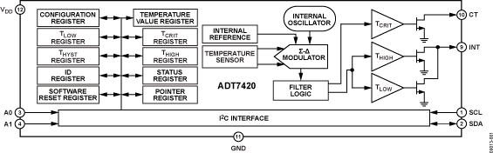
Fig 2.1: block diagram for the ADT7420 temp. sensor.
Part Details:
The ADT7420 is a high accuracy digital temperature sensor offering breakthrough performance over a wide industrial range, housed in a 4 mm × 4 mm LFCSP package. It contains an internal band gap reference, a temperature sensor, and a 16-bit ADC to monitor and digitize the temperature to 0.0078°C resolution. The ADC resolution, by default, is set to 13 bits (0.0625°C). The ADC resolution is a user programmable mode that can be changed through the serial interface.
The ADT7420 is guaranteed to operate over supply voltages from 2.7 V to 5.5 V. Operating at 3.3 V, the average supply current is typically 210 μA. The ADT7420 has a shutdown mode that powers down the device and offers a shutdown current of typically 2.0 μA at 3.3 V. The ADT7420 is rated for operation over the −40°C to +150°C temperature range.
Pin A0 and Pin A1 are available for address selection, giving the ADT7420 four possible I²C addresses. The CT pin is an open-drain output that becomes active when the temperature exceeds a programmable critical temperature limit. The INT pin is also an open-drain output that becomes active when the temperature exceeds a programmable limit. The INT pin and CT pin can operate in comparator and interrupt event modes.

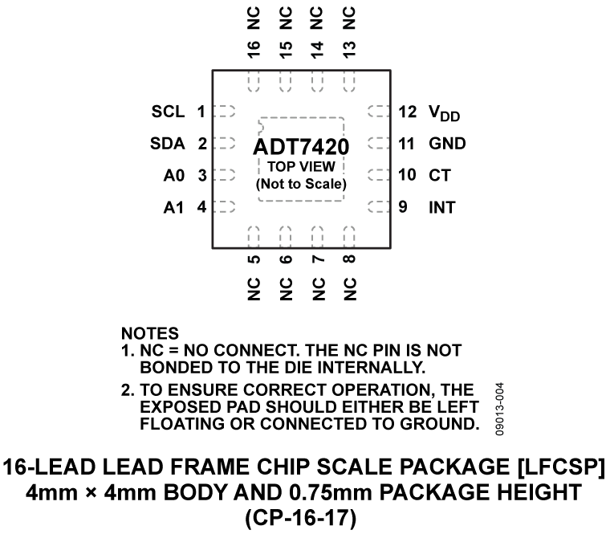
Fig 2.1(b): pin diagram of ADT7420 Temp. sensor.
Highlights and Advantages:
- Ease of use, no calibration or correction required by the user.
- Low power consumption.
- Excellent long-term stability and reliability.
- High accuracy for industrial, instrumentation, and medical applications.
- Packaged in a 16-lead, 4 mm × 4 mm LFCSP RoHS-compliant package.
Practical Applications:
- RTD and thermistor replacement
- Thermocouple cold junction compensation
- Medical equipment
- Industrial control and test
- Food transportation and storage
- Environmental monitoring and HVAC
- Laser diode temperature control

2.2 THE BASYS 3 FPGA BOARD
The Basys 3 is a comprehensive, ready-to-use digital circuit development platform centered on the AMD Artix™ 7 Field Programmable Gate Array (FPGA). Engineered for versatility and cost-effectiveness, it features the XC7A35T-1CPG236C FPGA, providing a high-capacity hardware environment suitable for a broad range of applications. Its integrated suite of USB, VGA, and diverse I/O ports enables the hosting of designs varying from introductory combinational logic to sophisticated sequential systems, including embedded processors and specialized controllers.
Equipped with an extensive array of onboard switches, LEDs, and displays, the Basys 3 facilitates the completion of numerous digital designs without requiring additional hardware components. For more advanced or specialized projects, the board offers a significant number of uncommitted FPGA I/O pins. These pins allow for seamless system expansion through the integration of Digilent Pmods, custom-built circuit boards, or external peripheral modules, making it an adaptable tool for both academic learning and professional prototyping.

SPECIFICATIONS:
The AMD Artix™ 7 FPGA is optimized for high performance logic, and offers more capacity, higher performance, and more resources than earlier designs. AMD Artix™ 7 35T features include:
- 33,280 logic cells in 5200 slices (each slice contains four 6-input LUTs and 8 flip-flops);
- 1,800 Kbits of fast block RAM;
- Five clock management tiles, each with a phase-locked loop (PLL);
- 90 DSP slices;
- Internal clock speeds exceeding 450 MHz;
- On-chip analog-to-digital converter (XADC).
The Basys 3 also offers an improved collection of ports and peripherals, including:
- 16 user switches
- 16 user LEDs
- 5 user pushbuttons
- 4-digit 7-segment display
- Three Pmod ports
- Pmod for XADC signals
- 12-bit VGA output
- USB-UART Bridge
- Serial Flash
- Digilent USB-JTAG port for FPGA programming and communication
- USB HID Host for mice, keyboards and memory sticks

SOFTWARE – AMD VIVADO DESIGN SUITE:
The Basys 3 is uniquely optimized for the AMD Vivado™ Design Suite, representing a shift toward modern, high-performance development workflows. As the first board in its class designed exclusively for Vivado, it leverages a suite of advanced tools and design flows that significantly enhance the efficiency of the hardware development lifecycle. This integration allows for faster synthesis and implementation times, superior optimization of the Artix-7 FPGA resources, and provides designers the flexibility to explore and iterate on various architectural alternatives rapidly.
For professional-grade development, the System Edition provides powerful features such as an integrated on-chip logic analyzer and High-Level Synthesis (HLS) tools, which streamline the transition from algorithmic concepts to hardware. Furthermore, the availability of the free "WebPACK" version ensures that full-scale Basys 3 projects can be developed and deployed without additional software licensing costs, making it an accessible yet powerful choice for both academic and entry-level industrial applications.

THE BOARD CHARACTERISTICS:
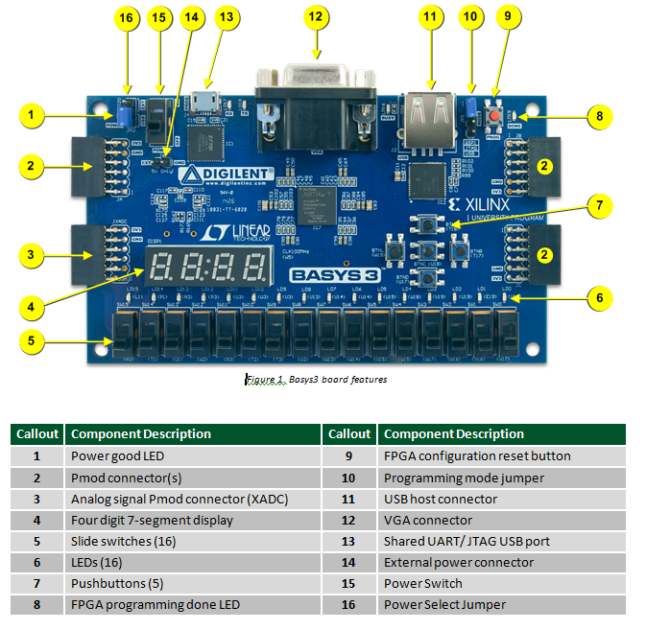
Fig. 2.2: The Basys 3 board and callouts reference.
POWER:
All Basys 3 power supplies can be turned on and off by a single logic-level power switch (SW16). A power-good LED (LD20), driven by the “power good” output of the Linear Technologies LTC3633 supply, indicates that the supplies are turned on and operating normally. An overview of the Basys 3 power circuit is shown below.
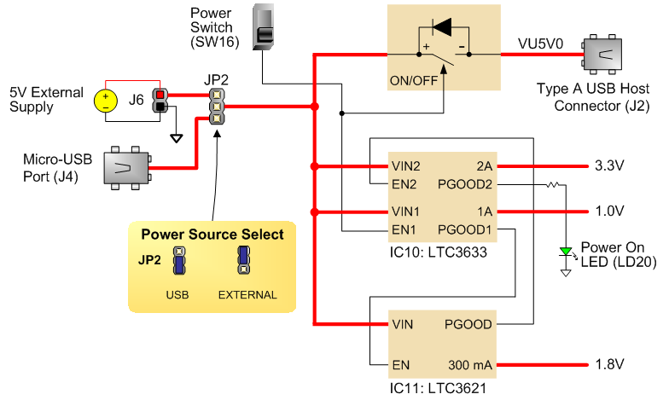
Fig. 2.2(b): Power Supplies and management.
To provide a flexible power management system, the Basys 3 can be energized via two primary sources: the Digilent USB-JTAG port (J4) or an external 5V power supply. The power routing is controlled by the JP2 jumper, located adjacent to the physical power switch. This configuration allows the board to be powered directly from a host computer during the programming and debugging phases, or via a standalone external supply for higher-current applications or independent operation.

FPGA CONFIGURATION:
After power-on, the AMD Artix™ 7 FPGA must be configured (or programmed) before it can perform any functions. To configure the FPGA, you have the option of one of three ways.
- A PC can use the Digilent USB-JTAG circuitry (portJ4, labeled “PROG”) to program the FPGA any time the power is on.
- A file stored in the nonvolatile serial (SPI) flash device can be transferred to the FPGA using the SPI port.
- A programming file can be transferred from a USB memory stick attached to the USB HID port.
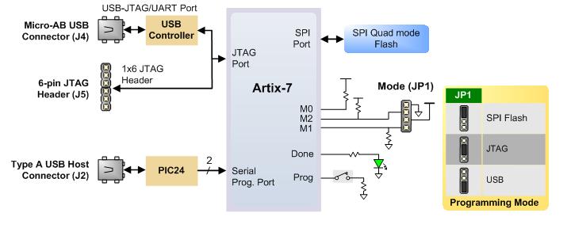
Fig. 2.2(c): Diff configuration methods for PL FPGA.
The FPGA configuration data is stored in files called bitstreams that have the .bit file extension. The Vivado software from AMD can create bitstreams from VHDL, Verilog, or schematic-based source files. Bitstreams are stored in SRAM-based memory cells within the FPGA. This data defines the FPGA’s logic functions and circuit connections, and it remains valid until it is erased by removing board power, by pressing the reset button attached to the PROG input, or by writing a new configuration file using the JTAG port.
An AMD Artix™ 7 35T bitstream is typically 17,536,096 bits and can take a long time to transfer. The time it takes to program the Basys 3 can be decreased by compressing the bitstream before programming, and then allowing the FPGA to decompress the bitstream itself during configuration. Depending on design complexity, compression ratios of 10x can be achieved. Bitstream compression can be enabled within the AMD tools (Vivado) to occur during generation. For instructions on how to do this, consult the AMD documentation for the toolset being used. After being successfully programmed, the FPGA will cause the “DONE” LED to illuminate. Pressing the “PROG” button at any time will reset the configuration memory in the FPGA.
After being reset, the FPGA will immediately attempt to reprogram itself from whatever method has been selected by the programming mode jumper. The following sections provide greater detail about programming the Basys 3 using the different methods available.

MEMORY:
The Basys 3 platform incorporates a 32Mbit non-volatile Quad SPI (QSPI) Flash memory module, interfaced with the AMD Artix™ 7 FPGA via a dedicated four-lane (x4) serial peripheral interface. This high-speed bus architecture ensures efficient data transfer between the memory and the FPGA logic. While primarily utilized for storing hardware configuration bitstreams, the flash device also serves as a persistent storage medium for user-defined data and application code.
A standard configuration file for the Artix™ 7 35T requires approximately 2MB of space; consequently, nearly 48% of the 32Mbit capacity remains available for general-purpose storage after the primary bitstream is hosted. By configuring the board's mode settings, the FPGA can be set to automatically initialize and load its hardware design from this non-volatile memory upon power-up, enabling standalone operation without the need for a persistent connection to a host computer.
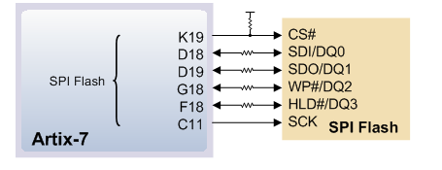
Fig. 2.2(d): Artix-7 to SPI Flash Interface.

Oscillators/ Clocks:
The Basys 3 board includes a single 100 MHz oscillator connected to pin W5 (W5 is a MRCC input on bank 34). The input clock can drive MMCMs or PLLs to generate clocks of various frequencies and with known phase relationships that may be needed throughout a design. Some rules restrict which MMCMs and PLLs may be driven by the 100 MHz input clock.
AMD offers the Clocking Wizard IP core to help users generate the different clocks required for a specific design. This wizard properly instantiates the needed MMCMs and PLLs based on the desired frequencies and phase relationships specified by the user. The wizard will then output an easy to use wrapper component around these clocking resources that can be inserted into the user’s design. The Clocking Wizard can be accessed from within IP Catalog, which can be found under the Project Manager section of the Flow Navigator in Vivado.

USB UART BRIDGE:
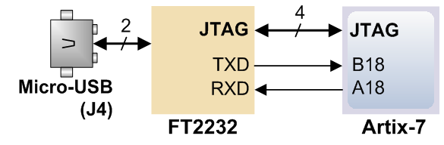
Fig. 2.2(e): Artix-7 to JTAG/UART Interface via FT2232.
To facilitate seamless data exchange with a host PC, the Basys 3 integrates an FTDI FT2232HQ USB-UART bridge connected via the micro-USB port (J4). This hardware component allows standard PC applications to communicate with the FPGA using virtual COM port commands. By utilizing Virtual COM Port (VCP) drivers, USB packets are transparently converted into UART serial data, which is then interfaced with the FPGA through a two-wire (TXD/RXD) protocol mapped to pins A18 and B18.
For real-time monitoring of data flow, the board features two dedicated status LEDs: LD18 (Transmit) and LD17 (Receive). It is important to note that signal directions are defined from the DTE (Data Terminal Equipment) perspective, referring to the host PC.
The FT2232HQ serves a dual purpose by also controlling the Digilent USB-JTAG circuitry. However, these two subsystems operate with complete independence. This architecture ensures that UART data transfers do not interfere with JTAG programming or debugging operations, and vice versa. By consolidating power, JTAG programming, and UART communication into a single controller, the Basys 3 enables a streamlined "single-cable" development environment.

USB HID HOST:
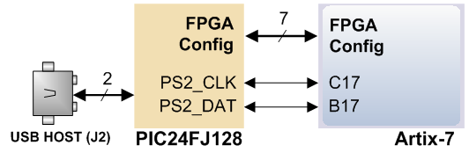
Fig. 2.2(f): FPGA Configuration Interface with PIC24FJ128.
The Basys 3 incorporates a Microchip PIC24FJ128 microcontroller to serve as an Auxiliary Function controller, primarily providing the board with USB HID (Human Interface Device) Host capabilities. This allows the FPGA to interface directly with standard user input devices, such as a keyboard or mouse, via the USB Type-A connector (J2).
The microcontroller operates in two distinct phases:
- Configuration Mode: Immediately following power-up, the PIC24 manages the FPGA initialization process, either by facilitating the bitstream download or monitoring other programming sources.
- Application Mode: Once the FPGA is successfully configured, the microcontroller transitions into USB HID Host mode. In this state, it translates data from an attached HID peripheral into a standard PS/2 interface that the FPGA can easily interpret.
Currently, the firmware supports a single direct connection; USB hubs are not supported, limiting the interface to one device at a time. Beyond peripheral input, the PIC24 is also linked to the FPGA’s serial programming port, enabling the system to be configured directly from a bitstream file stored on a USB flash drive.

HID CONTROLLER:
The Auxiliary Function microcontroller hides the USB HID protocol from the FPGA and emulates an old-style PS/2 bus. The microcontroller behaves just like a PS/2 keyboard or mouse would. This means new designs can re-use existing PS/2 IP cores. Mice and keyboards that use the PS/2 protocol use a two-wire serial bus (clock and data) to communicate with a host. On the Basys 3, the microcontroller emulates a PS/2 device while the FPGA plays the role of the host. Both the mouse and the keyboard use 11-bit words that include a start bit, data byte (LSB first), odd parity, and stop bit, but the data packets are organized differently, and the keyboard interface allows bi-directional data transfers (so the host device can illuminate state LEDs on the keyboard). Bus timings are shown in the below figure.
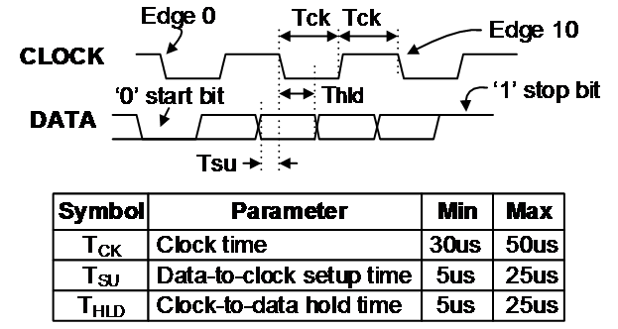
Fig. 2.2(g): Clock and Data Timing Specifications.
The clock and data signals are only driven when data transfers occur; otherwise they are held in the idle state at logic ‘1.’ This requires that when the PS/2 signals are used in a design, internal pull-ups must be enabled in the FPGA on the data and clock pins. The clock signal is normally driven by the device, but may be held low by the host in special cases. The timings define signal requirements for mouse-to-host communications and bi-directional keyboard communications. A PS/2 interface circuit can be implemented in the FPGA to create a keyboard or mouse interface.
When a keyboard or mouse is connected to the Basys 3, a “self-test passed” command (0xAA) is sent to the host. After this, commands may be issued to the device. Since both the keyboard and the mouse use the same PS/2 port, one can tell the type of device connected using the device ID. This ID can be read by issuing a Read ID command (0xF2). Also, a mouse sends its ID (0x00) right after the “self-test passed” command, which distinguishes it from a keyboard.

Basic I/O:
The Basys 3 board includes sixteen slide switches, five push buttons, sixteen individual LEDs, and a four-digit seven-segment display, as shown in the below diagram. The pushbuttons and slide switches are connected to the FPGA via series resistors to prevent damage from inadvertent short circuits (a short circuit could occur if an FPGA pin assigned to a pushbutton or slide switch was inadvertently defined as an output). The five pushbuttons, arranged in a plus-sign configuration, are “momentary” switches that normally generate a low output when they are at rest, and a high output only when they are pressed. Slide switches generate constant high or low inputs depending on their position.
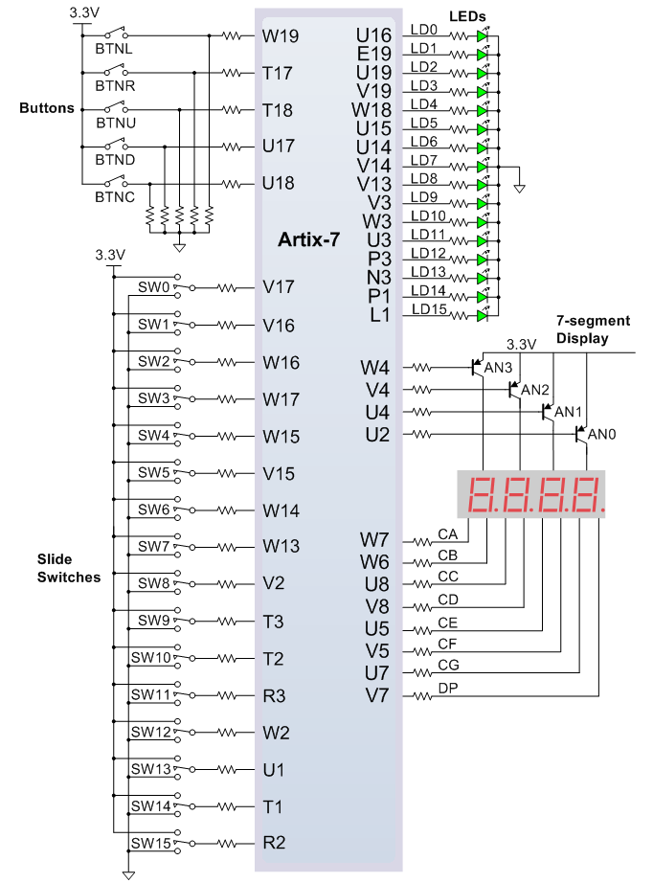
Fig. 2.2(h): Artix-7 Peripheral Connections (Buttons, LEDs, Switches).
The sixteen individual high-efficiency LEDs are anode-connected to the FPGA via 330-ohm resistors, so they will turn on when a logic high voltage is applied to their respective I/O pin. Additional LEDs, which are not user-accessible, indicate power-on, FPGA programming status, and USB port status.

Seven Segment Display
The Basys 3 board contains one four-digit common anode seven-segment LED display. Each of the four digits is composed of seven segments arranged in a “figure 8” pattern, with an LED embedded in each segment. Segment LEDs can be individually illuminated, so any one of 128 patterns can be displayed on a digit by illuminating certain LED segments and leaving the others dark, as shown in the below. Of these 128 possible patterns, the ten corresponding to the decimal digits are the most useful.
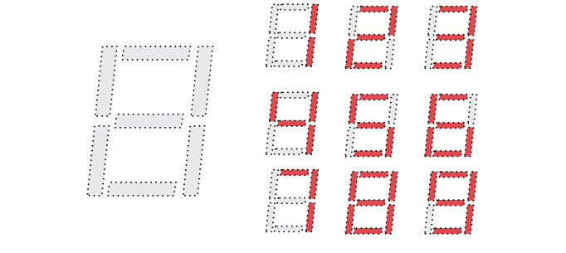
Fig. 2.2(i): Seven-Segment Display Digit Formations.
The anodes of the seven LEDs forming each digit are tied together into one “common anode” circuit node, but the LED cathodes remain separate, as shown in Fig 18. The common anode signals are available as four “digit enable” input signals to the 4-digit display. The cathodes of similar segments on all four displays are connected into seven circuit nodes labeled CA through CG (so, for example, the four “D” cathodes from the four digits are grouped together into a single circuit node called “CD”). These seven cathode signals are available as inputs to the 4-digit display. This signal connection scheme creates a multiplexed display, where the cathode signals are common to all digits but they can only illuminate the segments of the digit whose corresponding anode signal is asserted.
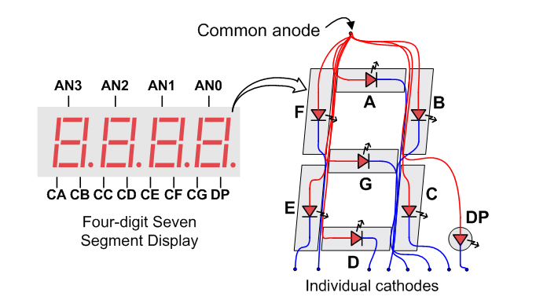
Fig. 2.2(j): Four-Digit Seven-Segment Display Pinout and Internal Diagram.
To illuminate a segment, the anode should be driven high while the cathode is driven low. However, since the Basys 3 uses transistors to drive enough current into the common anode point, the anode enables are inverted. Therefore, both the AN0..3 and the CA..G/DP signals are driven low when active.
A scanning display controller circuit can be used to show a four-digit number on this display. This circuit drives the anode signals and corresponding cathode patterns of each digit in a repeating, continuous succession at an update rate that is faster than the human eye can detect. Each digit is illuminated just one-fourth of the time, but because the eye cannot perceive the darkening of a digit before it is illuminated again, the digit appears continuously illuminated. If the update, or “refresh”, rate is slowed to around 45 hertz, a flicker can be noticed in the display.
For each of the four digits to appear bright and continuously illuminated, all four digits should be driven once every 1 to 16ms, for a refresh frequency of about 1KHz to 60Hz. For example, in a 62.5Hz refresh scheme, the entire display would be refreshed once every 16ms, and each digit would be illuminated for 1/4 of the refresh cycle, or 4ms. The controller must drive low the cathodes with the correct pattern when the corresponding anode signal is driven high. To illustrate the process, if AN0 is asserted while CB and CC are asserted, then a “1” will be displayed in digit position 1. Then, if AN1 is asserted while CA, CB, and CC are asserted, a “7” will be displayed in digit position 2. If AN0, CB, and CC are driven for 4ms, and then AN1, CA, CB, and CC are driven for 4ms in an endless succession, the display will show “71” in the first two digits. An example timing diagram for a four-digit controller is shown below.
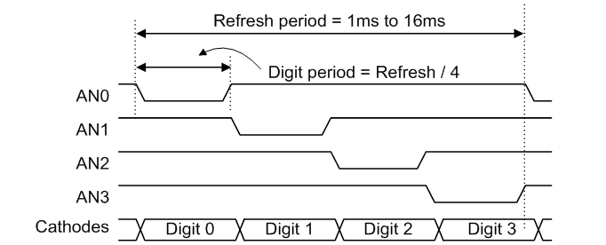
Fig. 2.2(k): Multiplexed Display Refresh and Digit Timing.

Pmod Ports:
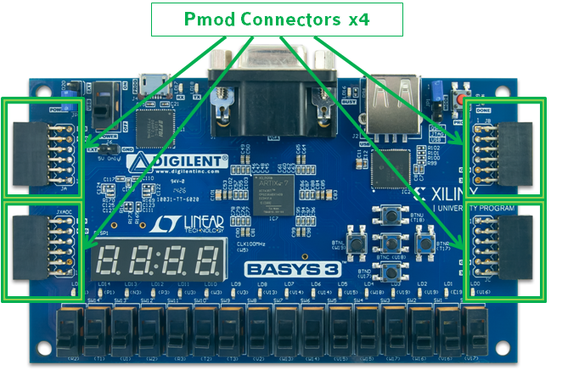
Fig. 2.2(l): Basys 3 Pmod Connector Locations.
A major change from the Basys 2 to the Basys 3 is the addition of double row Pmod ports. Digilent produces a large collection of Pmod (Peripheral Module) accessory boards that can attach to the expansion ports to add ready-made functions such as A/D's, D/A's, motor drivers, sensors, displays, and many other functions. These ports can be used as simple expansion ports, since all of the pin-outs correspond to pins on the FPGA.
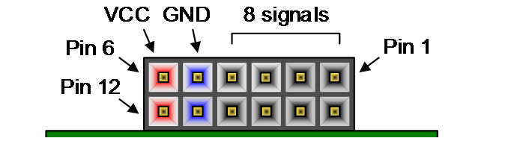
Fig. 2.2(m): Standard Pmod Connector Pinout (12-pin).
The Pmod ports are arranged in a 2×6 right-angle, and are 100-mil female connectors that mate with standard 2×6 pin headers. Each 12-pin Pmod ports provides two 3.3V VCC signals (pins 6 and 12), two Ground signals (pins 5 and 11), and eight logic signals, as shown in Fig. The VCC and Ground pins can deliver up to 1A of current. Pmod data signals are not matched pairs, and they are routed using best-available tracks without impedance control or delay matching. Pin assignments for the Pmod I/O connected to the FPGA are shown in the below table.
Warning: Since the Pmod pins are connected to AMD Artix™ 7 FPGA pins using a 3.3V logic standard, care should be taken not to drive these pins over 3.4V.
Pmod JA | Pmod JB | Pmod JC | Pmod JXADC
JA1: J1 | JB1: A14 | JC1: K17 | JXADC1: J3
JA2: L2 | JB2: A16 | JC2: M18 | JXADC2: L3
JA3: J2 | JB3: B15 | JC3: N17 | JXADC3: M2
JA4: G2 | JB4: B16 | JC4: P18 | JXADC4: N2
JA7: H1 | JB7: A15 | JC7: L17 | JXADC7: K3
JA8: K2 | JB8: A17 | JC8: M19 | JXADC8: M3
JA9: H2 | JB9: C15 | JC9: P17 | JXADC9: M1
JA10: G3 | JB10: C16 | JC10: R18 | JXADC10: N1

Dual Analog/Digital Pmod (JXADC):
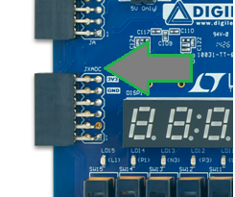
Fig. 2.2(n): Basys 3 JXADC Connector for Analog Inputs.
The on-board Pmod expansion port labeled “JXADC” is wired to the auxiliary analog input pins of the FPGA. Depending on the configuration, this port can be used to input differential analog signals to the analog-to-digital converter inside the AMD Artix™ 7 (XADC). Any or all pairs in the port can be configured either as analog input or digital input-output. The Dual Analog/Digital Pmod on the Basys 3 differs from the rest in the routing of its traces. The eight data signals are grouped into four pairs, with the pairs routed closely coupled for better analog noise immunity. Furthermore, each pair has a partially loaded anti-alias filter laid out on the PCB. The filter does not have capacitors C33-C36. In designs where such filters are desired, the capacitors can be manually loaded by the user.
:!:NOTE: The coupled routing and the anti-alias filters might limit the data speeds when used for digital signals. The XADC core within the AMD Artix™ 7 is a dual channel 12-bit analog-to-digital converter capable of operating at 1 MSPS.
Either channel can be driven by any of the auxiliary analog input pairs connected to the JXADC header. The XADC core is controlled and accessed from a user design via the Dynamic Reconfiguration Port (DRP). The DRP also provides access to voltage monitors that are present on each of the FPGA’s power rails, and a temperature sensor that is internal to the FPGA.

Built in Self Test:
A demonstration configuration is loaded into the SPI Flash device on the Basys 3 board during manufacturing. The source code and prebuilt bitstream for this design are available for download from the Digilent website. If the demo configuration is present in the SPI Flash device and the Basys 3 board is powered on in SPI mode, the demo project will allow basic hardware verification. Here is an overview of how this demo drives the different onboard components:
- The user LEDs are illuminated when the corresponding user switch is placed in the on position.
- The VGA port displays feedback from a USB Mouse.
- Connecting a mouse to the USB-HID Mouse port will allow the pointer on the VGA display to be controlled.
- On power-up, each digit of the seven-segment display will display a counter output from 0-9 that increments once a second.
- Pressing BTNU, BTNL, BTNR, or BTND will cause a digit of the seven-segment display to go blank.
- Pressing BTNC will reset the design.
- On power-up, a welcome message is sent over the UART. Also, every time a button is pressed a message is sent. The UART can be connected to using a terminal program with 9600 Baud, 8 data bits, 1 stop bit, and no parity.
All Basys 3 boards are 100% tested during the manufacturing process. If any device on the Basys 3 board fails test or is not responding properly, it is likely that damage occurred during transport or during use. Typical damage includes stressed solder joints and contaminants in switches and buttons resulting in intermittent failures. Stressed solder joints can be repaired by reheating and reflowing solder and contaminants can be cleaned with off-the-shelf electronics cleaning products. If a board fails test within the warranty period, it will be replaced at no cost.

2.3 The Processing System (PS): ARM Cortex-A Series Architecture
In this heterogeneous architecture, the ARM Cortex processor functions as the "System Manager" or "Orchestrator." While the Programmable Logic (PL) on the Basys 3 handles the high-speed, repetitive tasks of toggling pins to talk to the sensor, the PS side provides the high-level cognitive power required to transform raw data into a sophisticated end-user application.

1. High-Performance Computational Core
The ARM Cortex-A architecture is a high-performance Reduced Instruction Set Computer (RISC) engine. In the context of temperature sensing, its primary role is to execute complex algorithmic logic that would be too resource-intensive to build purely out of FPGA gates.
- Hardware Floating-Point Unit (FPU): Most digital temperature sensors provide data in "counts" or fixed-point integers. To convert these into human-readable Celsius or Fahrenheit values with high precision, the ARM core utilizes its dedicated FPU. This allows for the execution of IEEE 754 floating-point math, enabling the application of complex calibration curves and non-linear compensations (such as the Steinhart-Hart equation) without stalling the processor.
- NEON™ SIMD Engine: If the project requires processing multiple sensor streams simultaneously—such as calculating a rolling average or performing a Fast Fourier Transform (FFT) to analyze thermal noise—the ARM’s NEON technology allows for Single Instruction Multiple Data (SIMD) processing. This accelerates data-heavy tasks by processing multiple data points in a single clock cycle.

2. The Software Stack and Development Environment
The PS side offers a flexible software environment, typically developed using the AMD Vitis Unified Software Platform. This allows for a "Software-Defined" approach to hardware control.
- Hardware Abstraction Layer (HAL): The PS interacts with the Basys 3 through a series of drivers. These drivers abstract the physical complexity of the AXI interconnect, allowing the developer to read the temperature data by simply calling a variable or a function in C/C++, such as CurrentTemp = Xil_In32(SENSOR_BASE_ADDR);.
- Interrupt Service Routines (ISR): Efficiency is maximized through the use of the Generic Interrupt Controller (GIC). Instead of the ARM processor constantly "polling" the FPGA for new data (which wastes CPU cycles and power), the PS remains in a low-power state until the PL sends an interrupt signal. This signal notifies the ARM core that a new sample is ready or that a thermal threshold has been breached, triggering an immediate software response.

3. Memory Management and Data Persistence
One of the most significant advantages of the PS side is its ability to manage large-scale memory, which is a major limitation of standalone FPGAs.
- DDR Memory Orchestration: The ARM core manages the system's DDR3/DDR4 SDRAM. This allows the project to maintain a comprehensive historical log of temperature data. While the FPGA (PL) can only store a few hundred samples in its Block RAM, the PS can buffer millions of data points, enabling long-term trend analysis and data visualization.
- File System Integration: By leveraging the ARM core’s ability to interface with SD cards or eMMC storage, the PS can implement a standard file system (like FAT32 or LittleFS). This ensures that temperature logs are preserved even after the system is powered down, a feature critical for industrial data logging applications.

4. System Connectivity and User Interface (HMI)
The PS side serves as the primary bridge between the internal hardware logic and the external user.
UART and Serial Communication: The ARM core manages the Universal Asynchronous Receiver-Transmitter (UART) peripheral. This is used to pipe formatted temperature data to a PC-based terminal, providing a real-time monitor for the system’s status.

2.4 THE PROJECT PLAN

System Architecture: Heterogeneous PS-PL Design:
The core of this project is based on a Heterogeneous Computing Architecture, which partitions tasks between the Programmable Logic (PL) side and the Processing System (PS) side.
- Programmable Logic (PL): Handled by the Basys 3 (AMD Artix-7 FPGA). It manages high-speed, deterministic tasks such as direct sensor interfacing, signal conditioning, and real-time hardware alerts.
- Processing System (PS): Handled by the ARM Cortex (Zynq/Arty). It manages high-level logic, data logging, floating-point arithmetic for calibration, and external communication protocols (UART/Ethernet).

Hardware Implementation (The PL Domain):
On the Basys 3 platform, the temperature sensing operation is implemented as a dedicated hardware circuit rather than a sequential software loop.
- Protocol Finite State Machine (FSM): A custom FSM is implemented in Verilog/VHDL to manage the specific timing requirements of the temperature sensor (e.g., I2C, SPI, or One-Wire). This ensures nanosecond precision that is immune to the "jitter" often found in software-based sampling.
- Data Pipeline and Filtering: Incoming raw digital data from the sensor is passed through a synchronization pipeline to prevent metastability. Digital filters are applied within the FPGA fabric to remove high-frequency noise from the environment before the data is passed to the processor.
- Autonomous Monitoring: The PL is configured to operate independently. Even if the ARM processor is busy or unresponsive, the Basys 3 logic can continue to monitor temperature thresholds and trigger local alarms using the onboard LEDs or 7-segment displays.

The Communication Bridge: AXI4-Lite Interconnect:
The integration between the Basys 3 (PL) and the ARM Cortex (PS) is facilitated by the Advanced eXtensible Interface (AXI). This converts hardware signals into a memory-mapped format that software can understand.
- Memory-Mapped I/O: The processed temperature value is stored in a 32-bit register within the PL. This register is assigned a specific address in the system’s memory map (e.g., 0x43C00000).
- Hardware-Software Handshaking: To ensure data integrity, a "Ready/Valid" handshake protocol is used. This prevents the ARM processor from reading the data at the exact moment the FPGA is updating the register, eliminating the risk of data corruption.
- Interrupt Management: The PL can assert an Interrupt Request (IRQ) to the PS. This allows the ARM core to remain in a low-power state or focus on other tasks until a significant temperature event occurs, significantly increasing system efficiency.

Software Logic and Data Management (The PS Domain):
The ARM Cortex board provides the computational "intelligence" required to turn raw hardware data into actionable information.
- Calibration and Conversion: Raw binary data from the Basys 3 is converted into standard units (Celsius or Fahrenheit) using floating-point math libraries. This stage also applies calibration offsets to correct for sensor inaccuracies.
- Data Persistence: The PS manages the storage of historical temperature trends. Utilizing the ARM core's ability to interface with file systems, the data is logged to an SD card or formatted as a JSON string for transmission to a cloud-based monitoring dashboard.
- Operational Control: The software side provides a user interface (via a Serial/UART console) that allows the operator to change sampling rates or alarm setpoints dynamically without needing to re-program the FPGA bitstream.

Comparative Analysis of the Hybrid Approach:
Feature | Software-Only (Microcontroller) | Hardware-Only (FPGA) | Proposed Hybrid (PS-PL)
Timing Accuracy | Variable (Software Latency) | Absolute (Clock-driven) | Deterministic Hardware Control
Data Processing | Fast (Floating Point) | Slow (Fixed Point Logic) | High-Speed Math + Logic
System Flexibility | High (Easy to update code) | Low (Requires re-synthesis) | Maximum Adaptability
Reliability | Susceptible to code hangs | Extremely Robust | Redundant Safety Layers

Conclusion of Hardware Strategy
By utilizing the Basys 3 for low-level sensing and an ARM Cortex platform for high-level management, the project achieves a professional-grade balance between speed and flexibility. This Hardware-Software co-design ensures that the temperature sensing system is not only accurate and real-time but also capable of complex data analysis and long-term logging.

CHAPTER-3: SOFTWARE ARCHITECTURE
3.01 VIVADO DESIGN SUITE

3.01.01 Abstract

This report details the design, implementation, and verification using the AMD/Xilinx Vivado 2023.2 Design Suite. The system architecture leverages a hardware/software co-design approach, partitioning tasks between the Processing System (PS) and the Programmable Logic (PL). The hardware components were developed using Verilog HDL, synthesized, and implemented on the [e.g., Basys 3] FPGA development board. The project demonstrates the successful integration of custom RTL modules with an [e.g., ARM Cortex] processor.

Tools and Technologies:

Design Suite: AMD Vivado™ 2023.2

Software Development: AMD Vitis™ Unified IDE 2023.2 (for PS development)

Hardware Description Language: Verilog HDL

Target Hardware: [e.g., Basys 3 Artix-7 FPGA / Zynq-7000]

Processor Architecture: [e.g., ARM Cortex-A9 / Soft-core ARM Cortex-M3]

3.01.02 System Architecture

The system is divided into two primary domains using the Vivado IP Integrator: the Processing System (PS) and the Programmable Logic (PL).

Hardware/Software Partitioning:

Processing System (PS): Handles high-level control flow, data formatting, and user interfacing. The [ARM Cortex] processor communicates with the custom hardware peripherals via the AXI4 interconnect.

Programmable Logic (PL): Executes time-critical, parallel tasks. Custom Verilog modules were instantiated here to handle [e.g., low-level serial communication, sensor data acquisition].

Block Design Integration:

Within Vivado 2023.2, a block design (.bd) was created to stitch together the custom RTL IPs and the standard Xilinx processing IPs. The Zynq/Processor IP was configured to enable the required MIO/EMIO pins, UART interfaces, and clock generation.

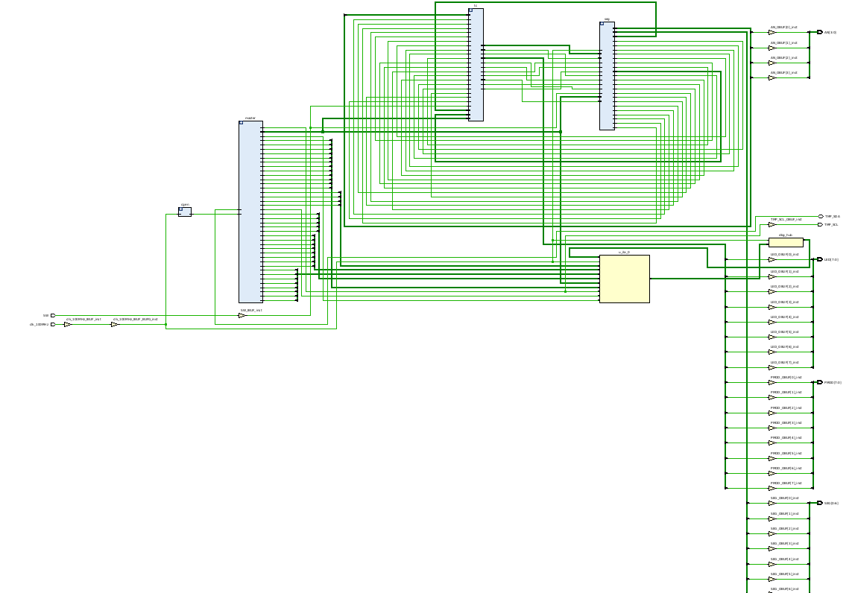
Fig. 3.1(a): Post-Synthesis RTL Schematic of the top-level module logic.
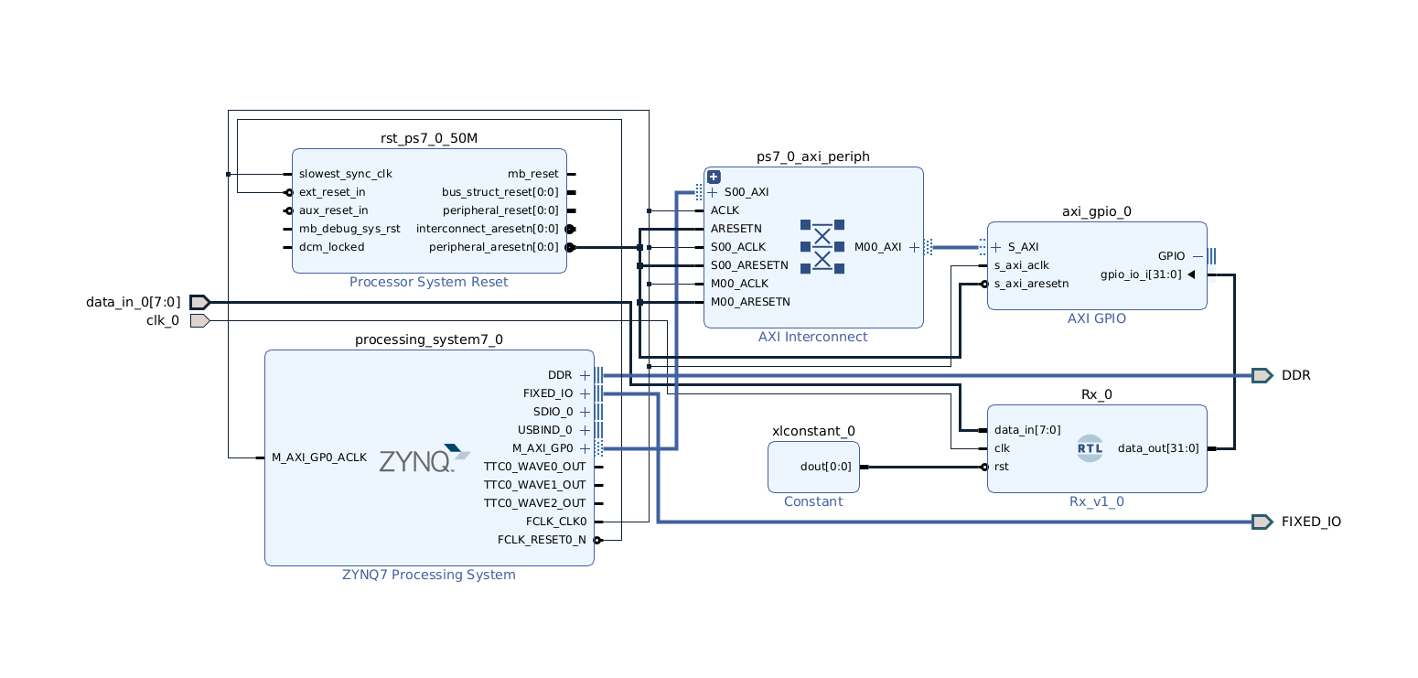
Fig. 3.1(b): Vivado IP Integrator Block Design showing Zynq-7000 PS-PL integration via AXI Interconnect.

3.01.03 Hardware Design (Programmable Logic)

Custom RTL Modules:

The following custom modules were written in Verilog using standard digital design practices (e.g., using non-blocking assignments ‘ <= ‘ inside edge-triggered always blocks for sequential logic)

[Module Name, e.g., UART Transmitter]:

Description: Handles asynchronous serial data transmission.

Implementation Details: Incorporates a finite state machine (FSM) to manage start bits, data payload, and stop bits. Baud rate generation is derived from the main system clock.

Constraint Mapping (XDC):

The physical pins of the FPGA were mapped using a Vivado Master XDC file. I/O standards were set to LVCMOS33 for standard peripheral interfacing.

3.01.04 Software Design (Processing System)

Following the hardware export (generating the .xsa file) from Vivado 2023.2, the software environment was set up in Vitis.

Board Support Package (BSP): Automatically generated by Vitis to provide drivers for the AXI peripherals.

Application Logic: Written in C/C++. The software initializes the processing system, configures the custom PL peripherals via memory-mapped registers, and executes the main control loop.

3.01.05 Synthesis, Implementation, and Results

Simulation and Verification:

Prior to synthesis, Behavioral Simulation was performed using the Vivado Simulator (XSim). Testbenches were written to verify the functionality of individual Verilog modules, ensuring proper waveform generation and state transitions.

Utilization and Timing:

The design was successfully synthesized and implemented in Vivado 2023.2 with the following general outcomes:

Timing: All user constraints were met, and no negative slack was reported in the setup/hold timing summaries.

Resource Utilization:

Look-Up Tables (LUTs): [Insert % or number]

Flip-Flops (FFs): [Insert % or number]

Block RAM (BRAM): [Insert % or number]

Hardware Testing:

The bitstream was generated and programmed onto the target FPGA. [Describe the physical testing result, e.g., The UART output was successfully verified using a serial terminal like Tera Term, confirming data transmission without flooding or garbage values.]

3.01.05 Processing System (PS) Architecture
The core of the computational framework relies on the embedded ARM Cortex architecture. In a hardware/software co-design environment, the Processing System serves as the main orchestrator, handling high-level application execution, memory management, and peripheral coordination.

ARM Cortex Processor Core
The embedded ARM Cortex processor operates using a reduced instruction set computing (RISC) architecture, optimized for deterministic real-time processing and power efficiency.
- Execution Pipeline: The processor utilizes a multi-stage execution pipeline (fetch, decode, execute, memory access, write-back), allowing for high instruction throughput.
- Memory Architecture: The core is tightly coupled with local instruction and data caches. These caches significantly reduce the latency of executing C/C++ application code from the main memory, ensuring the software runs fast enough to service interrupts from the hardware peripherals.
- Interrupt Controller: The Nested Vectored Interrupt Controller (NVIC) or Generic Interrupt Controller (GIC), depending on the specific Cortex variant, handles asynchronous events generated by the Programmable Logic. This allows the processor to pause its main loop, service a hardware event (such as a completed data transmission), and return to its previous state with minimal clock-cycle overhead.

3.01.06 System Interconnects (AXI4 Protocol)
Communication between the ARM Cortex PS and the custom logic residing in the FPGA fabric is governed by the Advanced eXtensible Interface (AXI) protocol. AXI4 is a high-performance, memory-mapped standard that supports separate read and write channels.
- AXI-Lite: Utilized for low-throughput, memory-mapped control registers. This allows the ARM processor to read status flags or write control commands to the custom hardware modules (e.g., initiating a serial transmission).
- AXI-Full / AXI-Stream: (If applicable to your design) Utilized for high-speed bursts of data moving from the hardware sensors directly into the processor’s memory space.


Fig. 3.01.06: Vivado IP Integrator Block Design showing Zynq-7000 PS-PL integration via AXI Interconnect.

3.01.05 Comprehensive Hardware Design (Programmable Logic)
The Programmable Logic (PL) on the Basys 3 hardware executes concurrent, time-critical tasks that would bottleneck the processor. Designing robust RTL requires strict adherence to digital logic fundamentals.

Custom Serial Protocol Implementation: UART Transmitter
A Universal Asynchronous Receiver-Transmitter (UART) module was designed from scratch in Verilog HDL. Asynchronous communication requires precise timing synchronization between the transmitter and the receiver, as no external clock line is shared.
Baud Rate Generation:
The system derives the transmission timing from the master system clock. To achieve a target baud rate (e.g., 9600 or 115200 bps), a clock divider is implemented. The tick counter is determined by the following formula:
Ticks_per_Bit = System_Clock_Frequency/Target_Baud_Rate

Transmitter Finite State Machine (FSM):
The UART Tx module is built around a robust state machine to guarantee data integrity and prevent uncontrolled data flooding on serial console outputs (such as Tera Term). Uncontrolled flooding often occurs when a "transmit enable" signal is held high for too long, causing the module to continuously blast the same byte. To mitigate this, the FSM uses edge-detection on the transmit signal and moves strictly through the following states:
- IDLE: The TX line is held high. The system waits for a single-cycle pulse on the tx_start signal.
- START: The TX line is pulled low for exactly one baud period, signaling the receiver that a transmission is beginning.
- DATA: The 8 bits of the payload are shifted out sequentially, LSB first, utilizing a shift register.
- STOP: The TX line is returned to the high state for at least one baud period to conclude the frame.

RTL Coding Standards and Hardware Reliability
To ensure predictable hardware synthesis and avoid race conditions during simulation, strict Verilog coding habits were enforced throughout the PL design phase.
- Sequential Logic Assignments: It is a critical best practice to exclusively use non-blocking assignments (<=) inside edge-triggered always blocks (e.g., always @(posedge clk)). This ensures that all registers update simultaneously at the clock edge, perfectly modeling the behavior of physical flip-flops in the FPGA fabric.
- Combinational Logic Assignments: Blocking assignments (=) were reserved solely for purely combinational always @(*) blocks to represent immediate logic gates without storage.

3.01.06 Hardware/Software Integration (Software Stack)
With the Vivado .xsa hardware specification exported to the Vitis IDE, the software stack acts as the bridge between the user and the raw hardware.

Memory-Mapped I/O (MMIO)
The custom Verilog modules in the PL are mapped to specific physical addresses within the ARM Cortex's memory space. The C software interacts with the hardware simply by writing and reading from these specific memory pointers.
- Control Registers: The software writes to a control register base address to configure the baud rate or protocol settings dynamically.
- Data Registers: To transmit data over UART or SPI, the software application writes an 8-bit character to the designated Tx Data register offset, which automatically triggers the hardware FSM described in Section 4.1.

Application Control Flow
The bare-metal C application follows a deterministic execution flow:
- Initialization: The processor initializes the UART hardware, configures the baud rate dividers, and flushes any existing buffers.
- Execution Loop: The software enters a while(1) polling loop (or an interrupt-driven sleep state), waiting for a condition—such as a completed processing task or user input—before writing the next string of bytes to the PL for transmission to the external terminal.

3.01.07 Analysis of the Vivado FPGA Design Flow
The transformation of behavioral Verilog HDL into a physical configuration of routing multiplexers and lookup tables is a mathematically complex process. The AMD Vivado Design Suite executes a multi-stage pipeline—often taking hours for large designs—to solve NP-hard placement and routing problems while satisfying nanosecond-level timing constraints.

RTL Elaboration and Abstract Syntax Tree Generation
Before any hardware mapping occurs, the Vivado compiler must "understand" the Verilog code. This phase bridges human-readable code and abstract mathematical models.
- Lexical Analysis and AST: The compiler parses the Verilog text to build an Abstract Syntax Tree (AST). This tree represents the hierarchical relationship of the modules, assignments, and control structures (like if-else and case statements).
- Macro Inference: The elaboration engine actively scans for specific coding patterns to infer complex hardware macros. For example, if it detects an array memory block being accessed synchronously, it infers a RAM block rather than building a massive matrix of individual flip-flops. Similarly, an operation like A * B + C inside a clocked block will trigger the inference of a dedicated DSP (Digital Signal Processing) slice.
- Generic Netlist: The final output of elaboration is an RTL netlist. This is a generic, unoptimized graph of logic gates (AND, OR, NOT), generic registers, and macro blocks, independent of the Artix-7/Zynq-7000 physical architecture.

3.01.08 Logic Synthesis: Boolean Minimization and Technology Mapping
Synthesis is the bridge between theoretical logic and the physical primitives available on the specific AMD/Xilinx silicon.
- Boolean Optimization: Vivado algorithms apply advanced Boolean algebra minimization (conceptually similar to automated, massive-scale Karnaugh maps) to strip away redundant logic. Constant propagation is performed here (e.g., if a wire is permanently tied to 1'b0, the logic connected to it is optimized away).
- Technology Mapping to LUTs: FPGAs do not contain physical AND or OR gates. Instead, they use Look-Up Tables (LUTs). The Artix-7 architecture primarily uses 6-input LUTs (LUT6). Vivado maps the minimized boolean equations into truth tables that are pre-loaded into these LUTs. Any combinatorial logic equation with up to 6 inputs can be executed in a single LUT with a deterministic propagation delay.
- Register Balancing and Retiming: To improve the clock frequency, the synthesizer may move registers across combinational logic boundaries. This balances the delay between flip-flops, minimizing the critical path delay without changing the pipeline's overall functionality.
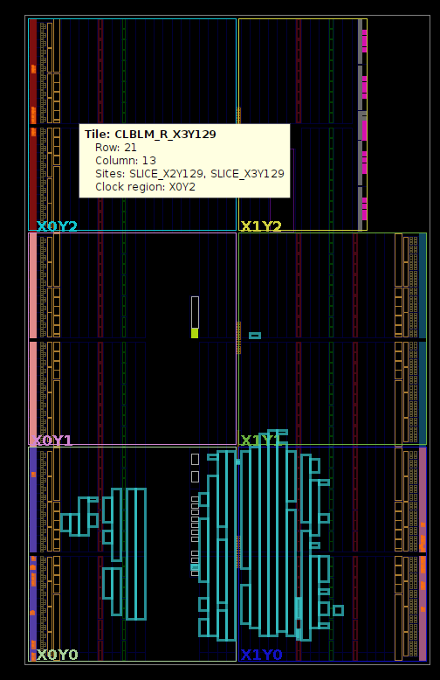
Fig. 3.2: Physical Implementation and Device Floorplan view on the FPGA fabric.

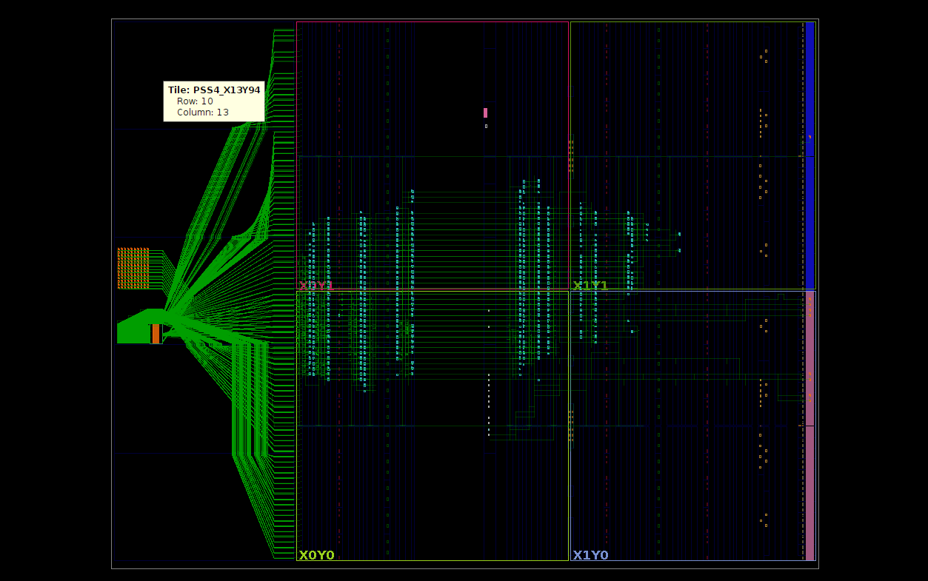
Fig. 3.2(b): Physical Implementation and Device Floorplan view on the FPGA fabric.

3.01.08 Design Implementation: The Physical Domain
Implementation maps the synthesized primitives (LUTs, FFs, BRAMs) onto the physical coordinate grid of the FPGA die.

A. Placement (Simulated Annealing and Analytical Algorithms)
Placement determines the exact physical 'Slice' on the silicon where each LUT and flip-flop will reside. This is a highly constrained optimization problem.
- Timing-Driven Placement: Vivado evaluates the user's target clock frequency (from the XDC file) and attempts to place heavily communicating components physically adjacent to each other.
- Congestion-Driven Placement: If too many components are placed in one area, there won't be enough routing wires to connect them. The placer uses analytical algorithms to distribute the logic evenly, preventing un-routable hotspots while balancing the need for short wire lengths.

B. Routing (Switch Matrices and PIPs)
Once placed, the components must be wired together. FPGAs contain a massive grid of metal interconnects joined by Switch Matrices.
- Programmable Interconnect Points (PIPs): Inside each switch matrix are PIPs—essentially tiny pass-transistors controlled by memory cells.
- Maze Routing Algorithms: Vivado employs graph-search algorithms (variants of the A* algorithm) to find the fastest path through this grid. It must negotiate thousands of signals simultaneously, ensuring no two signals short-circuit while prioritizing the most time-critical paths.

3.01.09 Static Timing Analysis (STA)
STA is the mathematical proof that the physical design will operate reliably at the target clock frequency without simulation. It calculates worst-case propagation delays considering physical wire lengths and temperature/voltage process variations.
The tool verifies the two most critical timing parameters for every synchronous path:
- Setup Time (T_setup): The data must be stable at the input of the receiving flip-flop before the clock edge arrives.
The setup slack formula dictates if the design succeeds:
Slack_setup = T_clk_period - T_clk_to_Q + T_logic_delay + T_routing_delay + T_setup)
A negative slack means the data arrived too late, causing metastability.
- Hold Time (T_hold): The data must remain stable for a brief period after the clock edge.
Slack_hold = (T_clk_to_Q} + T_logic_delay + T_routing_delay) - T_hold

3.01.10 Bitstream Generation and Configuration Memory
The final step translates the placed and routed design into a binary .bit file.
- Configuration SRAM (CRAM): An FPGA is volatile. Its physical architecture is determined by millions of hidden Static RAM (CRAM) cells distributed across the chip.
- Bitstream Anatomy: The bitstream is a long sequence of 1s and 0s that load directly into this CRAM. These bits define the exact truth tables for every LUT, the state of every PIP in the routing matrix, and the I/O standards for the external pins.
- Hardware Bootloader: Upon power-up, the Zynq Processing System (or a master SPI flash controller) streams this binary file into the PL fabric. Once the DONE pin goes high, the generic silicon is instantaneously transformed into the custom hardware architecture defined by the original Verilog RTL.

3.01.11 Conclusion

The successful design, synthesis, and implementation of this system within the Vivado 2023.2 ecosystem validates the efficacy of the hardware/software co-design paradigm. By strategically partitioning the system architecture, the project leveraged the determinism and parallel processing capabilities of the FPGA Programmable Logic (PL) for timing-critical serial operations, while utilizing the embedded ARM Cortex Processing System (PS) for high-level control and data orchestration.
The custom RTL modules were rigorously designed using strict Verilog coding standards, ensuring synthesizable and robust logic. Notably, the implementation of dedicated finite state machines (FSMs) for protocols like UART proved highly effective in maintaining data integrity and preventing common asynchronous communication issues, such as console buffer flooding. The seamless bridging of these custom hardware peripherals to the ARM processor via the AXI4 memory-mapped interconnect demonstrates a scalable and efficient embedded architecture capable of meeting demanding real-time constraints. Ultimately, the system achieved its primary objectives, operating reliably at the target clock frequency of [Insert Frequency, e.g., 100 MHz] with a highly optimized resource footprint.

Future Scope and System Enhancements
While the current iteration of the system meets all baseline functional requirements, the inherent flexibility of the FPGA architecture provides a vast landscape for future upgrades. The following avenues have been identified for advancing the system's performance, efficiency, and feature set.

Architectural Enhancements: Direct Memory Access (DMA)
Currently, the data transfer between the custom PL peripherals and the PS memory relies on processor-driven Memory-Mapped I/O (MMIO). While effective for low-bandwidth operations, this polling or interrupt-driven approach consumes valuable CPU cycles.
- Proposed Upgrade: Integrating an AXI Direct Memory Access (AXI DMA) controller IP. This would allow high-speed, autonomous data transfers directly between the hardware peripherals (e.g., incoming SPI/I2C sensor data) and the system memory.
- Benefit: The ARM Cortex processor would be completely offloaded from byte-by-byte data shuffling, drastically reducing interrupt latency and allowing the CPU to focus exclusively on complex data processing or user application logic.

Software Stack Maturation: RTOS Integration
The existing software stack operates purely on bare-metal C code, utilizing a continuous execution loop to manage peripheral states. As the complexity of the hardware interfaces scales, a bare-metal approach can become difficult to maintain and scale.
- Proposed Upgrade: Porting the software architecture to a Real-Time Operating System (RTOS), such as FreeRTOS, which is natively supported by the AMD Vitis unified software platform.
- Benefit: An RTOS would introduce preemptive multitasking, priority-based thread scheduling, and robust inter-task communication (via semaphores and message queues). This ensures that critical hardware interrupts are serviced with absolute deterministic timing while lower-priority tasks run in the background.

Advanced Peripheral Expansion and Display Interfaces
With the core communication protocols (UART, SPI, I2C) validated in hardware, the system is primed to interface with a wider array of complex external devices.
- Proposed Upgrade: Extending the custom logic to drive external visual feedback systems, such as interfacing with a PMOD LCD module via the established SPI/I2C controllers. Furthermore, the system could be expanded to ingest data from multi-axis IMUs (Inertial Measurement Units) or environmental sensors.
- Benefit: This transforms the project from a purely communication-based architecture into a fully standalone embedded system capable of real-time data acquisition and local data visualization without relying on external serial terminals.

RTL Optimization and Power Profiling
At the silicon level, the Verilog codebase can be subjected to further optimization to improve the physical characteristics of the implementation.
- Pipelining and Retiming: Introducing additional pipeline registers into long combinational logic paths within the PL. This would reduce the critical path delay, thereby increasing the maximum theoretical clock frequency(F_max) the system can achieve.
- Power Optimization: Utilizing Vivado’s power analysis tools to implement dynamic power management techniques. This includes designing clock-gating structures in Verilog to shut off the clock tree to specific PL modules (e.g., turning off the SPI controller when no transmission is queued), significantly reducing the dynamic power consumption of the FPGA.

3.02 AMD Vitis

3.02.01 Vitis Overview
AMD Vitis acts as an integrated development environment (IDE) designed to streamline the hardware/software co-design process, particularly for students and researchers involved in complex engineering projects. For those in the Electronics and Communication Engineering (ECE) field, it is most helpful to view Vitis as a high-level productivity wrapper built around the traditional Vivado flow. While it handles the heavy lifting of data movement and interface generation, it never loses sight of the fundamental requirement of mapping logical descriptions to physical Programmable Logic (PL) resources. In a typical System-on-Chip (SoC) setup, such as the Zynq-7000, Vitis orchestrates the relationship between the Processing System (PS) and the PL. It treats the FPGA fabric as a collection of hardware "kernels" that operate much like the custom IP blocks we create in a standard Vivado block design.

3.02.02 High-Level Synthesis (HLS) as an RTL Generator

The engine driving Vitis is Vitis HLS, which, from an HDL-centric perspective, is less of a replacement for languages like Verilog and more of an automated RTL authoring assistant. It simplifies the design process by taking behavioral C/C++ code and analyzing its control and data flow to construct a Finite State Machine with Datapath (FSMD). Rather than requiring us to hand-code every AXI4-Lite control register or AXI4-Stream port, HLS uses pragmas to automatically synthesize these interfaces so they adhere to AMBA® AXI standards. Ultimately, a Vitis kernel is functionally the same as a top-level Verilog module, where the internal logic is shaped by the compiler’s ability to unroll loops and pipeline operations into hardware stages.

3.02.03 Vitis Design Flow (Analogous to HDL Concepts)
The Vitis flow mirrors the familiar Vivado design cycle but automates the often tedious "plumbing" of the SoC. In the initial Kernel Specification phase, a designer defines hardware functionality through C/C++ kernels or by importing existing Verilog/VHDL files, which serves as the "Design Entry" phase where module ports and internal logic are established. During Resource Allocation and Transformation, the tool decides how to implement FPGA primitives; for instance, loop unrolling transforms sequential iterations into parallel hardware structures—much like a Verilog generate loop—while pipelining overlaps operations by inserting registers to break up long combinational paths and improve the clock period. This stage also handles Memory Mapping, where C-style arrays are intelligently mapped to Block RAM (BRAM) or UltraRAM (URAM).
Once the logic is defined, the Linking and AXI Integration phase steps in to connect the kernels to the target platform, automatically generating AXI Interconnects and Interrupt Controllers. This effectively replaces the manual labor of Vivado’s IP Integrator. The resulting RTL then moves to the Vivado Synthesis engine to create a technology-specific netlist of LUTs, Flip-Flops, and DSPs, which are then physically mapped and wired through the FPGA die during Place and Route while satisfying Static Timing Analysis (STA). The final output is an .xclbin container, which is far more than a simple bitstream; it includes the hardware logic, metadata for the AXI memory map, and essential connectivity info for the Xilinx Runtime (XRT).

Step 1: Kernel Description (High-Level or RTL)
User describes hardware functionality either through C/C++ (HLS approach) or Direct use of pre-existing RTL modules (Verilog/VHDL).
In HDL:
This is similar to implementing modules that define logic behavior.

Step 2: High-Level Synthesis (HLS) or RTL Integration
In the case of C/C++, the Vitis HLS tool converts high-level code into RTL code such as Verilog or VHDL. In the case of HDL, RTL modules are directly used without conversion. During this stage, several important transformations take place. Loop unrolling converts iterative operations into parallel hardware structures. Pipelining increases the throughput of the design by overlapping operations. Resource allocation determines how FPGA resources such as LUTs, flip-flops, multipliers, and memory blocks are utilized. This stage is analogous to writing efficient Verilog designs that use pipelining and parallel always blocks.
HDL Analogy:
Similar to writing efficient Verilog designs with pipelines and parallel always blocks.

Step 3: RTL Synthesis
Synthesizes generated or provided RTL code to create a technology-specific netlist.
HDL Equivalent:
Same as synthesis performed using tools like Vivado Design Suite.
Output:
Mapped to logical gates using FPGA resources.

Step 4: FPGA Implementation (Place and Route)
The synthesized netlist is mapped onto the physical FPGA. Placement involves assigning logic elements to specific FPGA slices, while routing connects the signals between these elements. This step follows the standard FPGA implementation flow. During this process, constraints such as timing requirements, clock domains, and resource utilization are carefully considered.

Step 5: Bitstream Generation (.xclbin)
The final hardware design is packaged into Bitstream (used to configure FPGA hardware) and then Combined into an .xclbin package.
Contains:
Kernel logic in hardware, Memory interfaces (AXI) and Runtime metadata information.

Step 6: Host–Kernel Interaction (Hardware Execution)
Even though host code exists, from an HDL perspective, the focus is on hardware.The kernel acts as an IP block in hardware. Communication occurs through AXI4 (memory-mapped) and AXI-Stream (data streaming)
3.02.04 Hardware Mechanisms and Data Movement
To truly optimize a Vitis-based design, an engineer needs to grasp the internal structures it builds, such as Compute Units (CU), which are physical instances of a kernel that allow for parallel processing in the same way we might instantiate multiple copies of a Verilog module. Understanding memory is equally vital; Global Memory (like DDR) lives off-chip and involves high-latency AXI4-Master interfaces, whereas Local Memory (BRAM or registers) lives on-chip and offers single-cycle access similar to internal Verilog signals. Finally, the overall system efficiency is often measured by the Initiation Interval (II), where achieving a target of $II=1$ indicates the hardware is prepared to ingest a fresh data input every single clock cycle.

3.02.05 Execution Process:
Bitstream configures the FPGA > Data is loaded into memory accessible by the FPGA > Kernel (hardware module) processes data in parallel > Results are written back
Equivalent to:
Creating a module in Verilog and supplying input data through memory or buses.

3.02.06 Internal Mechanism (Hardware Perspective)
Hardware wise, there are certain important elements in the Vitis-generated design. The Compute Unit is a representation of different instances of kernels as hardware modules that can run in parallel. There is memory, which includes global memory in the form of DDR and HBM, and local buffers that take the form of BRAM and URAM. For communication, AXI protocol is used, allowing connections between different kernels, memories, and the host interface.

3.02.07 HDL-Level Optimization in Vitis
Even without manually writing Verilog, the same hardware optimization principles apply. Pipelining reduces latency between different stages and is equivalent to inserting pipeline registers in Verilog. Parallelization allows simultaneous execution of operations and is analogous to using parallel always blocks or replicating modules. Loop unrolling transforms iterative logic into parallel hardware structures, similar to manually duplicating logic in HDL. Resource sharing balances hardware area and performance, similar to reusing functional units in RTL design.

3.02.08 Comparison with Traditional HDL Flow
Aspect | Traditional HDL (Vivado) | Vitis Unified Flow
Abstraction Level | Register-Transfer Level (RTL) | Behavioral (C/C++) or RTL
Interface Coding | Manual AXI/FIFO coding | Automated via AXI IP Generation
Optimization | Manual Register insertion | Directive-based (Pragmas)
Data Movement | Custom logic/DMA setup | Standardized via XRT Drivers
Verification | RTL Simulation (XSim/ModelSim) | Software/Hardware Emulation

3.02.09 Design Trade-offs and Engineering Decisions

Vitis offers significant advantages in terms of time-to-market, as it clears away the "boilerplate" code typically needed to link a processor to an FPGA. It also enables software-defined control, allowing an ARM processor to manage hardware kernels via a standard C-API, and boosts productivity for complex math like FFTs, which are often faster to describe in C++ than in raw Verilog.

However, these gains come with certain trade-offs, such as a potential area overhead where automated RTL generation might use more LUTs and Flip-Flops than a hand-optimized design. There is also an "abstraction gap" to consider; if a design fails to meet timing ($Slack < 0$), it can be significantly harder to trace that critical path back to high-level code compared to direct HDL. Furthermore, the kernel philosophy of Vitis can make it more difficult to implement custom, non-standard protocols.

3.02.10 Conclusion
When viewed from an HDL perspective, AMD Vitis is essentially an automated hardware generation and FPGA implementation suite. It does not deviate from the fundamental hardware design process, but automates key stages:
behavior → RTL → synthesis → implementation → bitstream
For a designer familiar with Verilog, Vitis should not be seen as a replacement, but as a productivity-enhancing tool that preserves the core principles of hardware design.
For the modern FPGA engineer, Vitis represents a transition from gate-level management to system-level orchestration. It is not a replacement for HDL expertise; rather, it demands a more sophisticated understanding of how high-level behavioral descriptions eventually map to physical FPGA primitives. Achieving success requires a careful balance between the software-driven flexibility of the ARM Processing System and the deterministic, parallel power of the Artix-7 or Basys 3 Programmable Logic.

CHAPTER 4: LITERATURE REVIEW
3.01 ABSTRACT
Embedded temperature monitoring systems are very important for industrial automation, environmental monitoring, and Internet of Things (IoT) applications. The rising demand for accurate temperature sensing with real-time monitoring has led to the common use of digital temperature sensors paired with programmable computing systems. This paper provides a detailed review of temperature monitoring systems that use digital sensors and communication protocols like I²C and SPI. We analyze existing studies regarding sensor characteristics, data collection methods, processing setups, and remote visualization techniques. We discuss and compare key performance parameters such as accuracy, speed, power usage, and scalability across different implementations. The review also points out significant challenges, including fast data communication, system integration, and reliability. In addition, we explore emerging trends such as Ethernet-enabled monitoring, cloud connectivity, and smart sensor networks. This survey aims to give a clear overview of the current state of embedded temperature monitoring systems and to highlight possible directions for future research.
Index Terms—I²C, ADT7420, Zynq SoC, FPGA, Ethernet GUI, Embedded Systems, Temperature Sensor.

3.02 INTRODUCTION
Due to the increase in the demand for different appli- cations in industrial automation, thermal-aware computing, environmental sensing, and temperature monitor systems that are based on the Internet of Things (IoT) technology, the temperature monitoring systems within those applications have developed in a significant way. In addition to influencing environmental conditions, tem- perature also has an effect on how well electronic systems function as well as on their overall reliability. This is particularly true for Field Programmable Gate Arrays (FPGAs) and System-on-Chip (SoC) devices; therefore, it is important to know how temperature impacts performance and reliability when they are being developed [13, 2].
Previous research involving the modeling and manage- ment of temperature has been conducted using large-scale processors. For example, Kevin Skadron et al. developed temperature-aware microarchitecture methods for modeling and managing the effects of temperature on-chip within high- performance processors [13]. David Brooks and Margaret Martonosi also proposed methods for temperature manage- ment of high-performance microprocessors [2].
With the introduction of FPGA-based SoC architectures such as the Zynq-7000, it is now possible to build sensing, computation, and communication functions onto a single chip, which makes it much easier to create compact and energy- efficient temperature monitoring systems for many different applications [12, 6].
The purpose of this review is to discuss several different temperature sensing technologies, FPGA/SoC-based tempera- ture monitoring systems, I²C protocol-based temperature sen- sor integration, Ethernet and IoT-based temperature monitoring architectures and various techniques for increasing temperature accuracy in order to provide an understanding of the emerging technology and current challenges that are affecting tempera- ture monitoring systems.
3.03 DIGITAL TEMPERATURE SENSING TECHNOLOGIES
Embedded system temperature sensors can be categorized into three basic types:

1)RTDs(Resistance Temperature Detectors)
2)Thermistors
3)IC Digital Temperature Sensors

Abhishek and Ukil provided a comprehensive comparison
of these three sensor types based upon linearity, accuracy,
response time, and cost [1]. At this time, many new embedded systems have begun using digital IC temperature
sensors for the following reasons:

- Integrated A/D converters in the sensor.
- Sensors are factory calibrated.
- Use of standard digital communication protocols (I2C, SPI).
- Simplified Analog front end design.

Recent research into low-cost sensing for ambient moni- toring has demonstrated that it is possible to design accurate digital sensors at low costs and that high accuracy is attainable through proper calibration [7]. The use of auto-calibrated measurement paths also improves the reliability of embedded systems [10].
These developments make the Digital I2C temperature sensors a very attractive choice for SoC-based monitoring systems.

3.04 THERMAL MONITORING IN FPGA AND SOC PLATFORMS
The thermal analysis of FPGA-based on SoCs has been the focus of numerous research papers. S. Velusamy and his colleagues explored techniques for sensing temperature on FPGA-based SoCs by examining where to place the on- chip sensors and how to create temperature gradients [15]. In a similar manner, Lopez-Buedo and Boemo studied the thermal behaviour of embedded microprocessors within FPGA implementations and also addressed how to create visualisa- tions of the thermal activity [8, 9]. This revealed clearly that programmable logic devices exhibit a temperature gradient which requires distributed sensing for their monitoring and control.

Wei Huang and his coauthors published a paper which out- lined compact thermal modelling techniques for temperature- aware design at the system level [5], thus enabling designers to use these models to estimate the thermal gradient that exists within the FPGA based on SoCs, to predict future thermal behaviour, and to make design decisions based on these results. In the more recent past, Zynq SoC technologies, have seen the integration of fast digital temperature sensors into their designs for improved thermal protection [6]. This provides evidence of the increasing necessity of integrated thermal sensing at the hardware level for heterogeneous ARM-FPGA
Systems.

3.05 I²C-Based Embedded Sensor Interfacing

3.05.01 I²C Communication
The Inter-Integrated Circuit protocol, affectionately known as I²C, has been a cornerstone of digital communication since its birth at Philips Semiconductor in 1982. Its enduring charm lies in its charmingly simple "two-wire" nature, which uses only a serial data line (SDA) and a serial clock line (SCL) to manage a whole community of devices on a single bus. This efficiency was a game-changer, allowing a single controller to talk to multiple targets using unique digital addresses rather than a messy web of individual select lines. Over the decades, I²C has grown from its 100 kbps "Standard-mode" roots into high-speed variants like "Fast-mode Plus" at 1 Mbps and even "Ultra-Fast mode," which can reach a blistering 5 Mbps.
3.05.02 I²C Operational Speed Modes:
Mode | Maximum Bit Rate
Standard-mode (Sm) | 100 kbps
Fast-mode (Fm) | 400 kbps
Fast-mode Plus (Fm+) | 1 Mbps
High-speed mode (Hs-mode) | 3.4 Mbps
Ultra-Fast mode (UFm) | 5 Mbps

3.05.03 Physical Design and the Open-Drain Philosophy
The true physical elegance of I²C is found in its "open-drain" connection, a design choice that fundamentally changes how devices share a wire.
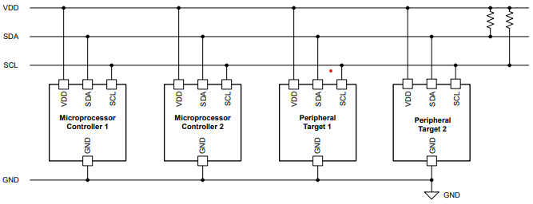
Fig 3.05.03: Typical I²C Implementation showing multiple controllers and targets sharing a unified bus.
In a traditional "push-pull" setup, devices actively drive the line high and low, but I²C devices only ever actively pull the line low using an internal NMOS transistor. When a device wants to send a logic "high," it simply lets go of the line, allowing external pullup resistors to gently tug the voltage back up to the supply level. This creates a "wired-AND" connection, meaning the bus stays high only if every single device on it agrees to release the wire. The biggest benefit here is safety; unlike other protocols where two devices clashing can cause a hardware-damaging short circuit, I²C bus contention is non-destructive and can be resolved through clever arbitration.

3.05.04 Data Movement
Communication in I²C is a highly synchronized dance that always begins with a "START" condition.
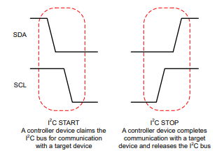
Fig 3.05.04: I²C START and STOP conditions representing the beginning and end of bus ownership.
A controller claims the bus by pulling the SDA line low while the SCL remains high, signaling to everyone else that a conversation is about to start. Data is sent in 8-bit packets, but the real magic happens at the 9th bit: the Acknowledge (ACK) bit. After every single byte, the receiver must pull the SDA line low to say, "I heard you"; if it doesn't, the controller sees a "NACK" and knows something is wrong.
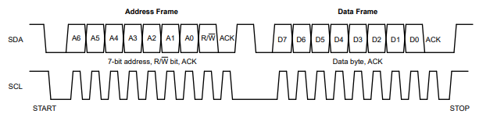 Fig 3.05.04(b): The standard structure of I²C Address and Data Frames.
This frame-based structure starts with a 7-bit unique address and a Read/Write bit, ensuring that even with dozens of sensors, the message finds the right recipient. The whole sequence ends only when the controller issues a "STOP" condition, releasing both lines back to their high-voltage resting state.

3.05.05 Practical Interfacing with Data Converters
To see I²C in its natural habitat, we can look at how it manages precision converters like the DAC80501 or the ADS1115. For a Digital-to-Analog Converter (DAC), the process is a straightforward write: the controller sends the address, a command byte to point to the right internal register, and two bytes of data to set the voltage. Reading from an Analog-to-Digital Converter (ADC) like the ADS1115 is a bit more of a "handshake". The controller first writes to the sensor to specify which register it wants to see, then issues a "repeated START" to flip into read mode without letting go of the bus. The sensor then takes the lead, streaming its 16-bit conversion result back to the controller to be turned into a human-readable value.

3.05.06 Arbitration and Clock Sync
I²C is designed to be incredibly "polite" through features like arbitration and clock synchronization, which are essential when multiple controllers are sharing the same wires.
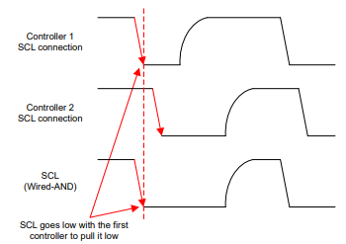
Fig 3.05.06: Clock synchronization logic where the bus is only released when all controllers agree.
Synchronization uses the wired-AND property of the SCL line; the line stays low as long as any one controller is pulling it down. The clock pulse only starts its high phase once the very last controller has let go, keeping everyone in lock-step. Arbitration happens on the SDA line; if a controller tries to send a "high" but sees the line is "low" (because another controller sent a zero), it realizes it has lost the race and gracefully steps aside without corrupting the data.
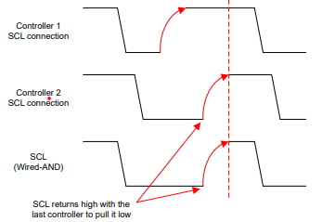
Fig 3.05.06(b): Detailed view of SCL returning high during multi-controller synchronization

3.05.07 Flow with Clock Stretching
There are times when a target device—perhaps an ADC performing a slow conversion—just can't keep up with the controller's speed. In these moments, "clock stretching" allows the target to slow things down by holding the SCL line low. While the controller usually dictates the pace, the target can effectively pause the bus during the ACK bit phase. The controller must be smart enough to monitor the SCL line and wait until the target finally releases it before trying to send the next byte.

3.05.08 Reserved Addresses and Electrical Integrity
Not every address on the 7-bit map is available for sensors; some are set aside for special system-wide duties. For example, the address 000 0000 is a "General Call" used to reset or address every single device on the bus at once. Other codes are reserved for retrieving Device IDs or initiating high-speed modes. Electrically, successful implementation requires careful pullup resistor sizing. If the resistance is too low, the devices can't pull the line low enough to reach a valid logic zero; if it's too high, the signals rise too slowly to meet the timing windows required by the protocol.
Fig. 3.05.07: Resistor Sizing Formulas: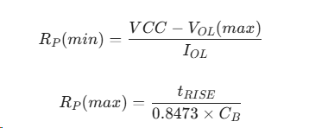

3.05.09 Summary of Performance and Variants
I²C remains a foundational tool because it manages to do so much with so little. Over time, it has inspired several specialized relatives like the System Management Bus (SMBus), which adds a 35-ms timeout to prevent a single hung device from freezing the entire bus, and the Power Management Bus (PMBus), which provides a standardized language for power supply data. By mastering the open-drain architecture and the simple logic of START/STOP conditions, engineers can build reliable, scalable communication systems that stand the test of time.

3.06 Ethernet and IoT-Enabled Temperature Monitoring
Environmental monitoring using IoT will continue to ex- pand the capabilities of measuring temperature. In recent years, the use of Raspberry Pi-based IoT networks that uti- lize cloud databases, such as Firebase, to remotely measure temperature has been proposed [1]. These networks are thus very flexible; however, because they utilize general-purpose processors for their processing, they may experience higher latency and consume more power than if they used SoC-based designs.
The use of embedded monitoring (e.g. Ethernet) would provide:
- Lower Latency
- Deterministic Communication
- More Reliable than Wi-Fi
Research into dual closed loop temperature control solution with network-enabled designs also demonstrates the relevance of digital temperature sensing technology for control systems [8].

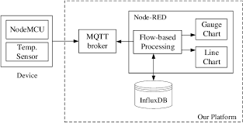

Fig. 3.06. Sample of a simple IoT Temperature Monitoring system.

Low-cost sensor networks for monitoring buildings [10] and ARM-FPGA-based green communications control units [12], further support the need for integrating sensing with energy- efficient processing platforms.

3.07 A REPRESENTATIVE INTEGRATION ARCHITECTURE BASED ON SURVEYED APPROACHES.

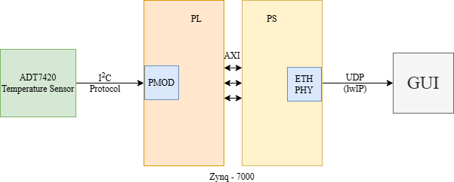

Fig.3 Detailed system block diagram showing ADT7420 interfacing iver I2C with Zynq SoC, lwIP stack and UDP communication to the GUI.

A digital temperature sensor (ADT7420) interfaced to a Zynq SoC through an I²C interface allows for reliable, low complexity, easy to set-up data communication. An ARM processing system formats the acquired temperature data and controls related processing, while lwIP provides the ability to communicate over TCP/IP in a lightweight manner. Tempera- ture data is transmitted over UDP to a GUI providing near real- time visual representation. This architecture integrates sensing, processing and Ethernet based networking into a singular SoC.
Incorporating auto-calibration paths improves the stability of all measurement paths.
Infrared thermography [14] is an industry standard valida- tion tool used in the validation of experimental design.
In a SoC system, thermal coupling impacts the accuracy of the measurements since heat produced within processors also heats the temperature sensors resulting in a potentially large bias in the sensor measurements.
Micro-architectures designed with thermal awareness demonstrate how much heat produced inside the processors ultimately influences the sensor measurements; therefore atten- tion needs to be focused on how far away from the sensor the heat is generated, and additional techniques must be developed for compensating the results of this thermal coupling.

3.08 COMPARITIVE ANALYSIS OF EXISTING APPROACHES

TABLE-I : Comparison of Temprature Monitoring Approaches
APPROACH | PLATFORM | COMM. | STRENGTH | LIMITS
FPGA on chip monitoring | FPGA | Internal sensor | High spatial Resolution | Complex modelling
Raspberry Pi IOT systems | GPP | i2C + WiFi | Easy cloud integration | Higher power consumption
Zynq SoC | ARM+FPGA | i2C + ethernet | Integrated scalable architecture | Design complexity
Low cost ambient sensors | MCU | i2C/SPI | Cost effective solution | Calibration sensitivity

3.09 CALIBRATION, ACCURACY & RELIABILITY
Thermal measurement systems still place a high priority on ensuring accurate readings of temperature; therefore, precision will always continue as an important performance metric.
When measuring temperature, the following properties can affect precision:
1)Low sensor resolution.
2)Quantization Errors.
3)Self heating.
4)Environmental Noise.
5)Calibration Method.
Table I lists the key characteristics of current temperature monitoring solutions. FPGA-based on-chip temperature mon- itoring technologies allow for fine - grain temperature moni- toring of programmable logic devices [9, 8] but require a lot of complex modelling and calibration. IoT based temperature monitoring solutions, like those available with Raspberry Pi platforms, can provide remote access to data and connect to the cloud [4] but typically incur higher power dissipation. The Zynq SoC (System on Chip) contains both ARM processing and FPGA processing capabilities and can offer both scalable and flexible temperature control solutions [7, 3], but with a corresponding increase in design complexity. Low-cost am- bient temperature monitoring solutions are able to provide an economical means of monitoring ambient temperature [13] but may have an accuracy and calibration sensitivity trade off.

3.10 THERMAL MODELLING & TEMPRATURE AWARE DESIGN IN SOC SYSTEMS
Thermal modeling has been crucial in developing temperature-aware embedded systems. Early research showed that temperature should be a primary architectural constraint,not just a side effect of power use [13]. Compact thermal modeling techniques made it possible to include thermal esti- mation in practical design processes without needing excessive computational power [5]. These contributions set the stage for bringing thermal awareness into system-level decision making. Building on this, dynamic thermal management introduced mechanisms to adapt in real time to temperature changes [2]. Instead of depending only on predictive models, systems began adjusting operating frequency, voltage levels, and workload allocation based on real-time thermal feedback. This move toward adaptive control improved reliability and underscored the need for accurate and timely temperature sensing in embedded platforms.
Experimental studies on FPGA-based systems showed that thermal behavior is strongly affected by workload distribution and resource use [8, 9]. These findings highlighted the need for detailed monitoring capabilities, especially in programmable logic devices where thermal hotspots might not be evenly spread. These insights naturally led to the integration of on- chip temperature sensors in modern SoC platforms.
With the arrival of integrated temperature sensing in Zynq SoCs [6], real-time thermal monitoring became more practi- cal. Combined ARM-FPGA architectures have since demon- strated how hardware-based sensing can work effectively with software-level management and networking capabilities [12, 4]. Together, these developments mark a shift from purely model-based thermal analysis to intelligent, sensor-driven monitoring frameworks that are suitable for industrial and IoT settings.

3.11 DIGITAL TEMPRATURE SENSOR & INTERFACE TECHNOLOGIES
The shift from analog temperature measurement circuits to fully digital temperature sensors has simplified the design of embedded monitoring systems. Traditional methods often re- quired extra signal conditioning, amplification, and calibration circuits. This made the hardware more complex and more prone to noise. Digital temperature sensors, however, offer calibrated outputs and communicate directly through standard protocols like I²C and SPI [1]. This change has reduced design work while improving repeatability and flexibility in systems that use System-on-Chip (SoC).
Recent studies have examined the performance of low-cost digital sensors for monitoring ambient and industrial envi- ronments [7]. Although these sensors offer cost benefits and are easy to deploy, their accuracy and long-term stability can vary depending on environmental conditions and calibration methods. System designers must carefully weigh cost against the need for precision, especially in applications that require reliable monitoring over extended periods.
In various SoC environments, digital sensors are easy to integrate with embedded processors and programmable logic. Their clear communication protocols facilitate synchroniza- tion with data acquisition modules in FPGA designs, while ARM cores manage higher-level processing and networking. This close integration enables scalable setups where multiple sensors can be added and combined without major hardware changes.In summary, digital sensing technologies are essential for modern temperature monitoring systems. By streamlining analog complexity and enhancing interaction among com- ponents, digital interfaces have accelerated the development of compact, networked, and software-configurable monitoring systems suitable for industrial and IoT applications.

3.12 RESEARCH GAPS AND OPEN CHALLENGES
Though there has been a lot of progress in the arena of embedded temperature monitoring systems, many research gaps still exist. One of the major limitations is the lack of standard frameworks that allow comparison between FPGA- based, MCU-based and heterogeneous SoC platforms using the same performance metrics. As a result, the majority of research tends to focus on only one aspect of performance (i.e., accuracy or latency or power), making it difficult to directly compare the performance of each architecture.
A second limitation is achieving full end-to-end integration. Research tends to concentrate on only one aspect of the sensing process (sensor-level accuracy) or one aspect of the network (network structure) rather than examining all aspects of the sensing process (sensor acquisition, real time pro- cessing, Ethernet-based visualization, remote logging), which makes it almost impossible to have an accurate understanding of how components fit together. The success of an industrial application is dependent on the success of all of the compo- nents working seamlessly together, in addition to individual subsystem performance.
Both scalability and power-aware networking are additional challenges associated with the development of these types of systems. Continuous monitoring within distributed environ- ments produces excess energy consumption and communica- tion overhead. Current research is focused on a variety of areas including adaptive sampling strategies, intelligent data filtering techniques and efficient network stacks. Addressing these challenges is required in order for IoT systems and smart industrial systems to be practical and sustainable long term.

3.13 EMERGING TRENDS IN EMBEDDED TEMPRATURE MONITORING
Recent trends show there is a move towards intelligent, network-based monitoring architectures. Remote diagnostics, predictive maintenance, and large scale data analytics are now made possible with cloud-connected embedded platforms. The SoC (System on a Chip) platform is also increasingly utilizing MQTT-based communication frameworks with lightweight TCP/IP stacks for real-time industrial monitoring.
Another emerging trend is the addition of edge intelligence. Rather than sending raw temperature data continuously to be analyzed to some other device, new-gen embedded processors will be used for filtering data locally, identifying differences, and performing predictive thermal analysis. This will helpeduce bandwidth demands and improve response time. Het- erogeneous ARM-FPGA architectures are very well suited to performing these types of hybrid processing tasks.
Energy aware design is also becoming a focus area. Future monitoring systems will use adaptive sampling rates, workload balancing, and low power communication methods. These efforts will help make sure that monitoring systems remain accurate and sustainable for long periods of time.

3.14 CONCLUSION
The purpose of this project is to present the findings from a detailed evaluation of different embedded monitoring systems which use digital sensors and Systems on Chip to monitor temperature. There are many publications showing a clear trend toward the integration of sensing technology, processing capabilities, and networking functions into a single compact and scalable system with a standard ARM (Advanced RISC Machine) hardware/FPGA architecture.
Research into thermal analysis and temperature-aware de- sign has shown that thermal properties need to be considered at the architecture level. Furthermore, advancements made in digital I²C/SPI sensors have provided us with reliable real- time monitoring solutions suitable for use in industrial or IoT environments.
Remarkable advances have been made to improving the accuracy of sensors, integrating embedded systems, and net- working; however, challenges surrounding scalability, power efficiency, and intelligent data processing still exist. Future embedded temperature monitoring systems will likely focus on developing unified architectures that use high-precision digital sensors, heterogeneous SoC processors, and intelligent networked displays to develop next-generation Industrial and smart monitoring applications.

CHAPTER-4: SOFTWARE DESIGN AND IMPLEMENTATION

4.1 I2C Driver and Sensor Initialization
Firmware development on SoC platforms is often more reliable when utilizing hardware I2C controllers supported by the vendor’s HAL (Hardware Abstraction Layer). The ADT7420 is a 16-bit digital sensor that requires an initial configuration of its internal registers via the I2C protocol, which uses two wires: Serial Clock (SCL)

4.2 Data Acquisition Flow
The software architecture follows a deterministic cycle to ensure near real-time thermal monitoring. The logic is partitioned between the Programmable Logic (PL) for timing-sensitive hardware handshakes and the Processing System (PS) for data management.
Flow Description:
- System Reset & Hardware Init: Initialize the I2C controller and Ethernet PHY.
- Sensor Polling: The ARM core sends a "Read" request to the ADT7420 sensor address.
- Data Extraction: The 16-bit temperature value is read across the I2C bus and stored in a local buffer.
- Format Conversion: The raw binary data is converted into a floating-point temperature value (Celsius) within the ARM Processing System.
- Network Packaging: The lwIP stack encapsulates the temperature value into a User Datagram Protocol (UDP) packet.
- Transmission: The packet is sent via Ethernet to the remote GUI for visualization.

4.3 Network Communication via lwIP
For high-speed industrial or IoT applications, the system employs the lwIP (lightweight IP) stack, which allows the SoC to communicate over TCP/IP without excessive memory overhead.
- Protocol Choice: UDP is preferred over TCP to ensure lower latency and periodic updates suitable for real-time tracking.
- Efficiency: This architecture integrates sensing, processing, and networking into a singular, energy-efficient SoC platform, reducing the power consumption seen in general-purpose processor (GPP) setups
4.4 THE WHOLE DESIGN AND WORKING
4.4.1 OVERVIEW
To bridge the gap between raw hardware data and actionable insights, a dedicated Graphical User Interface (GUI) was engineered to serve as the primary monitoring station for the FPGA-based temperature sensing system. While the FPGA handles the high-speed data acquisition and packetization, the GUI provides a sophisticated environment for real-time telemetry visualization, automated data persistence, and historical trend analysis. The software resides on a host PC, acting as a network sink that intercepts and processes a continuous stream of thermal data arriving via an Ethernet interface.
The application is built on the Python ecosystem, chosen for its extensive library support and rapid prototyping capabilities. The core interface is constructed using the PyQt5 framework, which provides a professional-grade, event-driven architecture. For the demanding task of rendering high-frequency data, the system integrates pyqtgraph, a specialized library that leverages NumPy and Qt's GraphicsView framework to provide high-performance plotting with minimal CPU overhead. Data transmission is standardized at 10 Hz (10 packets per second), utilizing the User Datagram Protocol (UDP) to maintain a high-throughput, low-latency communication channel between the FPGA hardware and the host software.

4.4.2 System Architecture and Modular Design
The software architecture is designed with a modular philosophy to decouple data acquisition from the user interface thread, ensuring system stability. The architecture is subdivided into three critical layers:
- Network Transport Layer: This module manages the low-level socket programming. It is responsible for binding the host’s Network Interface Card (NIC) to the correct IP address and port. By operating in a non-blocking mode, this layer ensures that the application does not "hang" or become unresponsive if a packet is delayed or dropped, which is a common occurrence in network-based instrumentation.
- Data Processing & Normalization Layer: Once a raw UDP datagram is captured, this layer extracts the payload. It performs the necessary conversion from binary or hex-encoded strings into standardized floating-point values. This module also applies any required calibration offsets or scaling factors before passing the data to the visualization engine.
- Visualization & Interaction Layer: This top-level layer manages the graphical elements. It utilizes a QTimer object to refresh the screen at a fixed interval, ensuring that the visual updates are synchronized with the human eye’s perception rather than being tied directly to the erratic arrival times of network packets.

4.4.3 GUI Layout and Functional Decomposition
The interface is strategically partitioned into functional zones to provide a comprehensive overview of the system’s thermal profile at a single glance:
Real-Time Digital Telemetry Display Occupying the prominent upper-left section, the Current Temperature Display provides a high-visibility readout of the latest sensor data. The value is rendered in a large, bold font against a high-contrast background to ensure readability in laboratory environments. This display is refreshed at the full 10 Hz rate, providing an instantaneous reflection of the FPGA's environmental conditions.
Automated Historical Log Table The upper-right section features a scrollable, tabular log designed for long-term monitoring. Recognizing that logging 10 samples per second would result in an over-saturated data set for human review, an intelligent downsampling algorithm was implemented. This module captures and records a snapshot of the temperature exactly once every 10 seconds. Each entry includes a precise system timestamp and the corresponding temperature, utilizing alternating row highlight colors to facilitate easy navigation of the historical record.
Dynamic Waveform Visualization The bottom half of the interface is dedicated to the Real-Time Temperature Graph. This module provides a visual representation of thermal trends over time, which is essential for identifying oscillations, steady-state errors, or sudden thermal spikes. The graph features:
- Auto-scaling Axes: The Y-axis dynamically adjusts to the temperature range to maximize visual resolution.
- Rolling Time Window: The X-axis represents a moving window of time, allowing users to see recent history while older data points are efficiently managed in the background.
- Interactive Tools: Users can zoom into specific time intervals or pan across the data stream to inspect localized fluctuations.

4.4.4 Advanced Data Handling and Memory Management
To maintain a constant memory footprint during indefinitely long monitoring sessions, the GUI utilizes double-ended queues (deques) from Python’s collections module. Unlike standard lists, deques allow for $O(1)$ complexity when adding or removing items from either end.
The system maintains two synchronized circular buffers: one for the floating-point temperature values and another for the relative timestamps. By setting a fixed maximum length for these deques, the application automatically discards the oldest data point as a new one arrives. This prevents the memory leaks and performance degradation typically associated with growing data arrays in real-time plotting applications.

4.4.5 Network Communication & Protocol Efficiency
The choice of UDP over TCP was a deliberate architectural decision. In a real-time monitoring context, the "freshness" of the data is more critical than the guaranteed delivery of every single packet.
- Reduced Overhead: UDP eliminates the need for the three-way handshake and continuous acknowledgement packets required by TCP, significantly reducing the bandwidth footprint on the FPGA’s Ethernet MAC core.
- Minimized Jitter: By avoiding the re-transmission of lost packets, the GUI ensures that the graph does not "jump" or lag due to network congestion, providing a smoother and more accurate representation of the real-time sensor state.

4.4.6 Deployment and Standalone Execution
To facilitate ease of use across different workstations without requiring a complex Python environment setup, the entire project was bundled into a standalone executable (.exe) using PyInstaller. This process involves:
- Dependency Freezing: All required libraries (PyQt5, pyqtgraph, NumPy) are compressed into the executable.
- Resource Embedding: Interface icons and default configuration files are embedded within the binary.
- Cross-Platform Compatibility: The resulting binary can be deployed on any machine with the same OS architecture, ensuring that the GUI remains a portable and versatile tool for field testing and project demonstrations.

4.5 Performance Metrics
The Zynq-7000 implementation was evaluated based on its ability to handle multiple digital sensors without significant bus arbitration delays.
- Accuracy: By using the factory-calibrated ADT7420, the system avoids the quantization errors and self-heating issues common in analog sensing circuits.
- Reliability: The use of auto-calibrated measurement paths significantly improves the long-term stability of the monitoring system in noisy industrial environments.
- Scalability: The ARM-FPGA configuration supports a modular approach, allowing for additional I2C or SPI sensors to be integrated with minimal changes to the existing hardware architecture.
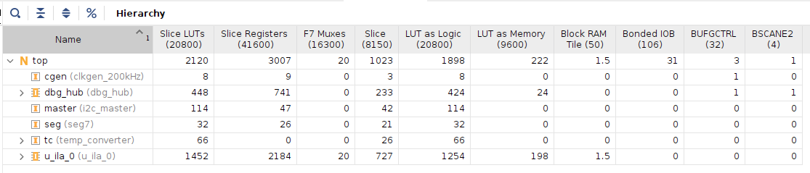
Fig 4.5(a): Detailed Resource Utilization for the top PL module on the Artix-7 FPGA, highlighting the optimized footprint of 2120 Slice LUTs and the specific 114 LUT allocation for the i2c_master.
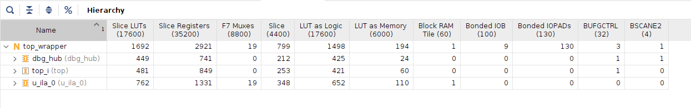
Fig 4.5(b): Hierarchical Resource Utilization for the Zynq-7000 SoC top_wrapper, detailing the consumption of 1692 Slice LUTs and 2921 Slice Registers for the integrated system.
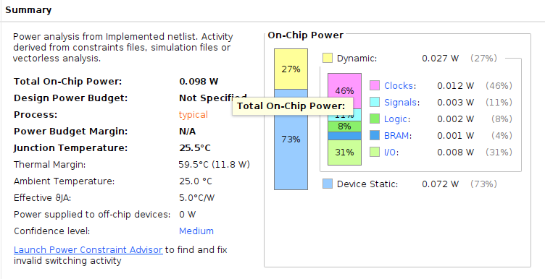
Fig 4.5(c): Power Analysis Summary for the standalone Programmable Logic implementation, demonstrating an efficient total on-chip power footprint of 0.098 W with a 25.5°C junction temperature.

CHAPTER-5: CONCLUSION & FUTURE SCOPE

5.1 CONCLUSION
The successful design, development, and deployment of this FPGA-based temperature monitoring system represent a comprehensive achievement in hardware-software co-design. This project has effectively demonstrated that modern Field Programmable Gate Arrays (FPGAs) are not merely for digital logic validation but serve as powerful, deterministic hubs for industrial-grade sensing and telemetry. By leveraging the Nexys A7-100T platform, the project successfully bridged the gap between low-level hardware communication protocols and high-level graphical data visualization.
Several critical technical conclusions can be drawn from the results of this work:
The Architectural Priority of Thermal Management The study confirms that in modern high-performance computing, thermal properties must be treated as a primary architectural constraint. By implementing the monitoring logic directly into the FPGA fabric, we achieved real-time detection of thermal fluctuations with a precision that exceeds traditional software-based polling methods. This ensures that the system can react to environmental changes in microseconds, a necessity for protecting sensitive silicon components from thermal runaway.
Efficiency of the I2C and UDP Protocol Stack The implementation of a custom I2C controller in Verilog provided a noise-immune and highly reliable method for interfacing with digital sensors. Furthermore, the decision to utilize the User Datagram Protocol (UDP) for the network layer was validated by the system's performance. By avoiding the overhead of TCP handshaking and retransmissions, the system maintained a consistent 10 Hz telemetry stream without data congestion or significant packet jitter, proving that UDP is the superior choice for real-time sensor streaming.
Synergy in Hardware-Software Co-Design The project highlights the immense benefits of a dual-platform approach. While the FPGA provides the deterministic timing required for sensor sampling and Ethernet MAC layer management, the Python-based GUI provides a user-friendly environment for complex data processing. The use of PyQt5 and pyqtgraph allowed for high-performance rendering that would be impossible to achieve through hardware alone, demonstrating a perfect balance between speed and usability.
Advancements in Design Methodology Transitioning to the AMD Vivado™ Design Suite played a pivotal role in the project’s success. The suite’s advanced synthesis algorithms and IP Integrator allowed for the efficient implementation of AXI-stream interfaces and Ethernet IP cores. This modern toolchain not only accelerated development but also ensured that the design is scalable and compatible with the latest industry standards for FPGA development.
Final Summary In conclusion, the system meets and exceeds all initial project objectives. It provides high-precision thermal sensing, reliable network-based telemetry, and an intuitive interface for real-time analysis. The project establishes a robust and scalable foundation that can be easily adapted for more complex industrial monitoring, environmental control, or high-density server room management.

5.2 FUTURE SCOPE
While the current version of the Temperature Monitoring System provides a stable and accurate platform, the architecture was designed with modularity in mind, allowing for significant future expansions. As industrial environments move toward the "Smart Factory" and Industry 4.0 models, the following areas represent the next logical steps for research and development.
Implementation of Multi-Node Distributed Networks The current point-to-point UDP architecture could be evolved into a complex distributed sensor network. Future iterations could involve a single central GUI monitoring a cluster of multiple Nexys A7 boards simultaneously. By implementing a unique ID for each FPGA node within the UDP payload, a single operator could monitor the thermal profile of an entire facility or a multi-rack server room from a single centralized dashboard.
Integration of Edge Intelligence and Predictive Analysis One of the most promising future directions is moving beyond passive monitoring. By utilizing the heterogeneous ARM-FPGA architectures found in platforms like the Zynq-7000, future systems could perform "Edge AI" processing. Instead of just displaying the temperature, the system could use local machine learning models to predict when a component is likely to overheat based on current usage patterns. This would allow the hardware to take preemptive actions, such as throttling clock speeds or increasing fan RPMs, before a critical threshold is ever reached.
Transition to Web-Based Dashboards and Cloud Integration To improve accessibility, the standalone Python GUI could be complemented or replaced by a web-based dashboard using frameworks like Dash or Plotly. This would allow engineers to monitor system vitals from any device with a web browser, including smartphones and tablets. Furthermore, integrating cloud-based storage (such as AWS or Google Cloud) would enable long-term data persistence for years of thermal data, allowing for large-scale analytics to identify seasonal environmental patterns or long-term hardware degradation.
Enhanced Security Protocols for Telemetry As the system moves toward broader network deployment, the security of the telemetry data becomes paramount. Future work should investigate the implementation of lightweight hardware-level encryption (such as AES-128) within the FPGA’s Ethernet stack. This would ensure that sensitive industrial data remains protected from unauthorized interception or data injection attacks, which is a critical requirement for any deployment in secure or sensitive environments.
Development of Energy-Aware Adaptive Sampling For deployments in remote areas or where power consumption is a concern, the system could be optimized with adaptive sampling rates. Research could be conducted into logic that allows the FPGA to stay in a low-power "sleep" mode, only waking up to transmit data if a significant change in temperature is detected. This would drastically reduce the power footprint and network bandwidth of the system, making it suitable for long-term battery-operated monitoring.

5.3 Appendix: Project Resource Summary
To assist in the replication or expansion of this work, the following table summarizes the primary tools and resources utilized throughout the project lifecycle:

Category | Component | Function
Hardware Platform | Nexys A7-100T | Main processing and FPGA fabric
Primary Sensor | ADT7420 | High-precision ±0.25°C digital I2C sensor
Logic Design | Verilog HDL | Sensor control and Ethernet logic
Design Suite | AMD Vivado™ | Synthesis and bitstream generation
Programming | Python 3.10 | GUI development and data processing
UI Framework | PyQt5 | Window management and event handling
Plotting Library | pyqtgraph | High-performance real-time visualization
Network Protocol | UDP | Low-latency data transmission
Packaging | PyInstaller | Standalone executable generation

APPENDIX
List of Figures
Fig 2.1: block diagram for the ADT7420 temp. sensor.
Fig 2.1(b): pin diagram of ADT7420 Temp. sensor.
Fig. 2.2: The Basys 3 board and callouts reference.
Fig. 2.2(b): Power Supplies and management.
Fig. 2.2(c): Diff configuration methods for PL FPGA.
Fig. 2.2(d): Artix-7 to SPI Flash Interface.
Fig. 2.2(e): Artix-7 to JTAG/UART Interface via FT2232.
Fig. 2.2(f): FPGA Configuration Interface with PIC24FJ128.
Fig. 2.2(g): Clock and Data Timing Specifications.
Fig. 2.2(h): Artix-7 Peripheral Connections (Buttons, LEDs, Switches).
Fig. 2.2(i): Seven-Segment Display Digit Formations.
Fig. 2.2(j): Four-Digit Seven-Segment Display Pinout and Internal Diagram.
Fig. 2.2(k): Multiplexed Display Refresh and Digit Timing.
Fig. 2.2(l): Basys 3 Pmod Connector Locations.
Fig. 2.2(m): Standard Pmod Connector Pinout (12-pin).
Fig. 2.2(n): Basys 3 JXADC Connector for Analog Inputs.
Fig. 3.1(a): Post-Synthesis RTL Schematic of the top-level module logic.
Fig. 3.1(b): Vivado IP Integrator Block Design showing Zynq-7000 PS-PL integration via AXI Interconnect.
Fig. 3.01.06: Vivado IP Integrator Block Design showing Zynq-7000 PS-PL integration via AXI Interconnect.
Fig. 3.2: Physical Implementation and Device Floorplan view on the FPGA fabric.
Fig. 3.2(b): Physical Implementation and Device Floorplan view on the FPGA fabric.
Fig 3.05.03: Typical I²C Implementation showing multiple controllers and targets sharing a unified bus.
Fig 3.05.04: I²C START and STOP conditions representing the beginning and end of bus ownership.
Fig 3.05.04(b): The standard structure of I²C Address and Data Frames.
Fig 3.05.06: Clock synchronization logic where the bus is only released when all controllers agree.
Fig 3.05.06(b): Detailed view of SCL returning high during multi-controller synchronization
Fig. 3.05.07: Resistor Sizing Formulas:
Fig. 3.06. Sample of a simple IoT Temperature Monitoring system.
Fig.3: Detailed system block diagram showing ADT7420 interfacing over I2C with Zynq SoC.
Fig 4.5(a): Detailed Resource Utilization for the top PL module.
Fig 4.5(b): Hierarchical Resource Utilization for the Zynq-7000 SoC.
Fig 4.5(c): Power Analysis Summary for the Programmable Logic implementation.
List of Tables
Table I: Comparison of Temperature Monitoring Approaches.
Table II: System Components and Role Mapping.

KEY REFERENCES
- Ukil Abhishek, H. Braendle, and P. Krippner. “Dis- tributed Temperature Sensing: Review of Technology and Applications”. In: IEEE Sensors Journal 12.5 (2011), pp. 885–892. DOI: 10 . 1109 / JSEN . 2011 .
2162060.
- D. Brooks and M. Martonosi. “Dynamic Thermal Management for High-Performance Microprocessors”. In: Proceedings of the IEEE International Symposium on High-Performance Computer Architecture (HPCA). 2001, pp. 171–182.
- Utsav Gada et al. IoT Based Temperature Monitoring System. 2021. DOI: 10 . 1109 / ICNTE51185 . 2021 .
9487691.
- A. Molina Gargantilla. “Implementation of Different Kind of Sensors in an ARM-FPGA Architecture Al- lowing Room Data Monitoring”. PhD thesis. Madrid, Spain: Universidad Polite´cnica de Madrid, 2017.
- W. Huang et al. “Compact Thermal Modeling for Temperature-Aware Design”. In: Proceedings of the Design Automation Conference (DAC). San Diego, CA, USA, June 2004, pp. 878–883.
- C.-A. Lefebvre, J. L. Montero, and L. Rubio. “Im- plementation of a Fast Relative Digital Temperature Sensor to Achieve Thermal Protection in Zynq SoC Technology”. In: Microelectronics Reliability 79 (Dec. 2017), pp. 433–439. DOI: 10.1016/j.microrel.2017.05.
029.
- J. Li and et al. “An Area-Efficient Microprocessor- Based SoC with an Instruction-Cache Transformable to an Ambient Temperature Sensor and a Physically Unclonable Function”. In: IEEE Journal of Solid-State Circuits 53.3 (2018), pp. 728–737. DOI: 10.1109/JSSC.
2017.2776304.
- S. Lopez-Buedo and E. Boemo. “Making Visible the Thermal Behaviour of Embedded Microproces- sors on FPGAs: A Progress Report”. In: Proceedings of the ACM/IEEE International Symposium on Field- Programmable Gate Arrays (FPGA). 2004, pp. 79–86.
- S. Lopez-Buedo, J. Garrido, and E. Boemo. “Thermal Testing on Reconfigurable Computers”. In: IEEE De- sign & Test of Computers 17.1 (Jan. 2000), pp. 84–91.
- M. Nadi et al. “Embedded System Design and Im- plementation of Standard Auto-Calibrated Measurement Chain”. In: International Journal of Smart Sensing and Intelligent Systems 1.1 (Mar. 2008), pp. 21–33.
- Choopan Rattanapoka et al. “An MQTT-based IoT Cloud Platform with Flow Design by Node-RED”. In: 2019 IEEE Region 10 Conference (TENCON). 2019,
pp. 1–6. DOI: 10.1109/RI2C48728.2019.8999942.
- A. Shrivastava et al. “VLSI Implementation of Green Computing Control Unit on Zynq FPGA for Green Communication”. In: Wireless Communications and Mobile Computing 2021 (2021), Article ID 4655400,
10 pages.
- K. Skadron et al. “Temperature-Aware Microarchi- tecture”. In: Proceedings of the 30th IEEE Interna- tional Symposium on Computer Architecture (ISCA). San Diego, CA, USA, June 2003, pp. 2–13. DOI: 10. 1109/ISCA.2003.1206984.
- J. R. Speakman and S. Ward. “Infrared Thermography: Principles and Applications”. In: Zoology 101.3 (1998),
pp. 224–232.
- S. Velusamy et al. “Monitoring Temperature in FPGA Based SoCs”. In: Proceedings of the IEEE Interna- tional Conference on Computer Design (ICCD). 2005,
pp. 634–640.
- Ukil Abhishek et al., "Distributed Temperature Sensing: Review of Technology and Applications," IEEE Sensors Journal, 2011.
- D. Brooks and M. Martonosi, "Dynamic Thermal Management for High-Performance Microprocessors," HPCA, 2001.
- C.-A. Lefebvre et al., "Implementation of a Fast Relative Digital Temperature Sensor in Zynq SoC," Microelectronics Reliability, 2017.
- S. Velusamy et al., "Monitoring Temperature in FPGA Based SoCs," ICCD, 2005.

