**Problem Solving**

Student Name: Tara Thorne

Student Number: 0003809521

**A Cat, a Parrot, and a Bag of Seed:**

A man finds himself on a riverbank with a cat, a parrot and a bag of seed. He needs to transport all three to the other side of the river in his boat. However, the boat has room for only the man himself and one other item (either the cat, parrot or seed). In his absence, the cat could eat the goat, and the goat would eat the cabbage. Show how he can get all the passengers to the other side, without leaving the wrong ones alone together.

1) Define the problem

a) Do this in your own words.

The man needs to transport himself, a cat, a parrot, a goat, cabbage and seed. He needs to arrive on the other shore with all surviving.

b) What insight can you offer into the problem that is not immediately visible from the word problem alone?  
The cat could eat the parrot, the goat could eat the cabbage and the parrot could eat the seed if he wasn’t present.

c) What is the overall goal?  
Get all the animals and product along with him to the other side of the river without something being eaten.

2) Break the problem apart

a) What are the constraints?

Certain animals could eat each other or the product.

b) What are the sub goals?

Getting the animals on the boat without eating each other.

3) Identify potential solutions

a) For each of the sub problems you’ve discussed in #2, what is a possible solution?

1. Get a cage to put the animals is.

2. Find something to tie them up and put them in separate places on the boat.

4) Evaluate each potential solution

a) Does each solution meet the goals?

b) Will each solution work for ALL cases?

Yes they both solve the problem of keeping the animals from eating each other and from the animals eating the products.

5) Choose a solution and develop a plan to implement it.

a) Explain the solution in full.

As most boats should have some ropes you should be able to find some on the boat to tie the animals in different locations to prevent them from eating each other. The products don’t need to be tied up since they can’t move on their own.

b) Describe some test cases you tried out to make sure it works.

(You can include drawings and diagrams as part of your explanation as long as they are clearly communicating the solutions.

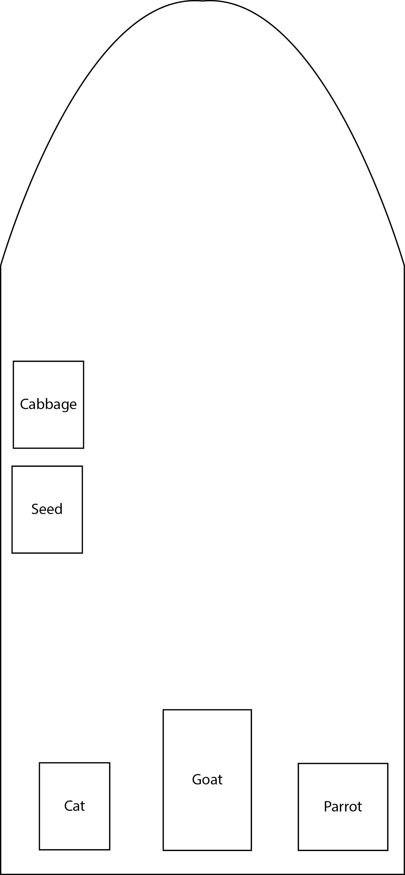

**Socks in the Dark:**

There are 20 socks in a drawer: 5 pairs of black socks, 3 pairs of brown and 2 pairs of white. You select the socks in the dark and can check them only after a selection has been made. What is the smallest number of socks you need to select to guarantee getting the following:

a) At least one matching pair

b) At least one matching pair of each color.

1) Define the problem

a) Do this in your own words.

A person needs a pair of matching socks while selecting them in the dark.

b) What insight can you offer into the problem that is not immediately visible from the word problem alone?

Are the socks in the draw neatly folded and color coordinated? If they were folded and color coordinated then the person would know where each pair was.

c) What is the overall goal?

To get a matching pair of socks and get a matching pair of each color sock.

2) Break the problem apart

a) What are the constraints?

It’s dark.

b) What are the sub goals?

There is only one goal to get matching socks.

3) Identify potential solutions

a) For each of the sub problems you’ve discussed in #2, what is a possible solution?

If you want a guarantee either turn the light on or take all the socks.

4) Evaluate each potential solution

a) Does each solution meet the goals?

Yes both solutions meet the goals.

b) Will each solution work for ALL cases?

Yes each solution will work for ALL cases unless the person isn’t able to turn the light on.

5) Choose a solution and develop a plan to implement it.

a) Explain the solution in full.

If for some reason you aren’t able to turn the light on then it’s pretty simple just take all the socks.

b) Describe some test cases you tried out to make sure it works.

(You can include drawings and diagrams as part of your explanation as long as they are clearly communicating the solutions.)

I just used logical thinking and common sense.

**Predicting Fingers:**

A little girl counts using the fingers of her left hand as follows: She starts by calling her thumb 1, the first finger 2, middle finder 3, ring finger 4, and little finger 5. Then she reverses direction, calling the ring finger 6, middle finger 7, first finger 8 and thumb 9, after which she calls her first finger 10 and so on. If she continues to count in this manner, on which finger will she stop?

a) What if the girl counts from 1 to 10?

b) What if the girl counts from 1 to 100?

c) What if the girl counts from 1 to 1000?

1) Define the problem

a) Do this in your own words.

A little girl needs to count to 10, 100 and 1,000 using only one hand.

b) What insight can you offer into the problem that is not immediately visible from the word problem alone?

c) What is the overall goal?

Count to 10, 100 and 1,000 using one hand and figure out which finger they will end on.

2) Break the problem apart

a) What are the constraints?

The girl is using one hand.

b) What are the sub goals?

I don’t see a sub goal.

3) Identify potential solutions

a) Count by 10s rotating between you pointer finger and your ring finger.

4) Evaluate each potential solution

a) Does each solution meet the goals?

Yes it meets the goals.

b) Will each solution work for ALL cases?

No it won’t work for all cases.

5) Choose a solution and develop a plan to implement it.

a) Explain the solution in full.

For each of the sub problems you’ve discussed in #2, what is a possible solution?

When she counted to 10 it would have landed on the pointer finger if you continue to count to 20 you’d notice that it would land on the ring finger. Now continue on to thirty you’ll notice it will land once again back on the pointer finger. Now you should notice the pattern that odd numbers are on the pointer finger and the even are on the ring finger.

b) Describe some test cases you tried out to make sure it works.

(You can include drawings and diagrams as part of your explanation as long as they are clearly communicating the solutions.)

This was the only thing I could come up with and it was just the matter of simply counting your fingers.