EM: the Expectation-Maximization Algorithm

Selected topics from Part 1 of Data Mining Intro

2025-01-28 21:32 GMT

Abstract

The EM algorithm is introduced and demonstrated.

Table of Contents

Background 1

Example: Old Faithful eruptions 2

Delay and Duration 2

Gausian Mixture Model 2

Latent Variable: Cluster Membership 3

Initial Estimates 3

Log Likelihood 5

EM Iterations 7

Closing Remarks 9

Resources 9

## Background

Latent Dirichlet Allocation (LDA) was proposed as a method of topic modeling in 2003 in a paper by Blei, Ng, and Jordan. The method is briefly mentioned in Part 1 of the course. Several course participants requested a more detailed description. This note prepares for the requested response by introducing the EM Algorithm.

## Example: Old Faithful eruptions

### Delay and Duration

The figure below represents the duration of eruptions (“duration”) and the interval between eruptions (“delay”)[1] of the “Old Faithful” geyser in Yellowstone National Park, Wyoming from August 1 to August 15, 1985.[2]

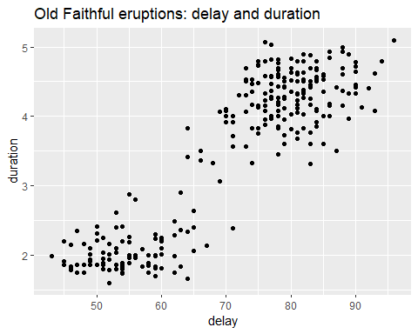

### Gausian Mixture Model

The figure shows two clusters of data points.[3] A plausible probability model for data-generation is the following mixture of bivariate Gaussian (normal) distributions.

$$\begin{matrix}\left(\text{delay},\text{duration}\right) & ∼p_{1} N\left(μ_{•}^{\left(1\right)},Σ^{\left(1\right)}\right)+p_{2} N\left(μ_{•}^{\left(2\right)},Σ^{\left(2\right)}\right) \\ & \\ & \text{where }p_{1}+p_{2}=1 \\ & \end{matrix}$$

Fitting a single multivariate normal distribution is straightforward, but less so for the above mixture of bivariate normal distributions. The Expectation-Maximization (EM) algorithm provides an approach for doing so, as follows.

### Latent Variable: Cluster Membership

In the EM framework, we iteratively assign a cluster-membership index, $z∈\{1,2\}$, to each data point, consistent with the following model.

$$\begin{matrix}\{\left(\text{delay},\text{duration}\right)|Z=z\} & ∼N\left(μ_{•}^{\left(z\right)},Σ^{\left(z\right)}\right) \\ & \\ & \text{where }z∈\{1,2\} \\ & \end{matrix}$$

Then conditioning on this assignment we update the parameter estimates (the “E” step of the EM algorithm). The new set of parameter estimates yields a new estimate of the likelihood function. We then re-assign cluster-membership to maximize the updated likelihood estimate (the “M” step). The iteration terminates once the magnitude of changes falls below a prescribed threshold.

### Initial Estimates

Based on the preceding figure we adopt the following initial estimates of the parameters.

1. Calculate the respective medians of the (delay, duration) variables.
2. For each data point determine whether the delay value is less than the median of all observed delay values. Similarly determine whether the duration value is less than the median of all observed duration values.
3. Based on these inequalities, categorize each (delay, duration) data point as belonging to one of four groups: (lower, lower), (lower, upper), (upper, lower), (upper, upper).
4. Restrict attention to the (lower, lower), and (upper, upper) groups. Within this restricted set of data points calculate the sample averages and covariance matrices for each of the two groups. Use these as initial estimates of $\left(μ_{•}^{\left(1\right)},μ_{•}^{\left(2\right)}\right)$ and $\left(Σ^{\left(1\right)},Σ^{\left(2\right)}\right)$.

The table below summarizes the groups delineated by the respective medians of (delay, duration).

Summary statistics for initial groups of data points

| delay_low | duration_low | count | delay_mean | duration_mean | delay_sd | duration_sd | dd_cor |
| --- | --- | --- | --- | --- | --- | --- | --- |
| FALSE | TRUE | 22 | 81.1 | 3.7 | 3.5 | 0.2 | -0.2 |
| TRUE | TRUE | 112 | 56.6 | 2.2 | 7.7 | 0.6 | 0.7 |
| FALSE | FALSE | 116 | 82.4 | 4.5 | 4.6 | 0.3 | 0.1 |
| TRUE | FALSE | 22 | 73.0 | 4.4 | 1.9 | 0.3 | 0.6 |

Restricting attention to the groups in which (delay, duration) jointly fall either below or above their respective medians, we extract the initial parameter estimates from the table above. Variable z is the labeling of each point in the restricted data set to cluster 1 or cluster 2.

Initial parameter estimates

| z | count | delay_mean | duration_mean | delay_sd | duration_sd | dd_cor |
| --- | --- | --- | --- | --- | --- | --- |
| 1 | 112 | 56.6 | 2.2 | 7.7 | 0.6 | 0.7 |
| 2 | 116 | 82.4 | 4.5 | 4.6 | 0.3 | 0.1 |

The figure below summarizes results so far. We’ve restricted attention to data points (delay, duration) such that the two variables are either both below their respective medians or else both above their respective medians. We’ve defined variable z as the grouping variable taking integer values (1, 2) in these two respective cases. For each of the two groups we’ve constructed an ellipse conforming to the sample mean vector and covariance matrix of the group. The ellipse is designed to capture 50% of the area under a bivariate normal distribution having these parameter values.

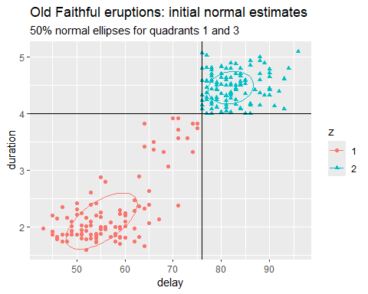

This completes the initial “E” step in the EM algorithm, the estimation of parameter values.

### Log Likelihood

We now begin the initial “M” step (maximization) of the EM algorithm. Using the above parameter estimates we now assign cluster membership (variable z) to the points not yet labeled by maximizing the likelihood function, or equivalently (and more conveniently), the logarithm of the likelihood function.

In general, recall that a multivariate normal distribution having mean vector $μ_{•}∈R^{m}$ and covariance matrix $Σ$ has likelihood function equal to the product of the multivariate normal density evaluated at each observation vector, say $x_{•}^{\left(ν\right)}$, (that is, at each row of the design matrix $X$).

$$\begin{matrix}L\left(X,μ_{•},Σ\right) & =\prod_{ν=1}^{n}{N}\left(x_{•}^{\left(ν\right)}-μ_{•}, Σ\right)\end{matrix}$$

Taking the natural logarithm of both sides of this equation, we obtain the log-likelihood function.

$$\begin{matrix}l\left(X,μ_{•},Σ\right) & =\sum_{ν=1}^{n}{\log_{e}}\left(N\left(x_{•}^{\left(ν\right)}-μ_{•}, Σ\right)\right) \\ & =-\frac{m}{2}\log_{e}\left(2π\right)-\frac{1}{2}\log_{e}\left(detΣ\right)-\frac{1}{2}\sum_{ν=1}^{n}{{\left(x_{•}^{\left(ν\right)}-μ_{•}\right)}^{⊺}} Σ^{-1}\left(x_{•}^{\left(ν\right)}-μ_{•}\right) \\ & \end{matrix}$$

Consequently, fitting parameters $μ_{•}$ and $Σ$ to the design matrix $X$ via maximum likelihood amounts to minimizing the sum of quadratic forms on the right side of this equation. (Each term in the sum is referred to as the squared *Mahalanobis distance* between the observation vector and the mean vector.)

$$\begin{matrix}\left({\hat{μ}}_{•},\hat{Σ}\right) & =argmin\sum_{ν=1}^{n}{{\left(x_{•}^{\left(ν\right)}-μ_{•}\right)}^{⊺}} Σ^{-1}\left(x_{•}^{\left(ν\right)}-μ_{•}\right) \\ & \end{matrix}$$

which yields the sample mean and a variant of the sample covariance matrix.

$$\begin{matrix}{\hat{μ}}_{•} & =\frac{1}{n}\sum_{ν=1}^{n}{x_{•}^{\left(ν\right)}} \\ & \\ \hat{Σ} & =\frac{1}{n}\sum_{ν=1}^{n}{\left(x_{•}^{\left(ν\right)}-{\hat{μ}}_{•}\right)}{\left(x_{•}^{\left(ν\right)}-{\hat{μ}}_{•}\right)}^{⊺} \\ & \end{matrix}$$

Let us now return to the Old Faithful data. Having estimated the normal parameters for clusters 1 and 2, we now label each data point as belonging to the cluster to which it is closest, in the sense of Mahalanobis distance. The results are shown in the next figure.

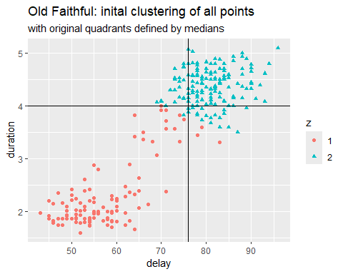

This completes the initial maximization step, and begins the next estimation step. The table below shows the revised summary statistics per cluster now that the initial assignment to clusters has been completed.

Summary statistics for initial clusters of data points

| z | count | delay_mean | duration_mean | delay_sd | duration_sd | dd_cor |
| --- | --- | --- | --- | --- | --- | --- |
| 1 | 115 | 57.1 | 2.3 | 8.4 | 0.6 | 0.7 |
| 2 | 157 | 81.0 | 4.4 | 5.3 | 0.3 | 0.1 |

## EM Iterations

We illustrate the iterations of the EM algorithm using function mvnormalmixEM() in R package mixtools. We provide the function with our initial estimates of normal parameters.

em_out <- faithful_tbl |>   
 mixtools::mvnormalmixEM(  
 lambda = c(0.5, 0.5),   
 mu = list(  
 # delay, duration  
 c(56.6, 2.25), # (lower, lower)  
 c(82.4, 4.47) # (upper, upper)  
 ),   
 sigma = list(  
 # (lower, lower)  
 matrix(  
 nrow = 2, ncol = 2,   
 data = c(  
 59.7, 3.27,   
 3.27, 0.35  
 )),   
 # (upper, upper)  
 matrix(  
 nrow = 2, ncol = 2,   
 data = c(  
 21.5, 0.19,   
 0.19, 0.08  
 ))  
 ),   
 verb = TRUE  
 )

## iteration= 1 diff= 41.60226 log-likelihood -1168.518   
## iteration= 2 diff= 14.54077 log-likelihood -1153.978   
## iteration= 3 diff= 12.21481 log-likelihood -1141.763   
## iteration= 4 diff= 9.461094 log-likelihood -1132.302   
## iteration= 5 diff= 1.962679 log-likelihood -1130.339   
## iteration= 6 diff= 0.0717014 log-likelihood -1130.267   
## iteration= 7 diff= 0.003089365 log-likelihood -1130.264   
## iteration= 8 diff= 0.000168951 log-likelihood -1130.264   
## iteration= 9 diff= 9.661982e-06 log-likelihood -1130.264   
## iteration= 10 diff= 5.582749e-07 log-likelihood -1130.264   
## iteration= 11 diff= 3.233686e-08 log-likelihood -1130.264   
## iteration= 12 diff= 1.874241e-09 log-likelihood -1130.264   
## number of iterations= 12

Reports from each iteration were requested by setting function parameter verb = TRUE (verbose). The estimated log-likelihood is shown for each iteration, along with the change in that value from the previous iteration.

The final estimates of the normal parameters are shown in the table below, and illustrated in the figure below.

Summary statistics for final groups of data points

| z | count | delay_mean | duration_mean | delay_sd | duration_sd | dd_cor |
| --- | --- | --- | --- | --- | --- | --- |
| 1 | 97 | 54.5 | 2.0 | 5.8 | 0.3 | 0.3 |
| 2 | 175 | 80.0 | 4.3 | 6.0 | 0.4 | 0.4 |

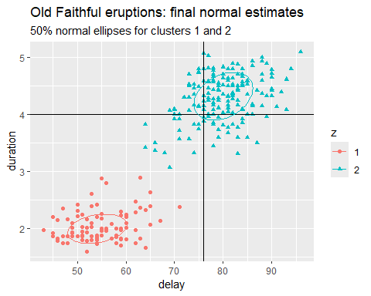

## Closing Remarks

Several papers present the mathematics underlying the EM algorithm, and one can also find tutorials that illustrate the convergence of the algorithm.

## Resources

[Maximum Likelihood from Incomplete Data via the EM Algorithm](https://www.ece.iastate.edu/~namrata/EE527_Spring08/Dempster77.pdf), by A.P. Dempster, N.M. Laird and D.B. Rubin, JRSS(B), 1977

[Expectation–maximization algorithm - Wikipedia](https://en.wikipedia.org/wiki/Expectation%E2%80%93maximization_algorithm)

[The EM Algorithm Explained](https://medium.com/@chloebee/the-em-algorithm-explained-52182dbb19d9) blog by Chloe Bi, 2019

[The plumbing of Old Faithful Geyser revealed by hydrothermal tremor - Vandemeulebrouck - 2013 - Geophysical Research Letters - Wiley Online Library](https://agupubs.onlinelibrary.wiley.com/doi/10.1002/grl.50422)

1. “Delay” here refers to the length of time *preceding* the current eruption. The (delay, duration) variables are recorded in minutes.
2. There are two prominent R packages representing the Old Faithful measurements during August, 1985. The MASS::geyser data set of 299 observations includes nocturnal measurements whose duration was coded as 2, 3 or 4 minutes, having originally been described as ‘short’, ‘medium’ or ‘long’. The datasets::faithful data set of 272 measurements, shown in the figure, excludes 27 of these nocturnal measurements.
3. Old Faithful eruptions are conjectured to occur in 2 distinct temporal patterns due to the presence of an upper and lower chamber beneath the vertical column (tube) that forms the geyser.