CLSID: D24D4453-1F01-11d1-8E63-006097D2DF48

MDT2DD! 587e9cf2()
MDT2DD! 587ba1c8()
MDT2DD! 587ba054()
MDT2DD! 587b2367()
MSHTML! 7d70e9ab()
MSHTML! 7d712250()
MSHTML! 7d712f5b()
MSHTML! 7d7137ca()
MSHTML! 7d713afa()
MSHTML! 7d70e889()
MSHTML! 7d715cfe()
MSHTML! 7d6fda

587E9CF2 mov eax,dword ptr [ecx]
587E9CF4 push 1
587E9CF6 call dword ptr [eax]
587E9CF8 and dword ptr [esi+98h],0
587E9CFF or dword ptr [ebp-4],0FFFFFFFFh
587E9D03 mov ecx,esi
587E9D05 call 587BD42C
587E9D0A mov ecx,dword ptr [ebp-0Ch]
587E9D0D pop esi
587E9D0E mov dword ptr fs:[0],ecx
587E9D15 leave
587E9D16 ret
587E9D17 mov eax,587F280Dh
587E9D1C call 587EF973
587E9D21 push ecx
587E9D22 mov eax,dword ptr [ebp+8]
587E9D25 push ebx
587E9D26 push esi
587E9D27 push edi
587E9D28 xor edx,edx
587E9D2A mov dword ptr [ebp-10h],esp
587E9D2D push edx
587E9D2E push edx
587E9D2F push dword ptr [eax+1Ch]
587E9D32 mov ecx,dword ptr [ecx+98h]
587E9D38 mov dword ptr [ebp-4],edx
587E9D3B push dword ptr [eax+18h]
587E9D3E mov esi,dword ptr [ecx]
587E9D40 push dword ptr [eax+14h]
587E9D43 push dword ptr [eax+10h]
587E9D46 push dword ptr [eax+0Ch]

587E9CF6 call dword ptr [eax]
587E9CF8 and dword ptr [esi+98h],0
587E9CFF or dword ptr [ebp-4],0FFFFFFFFh
587E9D03 mov ecx,esi
587E9D05 call 587BD42C
587E9D0A mov ecx,dword ptr [ebp-0Ch]
587E9D0D pop esi
587E9D0E mov dword ptr fs:[0],ecx
587E9D15 leave
587E9D16 ret
587E9D17 mov eax,587F280Dh
587E9D1C call 587EF973
587E9D21 push ecx
587E9D22 mov eax,dword ptr [ebp+8]
587E9D25 push ebx
587E9D26 push esi
587E9D27 push edi
587E9D28 xor edx,edx
587E9D2A mov dword ptr [ebp-10h],esp
587E9D2D push edx
587E9D2E push edx
587E9D2F push dword ptr [eax+

EAX = 74655320 EBX = 013267F0
ECX = 00180000 EDX = 02510000
ESI = 001F6F08 EDI = 8007000E
EIP = 587E9CF6 ESP = 00138394
EBP = 001383AC EFL = 00000206
MM0 = F00260ECFF0767F9
MM1 = 000000000F05070D
MM2 = 0010000000060010
MM3 = 00700001002D006E
MM4 = FF679CF4FFE5EDFD
MM5 = 8000000000000000
MM6 = 8000000000000000
MM7 = 8000000000000000
XMM0 = E32376B0BF805A6AF315E4D0E32376B0
XMM1 = BF8261FF00000002BF81420800000004
XMM2 = 00000001F315E7BCBC68E3D0BC683DE0
XMM3 = 97040966E2E95220BF822E9FF315E4C4
XMM4 = 0000000002040A1DE327665000000000
XMM5 = 0000000097040966BF823696F315E768
XMM6 = 822E93B8BC68E3D00000000102040A1D
XMM7 = 00010000E149E000F83CC7ABBC68E3D0
CS = 001B DS = 0023 ES = 0023 SS = 0023
FS = 003B GS = 0000 OV=0 UP=0 EI=1 PL=0
ZR=0 AC=0 PE=1 CY=0

74655320 = ????????

XMM00 = -3.01537E+02

MDT2DD! 587e9cf6()
MDT2DD! 587ba1c8()
MDT2DD! 587ba054()
MDT2DD! 587b2367()
MSHTML! 7d70e9ab()
MSHTML! 7d712250()
MSHTML! 7d712f5b()
MSHTML! 7d7137ca()
MSHTML! 7d713afa()
MSHTML! 7d70e889()
MSHTML! 7d715cfe()
MSHTML! 7d6fda53

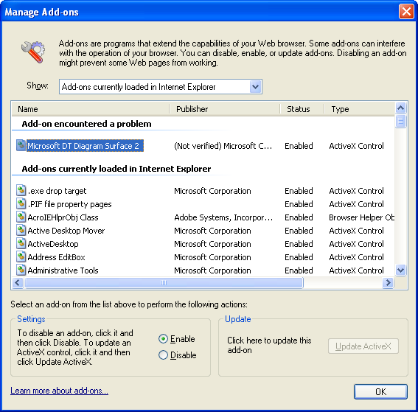

The requirements of crashing is that IE must load some <OBJECT> first, eg,

http://rh9/cgi-bin/clsid3_test.cgi?5056, or
http://rh9/cgi-bin/clsid3_test.cgi?5057

and then after some time, enter

http://rh9/cgi-bin/clsid3_test.cgi?5057

to load the 5057 CLSID, and then it will crash.

