Project 1 -- Logos
due 4/7/2016, 60 pts
CISC 190, Java
Tillinghast 75740 TR6-9:05 pm

This is the first of 2 projects, each worth 60 points. This project must be performed individually. All coding and solutions must be your own. You may ask others what descriptions of the project mean or aspects of what the project is supposed to do, but that is all. All work must be your own.

The Mesa college space program is planning their first rocket launch to Mars in early 2017. The department has assigned you the job of creating logos to display on the shuttle and boosters, as well as around the vicinity of the launch.

You will create a program to allow the faculty and students to design these logos using a movable icon 'Leonardo'. You will give them a set of commands they can use to move Leonardo around and to draw or not draw while he is moving.

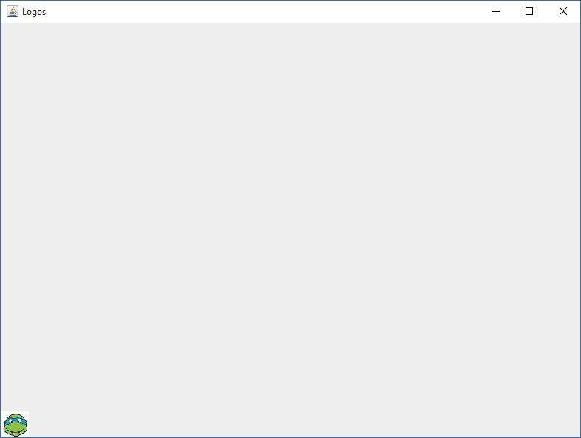

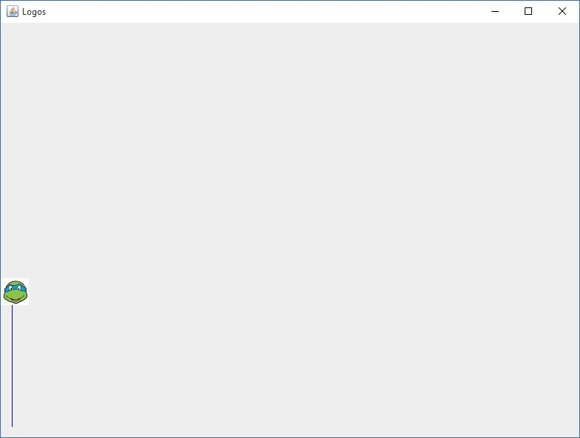
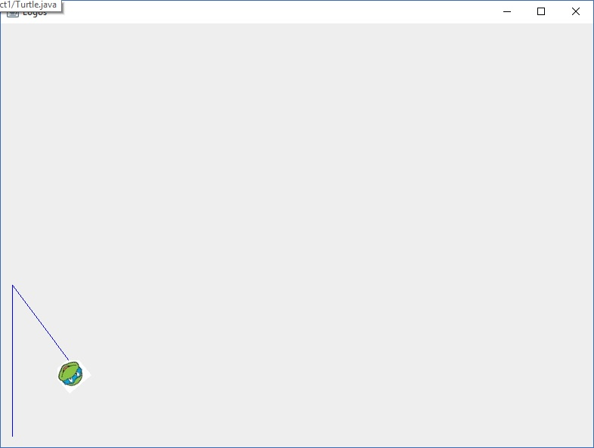

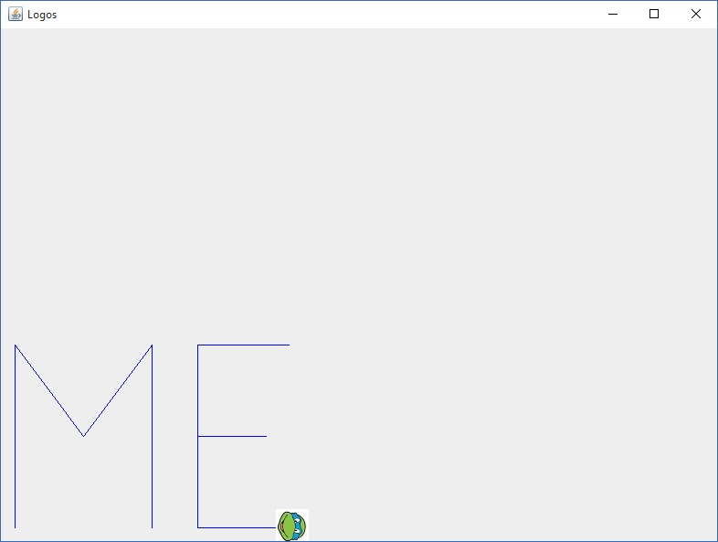

You will parse these commands and appropriately make calls to the "daVinci" java library (due to be released next week).

You will be required to parse and process the commands below from standard input. 'x' denotes an int variable while 'f' denotes a String variable.

forward x
move forward x pixels
backward x
move backwards x pixels
penup
draw when you move
pendown
don't draw when you move
right x
rotate the pen right by x degrees
left x
rotate the pen left by x degrees
for x [...]
repeat the code inside x times
home
return to the 'home' spot
clearscreen
start over: clear all drawing and return to the home spot
save f
save all commands so far to a file named f
load f
load and process all commands from a file named f
quit
quits the program

Fortunately for us, an early release of the daVinci interface is available. It looks as follows:

public interface daVinci {
public void forward(int x); //move forward x pixels
public void backward(int x); //move backward x pixels
public void penup(); //penup
public void pendown(); //pendown
public void rotate(int x); //rotate clockwise x degrees
public void home(); //return Leonardo to home position
public void clear(); //clear all drawing from the screen (Leonardo stays where he is).
}

When daVinci is released, you will be responsible for making it affect the commands you've been given.

Good Luck! Without your help, next year's mission to Mars could remain completely unnoticed.

Instructor reserves the right to make changes to the Project prior to the due date
Mesa college reserves the right to postpone Mars missions indefinitely and may not actually have a Space Program

